Sprint 3 Report – Gestión de Botiquines

Sprint Duration: September 25 – October 1, 2025

Objective: Implement alerts and visual indicators for medicines, completing the foundation of the dashboard.

# 1. Sprint Objectives

* ✅ Implement expiration and stock alerts (critical, preventive, normal).
* ✅ Add configurable stock threshold (reorder_level) per medicine.
* ✅ Provide clear visual indicators (badges and bars).
* ✅ Add filter options to the dashboard by medicine state.
* ✅ Implement a summary panel with key indicators.

# 2. Deliverables Completed

* ✅ Backend
* Medicine.status() extended for stock + expiry logic.
* /api/medicines/alerts endpoint created.
* /api/medicines/filter?status endpoint created.
* reorder_level fully configurable and validated in API.
* seed.py updated with medicines covering all categories.
* ✅ Frontend
* Status badges in inventory.html (Expired, Expiring Soon, Low Stock, OK, etc.).
* Filter buttons for each state (All, Expired, Expiring Soon, Low Stock, Out of Stock).
* Summary panel: total medicines, critical alerts, low stock, last update.
* Progress bar in Quantity column: shows stock level vs reorder threshold.

# 3. Evidence (Screenshots to insert)

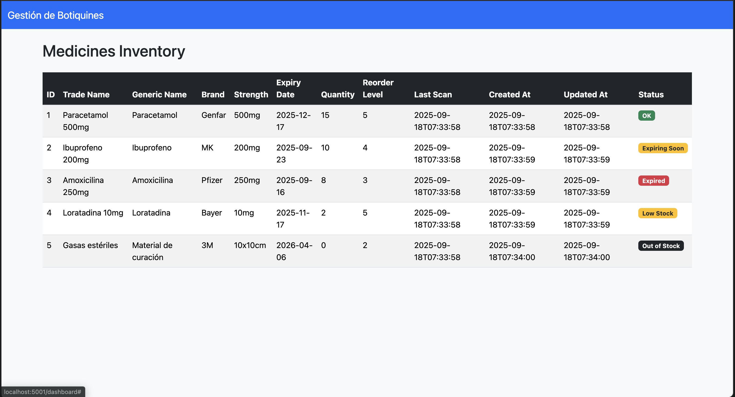

# 4. Pending Items

None for Sprint 3. All planned deliverables have been met.

# 5. Next Steps (Sprint 4 Preview)

* UI polish with Bootstrap responsiveness.
* Testing & bug fixing.
* Demo dataset for presentation.
* Documentation updates.
* Preparation for final deployment in DigitalOcean.

⚡ Sprint 3 successfully completed on time.