## A COMMUNITY SERVICE PROJECT REPORT ON SOCIAL RESPONSIBILITY

Submitted in partial fulfillment for the award of the degree of

# BACHELOROFTECHNOLOGY

IN

Computer Science and Engineering By

KAVALA DHANUSH GOPI

20A81A05M6

Under the Esteemed Supervision of MR. G. NATARAJ

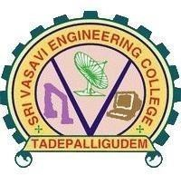Assistant Professor

Department of computer science and Engineering (Accredited by N.B.A)

SRI VASAVI ENGINEERING COLLEGE(Autonomous)

(Affiliated to JNTUK, Kakinada)Pedatadepalli, Tadepalligudem-534101, AP

2022-23

SRI VASAVI ENGINEERING COLLEGE

(Autonomous)

Department of Computer Science and Engineering

Pedatadepalli, Tadepalligudem





This is to certify that the Community Service Project Report entitled “SOCIAL RESPONSIBILITY” survey done in Pedatadepalli village, submitted by kavala Dhanush gopi (20A81A05M6), for the award of the degree of Bachelor of Technology in the Department of Computer Science and Engineering during the academic year 2022-2023.

|  |  |
| --- | --- |
| Name of Project Guide | Head of the Department |
| Mr. G.Nataraj | Dr. D Jaya Kumari |
| Assistant professor | Professor&HOD |

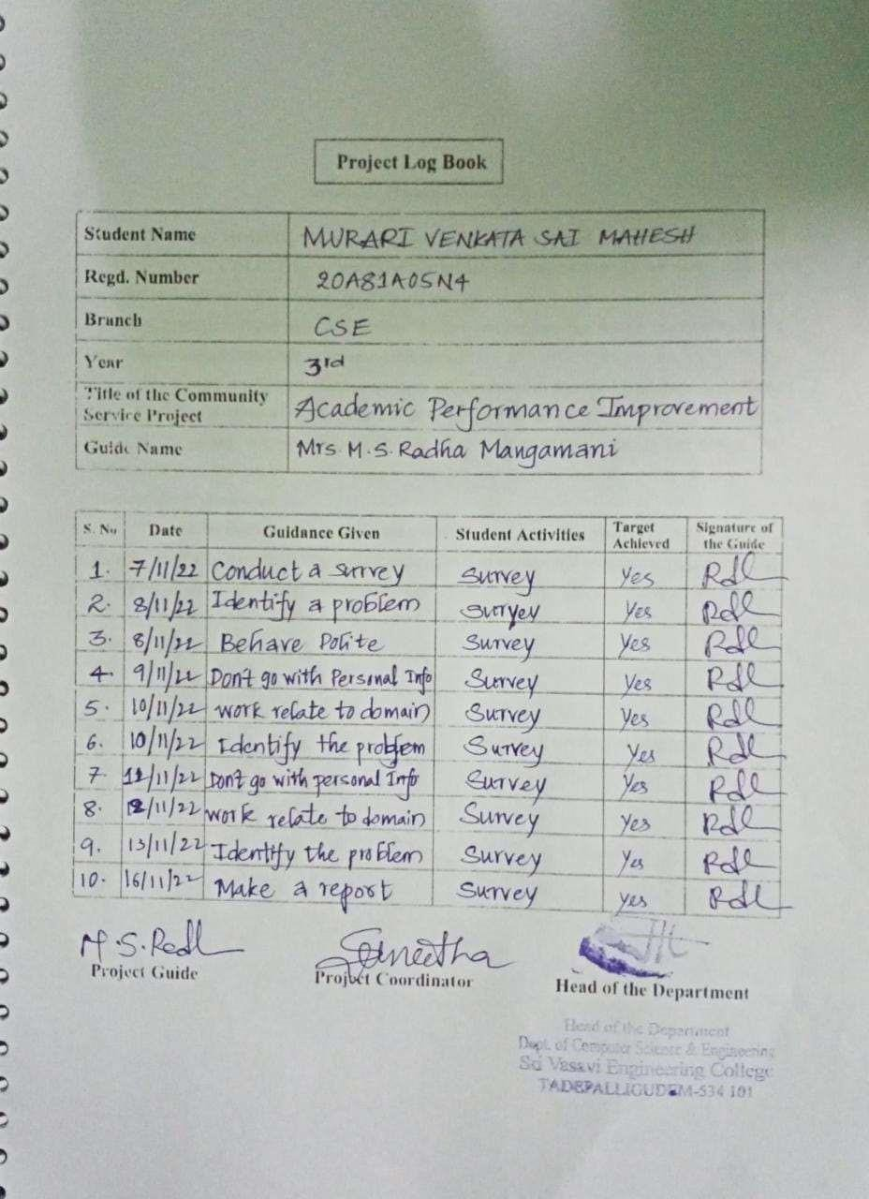

ACKNOWLEDGEMENT

First and foremost, we sincerely salute to our esteemed institute SRI VASAVI ENGINEERING COLLEGE, for giving us this golden opportunity to fulfill our warm dream to become an engineer. Our sincere gratitude to our project guide Mr. G. Nataraj Assistant Professor, Department of Computer Science and Engineering, for his timely cooperation and valuable suggestions while carrying out this project.

We express our sincere thanks and heart full gratitude to Dr. D. Jaya Kumari, M.Tech, Ph.d, Professor & Head of the Department of Computer Science and Engineering, for permitting us to do our project. We express our sincere thanks and heart full gratitude to Dr. G.V.N.S.R. Ratnakara Rao, Principal, for providing a favorable environment and supporting us during the development of this project.

Our special thanks to the management and all the teaching and non-teaching staff members, Department of Computer Science and Engineering, for their support and cooperation in various ways during our project work. It is our pleasure to acknowledge the help of all those respected individuals.

We would like to express our gratitude to our parents, friends who helped to complete this

project.

Kavala Dhanush gopi (20A81A05M6)

## SRI VASAVI ENGINEERING COLLEGE

(Autonomous)

Department of Computer Science and Engineering

Pedatadepalli, Tadepalligudem

(2022-2023)

Community Service Project for the UG Program Academic Performance Improvement

Name of the Student : kavala Dhanush gopi

|  |  |
| --- | --- |
| Regd No | : 20A81A05M6 |
| Branch | : CSE |
| Semester | : V |
| Topic | : Academic Performance Improvement |
| Area | : Pedatadepalli,Tadepalligudem |
| Project Guide | : Mr.G. Nataraj Asst.Professor |
| (Student) | (Project Guide) Mr. G. Nataraj |

Asst.Professor

# CONTENTS

## Introduction

Academic Performance Improvement Survey Awareness program & Photographs of Surveys Observation

## Suggestions Conclusion

INTRODUCTION

Today to sustain in this competitive world one needs to have knowledge. the acquisition of knowledge is obvious in the field of education. But Education is not just a teacher’s lesson or an aspect that student reads in a book . It’s the perception of the content & surroundings by the student’s very own way. So the education need to be taught according to the student’s inclination towards it

.especially the students who are taking their part in the school with young nature have very un - catchy, non-judge able,correctable opinions regarding their career and their perception in terms of grasping the education.with regard to this Academic performance improvement survey is needed.

So we’ve tried to spread our hands to the ends of student’s inner mind by surveying them regarding their academics as well as non-academics which also plays a perdominant role in making one’s life cherish able.This survey covers all types of aspects like questioning, knowing their academic details and a chunk of feedback from the student’s side to know their heart regarding education. Academic performance can’t be improved by just counseling regarding how to perceive education, but also by giving proper requirements. And we took this survey in both private and public schools.

## OBSERVATION

We have observed one acute difference after the seeing survey results .Obtained from public and Government schools. In terms of government school they are good at participating in cultural events with magnificent outer knowledge. However they have quite drawback at communicating in English and average in academics.

But the situations is quite inverse in the private school as they are good at communicating in English, better academic performance. But occasionally taking part in cultural events and competitive sport activities.

Apart from their performance the government school students are expecting some technical aspects like digital class support and lab facility. The private school students are expecting sport activities and they are wishing that their teachers to enrich them with external aspects apart from bookish knowledge.

GOVERNMENT SCHOOL

SUGGESTIONS

The students should be tuned towards enriching their communications skills.

The teachers of their school should try to aware them with happenings that are being taken place outside the world.

And Government and teachers should adapt the latest methodologies for teaching students like using a projector.

For a technical knowledge a computer lab should be installed in the school.

Frequent workshops should be conducted to the students regarding English and should make them to stick with trending skills.

PRIVATE SCHOOL

The teachers of their school should try to aware them with happenings that are being taken place outside the world.

Private school should allot regular sport timings in their curriculum. They should be taken for field trips and industrial visits.

Apart from this the teacher should spend some concern over their thoughts too and should tune them.The Current affairs should be employed in the curriculum for at least one hour per week.

## CONCLUSION

From our survey we came to understand that the school students should be aware of more outer knowledge. Schools should adapt teaching aspects that are taking place as part of 21st century evolution. Apart from education the students should enrich their skills by using the tech giant Google and most famous form of OTT i.e., YouTube. As everything is not been placed as a part of curriculum.

Encouragement in curricular activities as well as enriching sport activities should be increased. As they also play crucial role in shaping the student’s life by improving leadership skills and Team work abilities. The final foremost prior thing to be adapted is to take the student’s opinions to teach according to their heart.