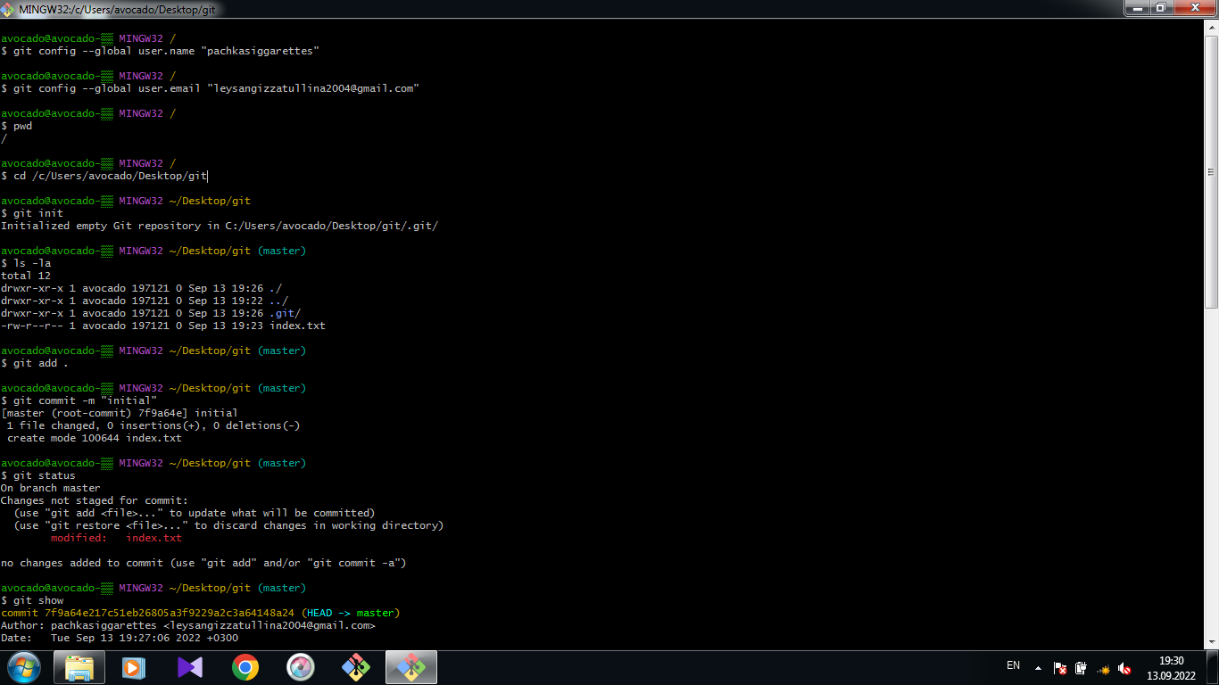

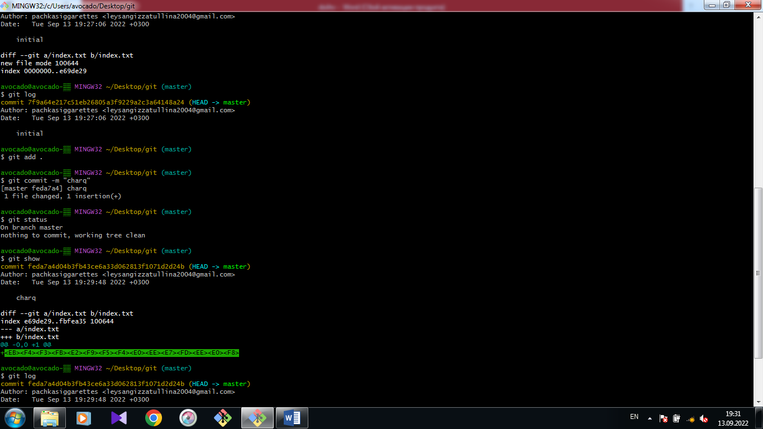

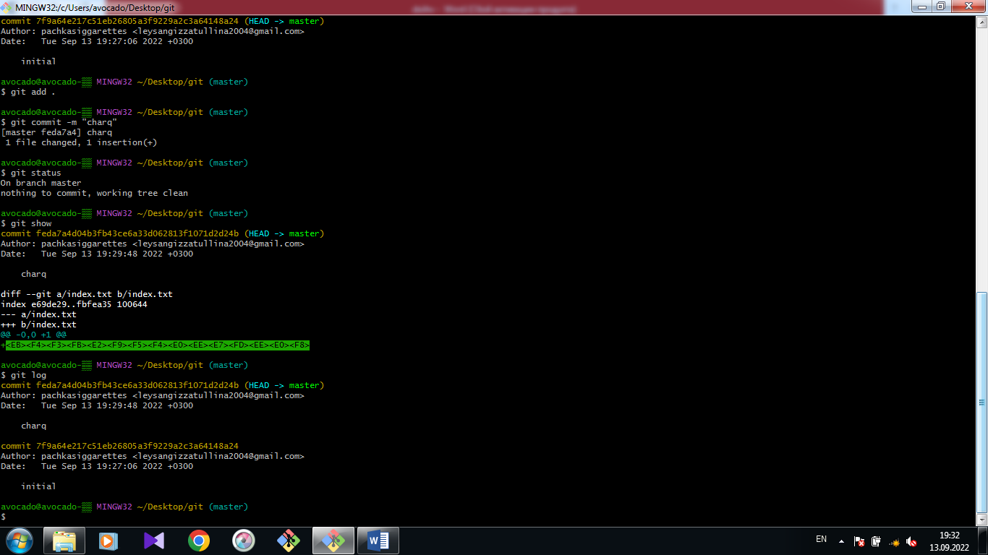

avocado@avocado-▒▒ MINGW32 /

$ git config --global user.name "pachkasiggarettes"

avocado@avocado-▒▒ MINGW32 /

$ git config --global user.email "leysangizzatullina2004@gmail.com"

avocado@avocado-▒▒ MINGW32 /

$ pwd

/

avocado@avocado-▒▒ MINGW32 /

$ cd /c/Users/avocado/Desktop/git

avocado@avocado-▒▒ MINGW32 ~/Desktop/git

$ git init

Initialized empty Git repository in C:/Users/avocado/Desktop/git/.git/

avocado@avocado-▒▒ MINGW32 ~/Desktop/git (master)

$ ls -la

total 12

drwxr-xr-x 1 avocado 197121 0 Sep 13 19:26 ./

drwxr-xr-x 1 avocado 197121 0 Sep 13 19:22 ../

drwxr-xr-x 1 avocado 197121 0 Sep 13 19:26 .git/

-rw-r--r-- 1 avocado 197121 0 Sep 13 19:23 index.txt

avocado@avocado-▒▒ MINGW32 ~/Desktop/git (master)

$ git add .

avocado@avocado-▒▒ MINGW32 ~/Desktop/git (master)

$ git commit -m "initial"

[master (root-commit) 7f9a64e] initial

1 file changed, 0 insertions(+), 0 deletions(-)

create mode 100644 index.txt

avocado@avocado-▒▒ MINGW32 ~/Desktop/git (master)

$ git status

On branch master

Changes not staged for commit:

(use "git add <file>..." to update what will be committed)

(use "git restore <file>..." to discard changes in working directory)

modified: index.txt

no changes added to commit (use "git add" and/or "git commit -a")

avocado@avocado-▒▒ MINGW32 ~/Desktop/git (master)

$ git show

commit 7f9a64e217c51eb26805a3f9229a2c3a64148a24 (HEAD -> master)

Author: pachkasiggarettes <leysangizzatullina2004@gmail.com>

Date: Tue Sep 13 19:27:06 2022 +0300

initial

**diff --git a/index.txt b/index.txt**

**new file mode 100644**

**index 0000000..e69de29**

avocado@avocado-▒▒ MINGW32 ~/Desktop/git (master)

$ git log

commit 7f9a64e217c51eb26805a3f9229a2c3a64148a24 (HEAD -> master)

Author: pachkasiggarettes <leysangizzatullina2004@gmail.com>

Date: Tue Sep 13 19:27:06 2022 +0300

initial

avocado@avocado-▒▒ MINGW32 ~/Desktop/git (master)

$ git add .

avocado@avocado-▒▒ MINGW32 ~/Desktop/git (master)

$ git commit -m "charq"

[master feda7a4] charq

1 file changed, 1 insertion(+)

avocado@avocado-▒▒ MINGW32 ~/Desktop/git (master)

$ git status

On branch master

nothing to commit, working tree clean

avocado@avocado-▒▒ MINGW32 ~/Desktop/git (master)

$ git show

commit feda7a4d04b3fb43ce6a33d062813f1071d2d24b (HEAD -> master)

Author: pachkasiggarettes <leysangizzatullina2004@gmail.com>

Date: Tue Sep 13 19:29:48 2022 +0300

charq

**diff --git a/index.txt b/index.txt**

**index e69de29..fbfea35 100644**

**--- a/index.txt**

**+++ b/index.txt**

@@ -0,0 +1 @@

+<EB><F4><F3><FB><E2><F9><F5><F4><E0><EE><E7><FD><EE><E0><F8>

avocado@avocado-▒▒ MINGW32 ~/Desktop/git (master)

$ git log

commit feda7a4d04b3fb43ce6a33d062813f1071d2d24b (HEAD -> master)

Author: pachkasiggarettes <leysangizzatullina2004@gmail.com>

Date: Tue Sep 13 19:29:48 2022 +0300

charq

commit 7f9a64e217c51eb26805a3f9229a2c3a64148a24

Author: pachkasiggarettes <leysangizzatullina2004@gmail.com>

Date: Tue Sep 13 19:27:06 2022 +0300

initial

avocado@avocado-▒▒ MINGW32 ~/Desktop/git (master)

$

