110 GHz Push-Push VCO with 3-stage Buffer Amplifier Chain
By: Phoebe Achonwa

Project Overview:
This project showcases a 55GHz dual supply rail push-push oscillator that utilizes the transistor parasitic capacitances and transmission lines to attain a 55GHz fundamental frequency and 110GHz second harmonic. The architecture uses a cross-coupled configuration to introduce negative resistance and sustain oscillation that would have been otherwise lost to resistive losses. Varactors are added to the fundamental harmonic to achieve 10% frequency tuning. The 3-stage cascode buffer amplifier improves the output power from -4dBm to +7.3dBm. Phase noise was calculated to be -68 dBc/Hz. Power consumption of the full circuit resulted in 150mW and a PAE of 4%

Final Stage:
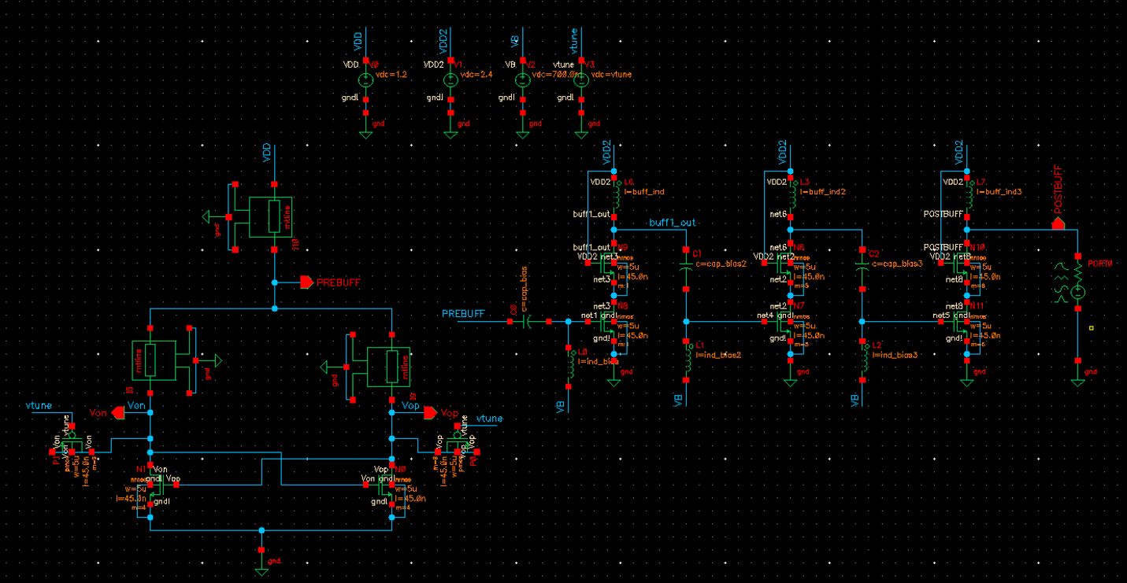

The oscillator is a cross-coupled push-push oscillator using the parasitics of the cross-coupled mosfets and transmission lines to create the oscillation. At the drains of the cross-coupled transistors is the fundamental harmonic reading at 55GHz and at the common node of the differential pair lies the second harmonic where the 180 degree out-of-phase fundamental power is canceled out while sending that power to the second harmonic . The second harmonic that is extracted reads 110GHz. The push-push design was chosen because of research stating that it provides a high output power and low phase noise.
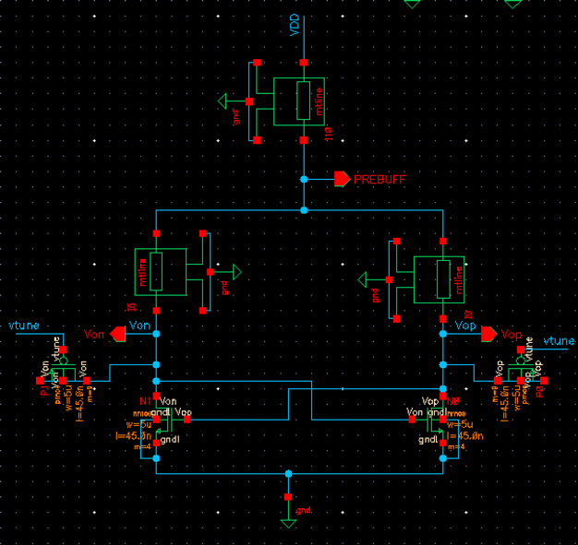
The transmission lines, labeled mtline act as inductors. The symmetric tlines in the oscillator tank are the inductors used for oscillation while the tline connected to VDD is used to direct the signal into the prebuff node.
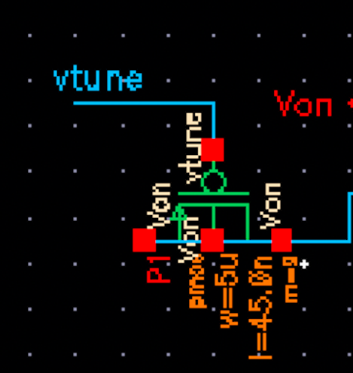
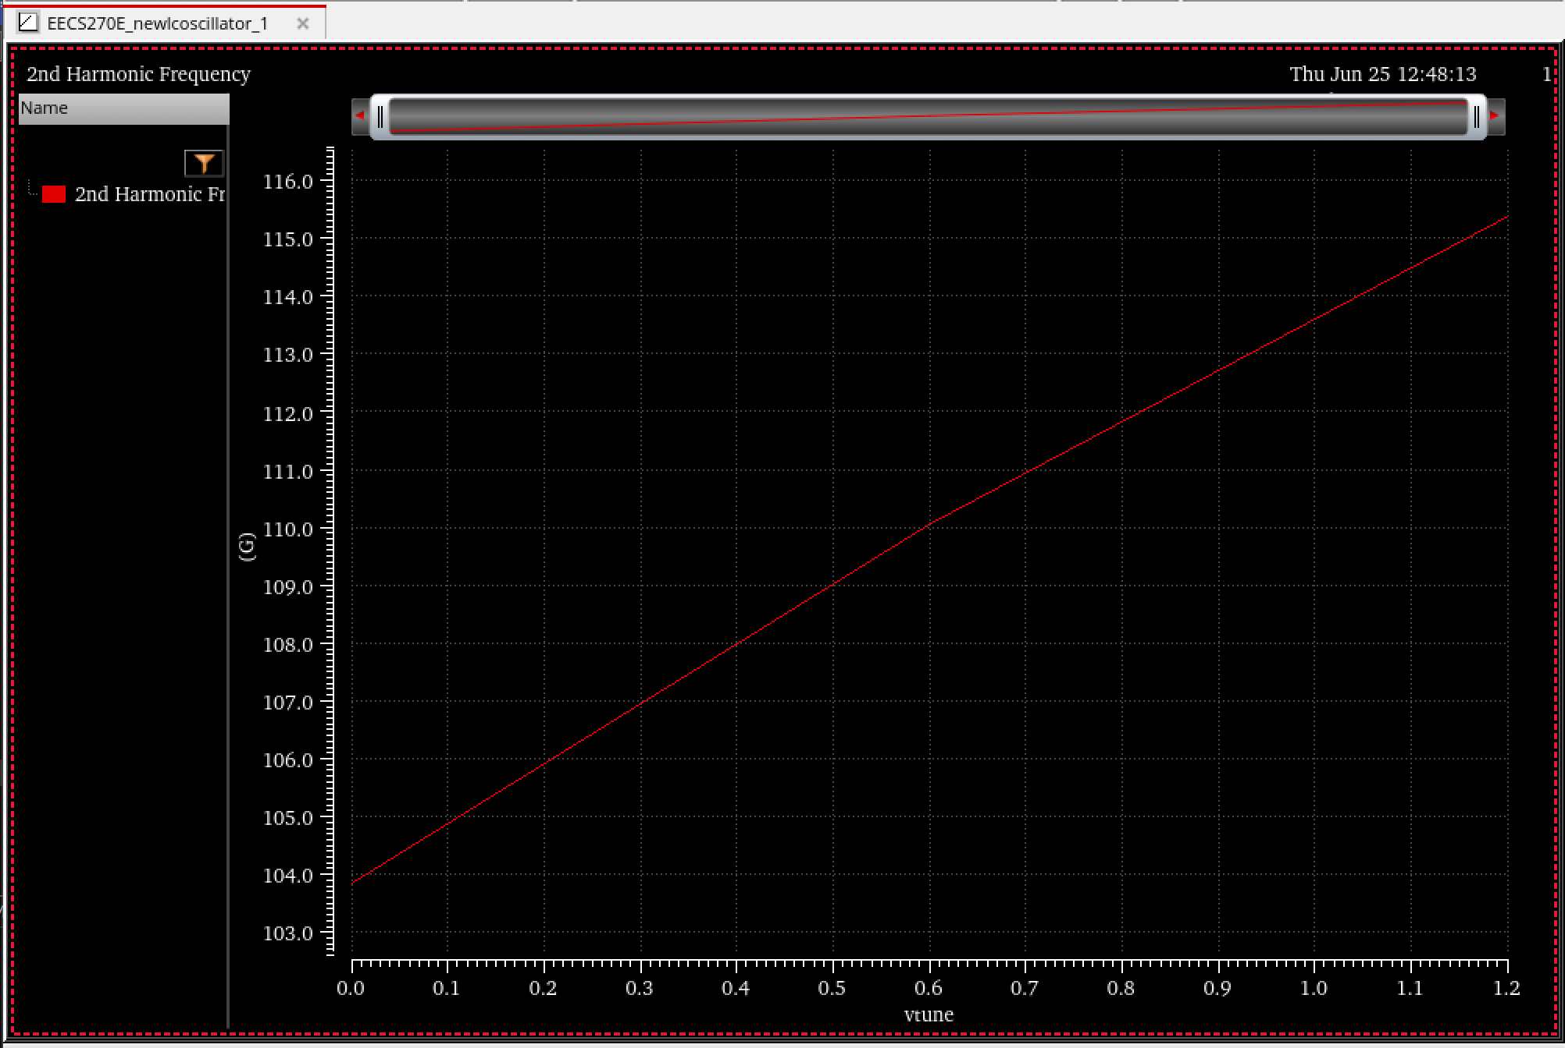
Figure: Second Harmonic Tuning Range (104G – 116G)
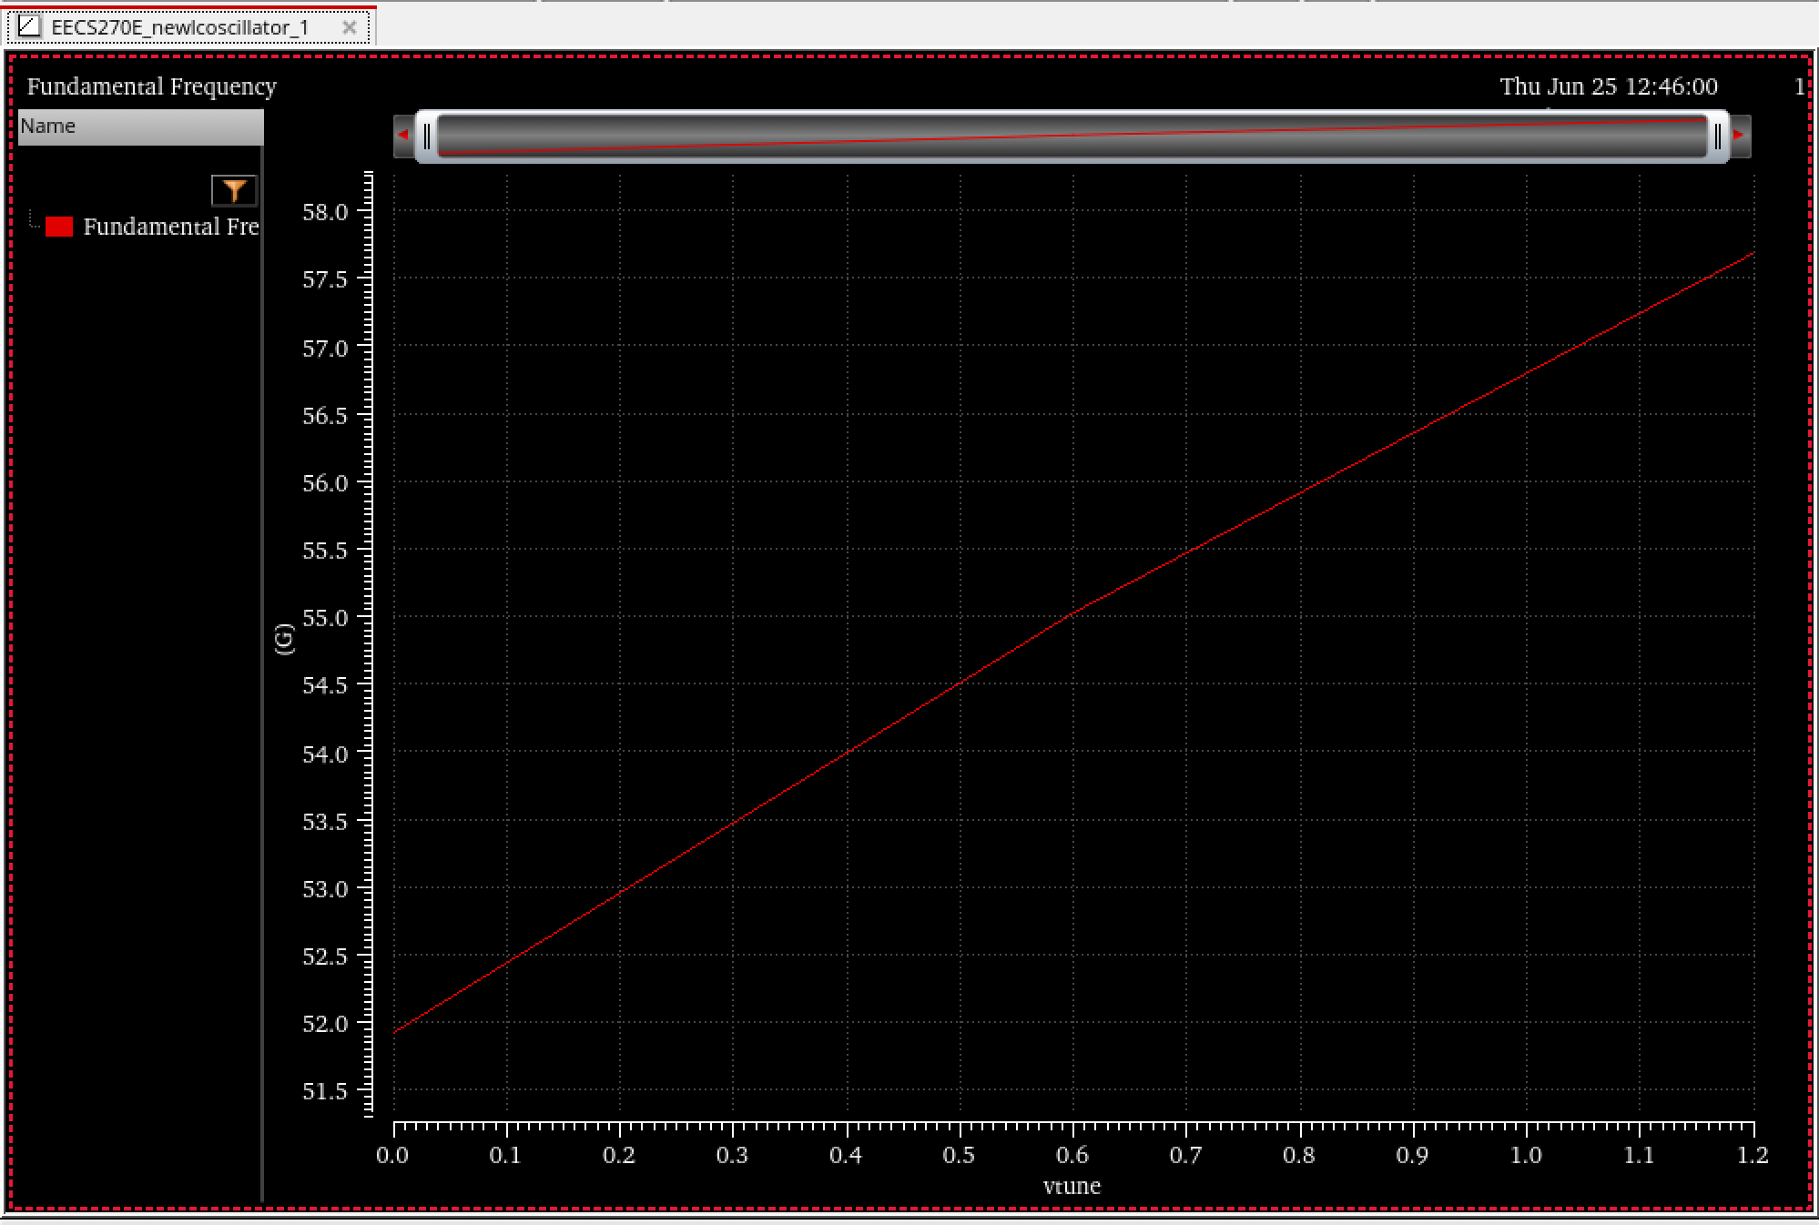
Figure: Fundamental Harmonic Tuning Range (51.9G – 57.6G)
Attached to the fundamental harmonic nodes are pmos varactors (source and drain tied together) with a width of 5um and multiplier of 9 resulting in a total width of 45um. The fingers parameter was not used because after multiple simulations, I realized that they were not making a difference and the parasitics remained the same. With a sweep of the tuning voltage from 0v – 1.2v, the circuit achieved a range from 51.9G – 57.6G.

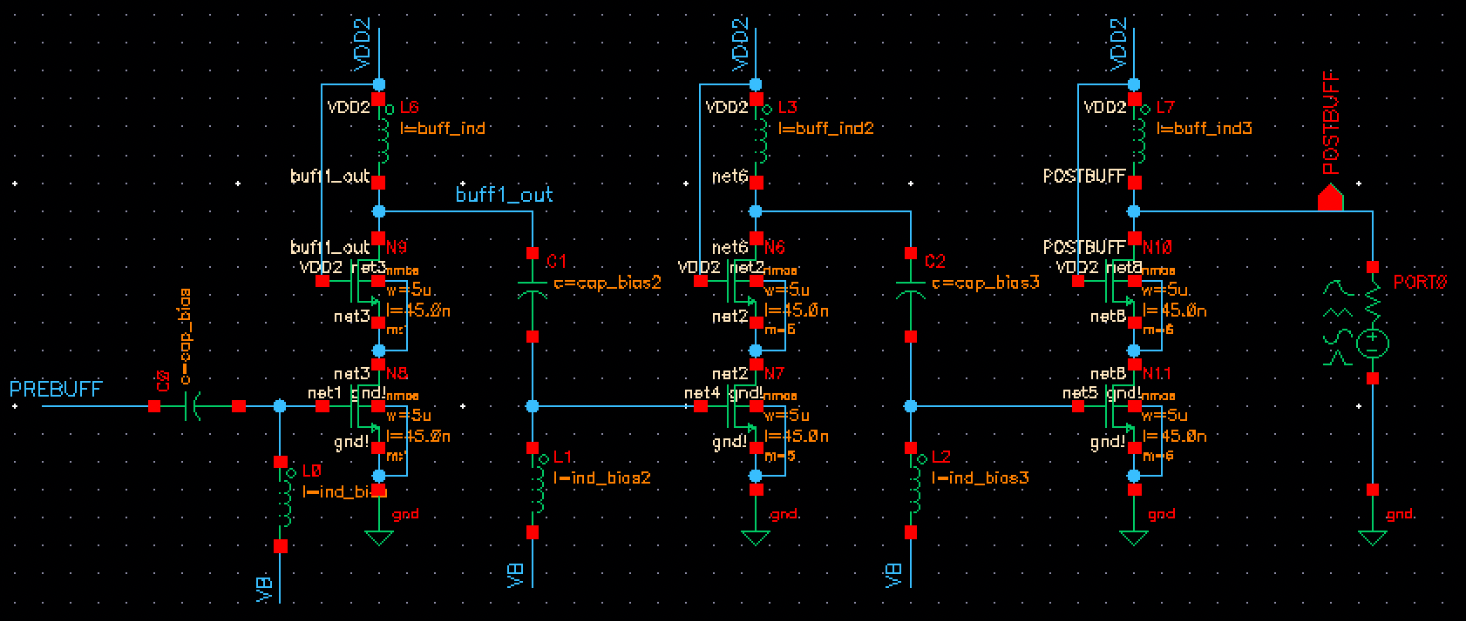

Three sets of cascode amplifiers are used to buffer the oscillator output and drive it to the next stage. A cascode configuration was chosen to limit the miller capacitance. Each stage uses has an inductor close to VDD2 (2.4v) to prevent the signal from flowing into AC ground. Between each stage including the input to the first stage is an RF choke to rebias the driver mosfet of each amplifier.

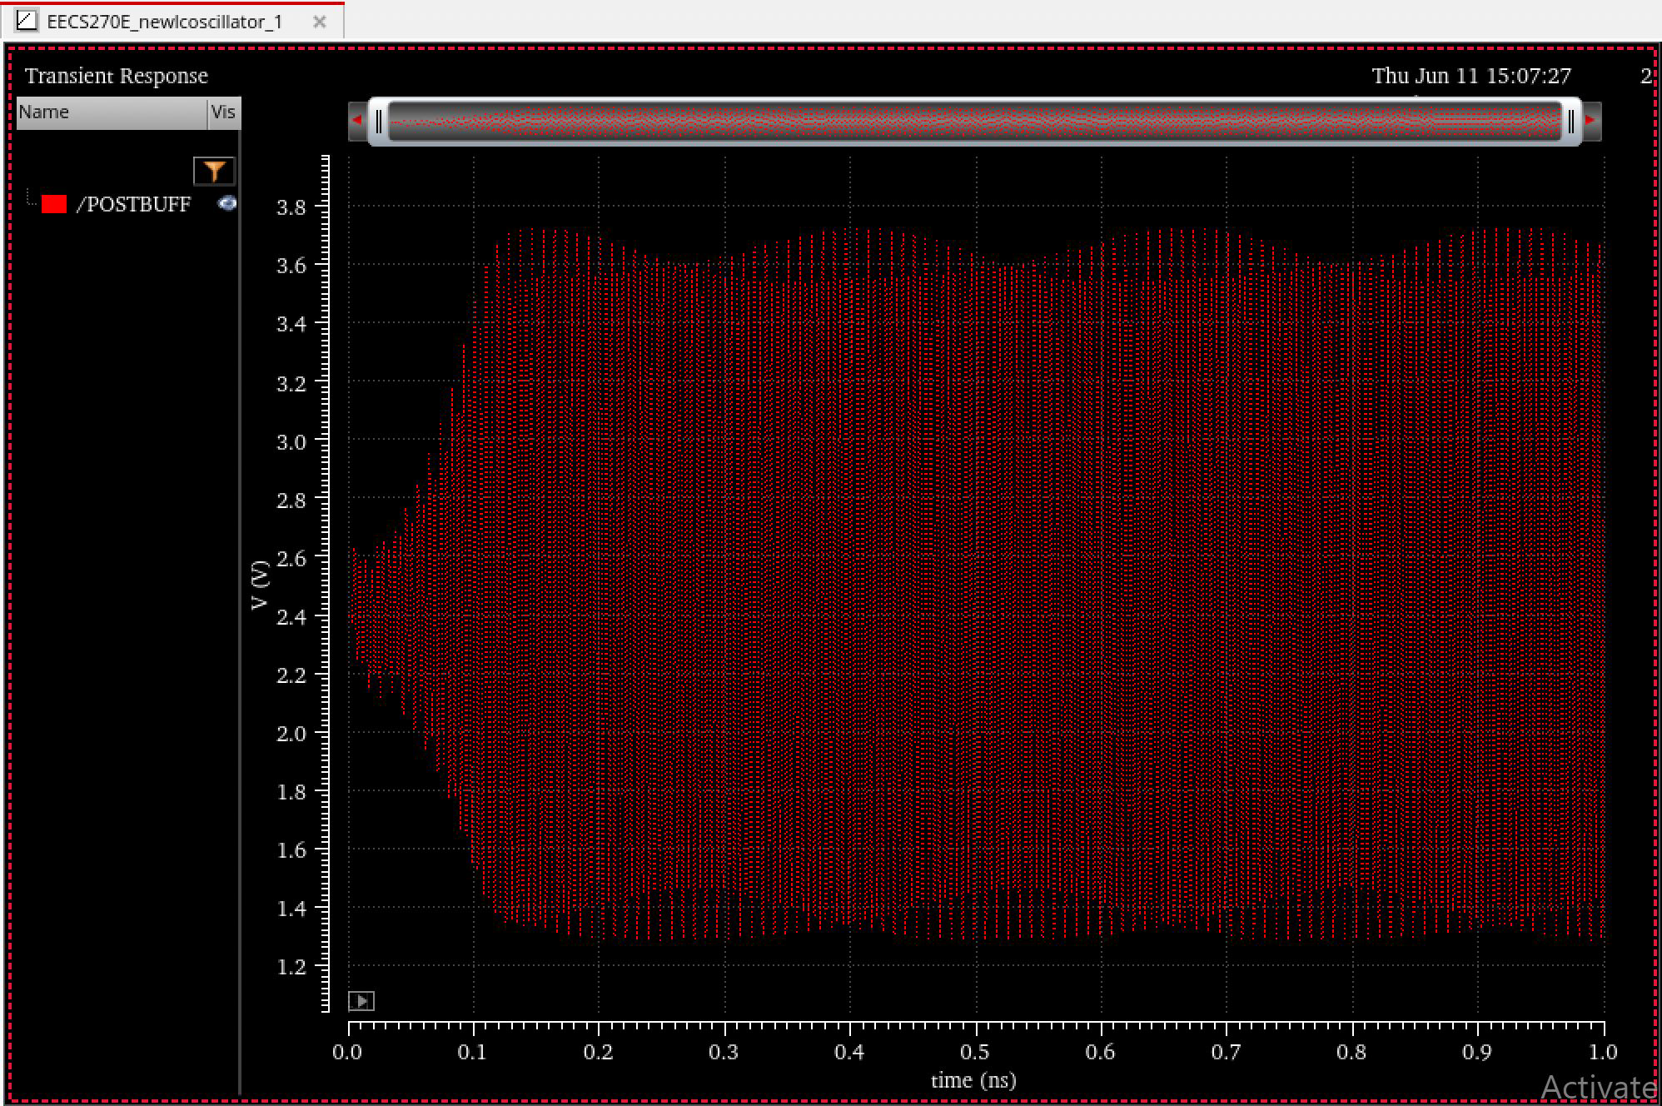
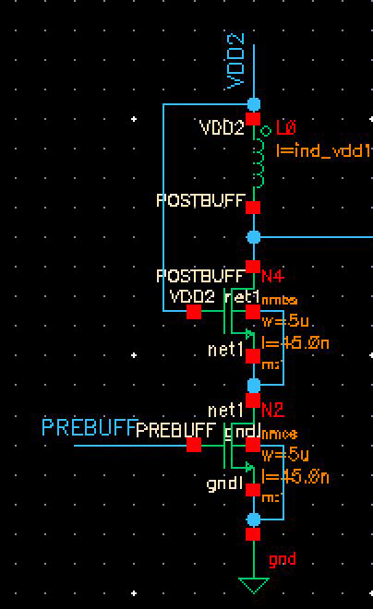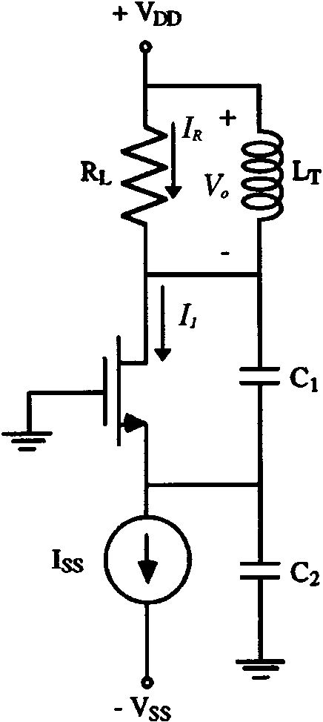
Without the RF choke, the VDD2 bias is set as the operating point and forces the driving transistor into triode. The interesting issue that arises without the RF choke is that the amplifier stage turns into a Colpitts oscillator due to the transistor parasitics and therefore the output captures both the frequency of the VCO and the Colpitts resulting in the above waveform.
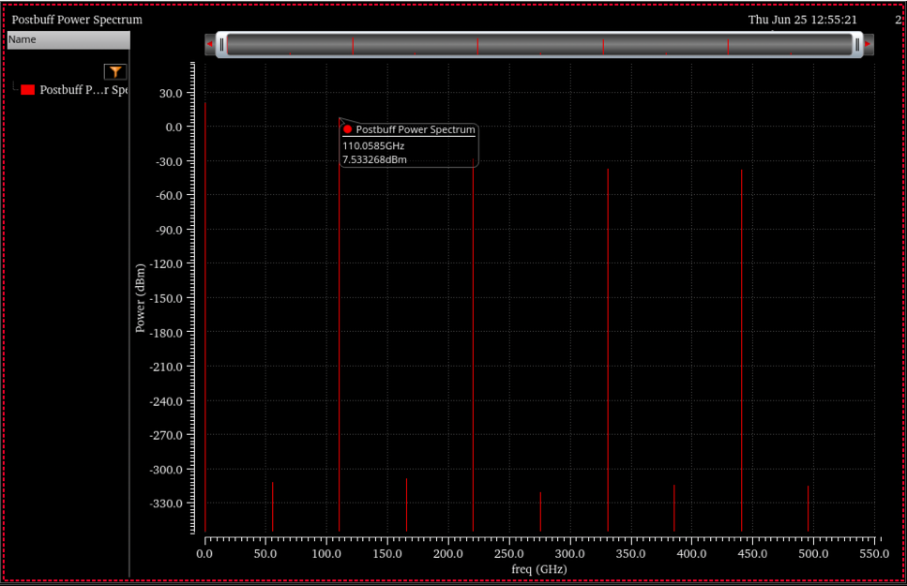

Connected to the last stage is a 50 Ohm port that allows for power extraction. Without a matching network, the output power settles at +7.3dBm after all three amplifier stages. Without the three amplifiers, the output power was around -4dBm.
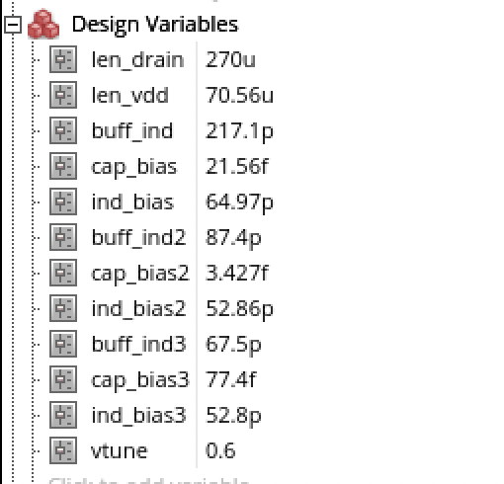
Results:
Transient Simulations:
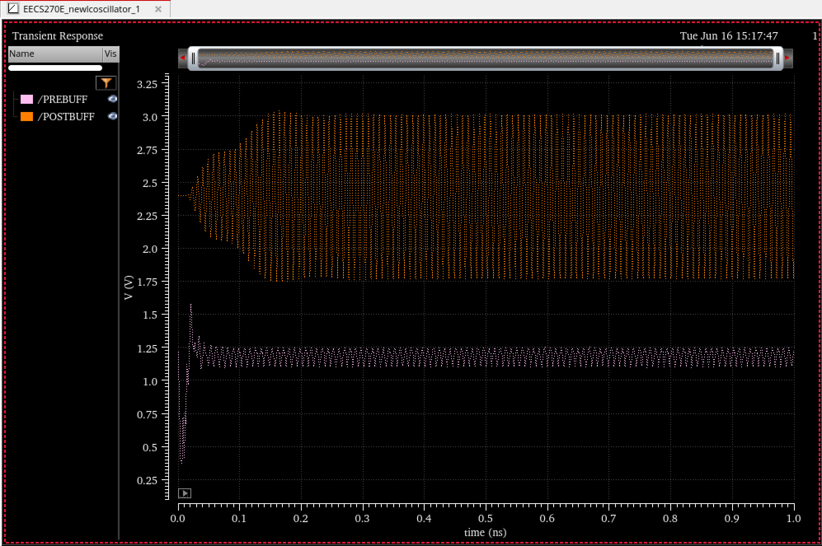
Prebuff is the output of the oscillator when loaded with the amplifier chain and postbuff is the waveform after the amplifier chain.
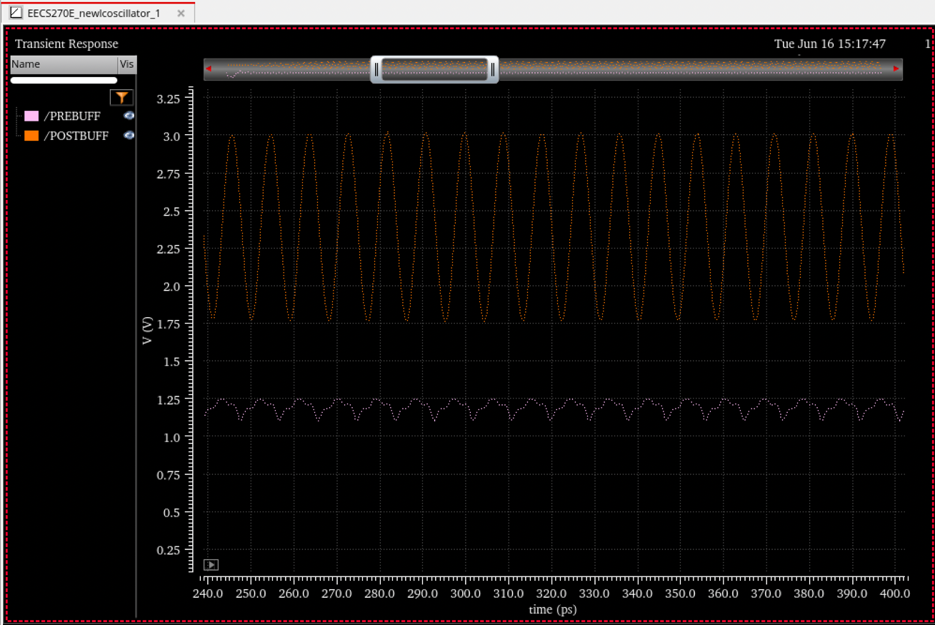
Power consumption:
As seen, the power consumption is high. If changes were to be made, I think changing the type of amplifier configuration will decrease the power consumption. I can use a common source configuration, use a one supply rail and limit millers’ effect through neutralization.

PAE:
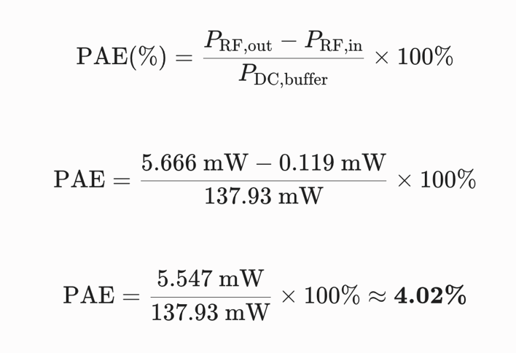

PAE is 4%.

Phase Noise:
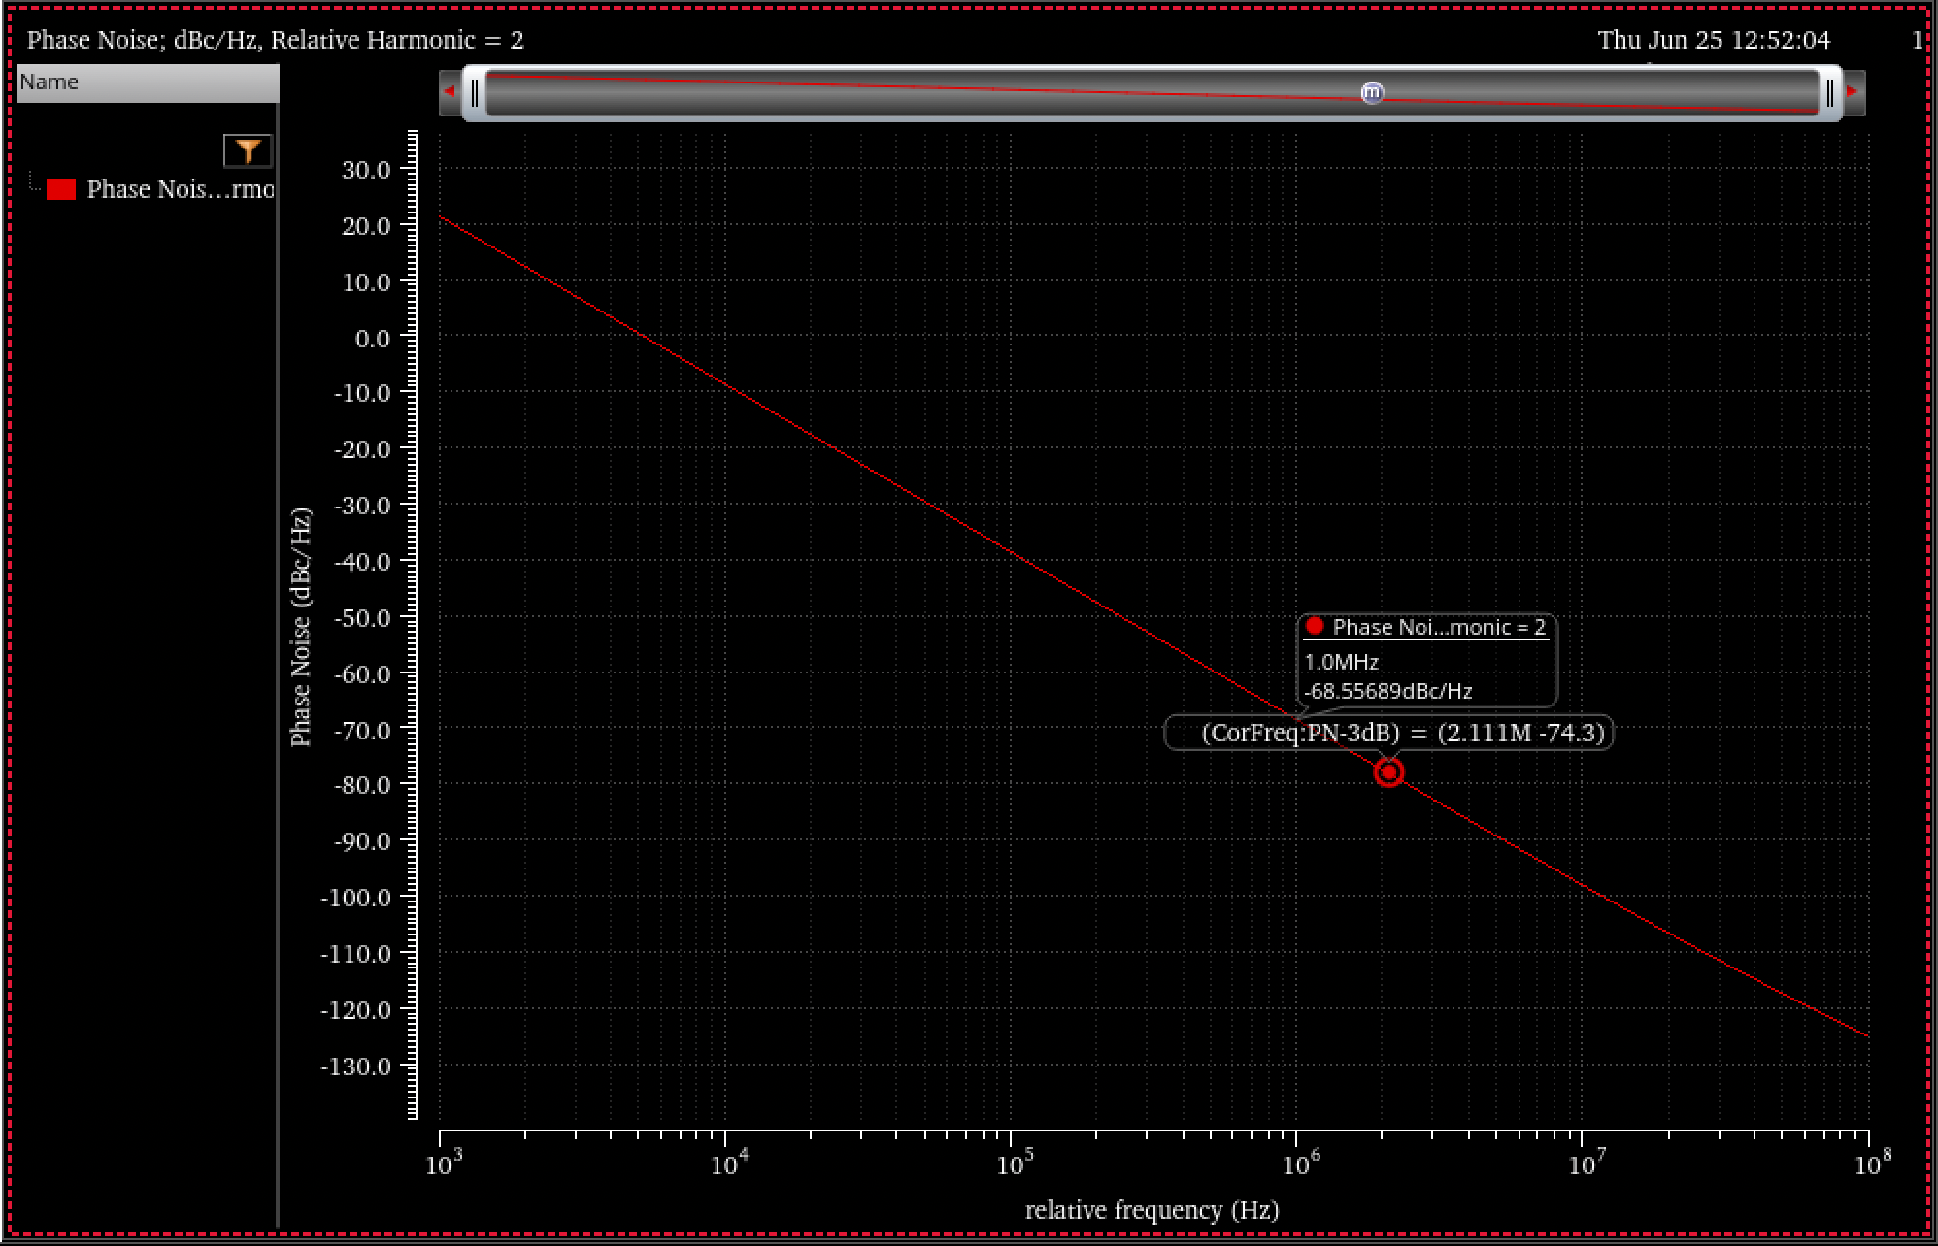
The phase noise sits at -68 dBc/Hz.

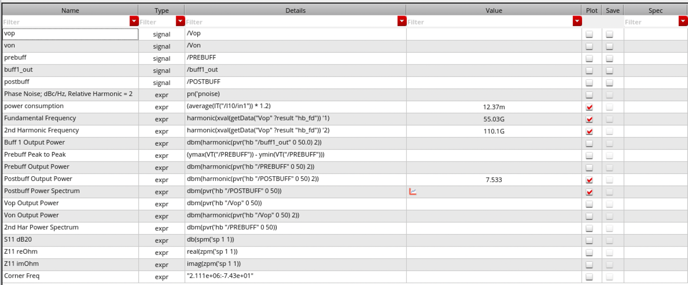

Stability:
Stability is still an issue that hasn’t been fixed yet. Because of oscillations that arise from the parasitics in the buffer stage transistors, the resulting waveform when the VCO is turned off is shown in the waveform below.
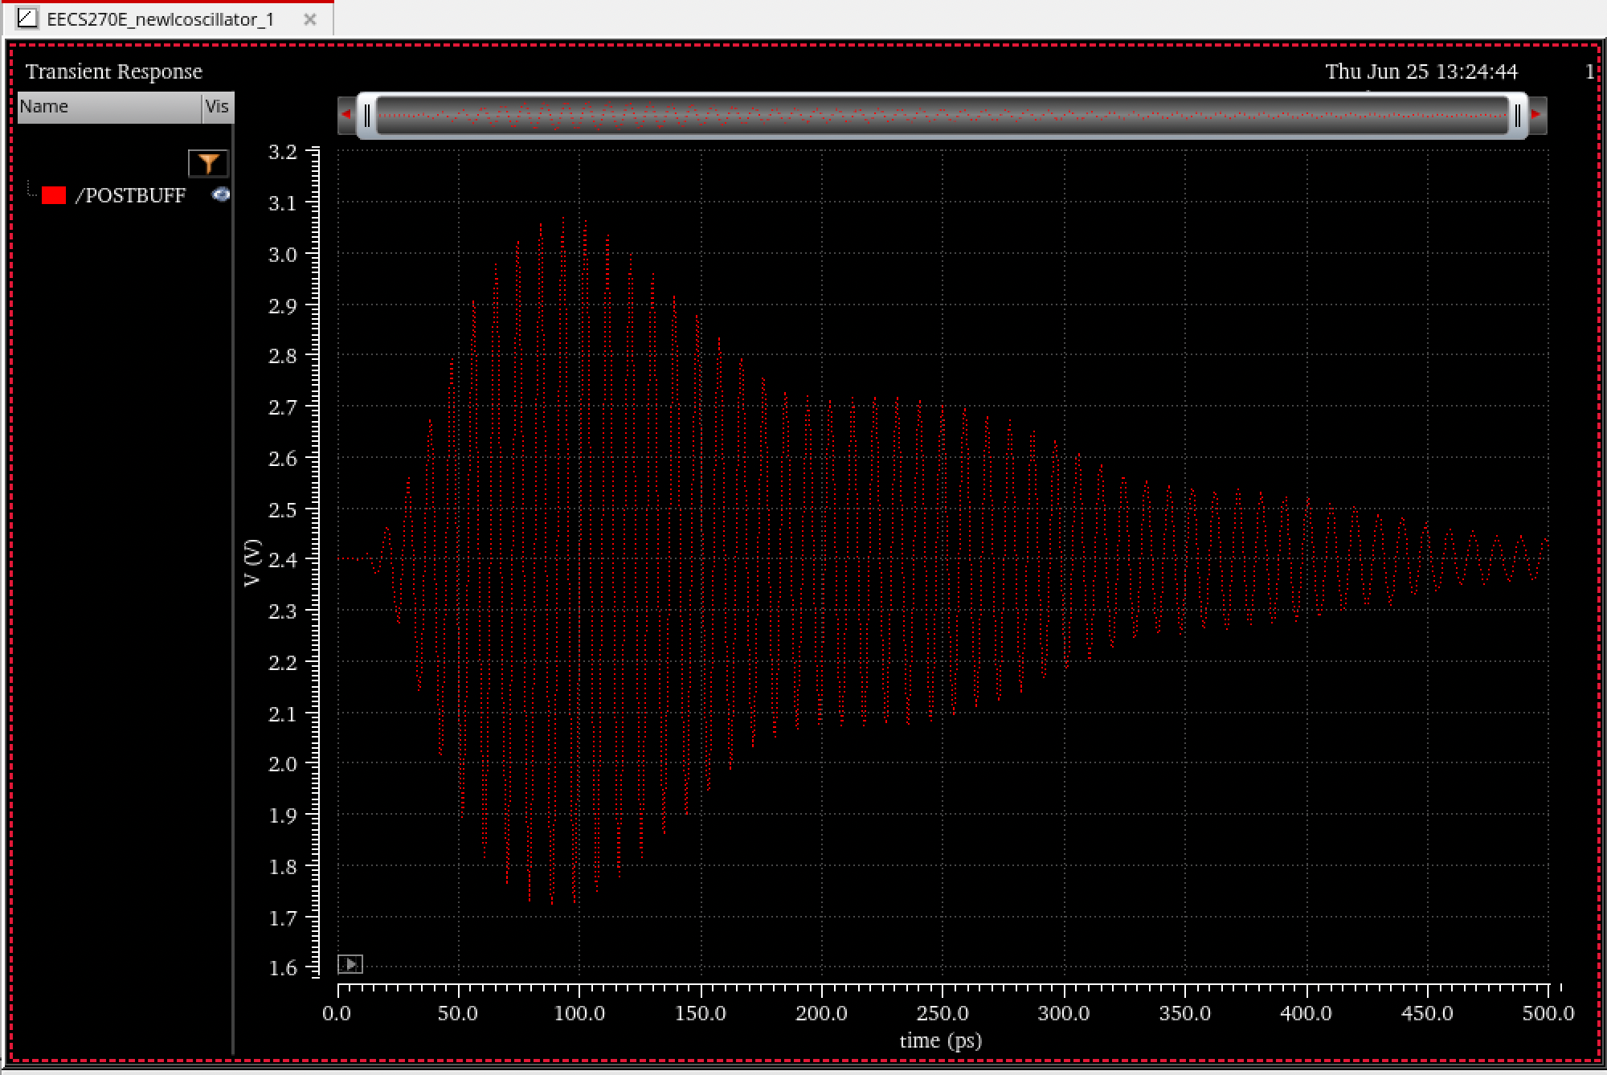

The signal’s voltage swing is significant and slowly decreases but the time that it takes is still too long. Potential fixes are to add passive components to dissipate the extra power.

