Gget.muscle for multiple species alignment
We want to use gget.muscle for multiple species alignments. These multiple species have different length ensembl_id/gene_names. Therefore, they start at different places on the page.
- 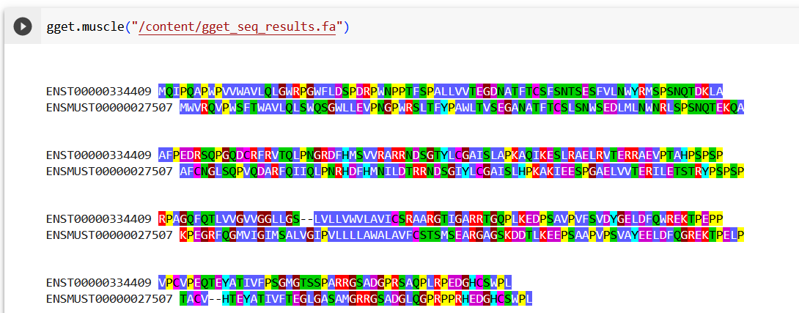

Multiple species alignment with frog, zebrafish, mouse and human for PDCD4
- 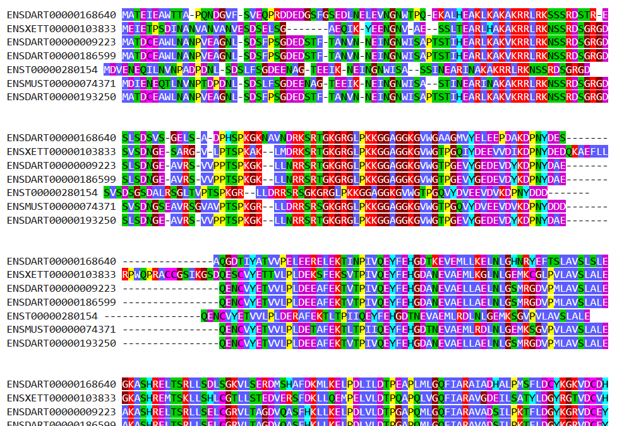
The ideal result would be that independent of gene name length the sequences would still start at the same place. This would make it easier to compare the sequences with each other.

