The Electric Field of precipitation

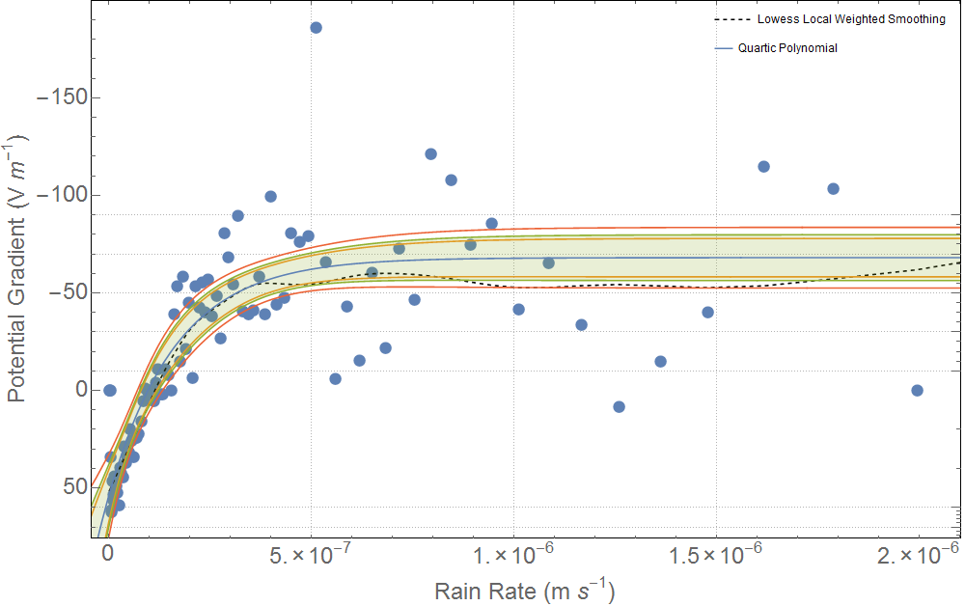

Figure 1: An ensemble of the potential gradient against the rain rate showing the effects of charged precipitation using the data at RUAO between 2006 and 2013. Each bin of the plot has an equal number of data points but variable in its spatial extent, thus providing more resolution for regions of higher information. Each bin has been averaged (median) and shows a distinct negative gradient between a rain rate of 0 an d $5×{10}^{-7}.$ A non-linear model was chosen to emphasis the plateau effect of their relationship and is defined by Equation 1. The variable $y_{0}$ determines the plateau level and was determined to be $\left(60±5\right)Vm^{-1}.$ From dimension analysis the gradient of such a function can be described as the magnetic flux density which was computed to be roughly $-4×{10}^{8}T$ which is comparable to that of a neutron star.

|  |  |
| --- | --- |
| $$y=y_{0}-(y_{0}-z)e^{-K(x-x_{0})}$$ | Equation 1 |