Figure 1: A kernel density estimation function used to determine the distribution of a data set. The majority of the data is within the 5 mm/hr range which small unique occurrences above that. The inset figure is a zoomed in representation of this function between 0 and 1 mm/hr used to disseminate details about the rain event thresholds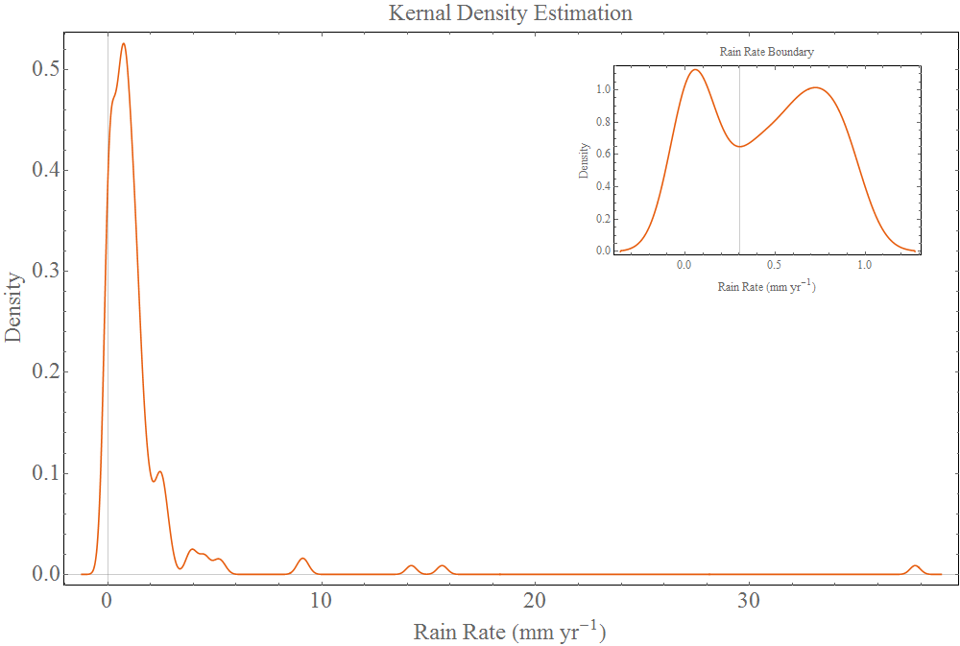

The boundary of the rain event horizon can be estimated using a kernel density estimation function which acts similar to a smoothed histogram. From the inset figure (Figure 1) a duplet is visible for extremely small rain rates which is due to the large number of occurrences of the rain rate being calculated between rain events providing extremely small values. The threshold was estimated at 0.055 mm/hr

11/02/16