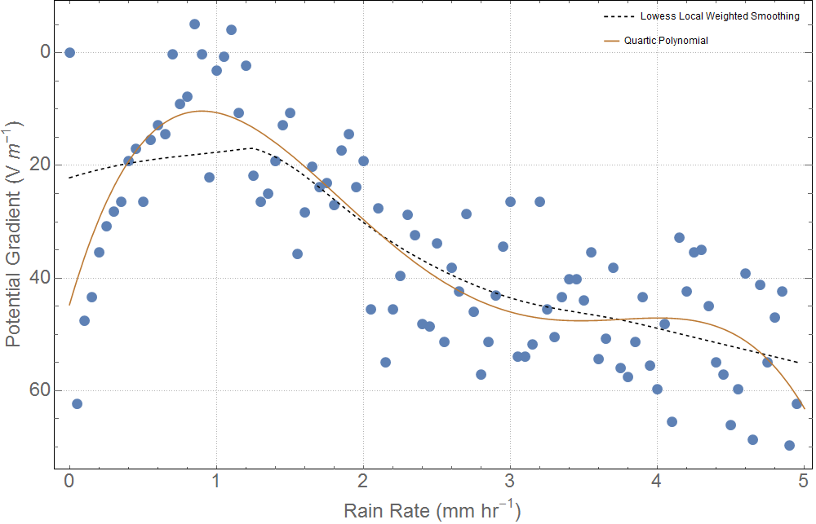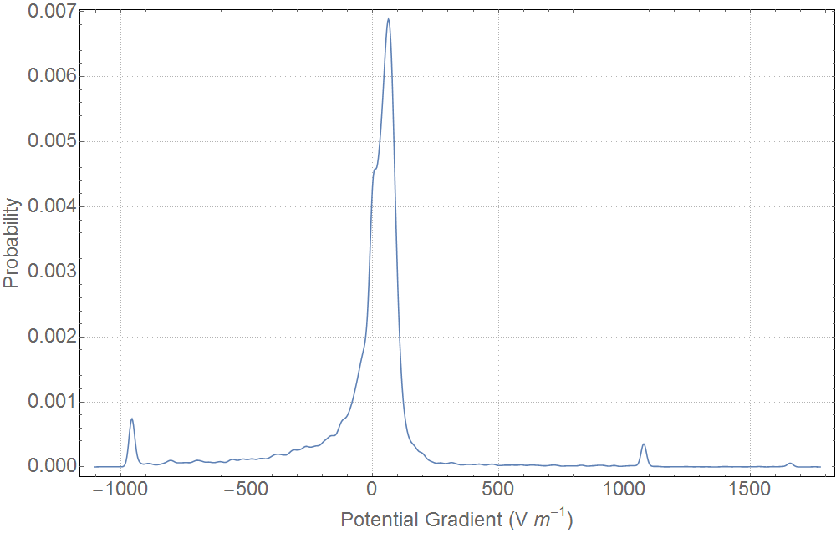

Figure : **Top**: An ensemble of the potential gradient against rain rate highlighting the effects of charge precipitation between 2006 and 2012. **Bottom:** A histogram of all the potential gradients during each rain even between 2006 and 2012.