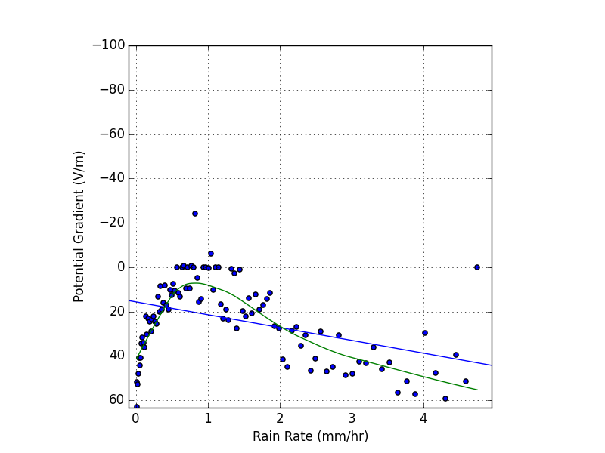
P-value = 2.44*10^-5 R^2 Value = 0.167 SE = 1.304
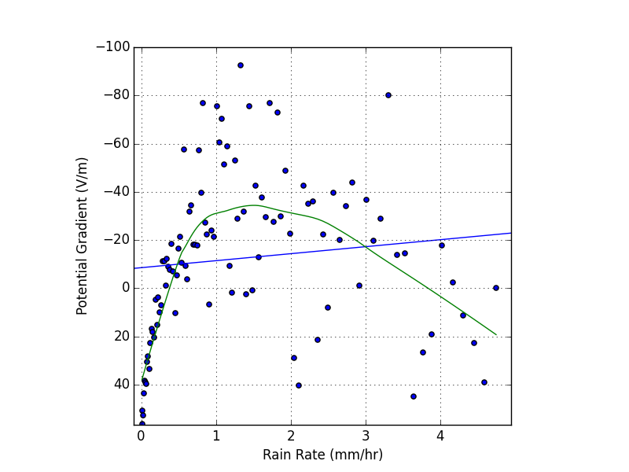
P-value = 0.279 R^2 Value = 0.112 SE=2.665

