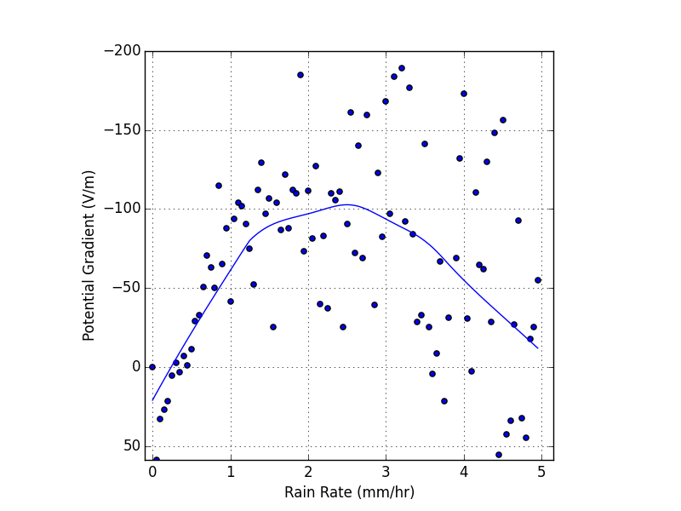
Figure 1: An ensemble of the median potential gradients as a function of rain rate which has been collected in 100 bins (e.g. 14.4 minutes per bin). The mean of each bin was found to determine an average of each rain rate point. A lowess interpolation method was used to determine the general trend in the local regions of the data.

