MC2 Model Technical Description
Dave Conklin 7/30/12 rev. 8/13

Contents

General Description 1

Fig. 1. Biome (upper left), physiognomic class (upper right), and potential vegetation type (lower) produced from the spinup phase of MC2, simulating the conterminous U.S. using the VEMAP grid and input datasets; output from MC2_P44_B159, 7/23/12. 1

Fig. 2. (next 2 pages) Biome, physiognomic class, and potential vegetation type for the globe produced from the spinup phase of MC2; output from MC2_P43_B159, 7/21/12. 1

Space-before-time vs. Time-before-space 1

NetCDF Files Used and Produced by MC2 1

Table 1. Input and output NetCDF files used or produced by each MC2 phase 1

MC2 Command Files 1

Global Simulations 1

MC2 Source Code 1

Table 2. Source code files which are compiled to create MC2. Files with red background are common to MC1, cmdMC2, and envMC2. Files with green background are specific to cmdMC2. Files with yellow background are common to cmdMC2 and envMC2. 1

Table 3. Principal classes and methods in MC2 1

MCfire Fire Model 1

Output Variables 1

Output Files 1

Adding an Output Variable 1

Where to Go for More Information about the Process Models 1

Appendix A. Additional information about the NetCDF files used and produced by MC2 1

Appendix B. Excerpts from the gridspecs.h source file 1

Appendix C. Qualification testing 1

Fig. C1 (next page). Comparative maps of MC1 and MC2 output for the BIOME, PHYSIOGNOMIC_CLASS, and VTYPE variable at the end of the spinup phase. 1

General Description

MC2 is a dynamic global vegetation model (DGVM) derived from MC1, an earlier DGVM. MC1 itself is a combination of the MAPSS static biogeography model, the CENTURY biogeochemistry model, and a fire model developed especially for MC1.

MC2 runs in four distinct phases:
“MAPSS phase” - static biogeography simulation using a one-year mean climate
“EQ phase” - static biogeochemistry simulation using a one-year mean climate
“spinup phase” - simulation with a climate having interannual variability but no long term trend, long enough for biogeochemical pools to reach equilibrium
“transient phase” - simulation using historical climate or future climate scenarios which may have long term trends as well as interannual variability

Each of the first 3 phases produces output data which is used as input data in the next phase. Output data from transient simulations may be used as input in additional transient simulations.

MC2 is designed to run in 2 different environments and hence will exist in 2 distinct versions: a command line version and an Envision version. Where it is useful to distinguish between the two versions in this document, they will be called “cmdMC2” and “envMC2”, respectively. “envMAPSS” refers to the current (as of 6/13/12) embodiment of MC2 on Envision, in which only the MAPSS phase is implemented.

MC2’s predecessor MC1 has used several different vegetation classification schemes over its 12-year life. The MAPSS phase uses the MAPSS vegetation classes: ~65 classes, identified with three digit numbers, where the first digit signifies the biome, i.e. 1xx for forests, 2xx for tree savannas, 3xx for shrub savannas, 4xx for grasslands, 5xx for deserts, and 6xx for cold region classes. The EQ phase uses VEMAP vegetation classes: 26 classes, identified with two digit numbers 1-23 and 90-92. The spinup and transient phases originally used the VEMAP classification; VEMAP classes were replaced at different times by a set of 14-18 classes for California, and a global set of ~40 classes. MC2 implements the global set. See the spreadsheet files BiogeographyAndFire.xlsx and MC2biogeography.xlsx for lists of the classes in the different schemes.

Any one vegetation classification scheme may be calibrated for a specific region, specific spatial resolution, and specific input dataset by adjusting the numeric values of thresholds used in the biogeography rules and parameters used in the fire model. MC2 is intended to support a number of discrete sets of threshold and parameter values, called “base calibrations”, and identified by name. As of July, 2012, two such base calibrations have been implemented in MC2: one for the conterminous U.S. (“CONUS”) and one for the earth as a whole (“GLOBAL”). The CONUS base calibration is tuned to the half-degree VEMAP spatial grid (3261 active cells) and the VEMAP input dataset. The GLOBAL base calibration is tuned to a half-degree global dataset (50,228 active cells in the northern hemisphere plus 12255 active cells in the southern hemisphere). See figures 1 and 2 for potential vegetation maps produced for the conterminous U.S. and for the earth, as produced by the spinup phase of the late July 2012 version of MC2.
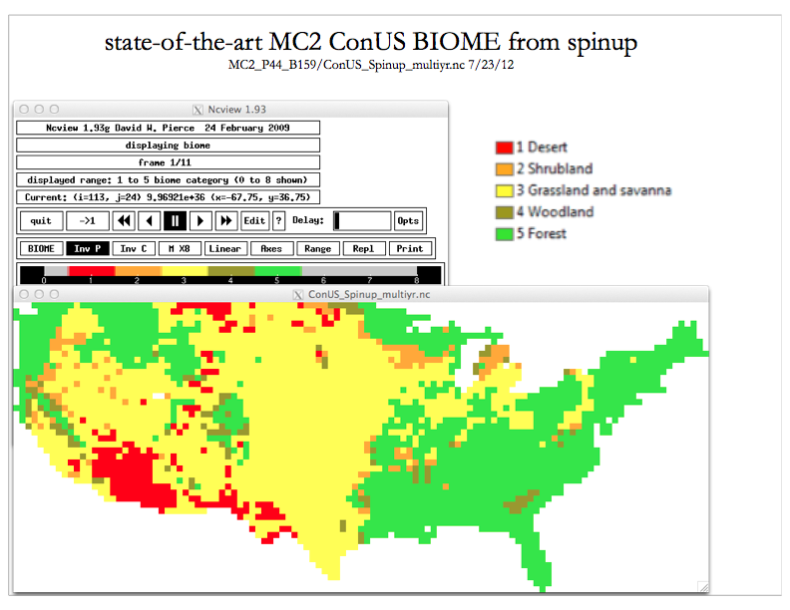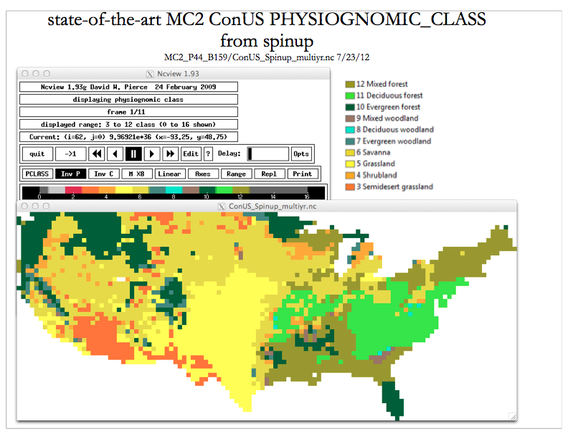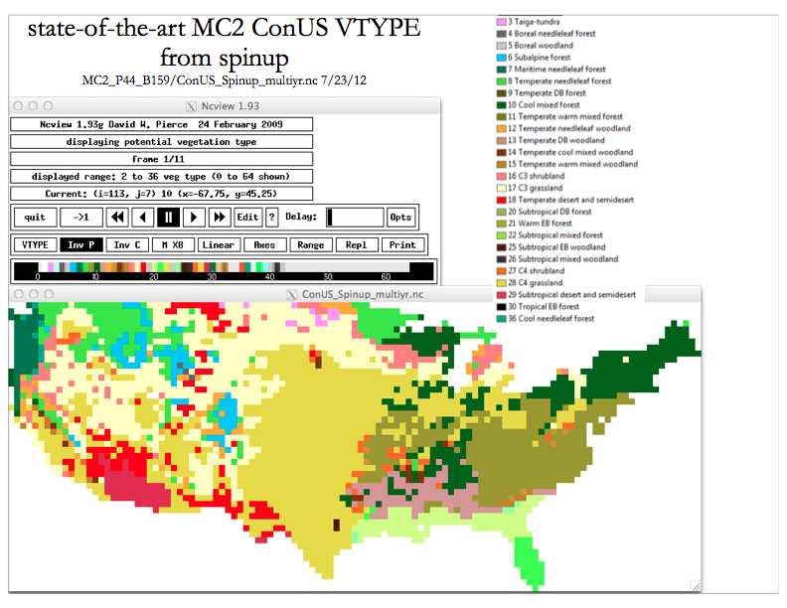
Fig. 1. Biome (upper left), physiognomic class (upper right), and potential vegetation type (lower) produced from the spinup phase of MC2, simulating the conterminous U.S. using the VEMAP grid and input datasets; output from MC2_P44_B159, 7/23/12.

Fig. 2. (next 2 pages) Biome, physiognomic class, and potential vegetation type for the globe produced from the spinup phase of MC2; output from MC2_P43_B159, 7/21/12.

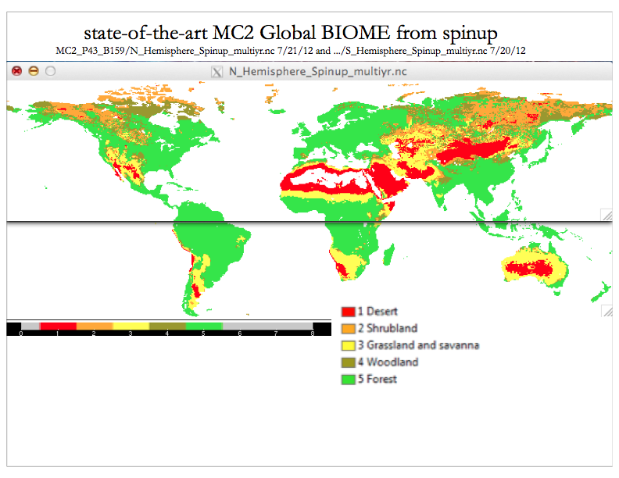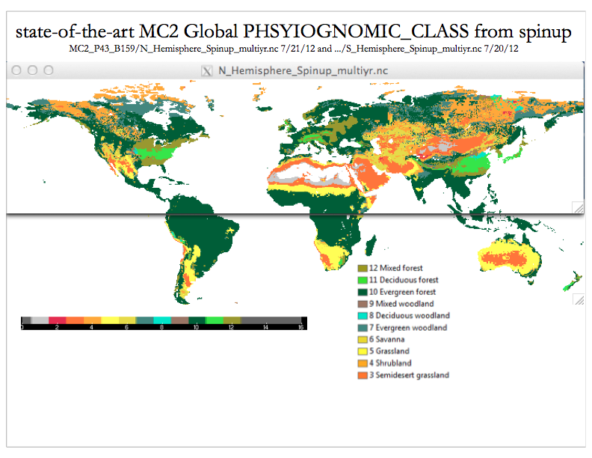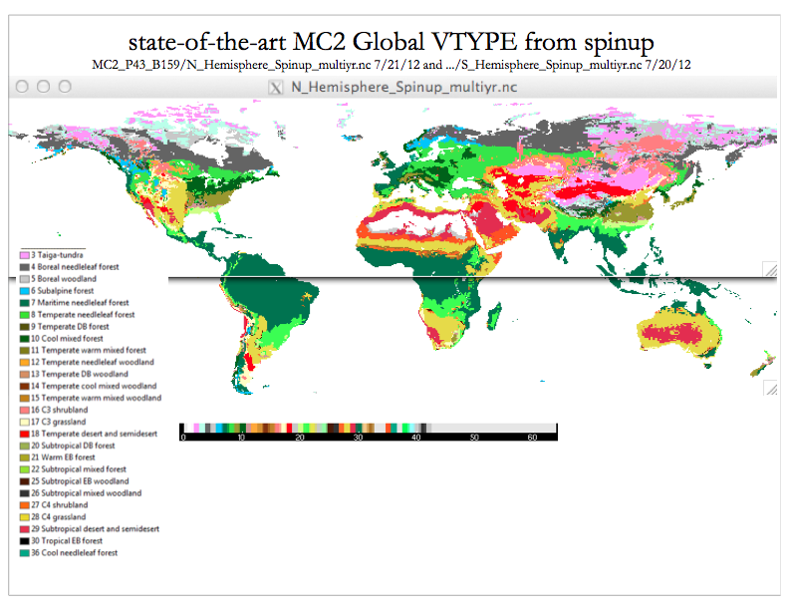

Each command line invocation of cmdMC2 runs one phase of simulation. The mc2 command takes two arguments:
mc2 <base calibration name> <command file path and name>

Values of some individual thresholds and parameters may be set in the command file to override the values in the base calibration; this method is used to tailor simulations more precisely to a specific study area, spatial resolution, or input dataset. The values which may be set in the command file are listed in the spreadsheet file MC2parameters.xlsx. A current list may always be obtained directly from cmdMC2 by invoking it without any arguments.

Space-before-time vs. Time-before-space

The MC1 model, from which MC2 is derived, runs in a command line environment and runs time before space, i.e. the entire sequence of time steps for one gridcell is simulated before moving on to the next gridcell. The new MC2 model has the ability to run its transient phase in either time-before-space or space-before-time. The space-before-time capability is required for the Envision environment, in which the entire spatial domain is simulated in each time step before moving on to the next time step. The MAPSS, EQ, and spinup phases are always run as time-before-space.

NetCDF Files Used and Produced by MC2

MC2 uses NetCDF files for data input and output. Table 1 lists the various files for each phase. More information about the file formats is given in Appendix A.

Table 1. Input and output NetCDF files used or produced by each MC2 phase
Defaults for optional files are shown in parentheses.

phase | input files | output files
MAPSS | ppt.nc  tmp.nc or (tmin.nc and tmax.nc)  vpr.nc or tdmean.nc  elev.nc  soil.nc  optionally wnd.nc (ON) | ..._mapss.nc
EQ | ..._mapss.nc  ppt.nc  tmin.nc  tmax.nc  vpr.nc or tdmean.nc  elev.nc  soil.nc  bd.nc  optionally wnd.nc (ON) | ..._eq.nc
spinup | ..._eq.nc  ppt.nc  tmin.nc  tmax.nc  vpr.nc or tdmean.nc  elev.nc  soil.nc  bd.nc  optionally wnd.nc (ON) | ..._ws.nc  optionally ..._multiyr.nc (ON)  optionally ..._year.nc (OFF)  optionally ..._month.nc (OFF)
transient | ..._ws.nc  ppt.nc  tmin.nc  tmax.nc  vpr.nc or tdmean.nc  elev.nc  soil.nc  bd.nc  optionally wnd.nc (ON) | optionally ..._ws.nc (OFF)  optionally ..._multiyr.nc (ON)  optionally ..._year.nc (ON)  optionally ..._month.nc (OFF)

MC2 Command Files

The format of MC2 command files is illustrated by the example below. The format allows for comments, using the '#' character, and blank lines.

#invoke as mc2 WWETAC runK-S_Hist.txt
# Simulation phase and parameters
run_mode = TRANSIENT
years_to_run = 114
unlimited_N_switch = ON
fire_mode_switch = ON

# Study area
grid_name = US4km
col_begin = 10
col_end = 74
row_begin = 153
row_end = 193
mask_file = mask_Klamath-Siskiyou.nc

# Input data
climate_data_directory = Input/Grid_US4km/K-S_HistClimate
earth_data_directory = Input/Grid_US4km/K-S_EarthData
soil_data_file = soils_scs.nc
CO2_file = Input/CO2ramps/co2ramp_1895_2011_SRES_A2_1col.txt
warmstart_file = Output/Klamath-Siskiyou/K-S_Spinup.nc

# Output data
output_file_prefix = K-S
output_variable_file = outVars.txt

end_of_commands

Blank lines and lines beginning with non-alphanumeric characters are considered to be comments, rather than commands. Anything in the command file after the “end_of_commands” token is ignored. Commands themselves have the format
<parameter name> = <parameter value> {# <comment>}
where the part within the braces is optional.

There are two kinds of parameters: model parameters and run parameters. All of the parameters in the example above are run parameters.

In general model parameters have to do with the science and calibration of the model, e.g. century_runoff_slope. Once the model is calibrated for a study area, you would not ordinarily expect to change a model parameter from one simulation run to the next. Model parameter sets represent model calibrations appropriate to different regions, spatial scales, and input datasets.

Run parameters, on the other hand, are the detailed specifications for a single simulation run - which cells to simulate, for which years, and so on.

There is an Excel spreadsheet file, MC2parameters.xlsx, which summarizes the command parameters and parameter sets. It has 5 tabs:
run parameters
model parameters
constants
base calibrations
MC1 command line crosswalk
The first two tabs list and describe MC2’s run parameters and model parameters, respectively. The third tab, “constants”, lists symbols used by MC2 whose values cannot currently be changed in the command file. The “base calibrations” tab lists the specific parameter values for the GLOBAL calibration, and the values for the CONUS calibration which differ from the GLOBAL values. Finally, the “MC1 command line crosswalk” tab lists, for each command line switch recognized by MC1 version B159, the corresponding MC2 parameter, if any.

Global Simulations

By convention, climate data input files are at a monthly timestep, start in January of the first year, and end in December of the final year. The MC1/MC2 model logic is designed to start each simulation year in the month following the winter solstice, so that the growing season normally comes in the middle of the year. In the northern hemisphere, the simulation year starts in January and ends in December. In the southern hemisphere, the simulation year starts in July and ends in June. So in simulations of locations in the southern hemisphere, yearly output data refers to simulation years, starting in July of one calendar year and ending in June of the following calendar year. For example, output data for the year “2001” for Argentina would be based on climate data for July 2001 thru June 2002. The first month of monthly output data from that simulation would be for July 2001 rather than January 2001.

Because of the temporal mismatch of simulation years across the equator, any single MC2 model run cannot cover a geographic area which crosses the equator. The run parameter
southern_hemisphere_switch <ON/OFF>, default OFF
is used to tell MC2 that the spatial domain is in the southern hemisphere. Cells whose center line lies on the equator are considered to be in the northern hemisphere.

MC2 Source Code

As of late July, 2012, the source code for MC2 is under development. A Subversion repository for MC2 has been established at the Biological and Ecological Engineering Department of Oregon State University, at
https://envision.bee.oregonstate.edu/svn/mc2
which is an address similar to the one for the MC1 repository except for the final character.

The main() entry point for the command line version of MC2 does little more than instantiate a Simulation object and invoke its run() method.

The Simulation class represents a single run of the MC2 model, which may encompass multiple points in space, multiple years in time, and different process models, but only a single one of the four phases (MAPSS, EQ, spinup, or transient phase). An example of such a run would be simulating the state of California on an “800 meter” grid for the years 1895-2010. Such a run would require the use of at least two and usually three process models: the biogeochemical model CENTURY, the MC2 dynamic biogeography model, and optionally the MC2 fire model. Those three models, together with the MAPSS static biogeography model, make up MC2’s suite of four process models. Each of the four process models is embodied in its own class, and all of those classes inherit properties from the ProcessModel class.

The Simulation::run() method handles the iteration across space and time. In contrast to MC1, which runs only time before space, Simulation::run() is structured to run the transient phase in either space before time, which is consistent with the order in the Envision modeling framework, or time before space. The core of the run() method is this call:
(*modelIterator)->runModelAndCollectData(year_index, row_index, col_index)
which is made once for each yearly timestep, each active gridcell, and each active process model.
*modelIterator is a pointer to one of the four process models. runModelAndCollectData() is a virtual method of the ProcessModel class; each of the subclasses representing specific process models implements its own version of runModelAndCollectData().

The Simulation::run() method handles the I/O to and from netCDF files. A constructor for Simulation initializes run and model parameters based on the two command line arguments:
mc2 <base calibration name> <command file path and name>

In the Envision environment, all the work of the Simulation class will be done by various Envision mechanisms. However, the source code for the process models is intended to be used in both the command line and Envision environments. Environment-specific code will be kept out of the process model code as much as possible.

The sizes of the source files used to build MC2 are shown in this output from the wc command made on 7/23/12:
lines words bytes
1549 5248 75424 CENTURY.cpp
52 292 2334 CENTURY.h
1079 4098 43303 MAPSSbiogeographyModel.cpp
484 2116 18882 MAPSSbiogeographyModel.h
2690 9203 82917 MAPSSfcns.cpp
107 304 2894 MAPSSvegClasses.h
2375 7879 95887 MC2.cpp
257 1155 11266 MC2.h
1228 4945 45352 MCbiogeog.cpp
42 89 1004 MCbiogeog.h
2257 10949 88628 MCfire.cpp
183 713 6124 MCfire.h
39 87 721 Makefile
436 1710 16294 ProcessModel.cpp
633 1884 18041 ProcessModel.h
1295 5054 33818 ScienceFcns.cpp
205 1140 8081 ScienceFcns.h
71 237 2198 category_bgc.h
1187 5112 51938 commandFile.cpp
67 177 1388 commandFile.h
859 3051 28965 gridspecs.h
4082 14150 113756 mc2_secondary.cpp
21177 79593 749215 total

Two libraries are explicitly called for at load time:
libnetcdf.dylib
libcent.a
libnetcdf.dylib is the NetCDF library. libcent.a is the library made from the FORTRAN and C source files in the src/century subdirectory of the MC1 source repository. As of July 2012, libcent.a, representing the portion of the MC1 model derived from the CENTURY 4 biogeochemical model, is used in both MC1 and MC2. It is intended that MC2 will ultimately incorporate a newer version of the CENTURY model.

cmdMC2 is built using the make command and the GNU g++ compiler. The makefile is in the same directory as the source files.

Table 2. Source code files which are compiled to create MC2. Files with red background are common to MC1, cmdMC2, and envMC2. Files with green background are specific to cmdMC2. Files with yellow background are common to cmdMC2 and envMC2.

header files | source code files
MAPSSvegClasses.h these files, which enumerate vegetation
category_bgc.h types, are shared with MC1
gridspecs.h this file is shared with the data prep programs
MC2.h  class Simulation | MC2.cpp netcdf.h, category_bgc.h, MAPSSvegClasses.h, ScienceFcns.h, gridspecs.h, MC2.h, ProcessModel.h, MAPSSbiogeographyModel.h, MCfire.h, MCbiogeog.h, CENTURY.h  main(), Simulation::run()
commandFile.h | commandFile.cpp  commandFile.h, ScienceFcns.h, category_bgc.h, MAPSSvegClasses.h, ProcessModel.h, MAPSSbiogeographyModel.h, MC2.h
mc2_secondary.cpp
output variable descriptions
ProcessModel.h  class ProcessModel  virtual runModelAndCollectData() | ProcessModel.cpp  MC2.h, ProcessModel.h
ScienceFcns.h  class ScienceFcns | ScienceFcns.cpp  ScienceFcns.h
MAPSSbiogeographyModel.h  class MAPSS_BiogeogModel  inherits from ProcessModel  friend of ScienceFcns | MAPSSbiogeographyModel.cpp  ProcessModel.h, ScienceFcns.h, MAPSS.h  MAPSS...::runModelAndCollectData()
 | MAPSSfcns.cpp
CENTURY.h  class CENTURY_BiogeochemModel  inherits from ProcessModel  friend of ScienceFcns | CENTURY.cpp  ProcessModel.h, ScienceFcns.h, CENTURY.h  CENTURY...::runModelAndCollectData()
MCfire.h  class MC_FireModel  inherits from ProcessModel  friend of ScienceFcns | MCfire.cpp  ProcessModel.h, ScienceFcns.h, MCfire.h  MC_FireModel::runModelAndCollectData()
MCbiogeog.h  class MC_BiogeographyModel  inherits from ProcessModel  friend of ScienceFcns | MCbiogeog.cpp  ProcessModel.h, ScienceFcns.h, MCfire.h  MC_Biogeog...::runModelAndCollectData()
Table 3. Principal classes and methods in MC2

MC2.cpp and .h

class Simulation Doesn’t inherit from any other class
Simulation(baseCalibrationName, cmdFileName, cmdLine) constructor
Interprets base calibration and command file, and initializes parameters.
void run() entry point called from C++ main()

the Simulation::run() routine
openInputFiles()
initializeOutputFiles()
for the first year thru the final year (space before time)
or just once (time before space)
for each active cell in the grid
for each active process model
instantiate the model
call the model’s runModelAndCollectData() method
saveOutputData()

ProcessModel.cpp and .h

class ProcessModel Doesn’t inherit from any other class
virtual bool runModelAndCollectData(const int year_index, const int row_index, const int col_index) = 0; Each process model has its own version of this routine.
void ProcessModelInit(Simulation * pRun); Called by each process model; sets up pointers to run parameters and model parameters.
VCategory convertMAPSStoVEMAP(MAPSSvegClass mclass); Translates MAPSS classes into VEMAP classes

Data classes
RunParamsClass
ModelParamsClass
InputDataClass
OutputDataClass
MC2centuryEQdataOutputs
StateVariables

Enumerations
RunModeEnum These are the simulation phases.
MAPSS_EQ
CENTURY_EQ
SPINUP
TRANSIENT

ModelParameterSetEnum These are the base calibrations.
unknownModelParameterSet
mc2GLOBAL
mc2ConUS

MAPSSparameterSetName Each base calibration includes a default MAPSS model parameter set, but the selection
of the MAPSS model parameter set is itself treated as a model parameter, which can be changed in
the command file.
ORNLparams
US10kmFAOparams
US10kmSCSparams
WiesYoseParams

GridNameEnum These correspond to different grid specifications in the grid_specs.h file.
Global
VEMAP
US12km
NA8km
US4km
US800m
CA800m
YNP800m
PNW800m
Yellowstone800m
CA12km
CA10kmAlbers
US10kmAlbers

MAPSSbiogeographyModel.cpp and .h

class MAPSS_BiogeogModel Subclass of ProcessModel and MAPSS_model_parameters
MAPSS_BiogeogModel(Simulation * pRun) Constructor
MAPSSmodelInit(MAPSSparamSet, soil_data, pptP, tmpP, vprP, wndP, elev)
runModelAndCollectData(year_index, row_index, col_index)
mapss_model(mapss_outputP) Runs the MAPSS model on one point.

Data classes
MAPSS_model_parameters
Soil_MAPSS The constructor for this class takes a soil data record and calculates soil water holding capacity, etc.

CENTURY.cpp and .h

class CENTURY_BiogeochemModel Subclass of ProcessModel
CENTURY_BiogeochemModel(Simulation * pRun) Constructor
runModelAndCollectData(year_index, row_index, col_index)
century_eq_model() Runs the biogeochemical EQ phase for one point
mc2_spinup() Runs the spinup phase for one point

MCfire.cpp and .h

class MC_FireModel Subclass of ProcessModel
MC_FireModel(pRun, fireStateP, inputP) Constructor
runModelAndCollectData(year_index, row_index, col_index)
FireData(pptP, tmpP, wndP, vprP, petP, tminP, tmaxP) Estimates daily data
DFuelMC() Calculates moisture content of dead fuels
liveFuelMoistureContent(stress, min_mc, max_mc)
FuelLoad(int vtype, float clai);
FireBehavior(int month_length);
FireOccur(mo, yrs_since_fire, zone, tree_typ, vtype)
FireEffect(fire_dom, fire_doy, vtype)

MCbiogeog.cpp and .h

class MC_BiogeographyModel Subclass of ProcessModel
MC_BiogeographyModel(modelParameterSet, ModelParamsClass * mP) Constructor
runModelAndCollectData(year_index, row_index, col_index)
BiogeogMC2(inVals, biomeP, physiognomic_classP, vtypeP)

ScienceFcns.cpp and .h

class ScienceFcns functions which communicate only thru the calling sequence
float efold(float tau, float raw, float previous);
void FindSlopeYIntercept(X1, Y1, X2, Y2, slopeP, y_interceptP)
Find the slope and y-intercept of a line passing between 2 points.
float C3prodPct(meantmp[]) Estimate C3 production as a % of total production, from monthly air temps,
without weighting by month-to-month LAIs
float normalizedC3prod(float soil_tmp);
float normalizedC4prod(float soil_tmp);
float estimate_max_soil_tmp(float meantmp[MONTHS]);
float FindRatio(float x, float slope, float y_intercept);
float GrowingDegreeDays(tmp[], base_temp, SouthernHemisphereFlag);
double sati(double tk); // saturated vapor pressure over ice
double satw(double tk); // saturated vapor pressure over water
int hle1(
double press, /* in: air pressure (Pa) */
double ta, /* in: air temperature (K) at height za */
double ts, /* in: surface temperature (K) */
double za, /* in: height of air temp measurement (m) */
double ea, /* in: vapor pressure (Pa) at height zq */
double es, /* in: vapor pressure (Pa) at surface */
double zq, /* in: height of spec hum measurement (m) */
double u, /* in: wind speed (m/s) at height zu */
double zu, /* in: height of wind speed measurement (m) */
double z0, /* in: roughness length (m) */
double *h, /* out: sens heat flux (+ to surf) (W/m^2) */
double *le, /* out: latent heat flux (+ to surf) (W/m^2) */
double *e); /* out: mass flux (+ to surf) (kg/m^2/s) */
double trbxfr(z, z0, t, t0, e, e0, u, elev);
double satvp(double tmp);
double psi(
double zeta, /* z/lo */
int code); /* code identifies which psi function */
float annual_max(float monthly_vals[]);
float annual_min(float monthly_vals[]);
float annual_average(float monthly_vals[], bool shift_flag);
float annual_sum(float monthly_vals[], bool shift_flag);
bool close_enough(float a, float b, float tolerance);
void MixIndex(ppt[], tmp[], p_hi_mult, tmp_indexP, ppt_indexP, mix_indexP);
float FrostIndex(float tmp[]);
ClimateZone4MAPSS(min_tmp, n_decid_bound, s_decid_bound, frost);
ClimateZone4Biogeography(gdd_zero, min_tmp, az_thres, bz_thres, tz_thres, tz_thres)
PhytomorphologicalIndices(tmp_index, ppt_index, evergP, needlP);
allometry_DavidKing(abovegr_live_wood, db_flag, tree_htP, dbhP);
tree_dim(tree_lai, ltree, deciduous, tree_htP, dbhP);
live_wood(dbh, deciduous, lwood, lbranchP, lstemP);
bed_depth(tot_fuel_bed_bio, depth_ratio);
doy_of_dom0(tgt_month, southernHemiFlag);
clip(val, minval, maxval);
crown_kill(ht, cl, hk);
CtoF(float degC)
mm_to_in(float mm)
ft_to_m(float ft)
btu_per_sec_per_ft_to_kW_per_m(float btu_per_sec_per_ft);
g_per_m2_to_tons_per_acre(float g_per_m2)
lbs_per_ac_to_g_per_m2(float lbs_per_ac)
cm_to_in(float cm)

MCfire Fire Model

The fire model implementation in MC2 follows a different design strategy than the original implementation. Whereas the original fire model code calculates many fire parameters for all 365 days of each year, the approach in the MC2 code is to calculate only as much as is necessary on any given day to rule a fire in or out. Once a fire has been simulated in a given year, then the fire model calculations are skipped until the beginning of the next year.

The VEMAP and VINCERA projects used different algorithms for deciding on when a fire should be simulated than the algorithm used in more recent MC1 projects. The VEMAP algorithm used a Standardized Precipitation Index (SPI) threshold, while the VINCERA algorithm used a Palmer Drought Severity Index (PDSI) threshold. The VEMAP and VINCERA fire algorithms are not implemented in MC2, and MC2 does not use SPI or PDSI.

Output Variables

For each output netCDF file created by MC2, an array of output variable description records is constructed at runtime. These arrays are called “output variable lists”. For each of the _mapss.nc, _eq.nc, and _ws.nc output files, the content is fixed, i.e. the list of variables to be included in the file is determined at compile time rather than at run time. For the _month.nc, _year.nc, _multiyr.nc, and _single.nc files (the “discretionary” output files), on the other hand, the variables included are determined at run time from the output_variable and output_variable_file specifications in the command file. A variable dictionary of all the potential discretionary output variables is constructed at runtime. It consists of an array VarDict[] of OutVarDescription records. Each record includes these fields (among others): name, description, units, and interval. Interval specifies the most frequent time interval at which the variable’s data can be collected. Several additional fields are normally set to null values, but are filled in when the variable is chosen for output: the show flag is set true, and the outNdx fields are set to the indices of the variable in the monthly, yearly, and multiyear output variable lists. Those output variable lists are populated in the order in which the output variable names are encountered in the command file and in the output variable file, if any.

Each output variable is identified within the MC2 source code by its index within its output variable list (for the _mapss.nc, _eq.nc, and _ws.nc variables), or within VarDict[] (for the discretionary output variables). In the ProcessModel.h source file, the #define macro is used to associate the output variable name with its numeric index. By convention, output variable names are in upper case. Here is an excerpt from the code:

// Indices for discretionary output variables in VarDict[]
#define PPT 0
#define TMP PPT+1
...
#define GPRD_TMP GPRD_PPT+1
#define LAST_MONTHLY_VAR GPRD_TMP

#define NPP LAST_MONTHLY_VAR+1
#define VTYPE NPP+1
...
#define NPP_GRASS NPP_TREE+1
#define LAST_YEARLY_VAR NPP_GRASS

#define LAST_MULTIYR_VAR LAST_YEARLY_VAR

#define ELEV LAST_MULTIYR_VAR+1
#define SWHC_TOP ELEV+1
...
#define LAST_SINGLE_VAR SWHC_DEEP

#define NUM_OPTIONAL_OUTVARS LAST_SINGLE_VAR+1 /* Number of discretionary output variable values */

The OutVarDescription class has a flag called show as a member data element. The default constructor for the OutVarDescription class initializes show as false. When a discretionary output variable is chosen for output, the show flag in its VarDict[] entry is set to true.

In the parts of the MC2 code which do the monthly and yearly simulation calculations, where the value for a discretionary output variable is available, the value is saved for output by calling the save() method of the variable’s VarDict[] entry. Here is an example from the CENTURY.cpp source file, from within the CENTURY_BiogeochemModel::mc2_spinup() routine:
pS->VarDict[PPT].save(ppt_raw[mo], MONTH_INTERVAL);
In the example, if VarDict[PPT].show is false, then the save() method just makes an immediate return without doing anything. If VarDict[PPT].show is true then save() stores the value of ppt_raw[mo] into a buffer along with values of the other discretionary variables chosen for output.

The logic to write out the output variables loops thru the entries in the output variable list for the file, rather than the looping thru the entire variable dictionary. This approach addresses a problem in the MC1 model. In MC1, the code loops thru the entire variable dictionary at each simulation timestep to find the desired output variables. Over the10+ years of MC1’s existence, more and more output variables have been added, and the overhead associated with looping thru the variable dictionary has become a significant part of MC1’s execution time. In MC2, by contrast, only the output file list is traversed in each timestep, rather than the entire variable dictionary.

At present, the values of integer output variables are converted to floats when they are buffered, and then converted back to integers before being written to the netCDF files. This practice has the consequence of limiting the precision with which integers are represented to the precision with which the mantissa of floats is represented. Integer outputs are used in the model to represent categorical values such as vegetation types, and indices with limited ranges such as Julian day or calendar year, both of which are exactly representable within the dynamic range of floats.

A special case is that of “default” output variables: a few of the “discretionary” output variables are designated as default choices which are always written out in the spinup and transient phases. These variables are the multiyear forms of:
VTYPE
PHYSIOGNOMIC_CLASS
BIOME
C_ECOSYS
NPP
PART_BURN

When not otherwise specified in the command file, MULTIYR_LEN will default to the length of the climate dataset, and MULTIYR_START will default to the beginning year of the simulation.

Output Files

Near the beginning of the Simulation::run() method, run() calls the Simulation::initializeOutputFiles() method. Inside the timestep loop in the run() method, each process model is called using the process model’s runModelAndCollectData() method. Finally, after the timestep loop has ended, the saveOutputData() method is called.

As of July 2012, the initializeOutputFiles() method calls different routines for the different netCDF files to be created:
for _mapss.nc file, it calls initializeMAPSSoutputFile()
for _eq.nc file, it calls initializeEQoutputFile()
for _ws.nc file, it calls initializeSpinupOutputFile()
for _month.nc, _year.nc, _multiyr.nc, and _single.nc files, it calls
initializeDiscretionaryOutputFiles()
All of the initialize...OutputFile() methods follow the same plan. First the netCDF file is created, then its global attributes are written, then a list of the output variables is created.

For _mapss.nc, _eq.nc, and _ws.nc output files, the numeric data is stored internally in floating point arrays which are member data of the ProcessModel class:
for _mapss.nc file, mapssOutput.mapssOutvars[]
for _eq.nc file, EQdata.cenOutvars[]
for _ws.nc file, stateData.cenOutvars[]
Actual data values are stored into these arrays by the runModelAndCollectData() methods. As of July 2012, substantive runModelAndCollectData() methods have been implemented for the MAPSS biogeography model and the CENTURY biogeochemical model. In each case, the final step in the runModelAndCollectData() method is to loop thru the entries in the list of output variables, and write out the corresponding data value from the OutVars[] array to the netCDF output file. The functionality of the fire model and the MC biogeography model is accessed from within the CENTURY_biogeochemModel::mc2_spinup() method, by instantiating MC_FireModel and MC_BiogeographyModel objects, and then calling methods of those objects other than the runModelAndCollectData() method.

The final step in the Simulation::run() method is to call saveOutputData(). saveOutputData() writes out the number of active cells to the netCDF output file as a global attribute, and then closes the file.

The _mapss.nc, _eq.nc, and _ws.nc files are automatically created by the MAPSS, EQ, and spinup phases, respectively. Table 1 identifies additional, optional output files for the spinup and transient phases, with suffixes of _month.nc, _year.nc, _multiyr.nc, and _single.nc. Moreover, the _ws.nc file is an optional output of the transient phase.

The lists of the variables contained in the automatic files, i.e. _mapss.nc, _eq.nc, and _ws.nc files, are fixed. As of July 2012, there are just 4 variables in the _mapss.nc file, while there are 557 in the _eq.nc file and 587 in the _ws.nc file.

The contents of the _month.nc, _year.nc, and _multiyr.nc files are determined at runtime from “output_variable” specifications in the command file and by inspection of the file identified by the “output_variable_file” specification in the command file, if it is present. An output variable file is a list of variable names, one per line, with optional blank lines and comment lines for legibility. Variable names must begin with a letter; any line which does not begin with a letter is treated as a comment. An example of an output list is

PET
TRANS
EVAP

PPT
TMP
VPD
VTYPE
NPP
PART_BURN

By convention, variable names are in upper case. Within the source code, the variable name is #defined as the index of the variable in the variable dictionary. The variable dictionary contains, among other things, information about which temporal aggregates are appropriate for the variable. In the list above, the first 3 variables are collected at monthly intervals, while the remaining variables are collected at yearly intervals.

Multiyear variables are the temporal mean (for continuous variables) or mode (for categorical variables) over an interval of years. For the spinup phase, the interval is the length of the spinup climate data. For transient runs, the user may specify the length of the interval, and the first calendar year of the first interval, using “multiyr_len” and “multiyr_start” specifications in the command file. Monthly variables are automatically aggregated at yearly and multiyear intervals, and yearly variables are automatically aggregated at multiyear intervals.

The sample output list above would result in the production of a _month.nc file with 3 variables, a _year.nc file with 9 variables, and a _multiyr.nc file, also with 9 variables.

The output variable file is processed by the Simulation::initializeOutputFiles() method. It determines which, if any, of the _month.nc, _year.nc, _multiyr.nc, and _single.nc files to produce, and which variables those files will contain. For each output file, a list of its variables is created and initialized, and a corresponding array of floats is allocated. These lists are member data of the Simulation class, and are referenced as “output file lists” below. There is an output file list for each of the netCDF output files which can be produced by MC2, i.e. one each for _mapss.nc, _eq.nc, _ws.nc, _month.nc, _year.nc, _multiyr.nc, and _single.nc files. For the discretionary output files (_month.nc, _year.nc, _multiyr.nc, and _single.nc), the output file list is populated by the initializeOutputFiles() method as it recognizes output variable names in the command file and output variable file.

There is a special case in the output variable logic for single cell simulations. Execution of MC2 from the command line for only a single gridcell is often useful during debugging and calibration. NetCDF output files, while useful for gridded output, are relatively inconvenient for single cell output. In the single cell case, instead of writing the output data to a netCDF file, MC2 writes it out to the console in a text format which can be conveniently imported into a spreadsheet program.

Finally, regardless of output_variable specifications and the contents of the output_variable_file, if any, the creation of specific output files can be enabled and disabled with these run parameters:
monthly_output_switch <ON/OFF>
yearly_output_switch <ON/OFF>
multiyr_output_switch <ON/OFF>
time_invariant_output_switch <ON/OFF> (for _single.nc files)
warmstart_output_switch <ON/OFF>

Adding an Output Variable

To make a calculated quantity visible, it may be added as a new output variable. The steps for doing so are listed here.

1. Give the output variable a name, beginning with a letter, consisting of upper case letters, numeric digits, and underscores, which has not already been used in the model source code.
Example: RH for relative humidity

2. Identify the smallest time step at which the output variable will be produced; it can be monthly, yearly, or time invariant. Multiyear outputs are automatically derived by the model from yearly outputs.
Example: monthly, for RH

3. In ProcessModel.h, add #define macros for the new variable, at the end of the #defines for other output variables of the same timestep.
Example, near the beginning of the ProcessModel.h file:
original code
#define GPRD_TMP GPRD_PPT+1
#define LAST_MONTHLY_VAR GPRD_TMP
code after adding RH
#define GPRD_TMP GPRD_PPT+1
#define RH GPRD_PPT+1
#define LAST_MONTHLY_VAR RH

4. The code for the Simulation::initializeVarDict() method is at the beginning of the mc2_secondary.cpp file. Near the end of the code for initializeVarDict(), but before the call to writeOutputVarList(), add a call to makeVarDictEntry() to set the metadata for the new variable.
Example:
original code
VarDict[ELEV] = makeVarDictEntry("ELEV", "elevation", "m", NC_FLOAT, SINGLE_INTERVAL);
writeOutputVarList("optional_output_vars.txt", VarDict, NUM_OPTIONAL_OUTVARS);
code after adding RH
VarDict[ELEV] = makeVarDictEntry("ELEV", "elevation", "m", NC_FLOAT, SINGLE_INTERVAL);
VarDict[RH] = makeVarDictEntry("RH", "relative humidity from unsmoothed temperature"
"and vapor pressure", "%", NC_FLOAT, MONTH_INTERVAL);
writeOutputVarList("optional_output_vars.txt", VarDict, NUM_OPTIONAL_OUTVARS);

5. In the parts of the MC2 code which do the monthly and yearly simulation calculations, add a call to the save() method of the variable’s VarDict[] entry.
Example in the CENTURY.cpp source file, in the CENTURY_BiogeochemModel::mc2_spinup() routine:
rh_raw[mo] = (vpr_raw[mo]/sciFn.satvp(tmp_raw[mo]))*100.;
pS->VarDict[RH].save(rh_raw[mo], MONTH_INTERVAL);
...
rh_year = sciFn.annual_average(rh_raw, modelParamsP->southernHemisphereFlag);
pS->VarDict[RH].save(rh_year, YEAR_INTERVAL);

6. At runtime, to cause the data for the new output variable to be written to the output file, use an output_variable directive in the command file.
Example: output_variable RH

Where to Go for More Information about the Process Models

There are several documents which pertain to the parts of MC2. As of 6/13/12, all are somewhat out of date, some more so than others. It is the present writer’s hope that, eventually, these documents will be brought up to date or replaced with others, so that the collection as a whole will represent reasonably thorough and accurate documentation of the MC2 model. Except as otherwise noted, all of these documents are available on request from Dave Conklin (david.conklin@mac.com).

Bachelet D, Lenihan JM, Daly C, Neilson RP, Ojima DS, Parton WJ (2001). MC1: A Dynamic Vegetation Model for Estimating the Distribution of Vegetation and Associated Ecosystem Fluxes of Carbon, Nutrients, and Water—technical documentation. Version 1.0. General Technical Report PNW-GTR-508. U.S. Department of Agriculture, Forest Service, Pacific Northwest Research Station, Portland, OR. 95 pages.

Lenihan M, Conklin DR, Neilson RP, Bachelet D (2006). MCFire Model Description. Unpublished, 93 pages.

MAPSS Model Description, early draft. (MAPSSmodelDescription.doc)

MC1 Biogeography Algorithm (MC1_Biogeography_Rules.doc)

Appendix A. Additional information about the NetCDF files used and produced by MC2

The different phases require slightly different sets of input files; see Table 1.

Climate data files
When used by the MAPSS and EQ phases, these files are assumed to contain 12 months of mean climate data. When used by the spinup phase, these files are assumed to contain many years (typically 100 years or more) of monthly data having interannual variation but no long term trend. Transient climate data files have both interannual variation and long term trend; they are usually about 100 years long, and may represent either historical climate or future climate scenarios. The wind data file, wnd.nc, unlike the other climate files, is always only 12 months long.
<climate_data_directory>/ppt.nc
<climate_data_directory>/tmp.nc
<climate_data_directory>/tmin.nc
<climate_data_directory>/tmax.nc
<climate_data_directory>/vpr.nc
<climate_data_directory>/tdmean.nc
<climate_data_directory>/wnd.nc

Earth data files
The data in these files does not vary with time.
<earth_data_directory>/elev.nc
<earth_data_directory>/<soil_data_file>
The three soil depths referred to here are surface (0-0.5 meters), intermediate (0.5-1.5 meters), and deep (greater than 1.5 meters deep).
MAPSS has a fixed number of soil layers, 3, and their thicknesses are also fixed: 0.5m, 1.0m, and 1.8m (some places in the MAPSS code also refer to the depth of the third layer as “indeterminate”). The Neilson 1995 paper states “The third soil layer does not contain roots and is present to allow an accurate base flow recession curve (slow, gravity-driven drainage into streams).”
soils_scs:band1 = "mineral_depth (mm)" ;
soils_scs:band2 = "sand[surface] (%)" ;
soils_scs:band3 = "sand[intermediate] (%)" ;
soils_scs:band4 = "sand[deep] (%)" ;
soils_scs:band5 = "clay[surface] (%)" ;
soils_scs:band6 = "clay[intermediate] (%)" ;
soils_scs:band7 = "clay[deep] (%)" ;
soils_scs:band8 = "rock_fragment_mineral[surface] (%)" ;
soils_scs:band9 = "rock_fragment_mineral[intermediate] (%)" ;
soils_scs:band10 = "rock_fragment_mineral[deep] (%)" ;

<earth_data_directory>/bd.nc

Files produced by MC2
<output_file_prefix>_mapss.nc - output from the MAPSS phase, input to the EQ phase
<output_file_prefix>_eq.nc - output from the EQ phase, input to the spinup phase
<output_file_prefix>_ws.nc - output from the spinup phase, optional output from the transient phase, required input to the transient phase
<output_file_prefix>_month.nc - optional output from the spinup and transient phases
<output_file_prefix>_yr.nc - optional output from the spinup and transient phases
<output_file_prefix>_multiyr - optional output from the spinup and transient phases; defaults to time-aggregated values for the length of the climate data set

There are sample input data files in the MC2 repository at the BEE department at Oregon State University
https://envision.bee.oregonstate.edu/svn/mc2
- The input data files are in an “Input” directory which is stored in the repository as a .zip file, “Input.zip”.

Additional sample input data files are available on the MC1 users website at
https://sites.google.com/site/mc1dgvmusers/file-cabinet
Look for the .tar files called "MC1SampleData" and "MC1SampleData_Miroc_A2".

Here are some details of the MC1 netCDF input files.

1. Climate variables have 3 dimensions: latitude or northing, longitude or easting, and time. The units for the associated coordinate variables are:
latitude and longitude - decimal degrees
northing and easting - meters
time - various, but it is helpful to pick something which ArcGIS and ncview can interpret.
The time index is the unlimited dimension.

2. Climate data variables should have attributes specifying units and scale factor. The data may be in floating point with a scale factor of unity, or in a fixed point form with an appropriate scale factor. The safest way to determine a workable format is to look at the sample data.

3. MC1 is set up to allow for simulating subgrids within a spatial grid. The position of the subgrid is specified by netCDF global attributes named "row_offset" and "col_offset". By convention, the origin of the grid is in its northwest corner. See Appendix B for specifications of commonly used grids.

4. It is helpful to include global attributes identifying the provenance of the data. MC1 has no format requirements for the global attributes other than row_offset and col_offset.

Appendix B. Excerpts from the gridspecs.h source file

/* Grid specs for the grids. Row numbers increase from north to south. Column numbers increase from west to east. */
/* Coordinates given here are of the northwest corner of the northwest grid cell. */
#define NOT_LAT_LON -360

// Global - Half degree by half degree (360 rows by 720 columns)
#define GlobalGRID_NAME "Global"
#define GlobalLATITUDE0 90. /* 90° 00' N */
#define GlobalLONGITUDE0 -180. /* 180° 00' W */
#define GlobalCELL_SPACING 0.5 /* 30 arc-minutes, expressed as decimal degrees */
#define GlobalNROWS_GRID 360
#define GlobalNCOLS_GRID 720

// VEMAP - Conterminous United States. 48 rows, 115 cols, 5520 gridpoints, 3261 populated points
#define VEMAPGRID_NAME "VEMAP"
#define VEMAPLATITUDE0 49.0 /* 49° 00' N */
#define VEMAPLONGITUDE0 -124.5 /* 124° 30' W */
#define VEMAPCELL_SPACING 0.5 /* 30 arc-minutes, expressed as decimal degrees */
#define VEMAPNROWS_GRID 48
#define VEMAPNCOLS_GRID 115

// US12km - Conterminous United States. 192 rows, 460 cols, 88,320 gridpoints, ~52,000 populated points
// This definition is preliminary on 11/22/08.
#define US12kmGRID_NAME "US12km"
#define US12kmLATITUDE0 49.0 /* 49° 00' N */
#define US12kmLONGITUDE0 -124.5 /* 124° 30' W */
#define US12kmCELL_SPACING 0.125 /* 7.5 arc-minutes, expressed as decimal degrees */
#define US12kmNROWS_GRID 192
#define US12kmNCOLS_GRID 460

// NA8km - The Lynx grid - North America at 5 arc-minutes: 720 rows, 1392 cols, 1,002,240 gridpoints, 392,132 populated points
#define NA8kmGRID_NAME "NA8km"
#define NA8kmLATITUDE0 85.0 /* 85° 00' N */
#define NA8kmLONGITUDE0 -168.0 /* 168° 00' W */
#define NA8kmCELL_SPACING 0.08333333333 /* 5 arc-minutes, expressed as decimal degrees */
#define NA8kmNROWS_GRID 720
#define NA8kmNCOLS_GRID 1392
// bounding rectangles
// OR-WA HUC5 -r 431,523 -c 519,621 (ARRA project) 93 rows x 103 cols 9,579 cells total 49deg 05' 00" N, 124deg 45' 00" W

// US4km - Conterminous United States at 2.5 arc-minute resolution
// This grid is collinear with, and has the same bounding rectangle as, the US800m grid,
// at 1/5 the resolution, and hence 1/25 as many gridcells.
#define US4kmGRID_NAME "US4km"
#define US4kmLATITUDE0 49.9375 /* 49° 56’ 15” N */
#define US4kmLONGITUDE0 -125.0208333 /* 125° 01’ 15” W */
#define US4kmCELL_SPACING 0.041666667 /* 2’ 30”, expressed as decimal degrees */
#define US4kmNROWS_GRID 621
#define US4kmNCOLS_GRID 1405
// southern boundary = 24° 03’ 45” N
// eastern boundary = 66° 28’ 45” W
// bounding rectangles
// OR-WA HUC5 -r 20,205 -c 7,209 186 rows x 203 cols = 37,758 cells, of which more or less 33,569 are active
// AZ-NM HUC5 -r 299,447 -c 242,544 149 rows x 303 cols = 45,147 cells
// SkyIslands -r 402,447 -c 320,396 46 rows x 77 cols = 3542 cells, of which ~2063 are active
// Klamath-Siskiyou (aka "OSW") -r 153,193 -c 10,74 41 rows x 65 cols = 2665 cells

// USeast 4km - Eastern United States
#define USeast4kmGRID_NAME "USeast4km"
#define USeast4kmLATITUDE0 50.47916667 /* 50° 28’ 45” N */
#define USeast4kmLONGITUDE0 -106.1458333 /* 106° 08’ 45” W */
#define USeast4kmCELL_SPACING 0.041666667 /* 2’ 30”, expressed as decimal degrees */
#define USeast4kmNROWS_GRID 651
#define USeast4kmNCOLS_GRID 975
// southern boundary = 23° 21’ 15” N
// eastern boundary = 65° 31’ 15” W

// US 800m - Conterminous United States
#define US800mGRID_NAME "US800m"
#define US800mLATITUDE0 49.9375 /* 49° 56’ 15” N */
#define US800mLONGITUDE0 -125.0208333 /* 125° 01’ 15” W */
#define US800mCELL_SPACING 0.008333333333 /* 30 arc-seconds, expressed as decimal degrees */
#define US800mNROWS_GRID 3105
#define US800mNCOLS_GRID 7025
// southern boundary = 24° 03’ 45” N
// eastern boundary = 66° 28’ 45” W
// bounding rectangles
// AZ-NM HUC5 -r 1498,2234 -c 1211,2718 737 rows x 1508 columns 1,111,396 cells total
// OR-WA HUC5 -r 104,1022 -c 35,1043
// Eastern Oregon study area (WWETAC VDDT project) -r 730,845 -c 380,519 116 rows x 140 cols
// Apache-Sitgreaves study area (WWETAC VDDT project) -r 1891,2007 -c 1848,1926 117 rows x 79 cols 9243 cells total
// 5311 live cells in 6HUC5 study area

// US West 800m - Conterminous United States west of longitude 104° W
#define USwest800mGRID_NAME "USwest800m"
#define USwest800mLATITUDE0 49.9375 /* 49° 56’ 15” N */
#define USwest800mLONGITUDE0 -125.0208333 /* 125° 01’ 15” W */
#define USwest800mCELL_SPACING 0.008333333333 /* 30 arc-seconds, expressed as decimal degrees */
#define USwest800mNROWS_GRID 3105
#define USwest800mNCOLS_GRID 2522

// BearSoil 800m - Conterminous United States
#define BearSoil800mGRID_NAME "BearSoil800m"
#define BearSoil800mLATITUDE0 49.37916667 /* 49° 22’ 45” N */
#define BearSoil800mLONGITUDE0 -124.7375 /* 124° 44’ 15” W */
#define BearSoil800mCELL_SPACING 0.008333333333 /* 30 arc-seconds, expressed as decimal degrees */
#define BearSoil800mNROWS_GRID 2980
#define BearSoil800mNCOLS_GRID 6934

// ATtest800m - test grid for Appalachian Trail project
#define ATtest800mGRID_NAME "ATtest800m"
#define ATtest800mLATITUDE0 38.77083333 /* 38° 46’ 15” N */
#define ATtest800mLONGITUDE0 -79.25416667 /* 79° 15’ 15” W */
#define ATtest800mCELL_SPACING 0.008333333333 /* 30 arc-seconds, expressed as decimal degrees */
#define ATtest800mNROWS_GRID 50
#define ATtest800mNCOLS_GRID 20

// California 800m - Used to be only from the Oregon border down to about the latitude of Mt. Whitney.
// Now the whole state. CA800m 0,0 = US800m 75,941 i.e. row 941, col 75
#define CA800mGRID_NAME "CA800m"
#define CA800mLATITUDE0 42.09583333 /* 42° 05’ 45” N */
#define CA800mLONGITUDE0 -124.3958333 /* 124° 23’ 45” W */
#define CA800mCELL_SPACING 0.008333333333 /* 30 arc-seconds, expressed as decimal degrees */
#define CA800mNROWS_GRID 1148 /* was 719; 1148 reaches the southern border at 32°32'S */
#define CA800mNCOLS_GRID 1243 /* was 743; 1243 reaches the eastern border at 114°08'W */

// YNP800m - Yosemite National Park
// This is a subgrid of CA800m defined by -r 468,552 -c 540,623
// This is also a subgrid of US800m defined by -r 1409,1493 -c 615,698
#define YNP800mGRID_NAME "YNP800m"
#define YNP800mLATITUDE0 38.19583333 /* 38° 11’ 45” N */
#define YNP800mLONGITUDE0 -119.8958333 /* 119° 53’ 45” W */
#define YNP800mCELL_SPACING 0.008333333333 /* 30 arc-seconds, expressed as decimal degrees */
#define YNP800mNROWS_GRID 85
#define YNP800mNCOLS_GRID 84

// Pacific Northwest 800m
/* boundaries of "PNW grid" (Brendan's grid)
north: 49deg 00' 15" N
south: 41deg 54' 15" N
east: 118deg 45' 45" W
west: 124deg 44' 15" W
852 rows X 717 columns = 610,884 cells */
/* The 0,0 cell of the PNW800m grid is the 34,112 cell of the US800m grid, i.e. row 112, col 34. */
#define PNW800mGRID_NAME "PNW800m"
#define PNW800mLATITUDE0 49.00416667
#define PNW800mLONGITUDE0 -124.7375
#define PNW800mCELL_SPACING 0.008333333333 /* 30 arc-seconds, expressed as decimal degrees */
#define PNW800mNROWS_GRID 847 /* originally 852 */
#define PNW800mNCOLS_GRID 717

// Yellowstone 800m
/* boundaries of "Yellowstone grid" (Lauren's grid)
north: 47deg 29' 45" N
south: 40deg 24' 15" N
east: 108deg 18' 15" W
west: 112deg 41' 45" W
851 rows X 527 columns = 448,477 cells */
#define Yellowstone800mGRID_NAME "Yellowstone800m"
#define Yellowstone800mLATITUDE0 47.49583333
#define Yellowstone800mLONGITUDE0 -112.6958333
#define Yellowstone800mCELL_SPACING 0.008333333333 /* 30 arc-seconds, expressed as decimal degrees */
#define Yellowstone800mNROWS_GRID 851
#define Yellowstone800mNCOLS_GRID 527

// California 12km - the entire state of California.
#define CA12kmGRID_NAME "CA12km"
#define CA12kmLATITUDE0 42.0 /* 42° 00’ 00” N */
#define CA12kmLONGITUDE0 -124.5 /* 124° 30' 00” W */
#define CA12kmCELL_SPACING 0.125 /* 7' 30", expressed as decimal degrees */
#define CA12kmNROWS_GRID 76
#define CA12kmNCOLS_GRID 84

// California 10km - entire state
// an Albers projection, used in the California Scenarios 2006 study that Jim Lenihan did
/*
10-192-138-127:Scenarios2006 daveconklin$ cat Header
north: 2480000
south: 1200000
east: -1620000
west: -2370000
rows: 128
cols: 75
10-192-138-127:Scenarios2006 daveconklin$ cat map_specs.asc
PROJECTION ALBERS
UNITS METERS
PARAMETERS
29 30 00 /* 1st standard parallel
45 30 00 /* 2nd standard parallel
-96 00 00 /* Central meridian
23 00 00 /* Latittude of projection's origin
0.0 /* False easting
0.0 /* False northing
*/
#define CA10kmAlbersGRID_NAME "CA10kmAlbers"
#define CA10kmAlbersLATITUDE0 2480000
#define CA10kmAlbersLONGITUDE0 -2370000
#define CA10kmAlbersCELL_SPACING 10000
#define CA10kmAlbersNROWS_GRID 128
#define CA10kmAlbersNCOLS_GRID 75

// US 10km
/*
north: 3200000
south: 250000
east: 2300000
west: -2400000
rows: 295
cols: 470
PROJECTION ALBERS
UNITS METERS
PARAMETERS
29 30 00 /* 1st standard parallel
45 30 00 /* 2nd standard parallel
-96 00 00 /* Central meridian
23 00 00 /* Latitude of projection's origin
0.0 /* False easting
0.0 /* False northing
*/
#define US10kmAlbersGRID_NAME "US10kmAlbers"
#define US10kmAlbersLATITUDE0 3200000
#define US10kmAlbersLONGITUDE0 -2400000
#define US10kmAlbersCELL_SPACING 10000
#define US10kmAlbersNROWS_GRID 295
#define US10kmAlbersNCOLS_GRID 470

// BLM_PSW4kmAlbers
// See e-mail from Ken Ferschweiler to Dave Conklin "Projection info for BLM projection" 8/24/11 1747
/*
north: 2 801 063.802 303 31
south: 881 063.802 303 31
east: -587 735.297 190 01
west: -2 502 735.297 190 01
rows: 480
cols: 480
116,472 active cells in a grid of 230,400 cells
PROJECTION ALBERS
UNITS METERS
PARAMETERS
29 30 00 /* 1st standard parallel
45 30 00 /* 2nd standard parallel
-96 00 00 /* Central meridian
23 00 00 /* Latitude of projection's origin
0.0 /* False easting
0.0 /* False northing
*/
#define BLM_PSW4kmAlbersGRID_NAME "BLM_PSW4kmAlbers"
#define BLM_PSW4kmAlbersLATITUDE0 2801063.80230331
#define BLM_PSW4kmAlbersLONGITUDE0 -2502735.29719001
#define BLM_PSW4kmAlbersCELL_SPACING 4000
#define BLM_PSW4kmAlbersNROWS_GRID 480
#define BLM_PSW4kmAlbersNCOLS_GRID 480

Appendix C. Qualification testing

MC2 is to be qualified 1) by reference to MC1, and 2) by testing internal consistency.

1. The method for testing by reference to MC1 is:

a. Select a representative set of test cases.

b. Run both MC1 and MC2 on the test cases and compare the MC2 output with the output from MC1. MC2 output which is substantially the same as the output from MC1 is considered to be correct.

c. Analyze and correct or justify the MC2 output which is different from MC1’s output.

As of 7/13/12, MC2 version P38 is producing output from the CENTURY EQ phase which is the same as that from MC1 version B153, for simulations over the 0.5 degree VEMAP grid across the conterminous U.S. The _eq.nc file produced by MC2 is compared with the _bgc.nc file produced in the EQ phase by MC1. The comparison is done by using the cdo infov command to calculate spatial means of the ~550 variables common to the two files, and then using Excel to compare the corresponding spatial means.

As of 7/24/12, MC2 version P43, using libcent.a from MC1 version B153 modified with a change which went into the repository as MC1 B159 (equivalent to MC2 version P44_B159), is producing output from the spinup phase without fire which is the same as that from MC1 version B153plus (equivalent to MC1_B159).

With fire turned, MC2 spinup does not match MC1 spinup exactly. Using the cdo infov command to compare the spatial means of the corresponding non-zero variables in the MC2 _ws.nc file with the MC1 _bgc.nc file (314 variables), and computing statistics on the quotients of the MC2 mean divided by the MC1 mean, the results are:
mean 1.0069
std dev 0.0759
max 2.23
min 0.751
There are 7 out of 314 variables where the difference is greater than 10%, 104 out of 314 variables where the difference is greater than 1%, and 201 out of 314 variables where MC1 and MC2 are not identical. Figure C1 shows MC1 and MC2 maps for BIOME, PHYSIOGNOMIC_CLASS, and VTYPE.

Pippin:MC1_B153plus daveconklin$ pwd
/Users/daveconklin/MC2dir/Output/MC2qualificationTests/MC1_B153plus
Pippin:MC1_B153plus daveconklin$ ncdump -h ConUS_Spinup_no_fire_bgc.nc | grep cmdline
:cmdline = "./mc1 -Y 1000 -c 0,114 -r 0,47 -P Input/Grid_VEMAP/Spinup -Cm -m 3 -F 0 -E 10 -f Input/OutputVariableLists/spinupVars.txt -o ConUS_Spinup_no_fire -t -4 -i 1 -B Input/ModelParameters_B41 -b Output/MC2qualificationTests/MC1_B153plus/ConUS_EQ_bgc.nc -J ../../CO2ramps/co2ramp_3000.txt -N 1 -0 0.5 -1 49.0 -2 -124.5 -G MC2 -d 13448\n",

Pippin:MC2_P43_B153plus daveconklin$ pwd
/Users/daveconklin/MC2dir/Output/MC2qualificationTests/MC2_P43_B153plus
Pippin:MC2_P43_B153plus daveconklin$ ncdump -h ConUS_Spinup_no_mapss_subalpine_no_fire_ws.nc
...
:cmdline = "/Users/daveconklin/MC2src/mc2_P43_B153plus GLOBAL runConUS_Spinup.txt" ;
:cmdfile_line1 = "-Y 300 -c 53,53 -r 37,37 -P Input/Grid_VEMAP/Spinup -Cm -m 3 -F 0 -E 10 -f Input/OutputVariableLists/spinupVars.txt -o ConUS_Spinup_no_fire -t -4 -i 1 -B Input/ModelParameters_B41 -b Output/MC2qualificationTests/MC1_B153/ConUS_EQ_bgc.nc -J ../../CO2ramps/co2ramp_3000.txt -N 1 -0 0.5 -1 49.0 -2 -124.5 -G MC2 -d 13448" ;
:cmdfile_line2 = "" ;
:cmdfile_line3 = "" ;
:cmdfile_line4 = "#this version is for comparing against MC1 without fire" ;
:cmdfile_line5 = "#invoke as mc2 GLOBAL runVEMAP_SPINUP.txt" ;
:cmdfile_line6 = "" ;
:cmdfile_line7 = "# Simulation phase and parameters" ;
:cmdfile_line8 = "run_mode = SPINUP" ;
:cmdfile_line9 = "years_to_run = 1000" ;
:cmdfile_line10 = "unlimited_N_switch = ON" ;
:cmdfile_line11 = "fire_mode_switch = OFF" ;
:cmdfile_line12 = "code_flag 5 ON # MAPSS_IN_SPINUP_CODE_FLAG" ;
:cmdfile_line13 = "" ;
:cmdfile_line14 = "# Study area" ;
:cmdfile_line15 = "grid_name = VEMAP" ;
:cmdfile_line16 = "mask_file = mask_VEMAP.nc" ;
:cmdfile_line17 = "row_begin = 0" ;
:cmdfile_line18 = "row_end = 47" ;
:cmdfile_line19 = "col_begin = 0" ;
:cmdfile_line20 = "col_end = 114" ;
:cmdfile_line21 = "" ;
:cmdfile_line22 = "# Input data" ;
:cmdfile_line23 = "climate_data_directory = Input/Grid_VEMAP/Spinup" ;
:cmdfile_line24 = "earth_data_directory = Input/Grid_VEMAP/EarthData" ;
:cmdfile_line25 = "soil_data_file = soils_scs.nc" ;
:cmdfile_line26 = "CO2_file = Input/CO2ramps/co2ramp_3000.txt" ;
:cmdfile_line27 = "warmstart_file = Output/MC2qualificationTests/MC2_P43_B153plus/ConUS_no_mapss_subalpine_eq.nc" ;
:cmdfile_line28 = "" ;
:cmdfile_line29 = "# Calibration values" ;
:cmdfile_line30 = "MAPSS_subalpine_threshold = 0.0" ;
:cmdfile_line31 = "maritime_threshold = 16." ;
:cmdfile_line32 = "tmmin_threshold = 1.5" ;
:cmdfile_line33 = "bui_EN_threshold = 122.85" ;
:cmdfile_line34 = "ffmc_EN_DB_threshold = 87." ;
:cmdfile_line35 = "bui_EN_DB_threshold = 110." ;
:cmdfile_line36 = "" ;
:cmdfile_line37 = "# Output data" ;
:cmdfile_line38 = "output_file_prefix = ConUS_Spinup_no_mapss_subalpine_no_fire" ;
:cmdfile_line39 = "" ;

Fig. C1 (next page). Comparative maps of MC1 and MC2 output for the BIOME, PHYSIOGNOMIC_CLASS, and VTYPE variable at the end of the spinup phase.
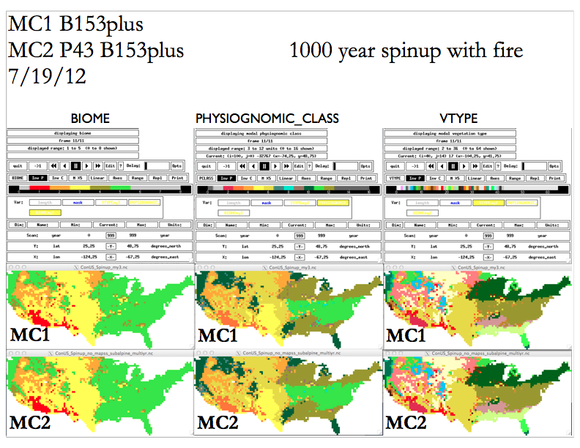
2. The method for testing internal consistency is:

a. Select a representative multiyear, gridded test case.

b. Run a single simulation for the test case which runs thru the entire time span.

c. Run a simulation for the first year of the time span, saving the _ws.nc output file.

d. Run a simulation for the remaining years of the time span, starting from the saved _ws.nc warmstart file.

e. Characterize the differences, if any, between output from step b and output from step d.

As of 8/12/12, using the conterminous U.S. simulated on the VEMAP grid for the historical period as the test case, there are small differences between the results obtained from a complete run of the 1895-1993 time span, and the results obtained from running 1896-1993, starting from a warmstart file saved at the end of a simulation for 1895. The test was performed using MC2 version P58 and/or P59 with libcent.a version B160.

There are also slight differences between the results obtained for a 2-year run of 1895-96, and results obtained from running 1896 starting from a warmstart file saved at the end of a simulation for 1895. 241 of the 588 variables were zero for both versions. I did statistics on the remaining 347 variables, by calculating the mean and standard deviation of the quotients formed by dividing the spatial mean from the 1896 run by the spatial mean from the 1895-96 run. If the values match, the quotient is exactly 1. The mean was 0.99997061 and the std deviation was 0.00013866. The largest difference was less than 0.1%. There were 72 variables out of 347 for which the quotient differed from 1 by more than 0.01%. For 217 of the 347 variables, Excel reported quotients of exactly 1, i.e. the spatial means were exactly the same.

Differences were larger, but still small in absolute terms, between the results obtained for a 99-year run of 1895-1993, compared with results from a 98-year run of 1896-1993, starting from the warmstart file saved at the end of the 1-year simulation of 1895. 240 of the 588 variables were zero for both versions. I did statistics on the remaining 348 variables, by calculating the mean and standard deviation as described above. The mean was 1.00087557 and the std deviation was 0.02478027. There was one variable (minerl_5_1) out of 348 for which the difference was greater than 10%, two variables with differences greater than 1% (minerl_5_1 and minerl_2_1), and 101 with differences greater than 0.1%. For 128 of the 348 variables, Excel reported quotients of exactly 1, i.e. the spatial means were exactly the same.

A possible reason for the differences would be a difference in the precision of the data in the netCDF warmstart file and the precision of the data in RAM during execution of the MC2 program. This is speculation; it has not been confirmed.

citation for MC1
citation for MAPSS
citation for CENTURY
citation for Envision
citation for VEMAP
citation for NetCDF

