# ## Automatic or Manual transmission for better fuel efficiency?

### Executive Summary

In this report we examined data from 32 cars, 1973-1974 models, to ascertain if an automatic or manual transmission is better with regards to fuel consumption. Data used in this report is from the 1974 Motor Trend US magazine and details can be found on R CRAN [here](http://stat.ethz.ch/R-manual/R-devel/library/datasets/html/mtcars.html). Our initial analysis found that manual cars seem to be more efficient than automatic cars. However, when interactions between other aspects of automobile design are taken into consideration, it is found that weight and acceleration play a significant role.

### Sample Distribution: T Test

The initial comparison is simply the summary statistics between automatic and manual. It is found that manual cars are more efficient, average of 24.39 ± 6.17 mpg, than automatic cars, average of 17.15 ± 3.83 mpg (see box plot in section#1 in appendix).

The two-tailed Student's T-Test for the groups confirms that automatic and manual cars are drawn from populations with different means (95% CI).

data(mtcars)  
  
manual <- as.list(subset(mtcars, am == 1, select = mpg))[[1]]  
automatic <- as.list(subset(mtcars, am == 0, select = mpg))[[1]]  
  
t.test(manual, automatic)

##   
## Welch Two Sample t-test  
##   
## data: manual and automatic  
## t = 3.767, df = 18.33, p-value = 0.001374  
## alternative hypothesis: true difference in means is not equal to 0  
## 95 percent confidence interval:  
## 3.21 11.28  
## sample estimates:  
## mean of x mean of y   
## 24.39 17.15

However, note that each car has different sets of automobile design parameters and there are likely multiple factors that influence fuel mileage. A more accurate model encompassing interactions amongst the various factors is required to better describe the fuel efficiency of a car.

### Model Selection

A subset of parameters most relevant to mpg must be determined. To better achieve a balance between a best fit and a small variance inflation a stepwise model selection is used. Since our primary interest is in the influence of type of transmission, this variable and all its interactions are included in the model selection.

var <- colnames(mtcars)[!(colnames(mtcars) %in% c("mpg", "am"))]  
formula.full <- formula(paste("mpg ~ factor(am):(", paste(var, collapse = "*"),   
 ")"))  
  
null = lm(mpg ~ 1, data = mtcars)  
full = lm(formula.full, data = mtcars)  
  
model <- step(null, scope = list(lower = null, upper = full), direction = "both",   
 trace = FALSE)  
model$call

## lm(formula = mpg ~ factor(am):wt + factor(am):qsec, data = mtcars)

Note that the weight of the car and the quarter-mile-time (qsec) signficantly impact the mpg for each type of transmission.

### Model Validation

A residual analysis was done to validate the regression model. To qualify as a good model, the residuals must be, (1) Normal with 0 mean and constant variance (2) Independent, no autocorrelation (iid). Section #2 in the appendix shows a plot summary of the residuals of the model. The "Residuals vs Fitted" and "Scale-Location" charts show that there is no trend to the residuals. The Q-Q plot shows that the the errors are approximately normally distributed.

### Model Interpretation

summary(model)

##   
## Call:  
## lm(formula = mpg ~ factor(am):wt + factor(am):qsec, data = mtcars)  
##   
## Residuals:  
## Min 1Q Median 3Q Max   
## -3.936 -1.402 -0.155 1.269 3.886   
##   
## Coefficients:  
## Estimate Std. Error t value Pr(>|t|)   
## (Intercept) 13.969 5.776 2.42 0.0226 *   
## factor(am)0:wt -3.176 0.636 -4.99 3.1e-05 ***  
## factor(am)1:wt -6.099 0.969 -6.30 9.7e-07 ***  
## factor(am)0:qsec 0.834 0.260 3.20 0.0035 **   
## factor(am)1:qsec 1.446 0.269 5.37 1.1e-05 ***  
## ---  
## Signif. codes: 0 '***' 0.001 '**' 0.01 '*' 0.05 '.' 0.1 ' ' 1  
##   
## Residual standard error: 2.1 on 27 degrees of freedom  
## Multiple R-squared: 0.895, Adjusted R-squared: 0.879   
## F-statistic: 57.3 on 4 and 27 DF, p-value: 8.42e-13

See Section #3 in the appendix for a co-plot of parameters in the model by transmission type.

#### For constant quarter-mile-time (qsec):

For each unit of increase in weight (1 unit = 1000lb) there is a 3.176 mpg **decrease** for automatic cars while there is a 6.099 mpg **decrease** for manual cars. This makes physical sense as heavier cars in general would require more fuel.

#### For constant weight (lb/1000):

For each unit of increase in quarter-mile-time (1 unit = 1 sec), there is a 0.834 mpg increase for automatic cars while there is 1.446 mpg increase for manual cars.

### Concluding Remarks

We cannot make the general conclusion that manual cars are more fuel efficient. The above analysis seems to indicate that for heavier cars a automatic transmission is more fuel efficient. For cars with greater quarter-mile-time (slower acceleration) manual transmission is more efficient.

## APPENDIX: PLOTS

### 1. Boxplot (am) vs mpg

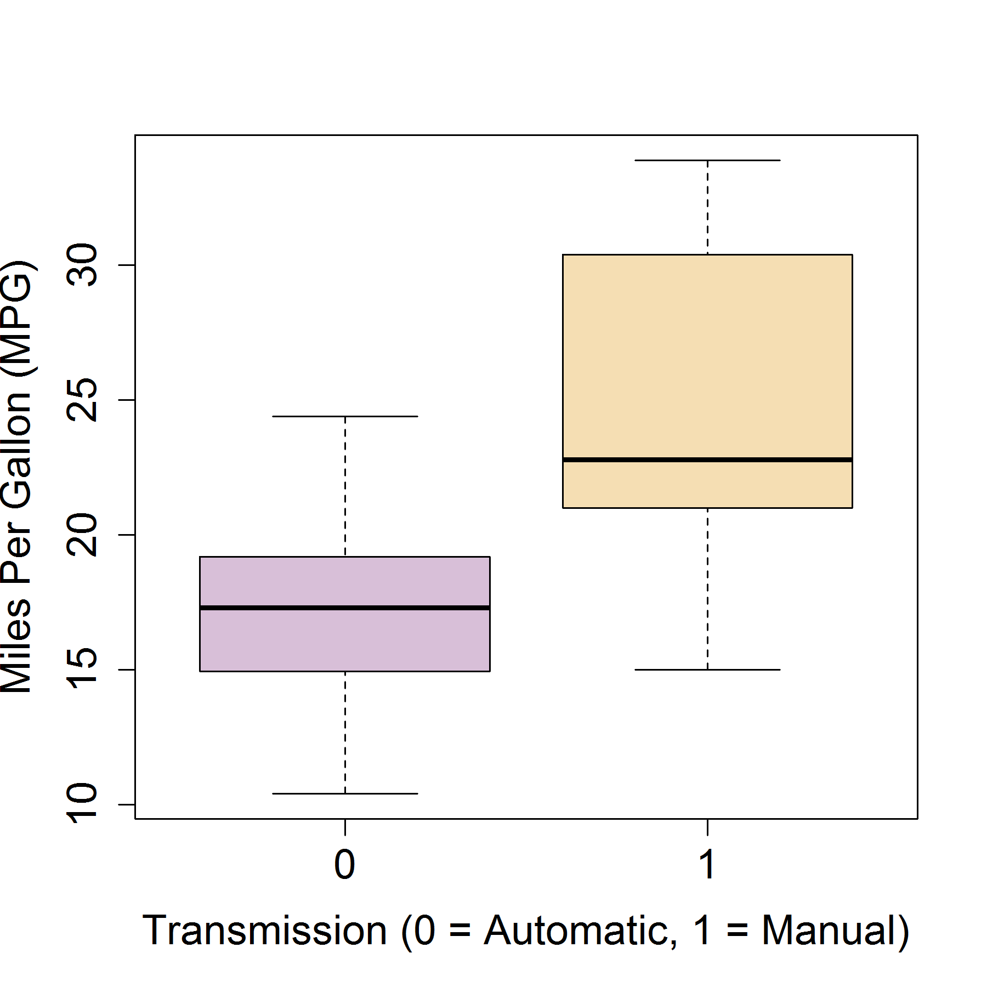

### 2. Residuals: model

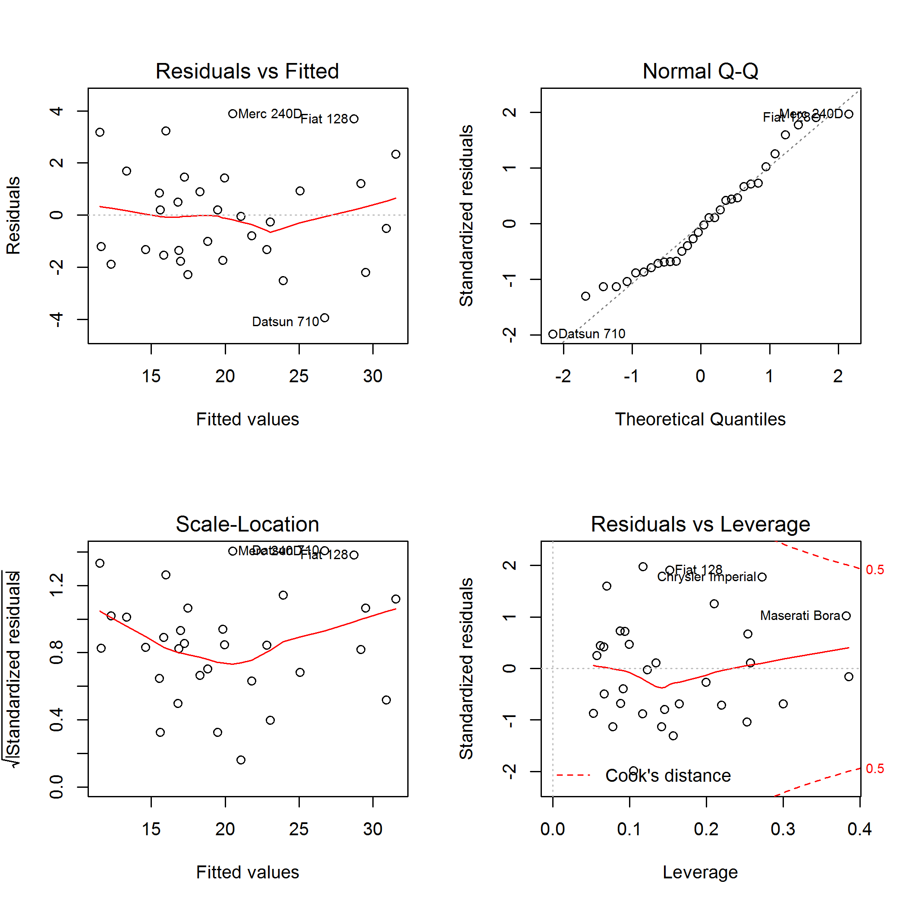

### 3. CoPlot: Fit by transmission type (am)

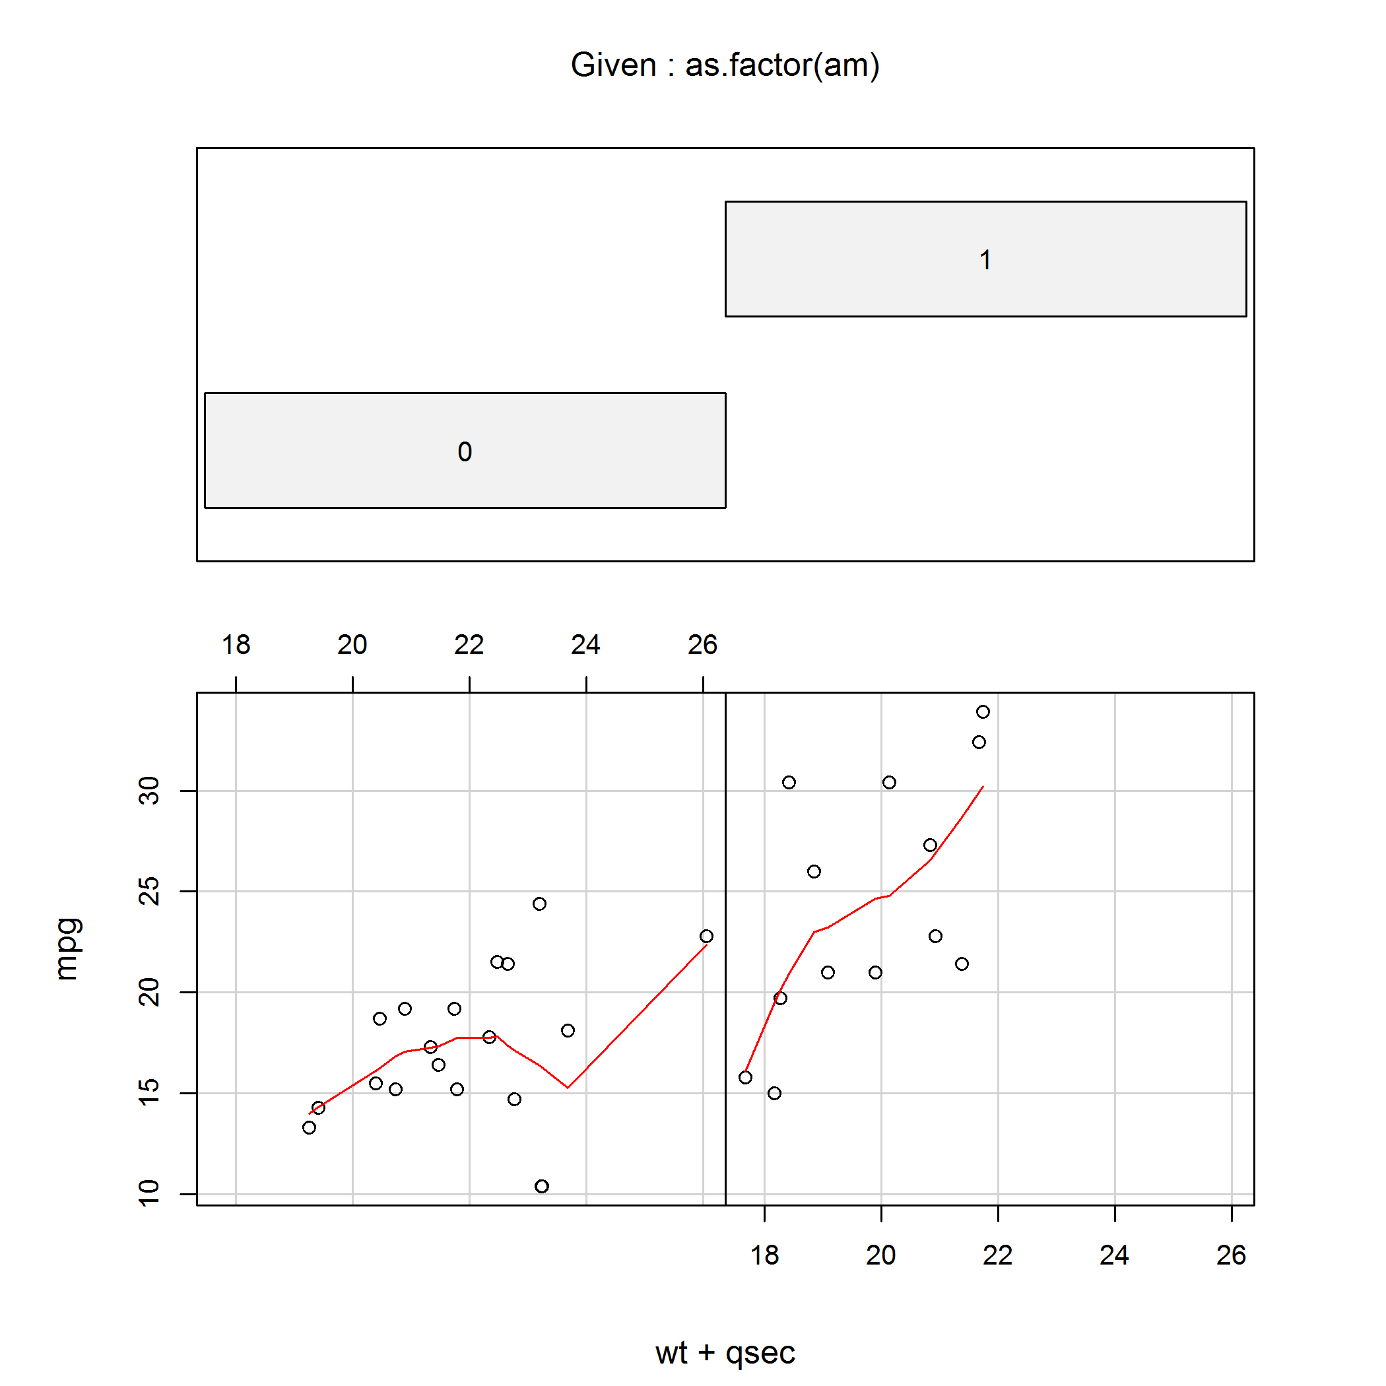

##   
##   
## processing file: course-project.Rmd  
## output file: course-project.md