1. Method-overloading

1. TestingParameter

1. ClassMember

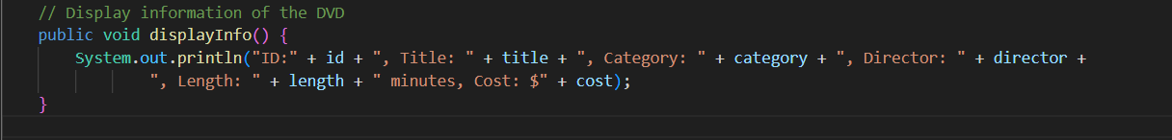

1. Cart

1. Stores

1. Refactor/Packages

1. Memory-Management-String

