Serial-Interface Design Proposal
Document Author(s): Anthony Brown
Date: November 28, 2023

UML Class Diagram

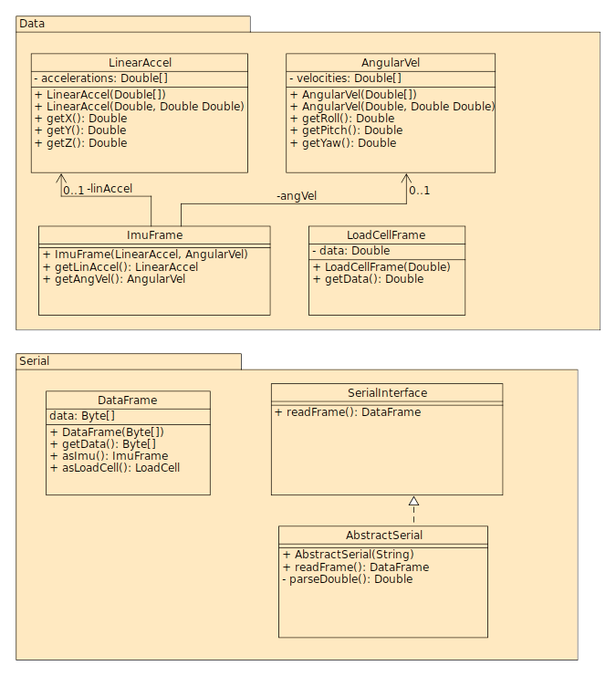
Design Rational
The proposed design for the Serial-Interface package consists of two sub-packages: Data and Serial.
The Data sub-package contains the structured representations of sensor data received from the serial communication port. A data frame of the IMU (inertial measurement unit) consists of two components: linear acceleration and angular velocity. Each of these components can be further broken down into three floating-point values which together provides a representation of the motion of the sensor. A data frame of the load cell consists of a single floating-point measurement representing the weight exerted on the sensor.
The Serial sub-package consists of classes used to directly access data from the serial port. The SerialInterface class provides a method for reading a single block of data from the serial port. The size and structure of the raw data can be defined by concrete classes which extend this interface. The AbstractSerial class extends the SerialInterface and defines a helper method for parsing floating-point values as they are read from the serial port. The DataFrame contains the unstructured sequence of bytes read from the serial port. The class contains two methods which can be used to provide a structured representation of the received frame to the client code.
This package exercises the Bridge design pattern. This decision allows extensions of the code to accommodate possible additional sensors. Additionally, the package will utilize the Adapter design pattern. This would allow the integration of third-party libraries with existing code with minimal modifications.

Date | Author | Change Description
11/28/2023 | Anthony Brown | - Provide initial description of the proposed design of the package

