**Alexa/Roku Volume Control**

**Purpose:**

This will provide the ability to ask Alexa to tell Roku to turn volume up or down and mute/unmute.

**AWS Lambda Code:**

VolumeDown: function (intent, session, response) {

sendCommand("/roku/VolumeDown",null,function() {

response.tellWithCard("Changing Volume Down");

});

},

VolumeMute: function (intent, session, response) {

sendCommand("/roku/VolumeMute",null,function() {

response.tellWithCard("Muting Volume");

});

},

VolumeUp: function (intent, session, response) {

sendCommand("/roku/VolumeUp",null,function() {

response.tellWithCard("Changing Volume Up");

});

},

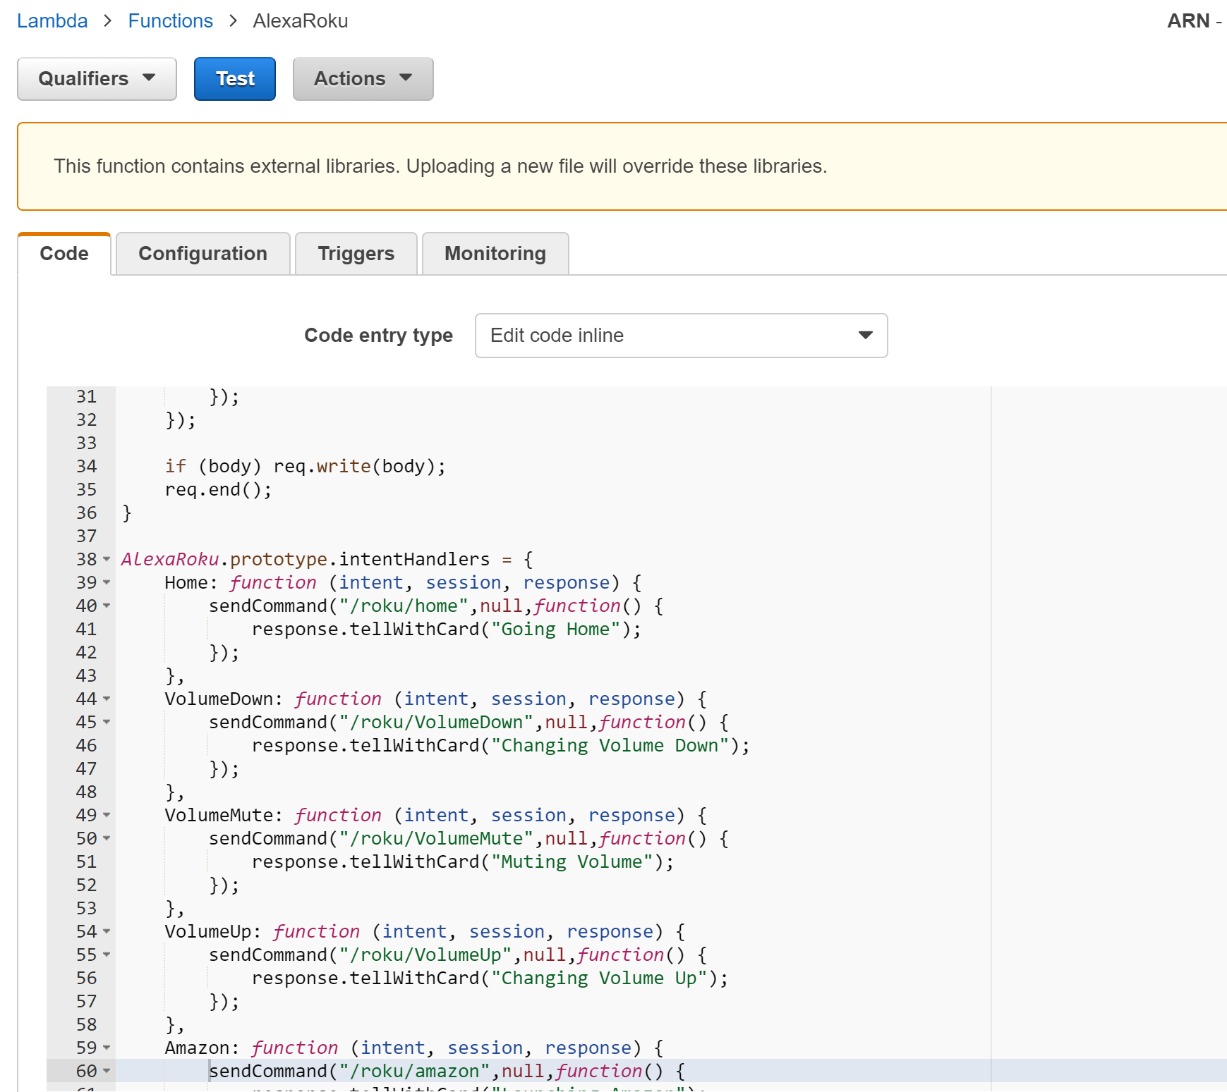

**Developer Site – Alexa Skills Kit:**

**Interaction Model – Intent Schema:**

{

"intent": "VolumeDown",

"slots": []

},

{

"intent": "VolumeMute",

"slots": []

},

{

"intent": "VolumeUp",

"slots": []

},

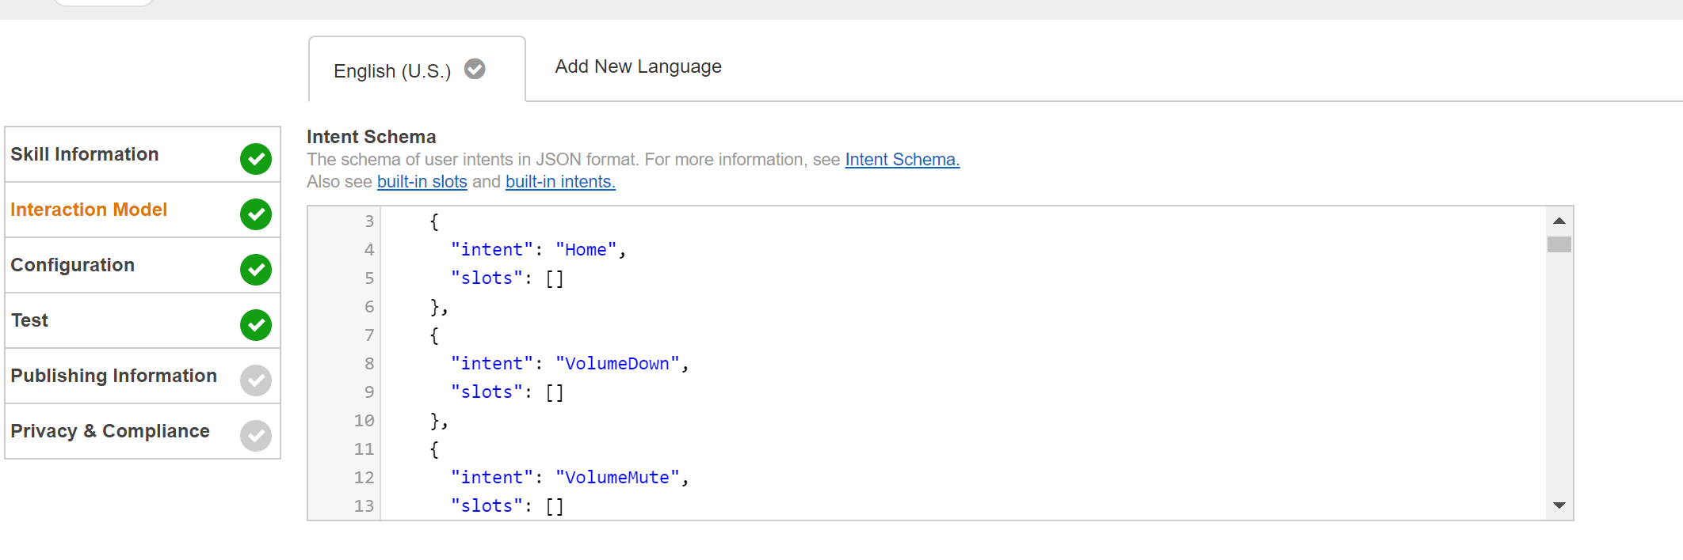

**Interaction Model – Sample Utterances:**

VolumeDown turn volume down

VolumeMute mute

VolumeUp turn volume up

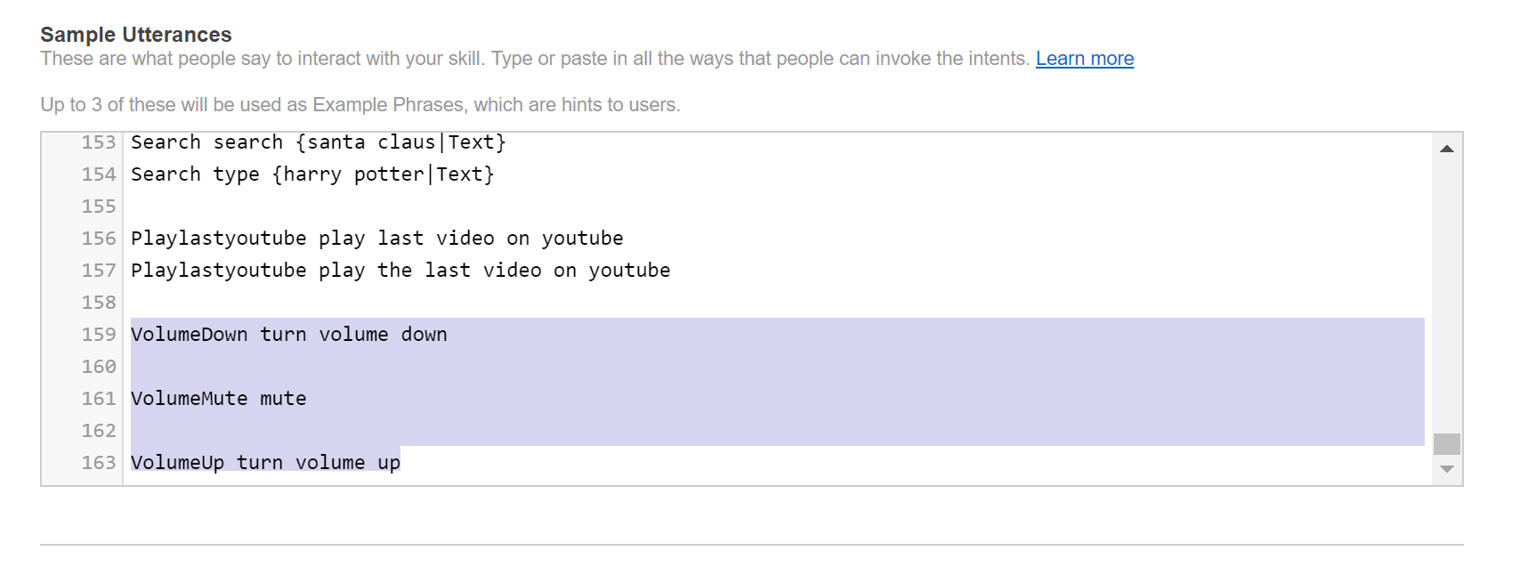

**Server File (located on PC under C:\Users*your user name*):**

"/roku/VolumeDown":function(request,response) { //Only for Roku TV - VolumeDown

postSequence([

VolumeDown(rokuAddress),

],function(){

});

response.end("OK");

},

"/roku/VolumeMute":function(request,response) { //Only for Roku TV - VolumeMute

postSequence([

VolumeMute(rokuAddress),

],function(){

});

response.end("OK");

},

"/roku/VolumeUp":function(request,response) { //Only for Roku TV - VolumeUp

postSequence([

VolumeUp(rokuAddress),

],function(){

});

response.end("OK");

},

