EiffelOpenGL
An Eiffel wrapping of the OpenGL, GLUT and OpenGL Auxillary libraries
Preliminary 1.0.2, 03 January 2001

Paul Cohen
(paco@enea.se)

Copyright © Paul Cohen 2000, All rights reserved.
This document may be freely copied and printed for personal and non-commercial use only.
All trade names, service names, trademarks or registered trademarks mentioned in this document are property of their respective owners.

Contents
Contents i
Preface iii
1 Introduction 1
1.1 Design Philosophy 1
1.2 About this document 2
1.3 Versioning 3
1.4 Conventions 3
1.5 Terminology and acronyms 4
1.6 Legal stuff 6
2 Overview of EiffelOpenGL 7
2.1 About OpenGL 7
2.2 About GLUT and GLAUX 8
2.3 Contents of the EiffelOpenGL wrapping 8
2.4 Examples of EiffelOpenGL application architectures 11
3 EGL 14
3.1 Introduction 14
3.2 Dependency description 14
3.3 Design 14
3.4 Naming conventions 14
3.5 Detailed specification Error! Bookmark not defined.
3.5.1 System chart: EGL 16
3.5.2 Cluster chart: EGL 16
3.5.3 Cluster chart: SPEC/COMPILER/ISE/EGL 17
3.6 Examples 18
4 EGLUT 21
4.1 Introduction 21
4.2 Dependency description 21
4.3 Design 21
4.4 Conventions 21
4.5 Detailed specification 22
4.5.1 System chart: EGLUT 22
4.5.2 Cluster chart: SPEC/COMPILER/ISE/EGLUT 22
4.6 Examples 23
5 EGLAUX 24
5.1 Introduction 24
5.2 Dependency description 24
5.3 Design 24
5.4 Conventions 26
5.5 Detailed specification 26
5.6 Examples 29
6 Installation 30
6.1 On Win32 computers 30
6.2 On X Window computers 30
Appendix A: References 31
Index 32

Preface
Eiffel is a wonderful fully object-oriented language. OpenGL is a wonderful graphics application programming platform. Thus an Eiffel wrapping of OpenGL must surely be a truly wonderful thing!
There were basically three interleaved motifs for me when I started implementing these wrappings:
- I have long wanted to try my skills at graphics programming.
- I wanted to do it using OpenGL.
- I wanted to do it using Eiffel.
It soon became evident that the wrapping would be much easier to evaluate and test if I also wrapped the GLUT and GLAUX libraries as well, since both these libraries are used extensively in the OpenGL litterature and by nearly all OpenGL example programs.
There are a number of interesting questions that are addressed by these wrappings, specifically:
- Is it possible to write OpenGL programs in Eiffel? Yes it is!
- How the design of an object-oriented wrapping of a ”procedural” API can be done. There are both implementation and performance issues to consider, but thought should also be given to how to ensure that existing documentation on the API can be used in conjection with the Eiffel wrapping.
- What the great benefits are in using Eiffels support for Design by Contract when wrapping an existing API (that is an API written in a programming language that lacks support for contracts). By using program contracts wherever identified and wherever possible, the quality of the OpenGL API has been greatly improved. This is because many of the requirements on OpenGL API function and procedure calls, that previously only were documented in English, a natural language, are now instead explicitly and formally expressed in a formal language. Namely through Eiffel program contracts which are integrated with the actual program code.
- How well suited Eiffel actually is for high performance graphics programming. I believe, though it remains to be proved, that EiffelOpenGL based Eiffel applications don’t incur any significant performance problem, compared to equivalent OpenGL applications written in C or C++. Just as importantly you actually get something very valuable for this performance price; garbage collection, program contracts during development and test phases and a more readable syntax than what C or C++ provides. And of course the support for writing OpenGL applications using a fully object-oriented language with support for multiple inheritance and genericity.
- How to interface Eiffel with C. Eiffel has very good support for this, although the existing documentation on this issue leaves a bit to be desired. Another problem is that the important parts of the Eiffel external clause, used for interfacing to other languages, are not standardized, and are thus handled differently by different Eiffel compilers.
I hope that the reader will find this document valuable in learning about how to use EiffelOpenGL.
I would like to thank Per Grape who first got me looking into OpenGL and who provided me with initial material and encouragement. I would also like to thank Daniel Rodríguez and Kim Waldén for many enlightening discussions on both pure technical as well as design issues. Andreas Leitner was one of the first to actually test some of the wrapping and provided both feedback and encouragement as well. Finally, ISE and Bertrand Meyer kindly provided me with both an Eiffel compiler and encouragement.

- Introduction
EiffelOpenGL is the collective name for the Eiffel wrappings of three distinct libraries; OpenGL, GLUT and the OpenGL Auxiliary library, also referred to as the AUX or Auxiliary library. Henceforth this latter API will be referred to as GLAUX.
OpenGL is actually comprised of two parts; the core OpenGL (GL) and the OpenGL Utility (GLU) libraries. There also exists a set of small extension libraries for all the windowing systems that support OpenGL. These extension libraries contain routines that extend specific windowing systems to support OpenGL. For example there exist extension libraries for Microsoft Windows 95/98/NT (WGL), the X Window System (GLX), the Apple Macintosh (AGL) and IBM OS/2 Warp (PGL).
GLUT and GLAUX are not part of OpenGL proper and they are also mutually independent of each other. They both implement small platform independent (ie. independent of the Win32, X Window platforms) windowing systems with support for basic windowing functionality such as creating windows and handling window, keyboard and mouse events.
All the libraries mentioned above are written in C and the API:s are accessable in the form of runtime libraries and C header files.
  - Design Philosophy
I definitely have more knowledge of, and experience in, using Eiffel than OpenGL, and the reader might find that fact reflected in the design of the wrapping.
One important principle I have tried to follow is to divide the wrappings into two logical layers. One layer is a ”raw” wrapping which simply provides a straightforward Eiffel wrapping of the C API and is comprised of classes that contain Eiffel external features. At the second layer a more ”Eiffelized” wrapping is provided. This layer contains identified contracts and a more object-oriented (ie. modularized through the use of classes) interface to the underlying C API and is comprised of classes with no external features. Ideally only the Eiffelized wrapping should be used by a client application, but occasionally there might be a need for a developer to access the raw wrapping directly. Of course, by bypassing the Eiffelized wrapping, all the benefits of using an API with formal contracts is lost!
I have tried to ensure that there is as little performance overhead as possible when using the Eiffelized wrapping. Eiffel provides very good support for implementing ”slim” wrappings with little performance overhead and without forcing one to abandoning the aim of modularizing the wrapping of the API into different classes and clusters of classes.
Another important aspect of this layering is that it allows people to change the existing implementation of the raw wrapping for another implementation. This is important since the syntax and semantics of the Eiffel external clause is not standardized and its implementation differs from Eiffel compiler to compiler. Layering facilitates the adaption of an entire wrapping to other Eiffel compilers. EiffelOpenGL is currently only compilable with ISE’s Eiffel compiler. I intend to add support for the GNU Eiffel compiler SmallEiffel.
As for the two windowing libraries; GLUT and GLAUX, I have followed the design patterns of ISE’s Eiffel Vision and WEL class libraries. In these frameworks a developer can simply write a new application specific GUI-component class and let it inherit from a relevant framework GUI-component class. In the new application specific GUI-component class the developer can then chose to redefine, and thus implement behaviour in, a number of callback features that are invoked as a result of various windowing application events. Examples of such features are ’on_show’, ’on_character’, ’on_mouseclick’, which are invoked respectively when a GUI-component is shown, the user enters a character or clicks on a mouse button.
It should also be emphasized that EiffelOpenGL is not an attempt at providing an OO model of graphical primitives or a general OO graphical application framework. That means that you will not find any POINT, LINE or CURVE classes in the library. It is fully possible to implement such an OO framwork, or even a more ambitious graphical scene framework, based on EiffelOpenGL. The main purpose of EiffelOpenGL is to provide Eiffel developers with an Eiffel interface to OpenGL. In this wrapping a number of the excellent and unique features of the Eiffel language have been utilized. The two most central features being:
- The use of classes as a way to modularize an API, where each class/module contains a well defined set of closely related methods and/or attributes. It should be pointed out that Eiffels clean and well designed support for multiple inheritance is fundamental to the design and implementation of the wrappings.
- The use of class invariants and feature pre- and postconditions, thus providing an Design by Contract interface for OpenGL.
The aim has been to ensure that EiffelOpenGL should work on, or be easily adaptable to, all platforms for which an OpenGL implementation exists. Also EiffelOpenGL should work with all available Eiffel compilers. However neither is the case now, but I hope I have designed EiffelOpenGL so this should be easy to add in the future.
EiffelOpenGL was originally developed with ISE Eiffel 4.2f on the Win32 API, and seems to work fine on both NT and Windows 95. It has been verified to work with ISE Eiffel 4.4 and 4.5 on these platforms as well. It does unfortunately not work on X Window or any OpenGL implementation (or imitating clone such as MESA) for the X Window System yet. I hope to address this in the near future.
It was also developed using WEL from ISE Eiffel, and EGL is currently dependent on WEL to some degree. I intend to remove this depencence in the future.
  - About this document
This document describes EiffelOpenGL and the three Eiffel class libraries EGL, EGLUT and EGLAUX that wrap respectively OpenGL, GLUT and GLAUX.
Chapter 1 contains a general introduction to EiffelOpenGL and this document in general.
Chapter 2 presents an overview of EiffelOpenGL. It describes what it contains and the various application architectures that can be chosen when writing an EiffelOpenGL application.
Chapter 3 describes EGL, the Eiffel wrapping of OpenGL proper, ie. the GL and GLU libraries and the various OpenGL windowing system extension libraries.
Chapter 4 describes EGLUT, the Eiffel wrapping of GLUT.
Chapter 5 describes EGLAUX, the Eiffel wrapping of GLAUX.
Chapter 6 describes how to install EiffelOpenGL.
Chapter 8 contains litterature and web references.
  - Versioning
EGL is the wrapping of OpenGL proper and it also includes the wrapping of the OpenGL extension libraries. EGL has its own versioning. EGLUT and EGLAUX are to be seen as separate wrappings and have their own respective versioning.
EGL | Version 0.1.1
EGLUT | Version 0.1.1
EGLAUX | Version 0.1.1
  - Conventions
I make use of a couple of left margin symbols and labels. The single left margin symbol is the warning triangle, that is used to draw the readers attention to an especially tricky or important part of the text. Here is an example:
This is a very important thing to note!
There also exists two left margin labels that are used to indicate Eiffel and C program text paragraphs. For example, here is some C program text:

C char doSomething (int i; char *c) {
char str[];
str = c
return (str[i]);
}

And here is some Eiffel program text:

Eiffel do_something (i: INTEGER; s: STRING): CHARACTER is
require
s_not_void: s /= Void
do
Result := s @ i
end

In this document BON is used to describe static and dynamic class relations. A full description of BON can be found in Seamless Object-Oriented Software Architecture – Analysis and Design of Reliable Systems [BON95]. BON is an excellent notation for formalizing OO abstractions. BON emphasizes strong typing and formal specification. Importantly it also emphazies the class as the central and fundamental abstraction of OO analysis, design and implementation. It is my opinion that for formulating static class diagrams and other static aspects of an OO-system, BON is much better than UML.
In addition to the BON client arrow used in static BON diagrams, I have introduced the notion of secondary client relations. I have introduced this notion only in order to explicitly illustrate implementation dependencies on WEL in some of the static BON diagrams.
Secondary client relations refer to situations where at least one feature in the client class uses a supplier class in at least one of the two following ways:
- As a type for a formal parameter in a feature signature.
- For declaring the type of a local feature attribute.
Obviously, secondary client relations cannot be uniquely labeled like ordinary client relations, since there may exist many features in the client class that use the supplier class in one of the two above mentioned ways. Secondary client relations are denoted in the BON diagrams with dotted client arrows.
Another addition to BON is that I have also annotated classes marked as interface classes (ie. that contain external features) in the BON static diagrams, with a parenthesis containing the name of the C-header file that the class interfaces to, as well as the number of constant-like macros, function-like macros and functions that the class has wrapper features for.
In conformance with the BON-notation, references in the text to Eiffel classes as well as Eiffel clusters are in slanted capitals.
  - Terminology and acronyms
Win32. The Microsoft Windows 32 bit OS API, to which Windows NT, Windows 95 and 98 conform.
API. Aplication Programming Interface. By API is generally meant what an application programmer sees of a programming environment, such as for example the library files and C header files of a C API.
OpenGL Open Graphics Language. A graphics programming platform and API. The first OpenGL specification release was done in 1992. The forerunner of OpenGL was GL from Silicon Graphics.
GLAUX. The name used in this document for AUX.
GLUT. OpenGL Utility Toolkit. A simple platform independent windowing system. GLUT is not an official part of OpenGL, but it can be downloaded from the OpenGL website (www.opengl.org).
AUX. The OpenGL Auxillary Library. Another simple platform independent windowing system. AUX is not an official part of OpenGL, though it comes bundled with most implementations.
BON. Business Object Notation. Actually both a method and a notation for developing O-O software that emphasizes seamlessnes, reversibility and formal specification. See [BON95].
WGL. The OpenGL extension for Microsoft Windows 95/98/NT.
GDI. The Win32 Graphic Device Interface.
GLX. The OpenGL extension for the X Window System.
AGL. The OpenGL extension for the Apple Macintosh.
MEL. Motif Eiffel Library. An Eiffel library from ISE Eiffel that wraps Motif.
WEL. Windows Eiffel Library. An Eiffel library from ISE Eiffel that wraps the windowing parts of the win32 API.
GEL. Gtk Eiffel Library. An Eiffel library from ISE Eiffel that wraps the Gtk X Window Toolkit.
  - Legal stuff
Finally a word on copyright and licensing. End users or software developers writing code based on the OpenGL API use the OpenGL libraries and API header files free of licensing requirements. The same goes for GLAUX. GLUT is not in the public domain, but it is freely distributable without licensing fees.
EiffelOpenGL is licensed under the Eiffel Forum License which is presented below .

Eiffel Forum License, version 1

Permission is hereby granted to use, copy, modify and/or distribute this package, provided that:

- copyright notices are retained unchanged
- any distribution of this package, whether modified or not, includes this file

Permission is hereby also granted to distribute binary programs which depend on this package, provided that:

- if the binary program depends on a modified version of this package, you must publicly release the modified version of this package

THIS PACKAGE IS PROVIDED "AS IS" AND WITHOUT WARRANTY. ANY EXPRESS OR IMPLIED WARRANTIES, INCLUDING, BUT NOT LIMITED TO, THE IMPLIED WARRANTIES OF MERCHANTABILITY AND FITNESS FOR A PARTICULAR PURPOSE ARE DISCLAIMED. IN NO EVENT SHALL THE AUTHORS BE LIABLE TO ANY PARTY FOR ANY DIRECT, INDIRECT, INCIDENTAL, SPECIAL, EXEMPLARY, OR CONSEQUENTIAL DAMAGES ARISING IN ANY WAY OUT OF THE USE OF THIS PACKAGE.

- Overview of EiffelOpenGL
  - About OpenGL
Briefly, OpenGL is an industry standard 2D and 3D graphics application programming interface (API). There exist OpenGL implementations on a variety of OS platforms, most notably nearly all, if not all, Unices including Linux, Win32, MacOS and BeOS. Furthermore many graphics hardware vendors provide support for OpenGL hardware acceleration as well.
Maintenance and development of the OpenGL specification is governed by the OpenGL Architecture Review Board (ARB). Current members of the ARB include among others Silicon Graphics, Microsoft, Hewlett-Packard, Intel and Compaq. Information about OpenGL and the ARB can be found on their website at www.opengl.org.
The OpenGL API is contained in two libraries; GL and GLU (GL Utility). GL contains the core OpenGL functionality, all in all roughly 200 routines, and GLU contains around 50 utility routines. Furthermore there exist a number of so called OpenGL extension libraries for every windowing/OS platform that has an OpenGL implementation. For the X Window system, the OpenGL extension is called GLX, for Win32 systems the extension is called WGL and for the Apple Macintosh system it is called AGL. How the extension libraries actually are integrated with the specific system may vary.
On the Win32 system WGL is implemented as a set of routines added to the Win32 GDI (Graphical Device Interface). The Win32 GDI library is one of the Win32 core libraries and contains the Win32 graphics API. These additions can be devided into two groups. The first group contains functions prefixed wgl that actually implement the WGL extension library. The second group contains additions to the Win32 GDI that support extra functionality that an OpenGL implementation would expect from the underlying platform. These additions include routines for (per window) pixel formats and double buffering. I will refer to these latter additions as GDI OpenGL add-ons.
Please refer to the official OpenGL documentation for a full description of OpenGL. The book OpenGL Programming Guide, Third edition, The Official Guide to Learning OpenGL 1.2 [GLGUIDE99] is an excellent book.
Mesa is an non-official OpenGL clone which implements most if not all of the functionality in OpenGL. Mesa is a fully valid alternative to OpenGL, but since it is not a formal licensed OpenGL implementation it makes no formal claims to being 100% percent compatible with OpenGL. Mesa was originally developed for the X Window system but there exist drivers for Windows, Apple MacIntosh and a number of other platforms as well. See www.mesa3d.org. EiffelOpenGL should work fine with Mesa.
  - About GLUT and GLAUX
OpenGL has no support for creating and managing windows or other common widgets/controls or any event-handling mechanisms usually supported by windowing systems. Every developer using OpenGL must implement the general application logic for the specific windowing platform that she/he is using. Since most newcomers to OpenGL are mainly interested in learning OpenGL and are not interested in messing about with a lot of Win32 or X Window specifics, the two libraries GLUT and GLAUX have been developed.
GLUT and GLAUX are two mutually independent libraries that each on their own implement simple platform independent windowing environments. Using GLUT or GLAUX makes it easy to write portable OpenGL programs without having to learn all the details of Win32 or X Window programming. Both libraries provide basic functionality for creating windows and for registering callback functions to be invoked on window, keyboard and mouse events. The windowing functionality provided by GLUT is slightly more advanced than in GLAUX.
They are not officially part of OpenGL but GLAUX seems to come bundled with most OpenGL implementations and GLUT can be downloaded from the OpenGL website www.opengl.org. It should be noted that GLAUX does not seem to be supported anymore and GLUT seems to be the choice library now for writing test and example OpenGL applications.
It is of course fully possible to write an OpenGL application written without using any of these two libraries, and that is most certainly the way to go when developing a full scale application based on OpenGL.
  - Contents of the EiffelOpenGL wrapping
As mentioned in the introduction, EiffelOpenGL is the collective name for the three Eiffel class libraries that wrap the OpenGL, GLUT and GLAUX libraries.
Below the wrappings together with the corresponding libraries are presented.
Library | Description | Status of the Eiffel wrapping
GL | OpenGL core library.  Include file:  gl.h  Library files:  Win32: gl.lib/opengl32.dll (4.0)  X Win: libgl.a, libgl.so (?) | Name: EGL (includes wrapping of GLU)  Status: Partially implemented. Most of the kernel functionality (initializing etc.) is wrapped and tested.
GLU | OpenGL utility library.  Include file:  glu.h  Library files:  Win32: glu.lib/glu32.dll | Name: EGL (includes wrapping of GL)  Status: Partially implemented.
WGL | OpenGL extension library for the Win32 system.  Include file:  win.h  Library files:  Win32: gdi.lib/gdi32.dll (4.0) | Name: EWGL (It also includes the wrapping of the GDI OpenGL add-ons).  Status: Nearly completely implemented.
GDI OpenGL add-ons for the Win32 system. | Pixel format and double buffering support on Win32.  Include file:  win.h  Library files:  Win32: gdi.lib/gdi32.dll (4.0) | Name: EWGL (It also includes the wrapping of the WGL extension library).  Status: Nearly completetly implemented.
GLX | OpenGL extension library for the X Window system. | Name: EGLX  Status: Not implemented yet.
AGL | OpenGL extension library for the Apple MacIntosh system. | name: EAGL  Status: Not implemented yet.
The OpenGL libraries and the corresponding Eiffel wrappings

Library | Description | Comment
GLUT | GLUT library.  Include file:  glut.h  Library files:  Win32: glut.lib/glut32.dll (4.0)  X Win: libglut.so.3.6 | Name: EGLUT  Status: Partially implemented. All of the kernel functionality is wrapped and tested.
The GLUT library and the corresponding Eiffel wrapping

Library | Description | Comment
GLAUX | GLAUX library.  Include file:  glaux.h  Library files:  Win32: glaux.lib | Name: EGLAUX  Status: Partially implemented. All of the kernel functionality is wrapped and tested.
The GLAUX library and the corresponding Eiffel wrapping
  - Examples of EiffelOpenGL application architectures
There are a number of architectural alternatives when writing an EiffelOpenGL based application. This section gives a brief overview of the alternatives available and the pros and cons of the different architectures.
The central building block for all EiffelOpenGL application architectures is EGL. This is natural since EGL is the Eiffel wrapping of OpenGL proper. The variable parameter of the application architectures is which windowing library/API to use. This decision in turn is dependent on what the target platforms for the application are.
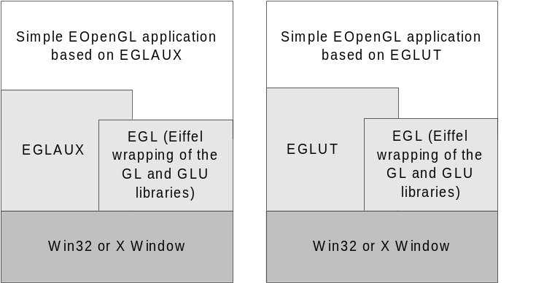
Figure 1. Two application architectures based on EGL and one of EGLAUX and EGLUT libraries
In the figure above two very similar EiffelOpenGL application architectures are presented. The left architecture is based on EGL and EGLAUX and the right architecture is based on EGL and EGLUT. The use of the word ”simple” in the phrase ”simple EiffelOpenGL application” refers to the fact that both GLAUX and GLUT are rather limited in their windowing functionality. For instance there are no dialogs, menu-bars, buttons, edit fields or other basic GUI components available in either GLAUX or GLUT. Of course, the OpenGL specific parts of the application does not need to be ”simple” in any sense of the word. Since there exist GLAUX and GLUT implementations on both the Windows and X Window platforms, portability is ensured across these platforms for any application based on the the above application architectures.
Both the above application architectures are supported by the current version of EiffelOpenGL. However they have not been verified to work on the X Window platform.

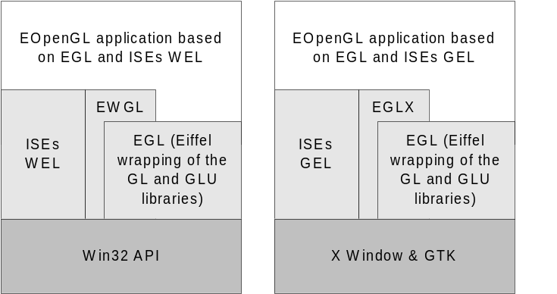

Figure 2. Two application architectures based on EGL and one of WEL and GEL libraries
In the figure above two other alternative EiffelOpenGL application architectures are presented. The left architecture is based on EGL and ISE Eiffels WEL (Windows Eiffel Library) and the right architecture is based on EGL and ISE Eiffels GEL (Gtk Eiffel Library). In both cases it is also necessary to use an Eiffel wrapping of OpenGL extensions for the respective platforms. For the Win32 platform the Eiffel wrapping of WGL, above called EWGL, is needed and for the X Window platform the Eiffel wrapping of GLX, above called EGLX, is needed.
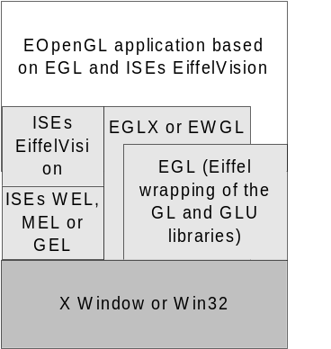Currently only the left architecture is supported by EiffelOpenGL since the EGLX wrapping does not exist at the moment.

Figure 3. An application architecture based on EGL and EiffelVision
Another way of achieving portability could be to chose the application architecture presented in figure 3 above. EiffelVision is a platform independent windowing Eiffel library provided by ISE Eiffel.
The current version of EiffelOpenGL does not support this architecture but it is certainly an interesting approach and should definitely be tested for viability. It would require, among other things, solving how to tie the EWGL and EGLX wrappings to EiffelVision.
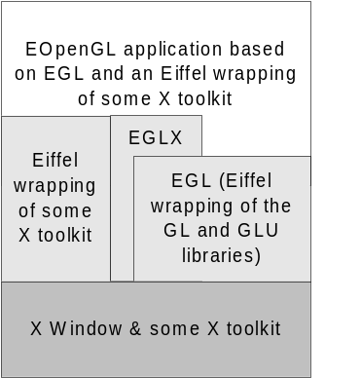
Figure 4. An application architecture based on EGL and some other Eiffel wrapping of an X Window toolkit
Of course it should be possible to use EGL with other Eiffel wrappings of X Window toolkits. In figure 4 above an application architecture for such a solution is presented.
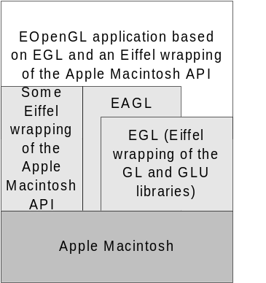The current version of EiffelOpenGL does not support this architecture since the EGLX wrapping does not exist at the moment.

Figure 5. An application architecture based on EGL and some Eiffel wrapping of the Macintosh windowing API
It would of course be neat if EGL could be used on the Apple Macintosh platform. In figure 5 above an EiffelOpenGL application architecture for the Apple Macintosh is presented. Since there now exists an OpenGL implementation for Macintosh, it should be reasonably easy to ensure that EGL works on that platform. Possibly also EGLUT and EGLAUX. It should thus be possible to write an application based on EGL and some Eiffel wrapping of the windowing part of the Macintosh API, as shown in figure 5. This would however also require an Eiffel wrapping of AGL, the OpenGL extension for the Macintosh, to be implemented.
Currently none of these suggested application architectures for the Macintosh platform are supported by the current version of EiffelOpenGL.
- EGL
  - Introduction
EGL is the name of the Eiffel class library that wraps OpenGL. This includes the wrapping of both the GL and GLU libraries. EGL also includes the Eiffel wrappings of the platform specific OpenGL extension libraries (WGL, GLX, AGL).
  - Dependency description
The current version of EGL will only compile with the ISE compiler, since it depends on the ISE compilers interpretation of the external construct. There also exist some dependencies on a few ISE WEL classes.
Furthermore only the Win32 OpenGL extension library WGL is wrapped at the moment.
In order to use use EGL you need to have the OpenGL and OpenGL Utility libraries including the corresponding include files installed on your computer. See the chapter on installing EGL for more details.
  - Design
The Eiffel wrapping of OpenGl is accessed through Eiffel classes in the cluster EGL. These classes are Eiffel compiler independent and platform independent and the classes contain contracts (pre- and postconditions and invariants) wherever identified. These classes are referred to as Eiffelized wrapper classes.
The classes in the cluster EGL rely on Eiffel compiler dependent wrapper classes of the OpenGL API. These classes are found in the cluster SPEC/COMPILER/ ISE/EGL. These classes are referred to as raw wrapper classes.
It is of course possible to access the OpenGL library via the raw wrapper classes. However in that case you will make your application a) bypass the contracts and b) become Eiffel compiler dependent.
The WGL library wrapping is found in the cluster (SPEC/PLATFORM/WIN32).
  - Naming conventions
In the OpenGL C API all function names are prefixed with gl and have leading capital letters for each word that make up the name of the specific OpenGL function, eg. glClearColor. The feature names in the raw wrapper classes are prefixed with gl_ and are then followed by the same words as in the OpenGL function, except that no letters are capitalized and ’_’ are inserted between words, eg. gl_clear_color.
OpenGL constants have the same name in Eiffel as in the C API but have all letters, except the first, in lower case, eg. GL_MODELVIEW becomes gl_modelview.
In the Eiffelized classes the OpenGL function names are prefixed with egl and are then followed by the function name, eg. egl_clear_color.
The Win32 WGL extension functions are wrapped in the raw wrapper class WGL. The features in that class have the prefixes wgl_ followed by the Win32 wgl-function name, eg. wglMakeCurrent becomes wgl_make_current. There also exists an eiffelized class EGL_RENDERING_CONTEXT that wraps the HGLRC handle used when accessing wgl-functions. The features in EGL_RENDERING_CONTEXT, that correspond to wgl-functions are prefixed with ewgl_. For instance, the creation feature of EGL_RENDERING_CONTEXT is called ewgl_create (which calls wgl_create_context).
  - Cluster and class listings
All cluster names are given relative to the EiffelOpenGL installation path.
    - System chart: EGL
SYSTEM | EGL |  |  | Part: 1/1
PURPOSE  All classes and clusters that make up EGL, the Eiffel encapsulation of the OpenGL library. |  |  | INDEXING  author: Paul Cohen  date: 2000-12-22
(Cluster) |  | Description
(EGL) |  | Contains all the classes that together constitute the EGL API, ie. the classes that an application developer using OpenGL would typically use. These classes contain not only the all the OpenGL functions but also pre- and postconditions on these functions as well as invariants in the classes.
(SPEC/COMPILER/ISE/EGL) |  | Contains the ISE Eiffel compiler dependent wrappings of the GL and GLU libraries.
(SPEC/COMPILER/ISE/EGL/GL_CONSTANTS) |  | Contains the ISE Eiffel compiler dependent wrappings of all the constants used in the GL library. All in all 54 classes.
(SPEC/COMPILER/ISE/EGL/GLU_CONSTANTS) |  | Contains the ISE Eiffel compiler dependent wrappings of all the constants used in the GLU library. All in all 16 classes.
(SPEC/PLATFORM/WIN32) |  | Contains the wrapping of the OpenGL extension library for Windows, WGL.

Bla bla bla. BON diagram over EGL goes here?
    - Cluster chart: EGL
CLUSTER | EGL |  |  | Part: 1/1
PURPOSE  Contains all the classes that together constitute the EGL API, ie. the classes that an application developer using OpenGL would typically use. These classes contain not only the all the OpenGL functions but also pre- and postconditions on these functions as well as invariants in the classes. |  |  | INDEXING  author: Paul Cohen  date: 2000-12-22
Class |  | Description
EGL |  | Eiffelized wrapping of the OpenGL GL library.
EGLU |  | Eiffelized wrapping of the OpenGL GLU library.
EGLU_QUADRIC |  | An Eiffelized OpenGL GLU library quadrics object.
GL_CONSTANTS |  | OpenGL GL library constants.
GLU_CONSTANTS |  | OpenGL GLU library constants.

    - Cluster chart: SPEC/COMPILER/ISE/EGL
CLUSTER | SPEC/COMPILER/ISE/EGL |  |  | Part: 1/1
PURPOSE  Contains the ISE Eiffel compiler dependent wrappings of the GL and GLU libraries. |  |  | INDEXING  author: Paul Cohen  date: 2000-12-22
Class |  | Description
GL |  | Raw wrapper class for the OpenGL GL library.
GLU |  | Raw wrapper class for the OpenGL GLU library.

    - Auxillary C code
Directory | Contents
spec/platform/win32/include | pfd.h /* Include file for the Eiffel class PIXEL_FORMAT_DESCRIPTOR. */

  - Examples
I will here briefly describe a typical EGL application to give the reader a feel for how EGL is supposed to be used. The application is meant to run on Win32. This means that we a) have to use the EWGL library and b) use some existing Eiffel wrapping of the Win32 API, in this case ISE’s WEL. The application implements an architecture as described in the left part of fig. 2 in the section on EiffelOpenGL application architectures.
Since this EGL application does not use AUX or GLUT it means that we have to write code for handling windowing events specific to the given platform, in this case Win32. It is assumed that the reader is fairly accquainted with WEL.
In our application we will have to implement code to:
- Initialize the OpenGL API via the EWGL library.
- Do our OpenGL rendering, i.e. drawing in the window, via the EGL library.
- Handle all interesting windows events that are to change the appearance of what we are displaying. We will catch windows events via WEL and use EGL to do our OpenGL rendering.
The application follows the standard WEL approach and has one APPLICATION class and one MAIN_WINDOW class. The latter contains all the relevant EGL and EWGL code.
    - Initializing the OpenGL API via the EWGL library
The basic steps in initializing the OpenGL API via EWGL are:
- Get a Windows Device Context (EWGL_WEL_CLIENT_DC) for the Window you want to do OpenGL rendering in.
- Create a PIXEL_FORMAT_DESCRIPTOR and set it up according to the characteristics you desire for your OpenGL rendering.
- Using the PIXEL_FORMAT_DESCRIPTOR you have created and set up, query your Windows Device Context to see if it supports it. If it’s not supported, EWGL_WEL_CLIENT_DC has functionality for returning a PIXEL_FORMAT_DESCRIPTOR that it does support and that is closest in display characteristics to the one you’ve created and set up.
- Once you’ve got hold of a valid PIXEL_FORMAT_DESCRIPTOR, ie. one that your Windows Device Context supports, you explicitly set it to be the current one for your Windows Device context.
- Now you can get an OpenGL Rendering Context for your Windows Device context. Once you have an OpenGL Rendering Context you are ready to issue OpenGL rendering commands!
Initializing the OpenGL API is done once in the application and is done the first time the on_show feature in MAIN_WINDOW is invoked. This feature is invoked whenever MAIN_WINDOW recieves a WM_SHOWWINDOW message from Windows.

on_show is
-- Create and get a OpenGL Rendering Context the first -- time the window is shown.
local
i: INTEGER
do
if device_context = Void then
-- Get the device context for this window (Step 1)
!! device_context.make (Current)
device_context.get

-- Choose a pixel format (Step 2)
device_context.choose_pixel_format (pixel_format)

-- Set the pixel format (Step 3 & 4)
device_context.set_pixel_format (device_context.chosen_pixel_format_index, pixel_format)

-- Create an OpenGL rendering context (Step 5)
!! rendering_context.create (device_context)
rendering_context.make_current (device_context)
end
end

...

device_context: EWGL_WEL_CLIENT_DC
-- Windows Device Context

rendering_context: EWGL_OPENGL_RENDERING_CONTEXT
-- OpenGL Rendering Context

Below is shown a class diagram for the involved EWGL classes.
SPEC/COMPILER/ISE/EWGL
WGL
PFD_CONSTANTS

PIXEL_FORMAT_
DESCRIPTOR

EWGL
wgl

OPENGL_
RENDERING_CONTEXT

wgl

EWGL_WIN32_
DEVICE_CONTEXT

*
wgl

PLATFORM_LIBRARY_ADAPTIONS/WEL
WEL/GDI
EWGL_WEL_CLIENT_DC

WEL_CLIENT_DC

Class diagram for EWGL.
If you wish to use EWGL with some other Eiffel wrapping of the Win32 API than ISE’s WEL, you will have to replace the class EWGL_WEL_CLIENT_DC with your own equivalent to that class.
Most importantly that class must have an effected feature ‘item’ that returns a handle (POINTER) to the Windows Device Context that is intended to be used for creating the OpenGL Rendering Context.
    - OpenGL rendering via EGL and handling Windows events
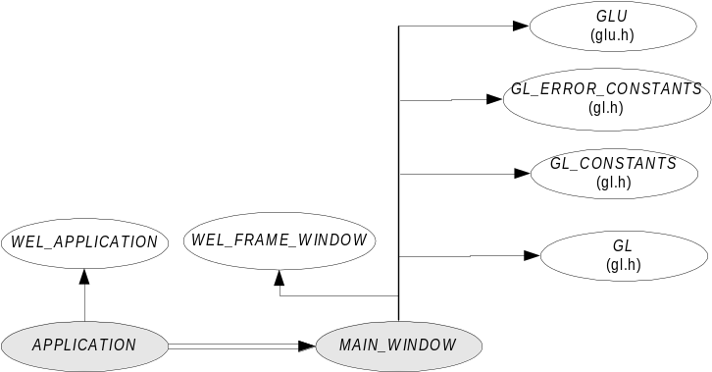To begin with, to implement a simple Win32 application with a single window using WEL, we need at least to implement one APPLICATION class, inheriting from WEL_APPLICATION) and one MAIN_WINDOW, inheriting from WEL_FRAME_WINDOW) class

Class diagram for the WEL/EWGL based example application.

- EGLUT
  - Introduction
GLUT can be described as ”a window system independent toolkit for writing OpenGL programs. It implements a simple windowing application programming interface (API) for OpenGL. GLUT makes it considerably easier to learn about and explore OpenGL programming. GLUT provides a portable API so you can write a single OpenGL program that works both on Win32 PCs and X11 workstations” (From the description of GLUT at www.opengl.org).
GLUT (version3) was originally written by Mark Kilgard, and then ported to the Win32 platform by Nate Robbins.
Information and documentation on GLUT can be obtained from the following places:
  - Dependency description
Currently EGLUT only works with ISE Eiffel. It has also not been tested on any other platform than Windows 95 and Windows NT.
On Windows, you need to have the glut32.dll and glut32.lib library files installed in order to be able to link and run your EGLUT applications.
  - Design
<Description with BON static and dynamic diagrams>
  - Conventions
<Class name and feature prefixes etc.>
  - Detailed specification
All cluster names are given relative to the EiffelOpenGL installation path.
    - System chart: EGLUT
SYSTEM | EGLUT |  |  | Part: 1/1
PURPOSE  All classes and clusters that make up EGLUT, the Eiffel encapsulation of the OpenGL GLUT library. |  |  | INDEXING  author: Paul Cohen  date: 2000-12-22
Class/(Cluster) |  | Description
EGLUT |  | This cluster is empty at the moment since there are no Eiffel compiler independent classes yet!
(SPEC/COMPILER/ISE/EGLUT) |  | Contains the ISE Eiffel compiler dependent wrappings of the OpenGL GLUT library.

    - Cluster chart: SPEC/COMPILER/ISE/EGLUT
CLUSTER | SPEC/COMPILER/ISE/EGLUT |  |  | Part: 1/1
PURPOSE  Contains the ISE Eiffel compiler dependent wrappings of the OpenGL GLUT library. |  |  | INDEXING  author: Paul Cohen  date: 2000-12-22
Class |  | Description
EGLUT |  | Wrapping of GLUT.
EGLUT_WINDOW |  | General notion of a GLUT window. Wraps most of the GLUT window sub-API.
EGLUT_TOP_LEVEL_WINDOW |  | An EGLUT top level window. All EGLUT applications must have one class that inherits from this class and that class must be the `main_window' of the applications EGLUT_APPLICATION class.
EGLUT_SUB_WINDOW |  | An EGLUT sub window.
EGLUT_CONSTANTS |  | Wrapping of GLUT constants.
EGLUT_APPLICATION_CONTEXT |  | The context of an EGLUT application. Keeps a hash table of all EGLUT window objects in the application hashed by GLUT window id.
EGLUT_APPLICATION |  | An EGLUT application. There is only one of this class in any EGLUT application. All applications must have one class that inherits from this class.

    - Auxillary C code
Directory | Contents
eglut/c | eglut.c /* C code for handling the registration of GLUT callback functions and the calling of the Eiffel callback feature. */
eglut/include | eglut.h /* Header file for eglut.c. */
eglut/lib | eglut.lib /* Static C library needed by all EGLUT based applications. */

  - Examples
<TBD>
- EGLAUX
  - Introduction
The GLAUX (OpenGL AUX) library is a windowing platform independent library that implements a basic windowing environment and some higher level graphics functions that are based on the underlying OpenGL API.
The GLAUX library as such is not part of the OpenGL standard API, but is usually bundled together with OpenGL on all platforms. The GLAUX library is meant to facilitate the learning of OpenGL and make it easy to write small demo or exercise programs without getting involved with the nitty gritty details of the windowing platform you're on (MS Windows or X Window).
Information and documentation on GLAUX can be obtained from the following places:
  - Dependency description
<ISE, WEL dependencies, Libraries, dll:s etc>
  - Design
There is a deferred class EGLAUX_WINDOW that contains all the features needed to initialize the GLAUX library and set up the callback functions. The rest of the GLAUX library that is concerned with graphics stuff, is encapsulated in the class EGLAUX. The inheritance hierarchy looks like this:
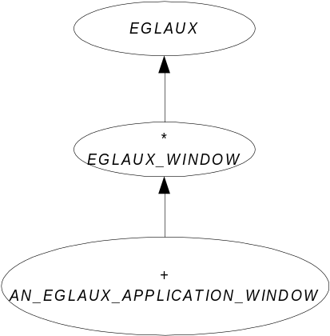
Note that both EGLAUX and EGLAUX_WINDOW are interface classes. The class AN_EGLAUX_APPLICATION_WINDOW is the effective EGLAUX class for a specific EGLAUX application.
The main problem is how to encapsulate the registering of callback functions. For example, the GLAUX API allows the user to register a callback function for key events in the following manner:

C void APIENTRY auxKeyFunc(int, AUXKEYPROC);

where AUXKEYPROC is defined thus:

C typedef void (CALLBACK* AUXKEYPROC)(void);

That means that a user (writing C code) of the API is required to write a unique function for each key event he/she wants their program to respond to, and then to register the functions with the auxKeyFunc function together with the specific key.
Note that no information about the key is passed back to the callback function from the GLAUX API when the callback function is invoked (from the GLAUX API). This specifically means that we cannot register the same callback function for all key events and then just use a switch statement (switching on the key) in the callback function to find out what key was pressed.
Instead we are forced to register a unique callback function for every key event that we are interested in. To be frank and to use americaspeak; this sucks. And no, there is no way to query the GLAUX API which key had the last key event.
The other callback registration functions in GLAUX are, together with the callback function signatures:

C typedef void (CALLBACK* AUXMAINPROC)(void);
void APIENTRY auxMainLoop(AUXMAINPROC);

typedef void (CALLBACK* AUXEXPOSEPROC)(int, int);
void APIENTRY auxExposeFunc(AUXEXPOSEPROC);

typedef void (CALLBACK* AUXRESHAPEPROC)(GLsizei, GLsizei);
void APIENTRY auxReshapeFunc(AUXRESHAPEPROC);

typedef void (CALLBACK* AUXIDLEPROC)(void);
void APIENTRY auxIdleFunc(AUXIDLEPROC);

typedef void (CALLBACK* AUXMOUSEPROC)(AUX_EVENTREC *);
void APIENTRY auxMouseFunc(int, int, AUXMOUSEPROC);

So, since we have to register a unique callback function for every single key event in GLAUX (recognized keys in GLAUX are <Return>, <Esc>, <Space>, <Left>, <Right>, <Up>, <Down>, "A", ..., "Z", "a", ..., "z", "0", "1", ..., "9" – all in all 69 individual key codes), lets consider the following solution:

We will have a c file ”eglaux.c” where we declare the attribute:

C EIF_OBJ eglaux_app = NULL;

that will keep track of my GLAUX_WINDOW Eiffel-object during runtime. In this file we also define a function:

C subscribe_to_events_from_key (int key) {
/* Do a case statement on the parameter key and call
auxKeyFunc(int, AUXKEYPROC) with the parameter key and
the appropriate AUXKEYPROC. The appropriate AUXKEYPROC
being fx. aux_key_proc_A */
}

In the same file ”eglaux.c”, we also have one AUXKEYPROC function for every defined key in the GLAUX API, ie. 69 functions. These functions will look like this:

C aux_key_proc_A(Void) {
EIF_PROC ep;
EIF_TYPE_ID eti;

eti = eif_type_id("EGLAUX_WINDOW");
ep = eif_proc("key_event_callback", eti);
(ep)(eif_access(eglaux_app), AUX_A);
}

AUX_A is the GLAUX defined key code for the key ”A”. In my class GLAUX_WINDOW I will have a feature:

Eiffel frozen key_event_callback (key: INTEGER) is
do
on_key (key)
end

and another:

Eiffel on_key (key: INTEGER) is
-- A key event has been received. See
-- GLAUX_KEY_CONSTANTS for values of 'key´.
do
end

  - Conventions
<Class name and feature prefixes etc.>

  - Detailed specification
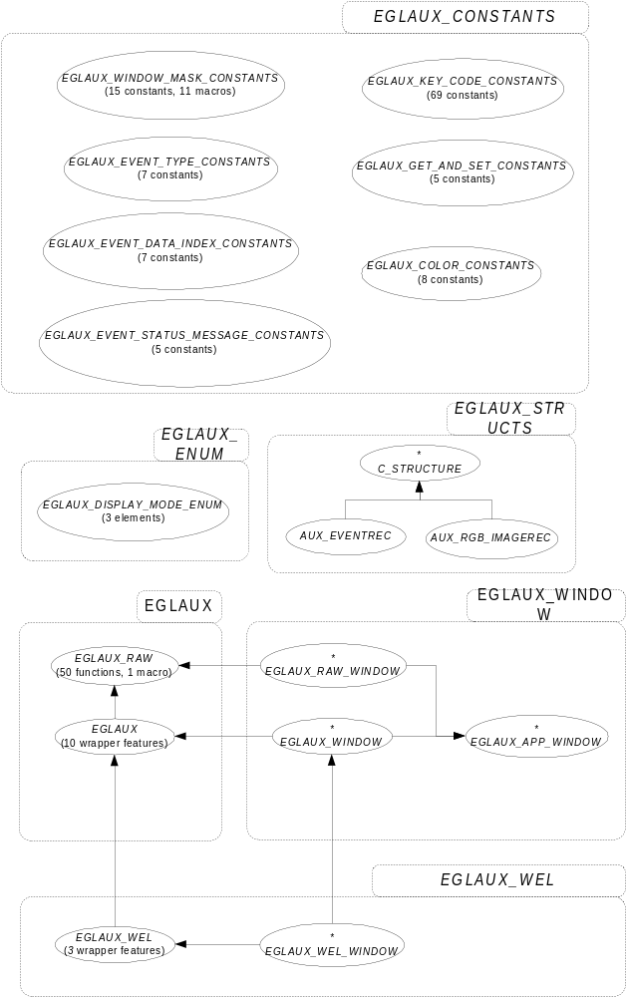Below is a static BON diagram over all clusters and classes in EGLAUX.

On the next page can be found BON system and cluster charts for EGLAUX.

SYSTEM | EGLAUX |  |  | Part: 1/1
PURPOSE  All classes and clusters that make up the EGLAUX Eiffel encapsulation of the GLAUX (OpenGL AUX) library. |  |  | INDEXING  author: Paul Cohen  date: 1999-11-09
Class/(Cluster) |  | Description
(EGLAUX_CONSTANTS) |  | Contains constant classes wrapping all “glaux.h” constant-like macros. All in all 7 classes.
(EGLAUX_ENUMS) |  | Contains an enum class that wraps the single typdef:ed enum in “glaux.h”.
(EGLAUX_STRUCTS) |  | Contains wrapper classes for the two typedef:ed strcuts in “glaux.h”.
(EGLAUX) |  | Contains both a raw wrapper class for all prototyped functions and one function-like macro in “glaux.h”. It also contains a more “Eiffel friendly” wrapper class that takes care of STRING handling and the passing of addresses to and from the C API.
(EGLAUX_PLATFORM) |  | Contains one deferred “platform” class. Contains a wrapper class for the three prototyped Win32 specific functions in “glaux.h”
(EGLAUX_WINDOW) |  | Contains a class implementing a notion of a GL AUX window. This window wraps the underlying callback mechanisms so that an inheriting class has an easy way of specifying which events to listen to and also of providing the actual feature to be executed when an given event occurs.
(EGLAUX_WEL) |  | Contains two classes that integrates EGLAUX with ISE Eiffel’s WEL.
EGLAUX_WINDOW |  | Deferred window class that contains features needed to initialize the AUX library as well as features for setting up the callback functions. It also contains the main feature that is the entry point for all EGLAUX based applications.
EGLAUX |  | Contains all the graphics features of AUX.
EGLAUX_KEY_CONSTANTS |  | Contains all the AUX key constants.
EGLAUX_WINDOW_TYPE_CONSTANTS |  | Contains all the AUX window type constants and the query features for checking the type of window.
EGLAUX_EVENTREC |  | Encapsulation of the _AUX_EVENTREC structure.
EGLAUX_EVENT_ CONSTANTS |  | Contains all the AUX event type, event data indices and event status constants.
EGLAUX_COLOR_CONSTANTS |  | Contains all the AUX color macro constants.
EGLAUX_WIN32 |  | Contains Win32 API specific AUX code.
  - Examples
- Installation
This section describes how to install and set up EiffelOpenGL. It is a good idea to read the ”readme.txt” file, that is located in the top EiffelOpenGL directory after unzipping the EiffelOpenGL archive file, for more up to date information on EiffelOpenGL.
  - On Win32 computers
This section describes how to install EiffelOpenGL on a Win32 computer.
The basic requirements is that you have ISE Eiffel 4.2f (or later version) installed. You must also have WEL installed. This is installed together with ISE 4.2f unless you have explicitly stopped this during the installation of the ISE environment. You must also have OpenGL and GLUT installed. If you are using MS Visual C++ 5.0 or later, OpenGL comes bundled with that installation. If you don’t have OpenGL installed you can always download it from www.opengl.org, where you also can download GLUT.
Unzip the ”eopenglXX.zip” file in some appropriate directory. The Ace files for the EiffelOpenGL test applications assume that the following environment variables are defined:
- $EIFFEL4 points out the ISE Eiffel installation directory. This environment variable is automatically set when you install ISE Eiffel.
- $GL pointsout where OpenGL and GLAUX are installed. The Ace files assume that there exists both an ”include” and ”lib” directory under $GL where the OpenGL include and import library files reside. This environment variable must be set manually. You might even have to create the ”include” and ”lib” directories under $GL and move the include and library files there as well.
- $GLUT points out where GLUT is installed. The Ace files assumes that there exists both an ”include” and ”lib” directory under $GLUT where the GLUT include and import library files reside. This environment variable must be set manually. You might even have to create the ”include” and ”lib” directories under $GLUT and move the include and library files there as well.
  - On X Window computers
<TBD>

Appendix A: References
- [ETL92] Bertrand Meyer, Eiffel The Language, Prentice Hall, 1992, ISBN 0-13-247925-7.
- [BON95] Kim Waldén & Jean-Marc Nerson, Seamless Object-Oriented Software Architecture – Analysis and Design of Reliable Systems, Prentice Hall 1995, ISBN 0-13-031303-3.
- [GLSPEC99] Mark Segal & Kurt Akeley, The OpenGL Graphics System: A specification (Version 1.2.1), April 1 1999. Downloadable from www.opengl.org.
- [GLGUIDE99] Mason Woo, Jackie Neider, Tom Davis & Dave Shreiner, OpenGL Programming Guide, Third Edition, The Official Guide to Learning OpenGL, Version 1.2, Addison Wesley, 1999, ISBN 0-201-60458-2.
- [GLBIBLE95] Richard S. Wright & Michael Sweet, OpenGL Superbible: The Complete Guide to OpenGL Programming for Windows NT and Windows 95, Waite Group Pr, 1996, ISBN 1571690735.
- [FOSNER96] Ron Fosner, OpenGL Programming for Windows 95 and Windows NT, Addison-Wesley Pub Co, 1996, ISBN: 0201407094.
- [GLX98] Paula Womack & Jon Leech, OpenGL Graphics with the X Window System (Version 1.3), October 19 1998. Downloadable from ?
- [GLUT96] Mark J. Kilgard, The OpenGL Utility Toolkit (GLUT) Programming Interface (API Version 3), November 13 1996. Downloadable from ?

Index
Error! No index entries found.

