How to Commit Changes to GitHub:

1. Save the “BlockchainInterface.xlsm” file in the “src” folder. This document contains all the VBA files
2. In the VBA Interface do the following for each file that has changed for the commit
   1. Save File
   2. Right Click on the File in the VBAProject Menu
   3. Export File…

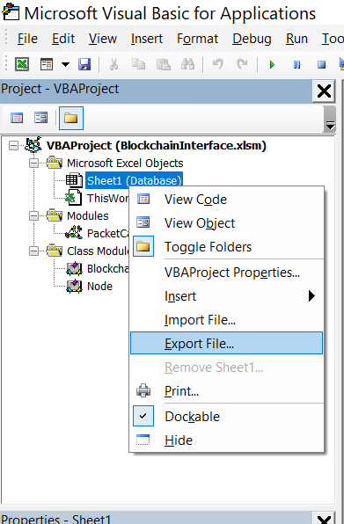

* 1. Save the exported file to its corresponding folder in the repo

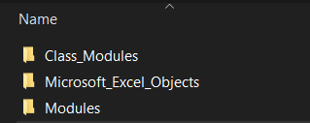

* 1. Now just commit and push to the repo