BDA400
Data Science Tools and Techniques
Assignment 2
Technical Analysis using R -- Preliminary Stage
Prepared by: Onuegbo Nnaemeka Philip
Program: Data Analytics, CDI College (Ontario)
Date: September 16, 2026
GitHub Repository:
https://github.com/pacspagne/TechnicalAnalysis

Section 1: GitHub Account and Repository Setup
- Created a New repository.
- Named the repository exactly: TechnicalAnalysis
- Set visibility to Public and checked 'Add a README file'.
- Clicked Create repository.
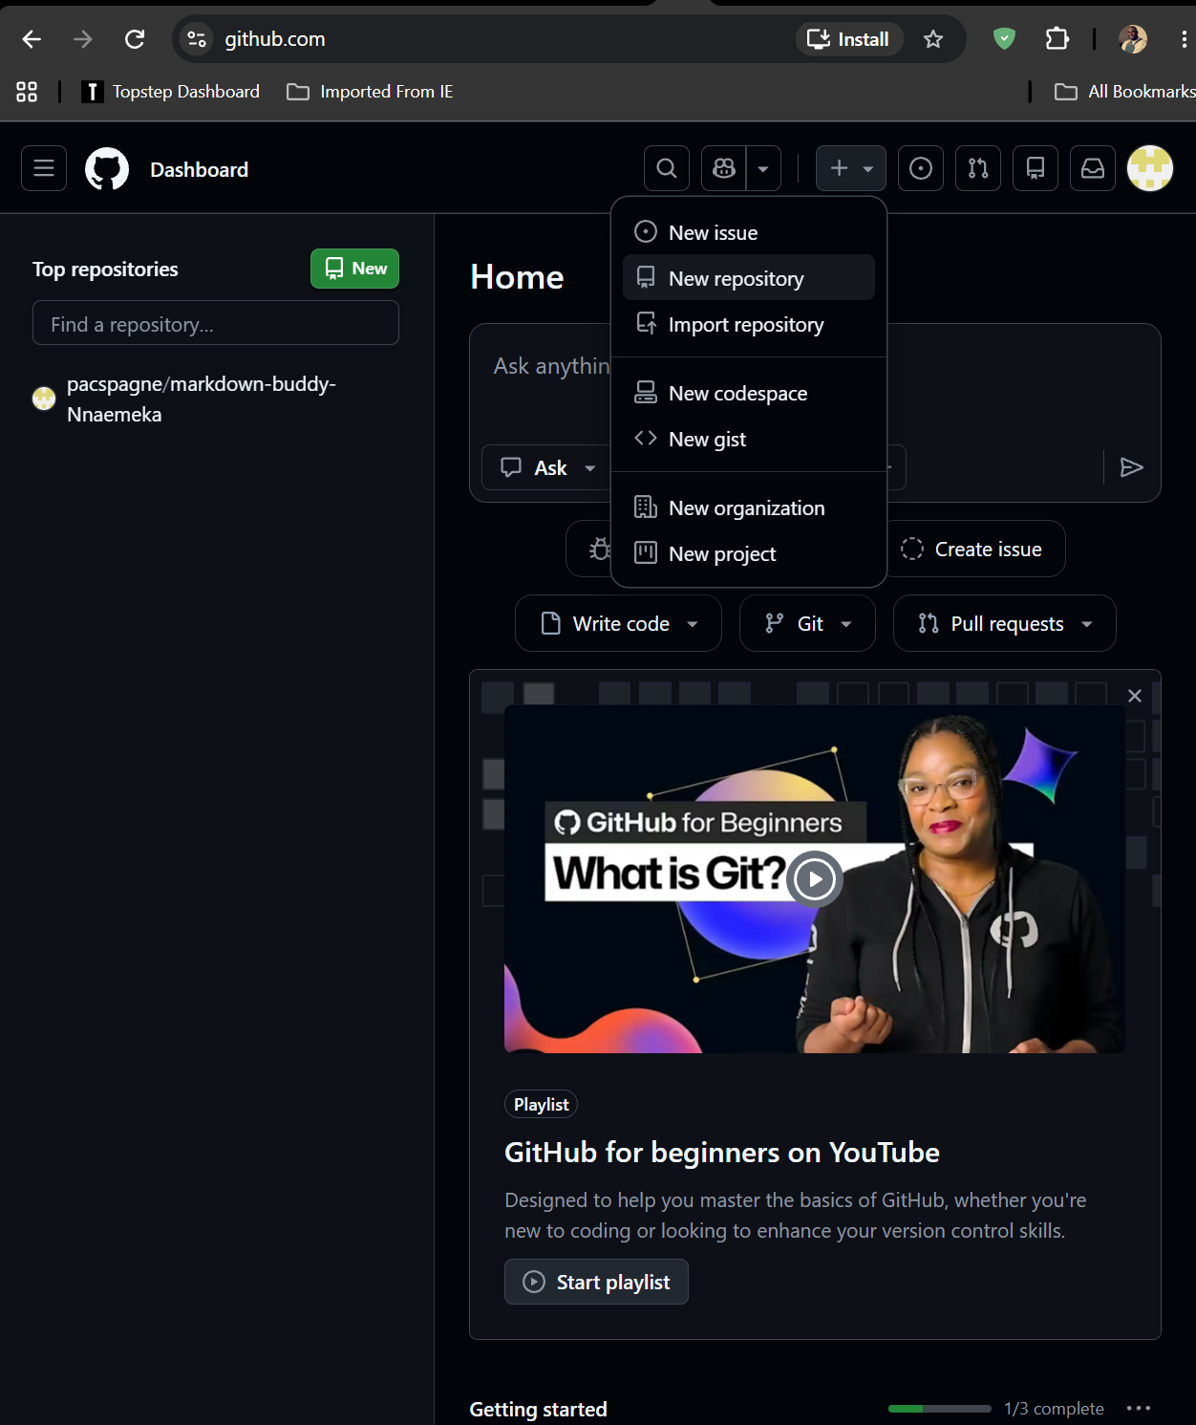
Figure 1 showing the process of creating new repository

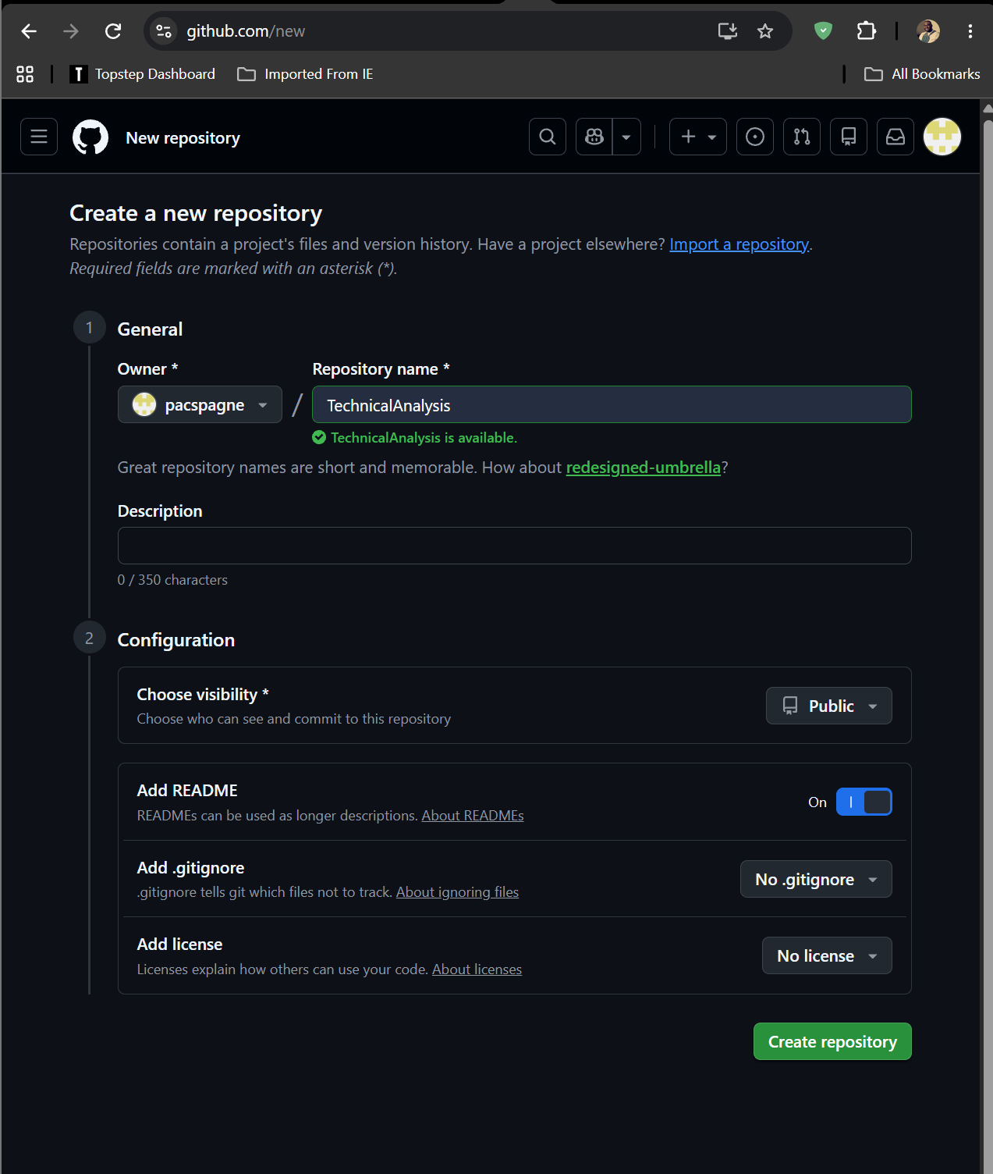
Figure 2 setting up the new repository
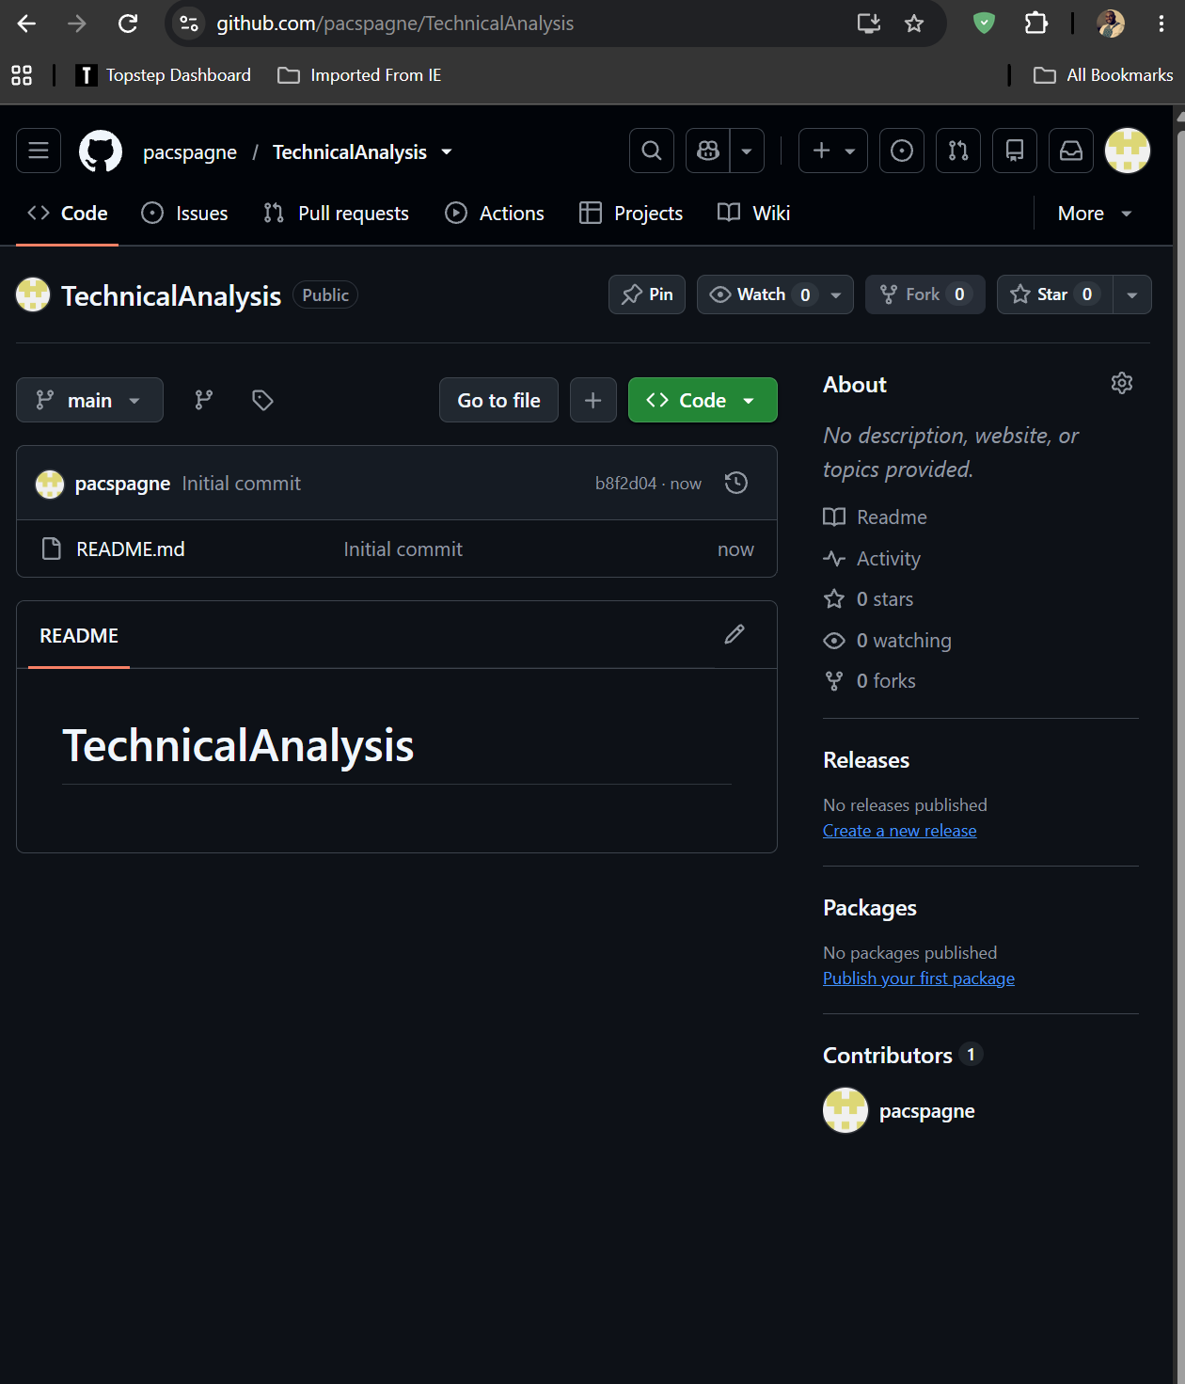
Figure 3 Repository successfully created

Section 2: Installing and Configuring R and RStudio
Steps:
- 1. Go to https://cran.rstudio.com/ and download the R installer for your operating system (Windows/macOS/Linux).
- 2. Run the installer and complete the R installation with default options.
- 3. Go to https://posit.co/download/rstudio-desktop/ and download RStudio Desktop (free version).
- 4. Run the RStudio installer and complete installation.
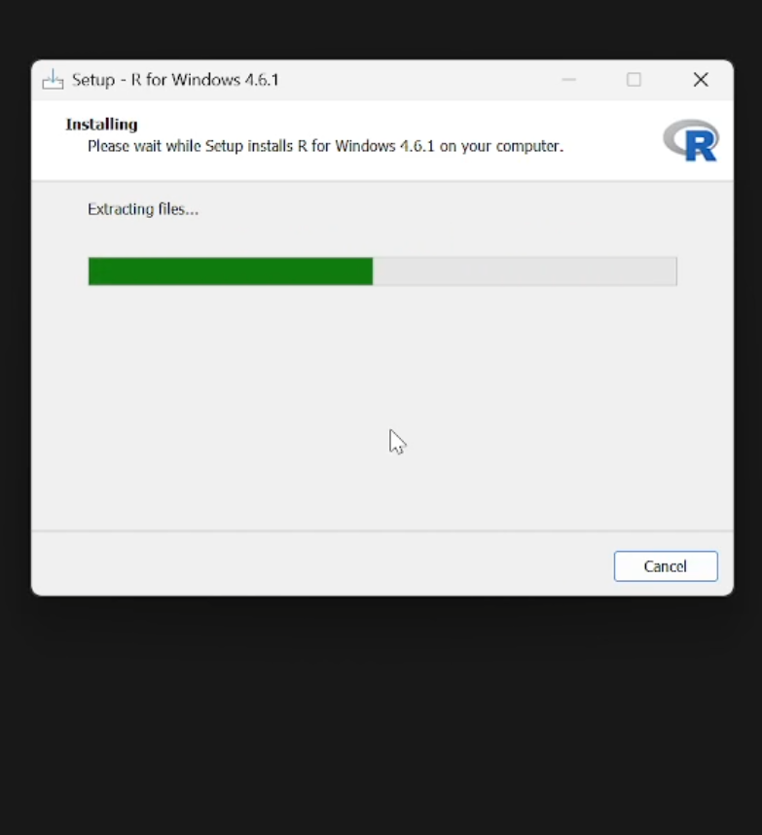
Figure 4 installing R
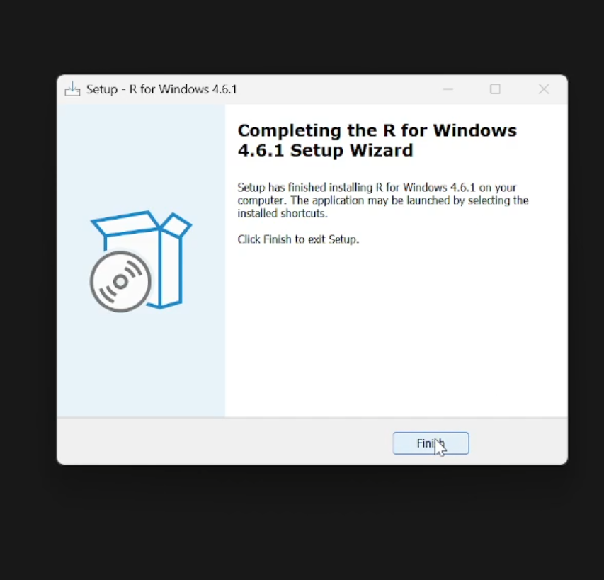
Figure 5 R successfully installed on my computer

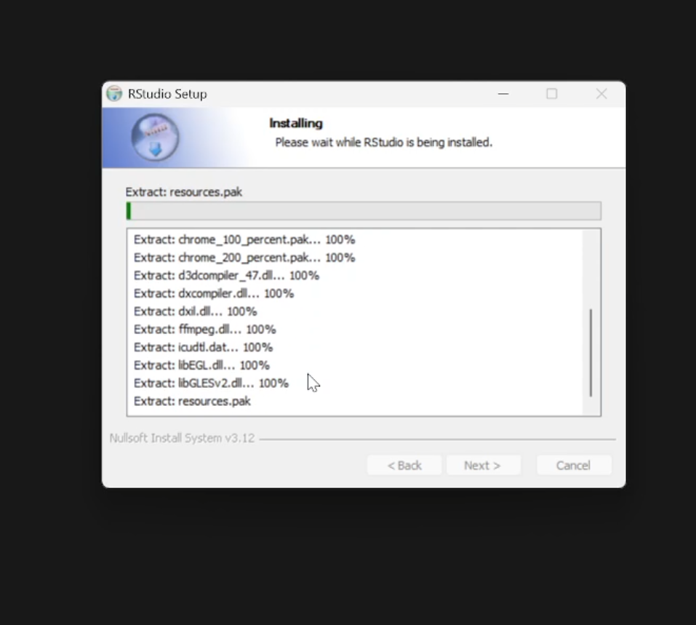
Figure 6 installing R studio
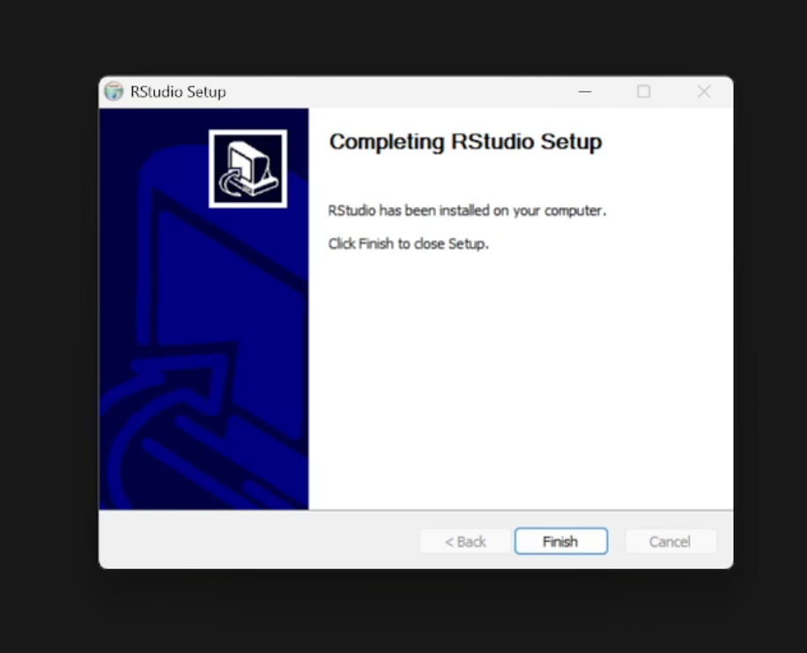
Figure 7 R studio successfully installed

Section 3: Downloading and Installing R Packages
In the RStudio console, run the following command to install the packages needed for technical analysis:
install.packages(c("quantmod", "TTR", "xts", "zoo"))
apt-get install -y r-cran-quantmod r-cran-ttr
Verified package versions actually loaded during development of this assignment:
- quantmod version 0.4.29
- TTR version 0.24.4
On your own PC (following the standard install.packages() command above), confirm your installed versions with packageVersion("quantmod") and packageVersion("TTR") and capture the console output.
Screenshot 7 -- install.packages() running in RStudio console with successful completion message:
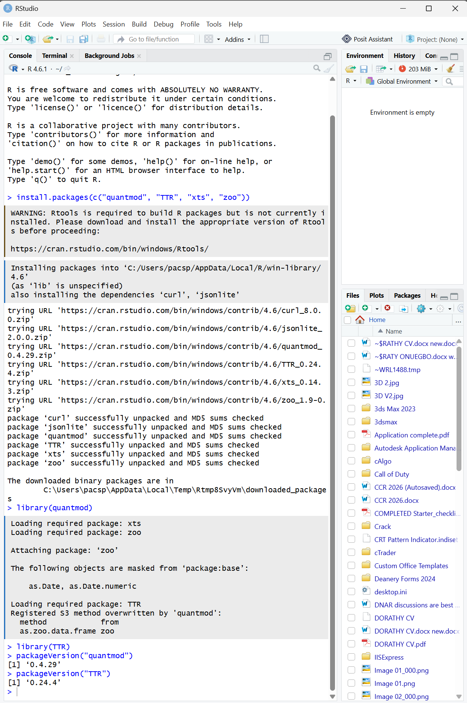
Figure 8 install.packages running in RStudio console with successful completion message and library(quantmod); library(TTR) loading without errors

:

Section 4: Project Configuration and Initialization
The file portfolio.txt lists one stock symbol per line:
AAPL MSFT GOOGL AMZN JPM
Symbols chosen: Apple (AAPL), Microsoft (MSFT), Alphabet/Google (GOOGL), Amazon (AMZN), and JPMorgan Chase (JPM) -- a mix of large-cap technology and financial-sector stocks to give the portfolio some sector diversity for later analysis stages.
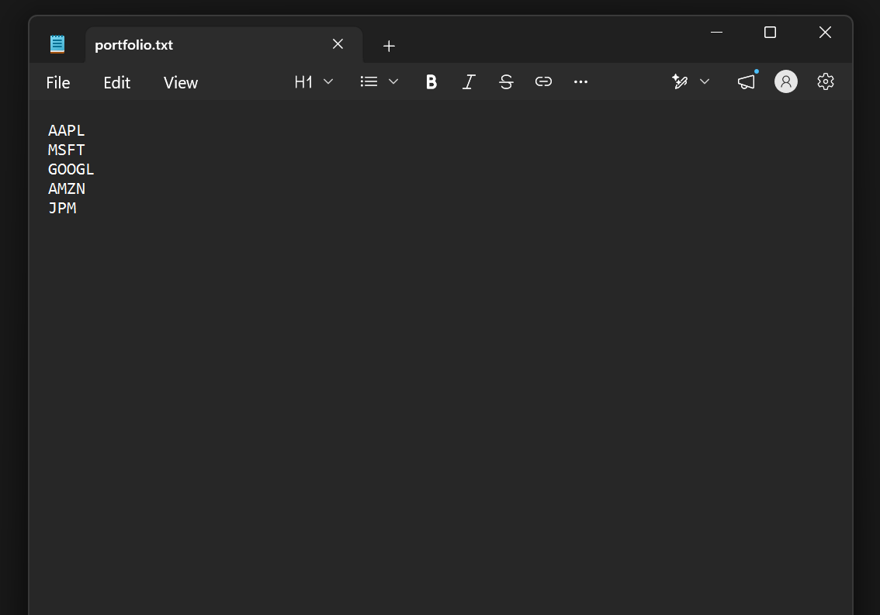
Figure 9 showing portfolio.txt with the selected stocks symbol

Section 5: Function to Import and Load Stock Data
load_stock_data() (in scripts/load_stock_data.R) reads portfolio.txt, then calls quantmod::getSymbols() once per symbol, returning a named list of data frames (one per stock) with columns Date, Open, High, Low, Close, Volume, and Adjusted.
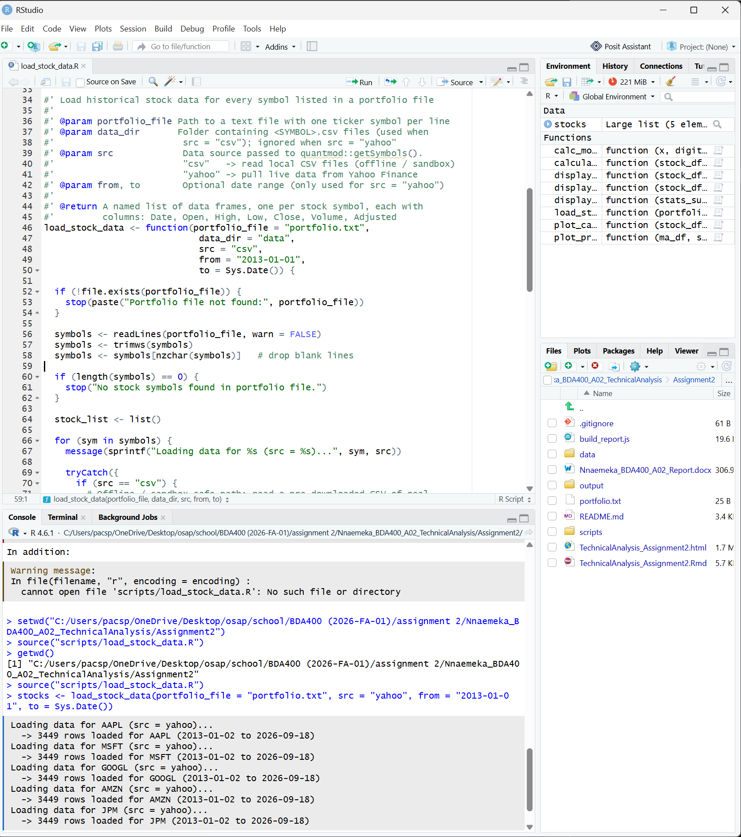
Figure 10 showing Function to Import and Load Stock Data

Section 6: Function to Compute Basic Statistics
calculate_statistics() (in scripts/calculate_statistics.R) takes a stock's data frame and computes the mean, median, mode, standard deviation, min, and max of the closing price, plus 20-day and 50-day simple moving averages (SMA) via the TTR package. R has no built-in statistical mode() function (base R's mode() returns an object's storage type), so a custom calc_mode() helper was written that rounds prices to the nearest dollar and returns the most frequently occurring rounded value.
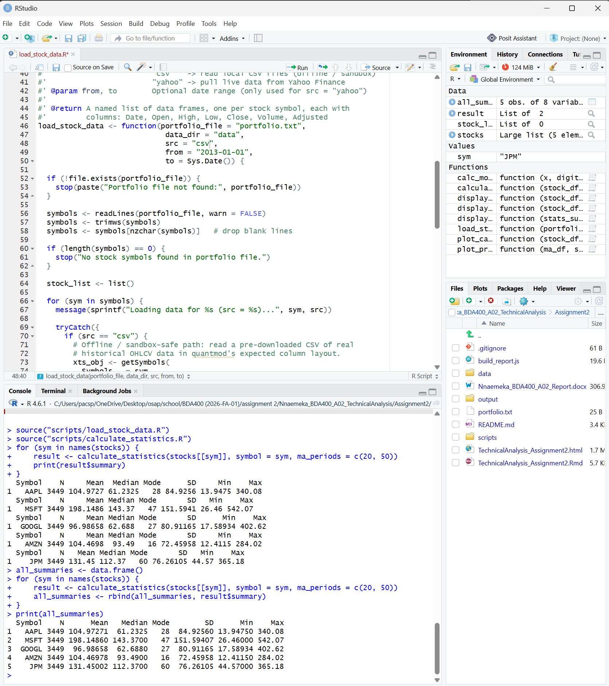
Figure 11 showing Function to Compute Basic Statistics
Independent verification: for every symbol, the mean and standard deviation produced by R's built-in mean() and sd() functions were cross-checked against a manually-coded recomputation using the raw formulas (sum(x)/n for the mean; the textbook sample-variance formula for standard deviation). All 10 checks (5 symbols x 2 statistics) matched to floating-point precision:

Section 7: Displaying Output
Researching how stock data is commonly presented (Yahoo Finance's stock pages, and standard technical-analysis dashboards) informed three complementary display styles implemented in scripts/display_output.R:
- A 'latest quote' snapshot -- current close, dollar/percent change, day's range, and volume (mirrors the header box on a Yahoo Finance stock page).
- A tabular price history -- the most recent N trading days in a clean table (Date, Open, High, Low, Close, Volume).
- A portfolio-wide statistics table -- mean/median/mode/SD/min/max for every tracked stock side by side.
- Two chart types: a line chart of closing price with overlaid moving averages, and a full OHLC candlestick chart with volume (via quantmod's chartSeries()).
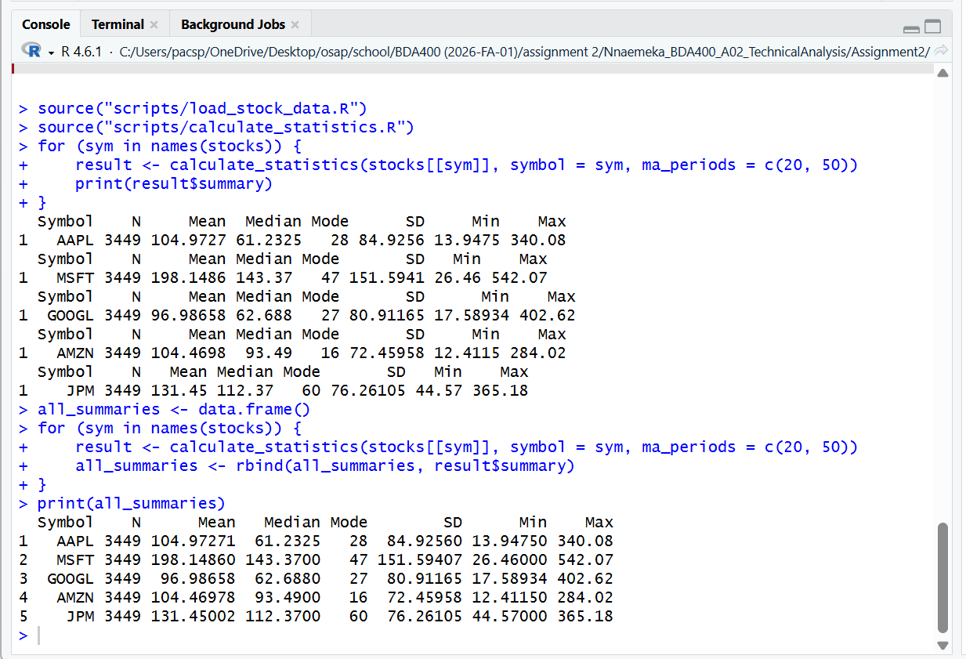
Figure 12 showing 'latest quote' output

Section 8: Visualizations
AAPL -- Closing price with 20-day and 50-day simple moving averages:
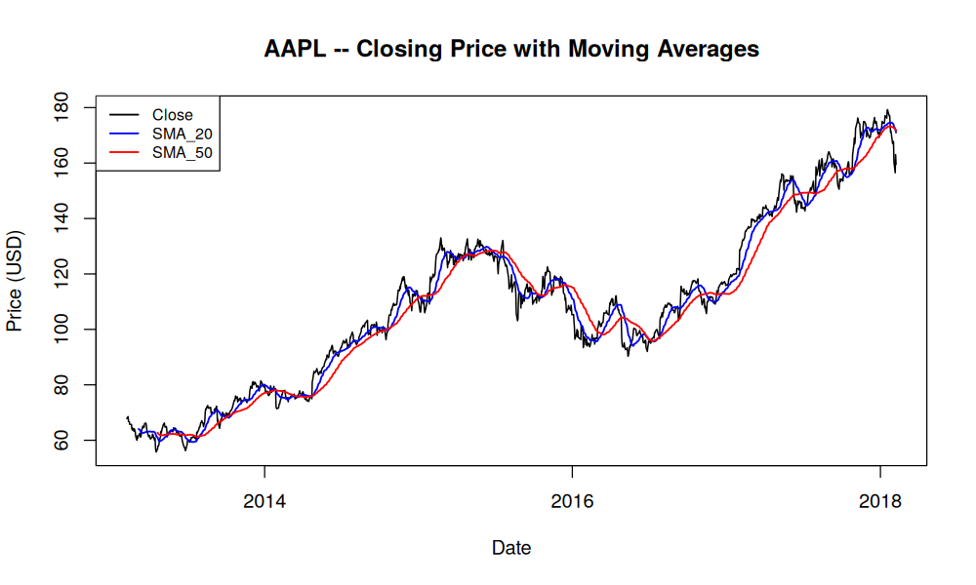
Figure 1: AAPL closing price with SMA-20 (blue) and SMA-50 (red)
AAPL -- OHLC candlestick chart with volume (last 180 trading days):
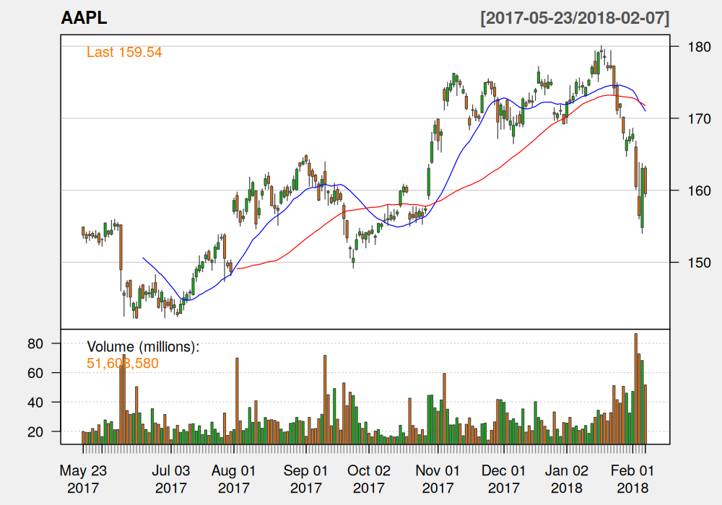
Figure 2: AAPL candlestick chart with moving averages and volume
MSFT -- Closing price with moving averages:
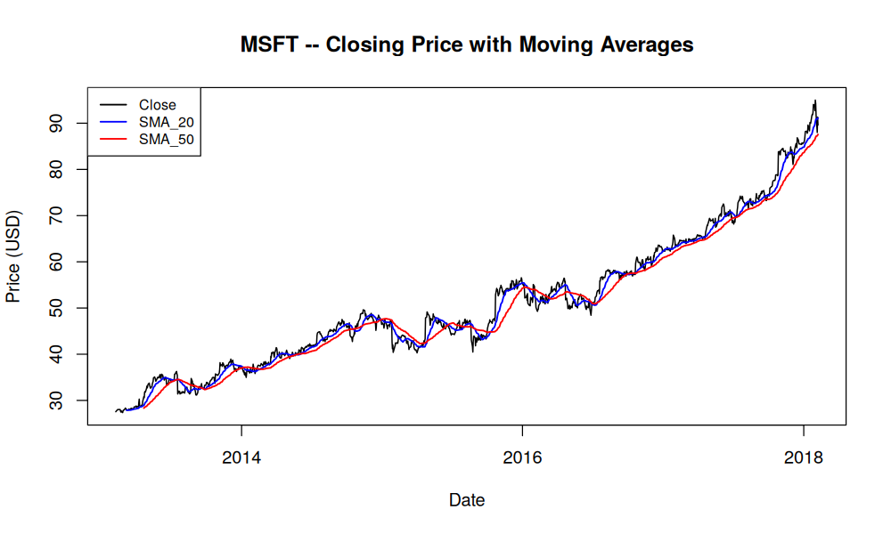
Figure 3: MSFT closing price with SMA-20 and SMA-50
JPM -- Closing price with moving averages:
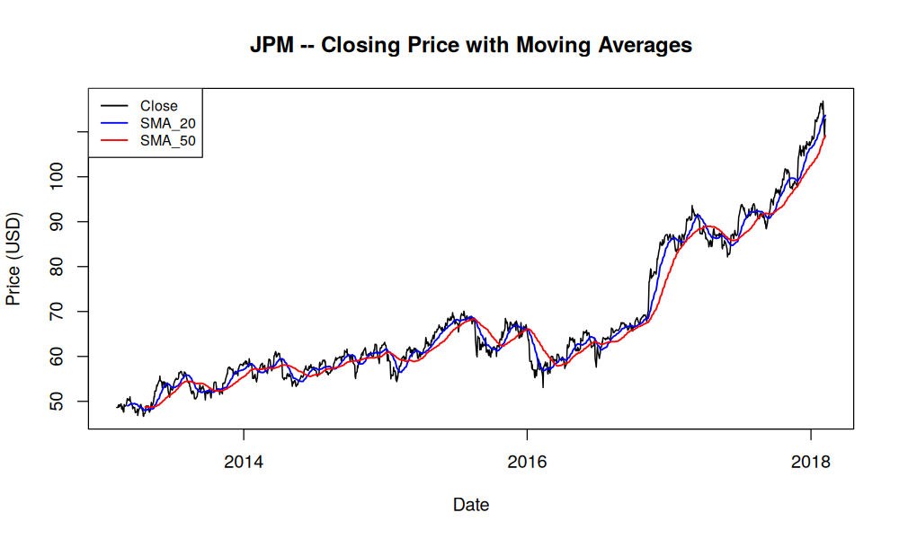
Figure 4: JPM closing price with SMA-20 and SMA-50
Equivalent charts for GOOGL and AMZN are included in the output/ folder of the GitHub repository.

Section 9: Repository Structure
The GitHub repository is organized as follows, per the assignment's instruction to create one subdirectory per assignment:
TechnicalAnalysis/ Assignment2/ portfolio.txt data/ AAPL.csv, MSFT.csv, GOOGL.csv, AMZN.csv, JPM.csv scripts/ load_stock_data.R calculate_statistics.R display_output.R output/ statistics_summary.csv <SYMBOL>_price_ma.png (x5) <SYMBOL>_candlestick.png (x5) TechnicalAnalysis_Assignment2.Rmd TechnicalAnalysis_Assignment2.html (knitted report) Nnaemeka_BDA400_A02_Report.docx (this document)

Section 10: Reflection and Next Steps
This preliminary stage established a working, verified pipeline: import raw price data for a defined portfolio, compute the required descriptive statistics with an independent cross-check, and display the results in multiple formats. The two follow-on stages of this three-part project will likely build on these functions to add further technical indicators (e.g. RSI, Bollinger Bands, MACD) and a more complete trading-signal or portfolio-comparison layer -- the modular structure here (separate load/compute/display scripts, each independently runnable) was chosen specifically so later stages can extend it without rewriting the current functions.

Appendix: GitHub Repository Link
Repository name: TechnicalAnalysis
Repository URL: https://github.com/pacspagne/TechnicalAnalysis

