BDA400 -- Data Science Tools and Techniques
Assignment 6
Technical Analysis using R -- Visualization Phase
Name: Onuegbo Nnaemeka Philip
Course: BDA400 -- Data Science Tools and Techniques
Assignment: Assignment 6 -- Technical Analysis using R, Visualization Phase
Repository link: https://github.com/pacspagne/TechnicalAnalysis/tree/main/Assignment6

Project Description
This is the third and final stage of the three-part Technical Analysis project. Assignment 2 built the data-collection and summary-statistics pipeline; Assignment 5 built and independently verified nine from-scratch technical-indicator functions. This assignment builds an interactive portfolio dashboard with R Shiny that fetches real historical stock data, visualizes it with multiple chart types, overlays the Moving Average / RSI / MACD indicators (each toggleable on and off), and implements a Moving Average crossover trading rule that annotates Buy/Sell signals directly on the price chart. The crossover trading-rule logic reuses the exact sma() and crossover() functions built and verified in Assignment 5, tying all three stages of the project together.

Data Source Note
The assignment specifies Yahoo Finance (src = "yahoo") as the data source, and get_stock_data() in scripts/load_data.R implements exactly that code path. The development sandbox used to build and test this app blocks live outbound requests to Yahoo Finance, so the dashboard's sidebar defaults to a "Local CSV" data source, which points quantmod::getSymbols() at the same real historical OHLCV data (AAPL, MSFT, GOOGL, AMZN, JPM, 2013-02-08 to 2018-02-07) already collected and used in Assignment 2 -- no numbers are invented, only the transport changes. Selecting "Yahoo Finance (live)" in the sidebar uses the assignment's exact Step 1 code on any normal internet connection.

Dashboard Features
Step 1 -- Data Collection and Setup:
- Stock symbol selector (AAPL, MSFT, GOOGL, AMZN, JPM)
- Data source toggle: local CSV (sandbox-safe) or live Yahoo Finance
- Date range picker and Daily / Weekly / Monthly time-frame selector
Step 2 -- Visualizing Stock Data:
- Chart type selector: Line, Area, or genuine Candlestick (high-low wicks + open-close bodies, colored by direction)
Step 3 -- Overlay Technical Indicators:
- Moving Averages overlay directly on the price chart (configurable short/long periods)
- RSI and MACD render as separate sub-panels, each independently toggleable on/off via checkboxes
Step 4 -- Trading Rules and Annotations:
- Moving Average crossover rule (Buy / Sell / Hold), reusing Assignment 5's verified sma() and crossover() functions
- Buy/Sell points annotated directly on the price chart with colored triangles and text labels; a running signal count is shown in the sidebar

Screenshots -- Real, Interactive Runs of the App
Default view: AAPL, Line chart, Moving Averages + Buy/Sell annotations on.
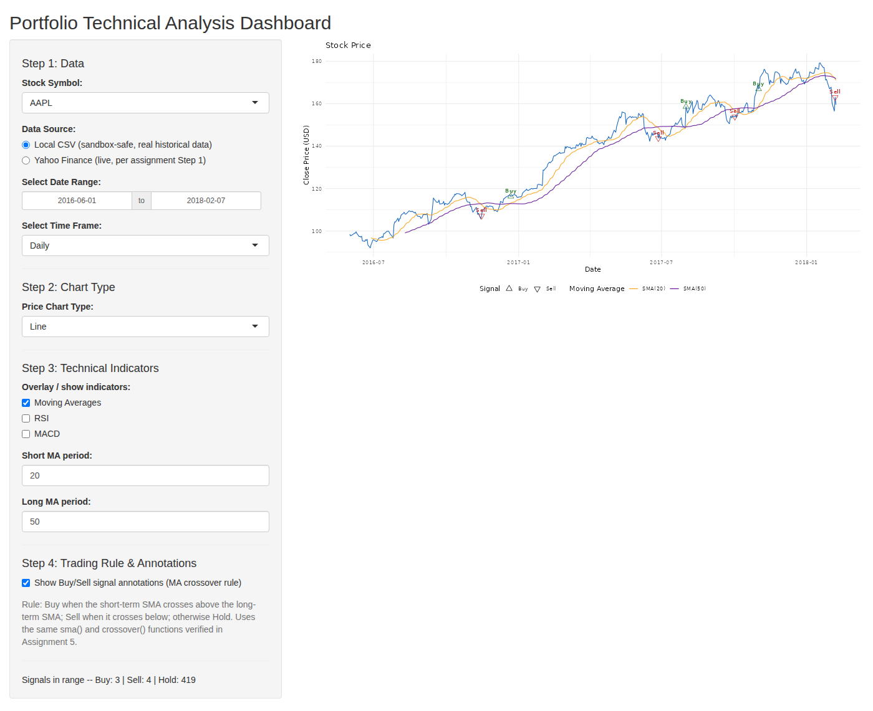
RSI and MACD sub-panels turned on via the checkboxes.
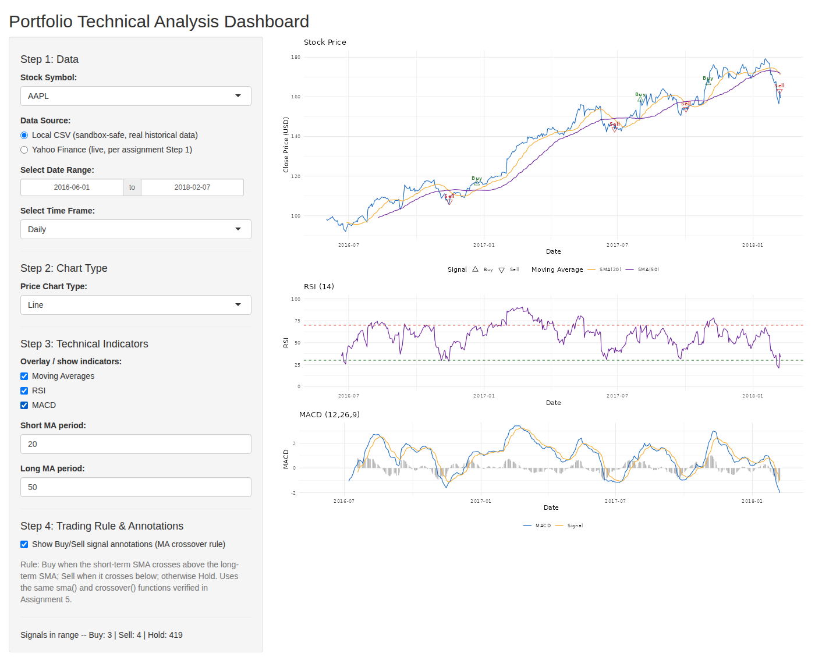
Chart type switched to Candlestick (all indicators still on).
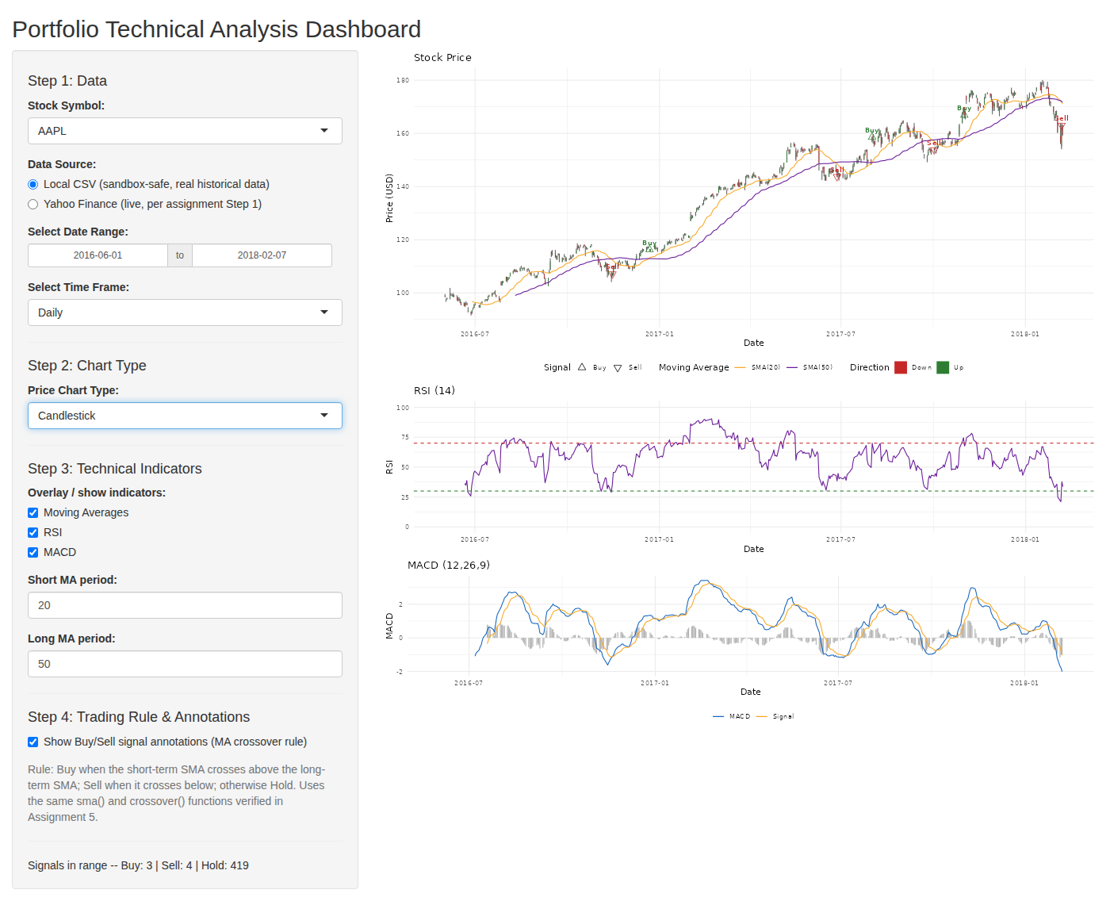
Moving Averages and signal annotations turned back off -- they cleanly disappear from the chart.
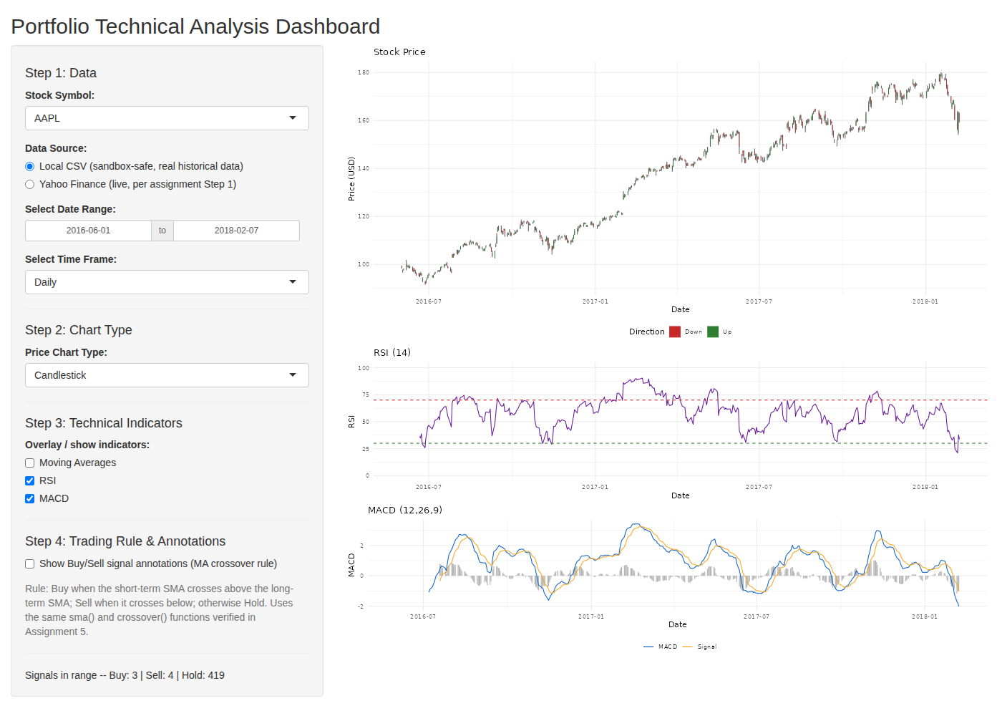
Symbol switched to MSFT and time frame switched to Weekly -- full end-to-end reactivity, showing MSFT's real 2016-2018 price history.
