IEEE
Electronic Copyright

INCLUDEPICTURE "http://a957.g.akamai.net/f/957/3680/1h/www.ieee.org/portal/cms_docs/about/documentation/copyright/MBblack.gif" \* MERGEFORMATINET INCLUDEPICTURE "http://a957.g.akamai.net/f/957/3680/1h/www.ieee.org/portal/cms_docs/about/documentation/copyright/MBblack.gif" \* MERGEFORMATINET INCLUDEPICTURE "http://a957.g.akamai.net/f/957/3680/1h/www.ieee.org/portal/cms_docs/about/documentation/copyright/MBblack.gif" \* MERGEFORMATINET INCLUDEPICTURE "http://a957.g.akamai.net/f/957/3680/1h/www.ieee.org/portal/cms_docs/about/documentation/copyright/MBblack.gif" \* MERGEFORMATINET INCLUDEPICTURE "http://a957.g.akamai.net/f/957/3680/1h/www.ieee.org/portal/cms_docs/about/documentation/copyright/MBblack.gif" \* MERGEFORMATINET INCLUDEPICTURE "http://a957.g.akamai.net/f/957/3680/1h/www.ieee.org/portal/cms_docs/about/documentation/copyright/MBblack.gif" \* MERGEFORMATINET INCLUDEPICTURE "http://a957.g.akamai.net/f/957/3680/1h/www.ieee.org/portal/cms_docs/about/documentation/copyright/MBblack.gif" \* MERGEFORMATINET INCLUDEPICTURE "http://a957.g.akamai.net/f/957/3680/1h/www.ieee.org/portal/cms_docs/about/documentation/copyright/MBblack.gif" \* MERGEFORMATINET INCLUDEPICTURE "http://a957.g.akamai.net/f/957/3680/1h/www.ieee.org/portal/cms_docs/about/documentation/copyright/MBblack.gif" \* MERGEFORMATINET INCLUDEPICTURE "http://a957.g.akamai.net/f/957/3680/1h/www.ieee.org/portal/cms_docs/about/documentation/copyright/MBblack.gif" \* MERGEFORMATINET INCLUDEPICTURE "http://a957.g.akamai.net/f/957/3680/1h/www.ieee.org/portal/cms_docs/about/documentation/copyright/MBblack.gif" \* MERGEFORMATINET INCLUDEPICTURE "http://a957.g.akamai.net/f/957/3680/1h/www.ieee.org/portal/cms_docs/about/documentation/copyright/MBblack.gif" \* MERGEFORMATINET INCLUDEPICTURE "http://a957.g.akamai.net/f/957/3680/1h/www.ieee.org/portal/cms_docs/about/documentation/copyright/MBblack.gif" \* MERGEFORMATINET INCLUDEPICTURE "http://a957.g.akamai.net/f/957/3680/1h/www.ieee.org/portal/cms_docs/about/documentation/copyright/MBblack.gif" \* MERGEFORMATINET 

IEEE
445 Hoes Lane
Piscataway, NJ 08854, USA

Change History:
Ver | Date | Changed By: | Comments
2.0 | May 2019 | IEEE | eCF API for Publications
2.1 | August 2022 | Kabir Jakkamsetti | Added client_id and client_secret for QA environment

Contents
Conferences 1
1: Get list of articles for a conference record number 1
Index 1
Sample parameters 1
Response: 1
Error Response: 1
2 : Get Copyright article count for conference record number 1
Index 1
Sample Parameters 1
Response: 1
Error Response: 1
3 : Get Copyright Status of an article 1
Index 1
Sample Parameter: 1
Response: 1
Error Response: 1

Conferences

IEEE eCopyright offers an API ( Application Programming interface ) that allows your systems and applications to connect to eCopyright database to consume below services
- Get list of articles/manuscripts submitted for copyright ( completed and Pending ) for a given Conference Record Number
- Get count of articles/manuscript submitted for copyright ( completed and Pending ) for a given Conference Record Number
- Get copyright status of articles/manuscript for a given ecfid/paper id and Conference Record Number
These api’s will work only for conferences that use
- Conference record number as the artsource while connecting to eCopyright System for Copyright Transfer
- Conferences registered after Aug 2018 for Copyright Submission
Oauth 2.0 is used as Authorization framework
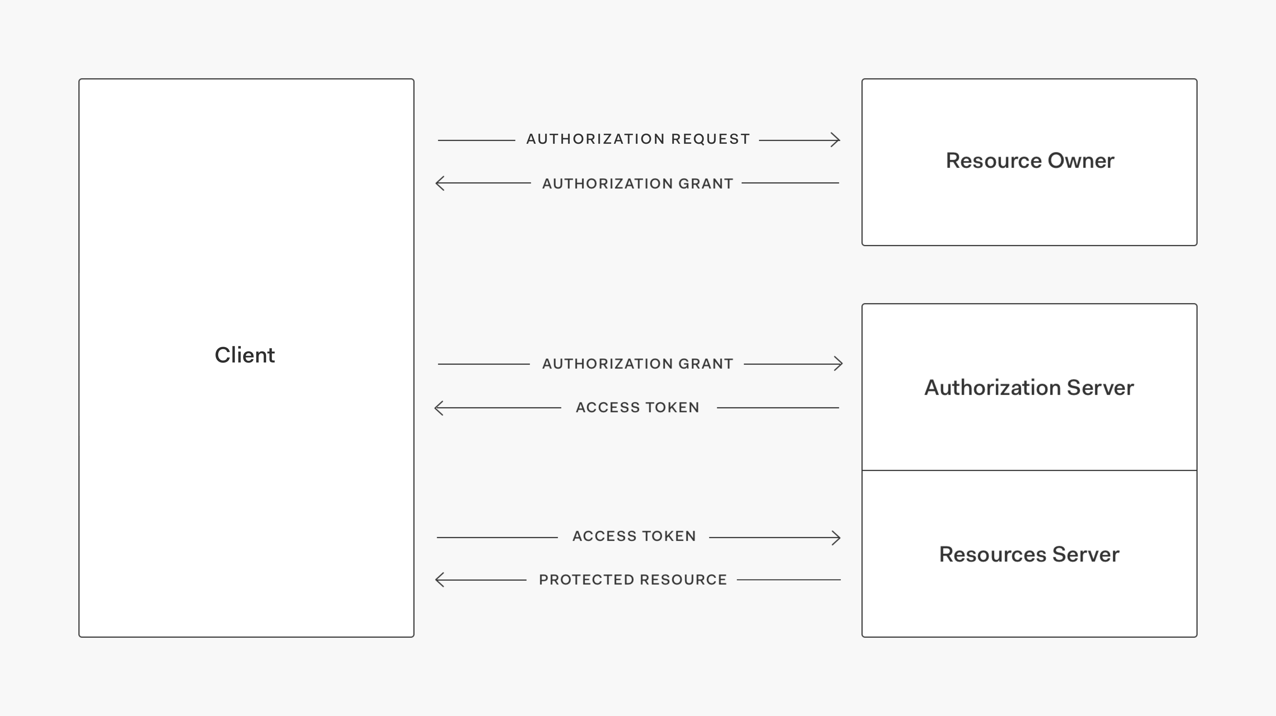

Get Access Token ( POST REQUEST)
- Test Url : https://services11.ieee.org/pubsapi/api/oauth/token
- Production Url : https://services13.ieee.org/pubsapi/api/oauth/token
- ("grant_type", "client_credentials")
- ("client_id", "To be provided by IEEE")
- ("client_secret", "To be provided by IEEE")
- ("scope", "ecfarticle,ecfarticles,ecfarticlecount,ecfpublications")

Use the appropriate client_id and client_secret from the table below based on the scope
App | client_id | client_secret | scope
eCF Conference Registration | 716eda48-23e0-4b3a-b3a9-6644610d088c | b889750b-8305-4c8a-9f26-892cf9fe4e20 | ecfregistration,ecfmetadata,ecfrequired,ecfarticle, ecfarticles,ecfarticlecount
eCF Copyright External | 1ddd065d-b671-4ae5-a1d6-b4c511f59cf2 | 27a07fe4-3b6c-4c05-9f78-8ae4031649ad | ecfarticle, ecfarticles,ecfarticlecount,ecfpublications
ecf Copyright Status WMS | 3ea7fbbf-82d8-40fe-9384-7791d782859f | d6b963d4-1710-4da0-a2eb-ce581584e398 | wmsarticle

Invoke API using Access Token
- Test Url : https://services11.ieee.org/ *
- Production Url : https://services13.ieee.org/*
- Header ("Authorization" , "Bearer " + Accesstoken);
- Content_Type : application/json

1: Get list of articles for a conference record number

REQUEST TYPE | GET
URL | https://services11.ieee.org/pubsapi/ecfarticles?source=39505&pubtype=c
Request Parameter | pubtype=C, source=string
DESCRIPTION | Get list of copyright articles for a given conference record number
Oauth Scope | ecfarticle,ecfarticles,ecfarticlecount,ecfpublications
Curl Command | curl -H 'Authorization: Bearer TokenValue' 'Accept: application/json' 'https://services11.ieee.org/pubsapi/ecfarticles?pubtype=c&source=39505'

Index
articlecount | Number of articles submitted for a conference
ecfId | Paper Id in eCF System
signature | Copyright Signature
date | Date copyright was signed
title | Paper Title
email | Comma separated Author emails
Authors | Comma separated Author Names
quoteId | Quote Id created ( For Open access papers Only)
paymentStatus | Payment Status of the Quote ( For Open access papers Only)
copyrightType | Type of Copyright Signed (IEEE,USG,CRWN,EU,CCBY) , PENDING
contactName | Delegated Signing Authority Contact Name
contactEmail | Delegated Signing Authority Contact Email
publicationtitle | Conference/Publication Title
articlecount | Number of articles

Sample parameters
- source=39505 pubtype=C

Response:
{
"statusCode": 200,
"status": "Success",
"publicationtitle": "2016 5th International Conference on Electronic Devices, Systems and Applications (ICEDSA)",
"articlecount": 2,
"articleList": [
{
"ecfId": "0611136",
"authors": "Said Test",
"signature": "Said test",
"copyrightType": "IEEE",
"title": "Improving What Matters the Most to e-Service Consumers Using the TDMVM Analysis",
"email": "said.test@ieee.org ",
"quoteId": "",
"paymentStatus": "",
"contactName": "",
"contactEmail": "",
"date": "28-11-2016"
},
{
"ecfId": "0711157",
"authors": "Sihab test, John Doe",
"signature": "test test",
"copyrightType": "IEEE",
"title": "Integrating Internet of Things with Maintenance Spare Parts’ Supply Chain.",
"email": "sihab.test@ieee.org",
"quoteId": "",
"paymentStatus": "",
"contactName": "",
"contactEmail": "",
"date": "03-12-2016"
}
]
}

Error Response:
No Article
{
"statusCode": 200,
"status": "Success",
"errorMessage": "No copyright has been submitted for Conference with recordnumber: 395057",
"publicationtitle": "",
"articlecount": 0,
"articleList": []
}
Parameter pubtype cannot be empty
{
"statusCode": 400,
"status": "Failure",
"errorMessage": "pubtype parameter cannot be empty"
}
Parameter pubtype can be only C or P

{
"statusCode": 400,
"status": "Failure",
"errorMessage": "pubtype paramter value can be only C or P"
}

2 : Get Copyright article count for conference record number
REQUEST TYPE | GET
URL | https://services11.ieee.org/pubsapi/ecfarticlecount?source=39505&pubtype=C
Request Parameter | pubtype=C, source=string
DESCRIPTION | Get count of copyright articles for a given conference record number
Oauth Scope | ecfarticle,ecfarticles,ecfarticlecount,ecfpublications
Curl Command | curl -H 'Authorization: Bearer TokenValue' 'Accept: application/json' 'https://services11.ieee.org/pubsapi/ecfarticlecount?pubtype=c&source=39505'

Index
count | Number of articles
publicationtitle | Conference Publication Title

Sample Parameters
Pubtype=C , source=39505

Response:
{
"statusCode": 200,
"status": "Success",
"articlecount": {
"count": 13,
"publicationtitle": "2016 5th International Conference on Electronic Devices, Systems and Applications (ICEDSA)"
}
}

Error Response:
pubtype parameter is missing
{
"statusCode": 400,
"status": "Failure",
"errorMessage": "pubtype parameter cannot be empty"
}

Parameter pubtype can be only C or J

{
"statusCode": 400,
"status": "Failure",
"errorMessage": "pubtype paramter value can be only C or P"
}

0 articles found for a conference
{
"statusCode": 200,
"status": "Success",
"articlecount": {
"count": 0,
"publicationtitle": "2018 International Test Conference"
}
}

3 : Get Copyright Status of an article
REQUEST TYPE | GET
URL | https://services11.ieee.org/pubsapi/ecfarticle?source=39505&ecfid=23234889
Request Parameter | ecfid=string , source=string (conference record number)
DESCRIPTION | Get Copyright Status of an article for a given conference record number
Oauth Scope | ecfarticle,ecfarticles,ecfarticlecount,ecfpublications
Curl Command | curl -H 'Authorization: Bearer TokenValue' 'Accept: application/json' 'https://services11.ieee.org/pubsapi/ecfarticle?source=39505&ecfid=23234889'

Index
articlecount | Number of articles submitted for a conference
ecfId | Paper Id in eCF System
signature | Copyright Signature
date | Date copyright was signed
title | Paper Title
email | Comma separated Author emails
Authors | Comma separated Author Names
quoteId | Quote Id created ( For Open access papers Only)
paymentStatus | Payment Status of the Quote ( For Open access papers Only)
copyrightType | Type of Copyright Signed (IEEE,USG,CRWN,EU,CCBY) , PENDING
contactName | Delegated Signing Authority Contact Name
contactEmail | Delegated Signing Authority Contact Email

Sample Parameter:
ecfid=0611136 , source=39505

Response:
{
"statusCode": 200,
"status": "Success",
"article": {
"ecfId": "0611136",
"authors": "Said test",
"signature": "Said test ",
"copyrightType": "IEEE",
"title": "Improving What Matters the Most to e-Service Consumers Using the TDMVM Analysis",
"email": "said. test@ieee.org",
"quoteId": "",
"paymentStatus": "",
"contactName": "",
"contactEmail": "",
"date": "28-11-2016"
}
}
Error Response:
Article not found
{
"statusCode": 400,
"status": "Failure",
"errorMessage": "Article with ecfid 0611136 and Source 41524 not found"
}

