How to use JMR Migration
A plain-English guide for managers to learn the site, then teach their department.
The pictures in this guide use sample names, such as Maria Santos and Pedro Garcia. Your live site shows your real staff. The buttons and menus are the same.
How to use this guide
Read parts 1 to 6 with your whole department. Those are the everyday pages. Then use the later parts only with the people who need them.
• Members use Records, Projects, Employees, and Years.
• Leaders use those same pages, but only for their own group, plus Control.
• Managers see every group, and use Control to set roles.
• The developer is the only person who can upload files.
A short class is enough. Open the site, search for one project, open one employee, and show Years. That covers a normal work day. Stay after class if you need to show Control.
1. Open the website
You do not need a special program. Use Microsoft Edge.
1. Open Edge.
2. Click the website link your office gave you, or type it into the address bar.
3. The site should open on All records. The blue bar on the left is the menu.
Office website link: ______________________________________________
Ask your manager for this address. Paste or write it on this line before you print the guide.
Most people arrive already signed in, because the office link recognizes their work account. If the Sign in page appears, use the email and password the office gave you, then click Sign in. Tick Keep me signed in if this is your own computer. If you do not have a password, do not guess. Ask the office.
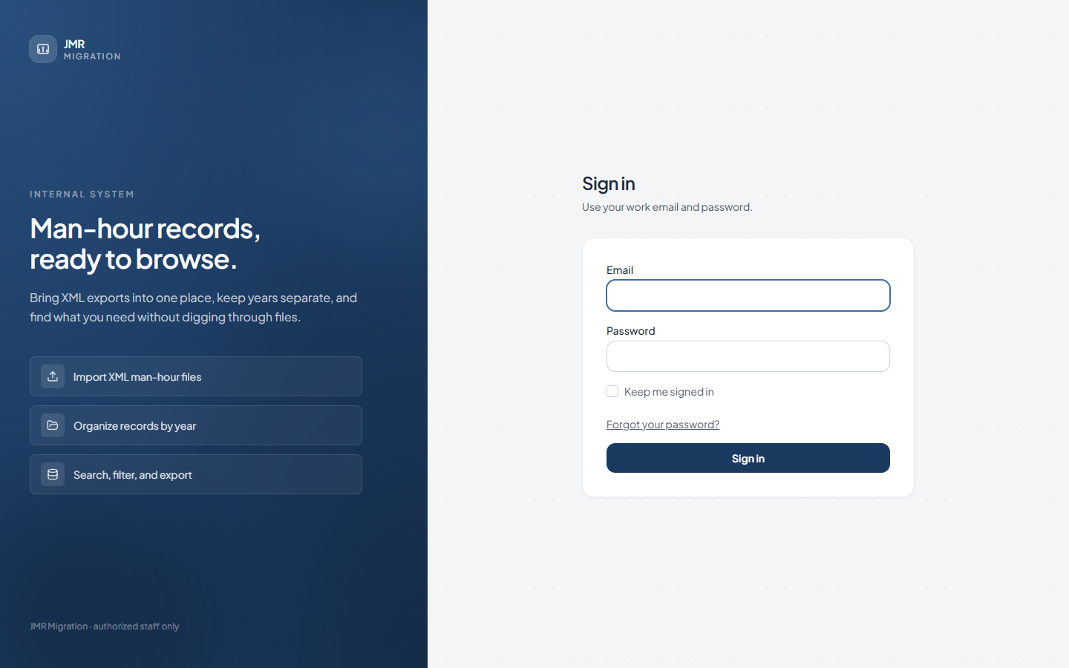
Picture 1. The Sign in page. You only see this when the site asks you to sign in.
2. Words you will see
• Record — one line of hours for one person on one date.
• Project — the job those hours belong to, such as Bridge A.
• Employee — the person who did the work. The number beside the name is the employee ID.
• Group — the department, such as EE or CAD.
• IOW — Item of Works. This is the task, such as Deck drawing. The small circle next to IOW explains the short name.
• TOW — Type of Works. This is the kind of work, such as Drafting or Checking.
• JRD — Job Request Description. You see this on a project page. It is the longer description of the task.
• Active — these hours count in the totals.
• Inactive — the line stays on the list, but the hours do not count.
• Role — Member, Leader, Management, or Developer. This is what the person is allowed to do.
3. The left menu
The blue bar stays on the left. Click a name to change pages.
• Records — every line of hours.
• Projects — hours added up by project and by month.
• Employees — each person, and the hours under their name.
• Years — one card for each year that has been uploaded.
• Control — only for a leader, a manager, or the developer.
• Upload — only for the developer.
• Daily Report — under Links. This opens another website in a new tab.
Your name is at the bottom of the blue bar. Click it if you need your profile. Sign out is the last line. On a small screen, the blue bar is hidden. Click the menu button at the top left to open it.
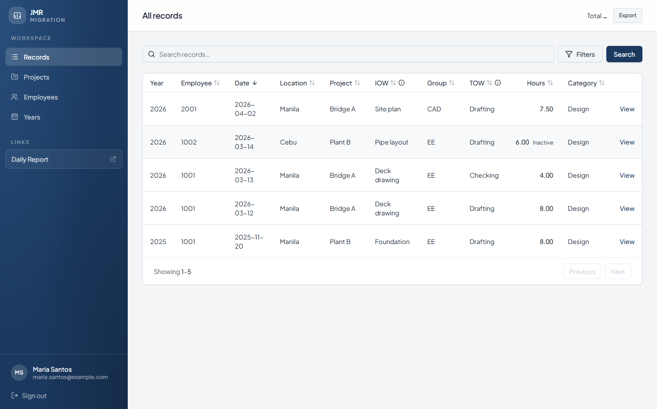
Picture 2. All records. This is the home page. Maria is a member, so she does not see Control or Upload.
4. Find hours on Records
This is the page people use most.
1. Click Records.
2. Type a name, project, place, or employee ID in the search box.
3. Click Search. You can also press Enter.
4. Read the table. Each row is one record.
5. Click View on the right to open that one line.
6. Click Export if you need a spreadsheet of the rows on screen.
The table columns are Year, Employee, Date, Location, Project, IOW, Group, TOW, Hours, and Category. Click a column title to sort. Click it again to sort the other way.
Total, at the top right, is the sum of the active hours that match your search. If a row says Inactive next to the hours, those hours are left out of the total. In the sample, Juan’s 6.00 hours are inactive, so they are not part of the 19.50 total for 2026.
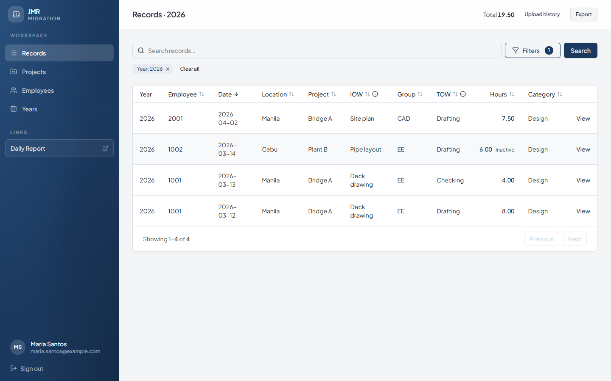
Picture 3. Records for 2026. The Year chip shows the filter. Inactive hours stay on the list but are not in the total.
To narrow the list, use Filters.
1. Click Filters. A panel opens on the right.
2. Choose a year, or type a date in From and To.
3. You can also fill Employee ID, Location, Project, Type of Works, Category, Group, or Person in charge. Fill only what you know.
4. Click Apply filters.
5. A small chip appears under the search box, such as Year: 2026. Click the × on a chip to remove that one filter. Click Clear all to remove every filter.
6. Click Reset inside the panel if you want to start the panel over.
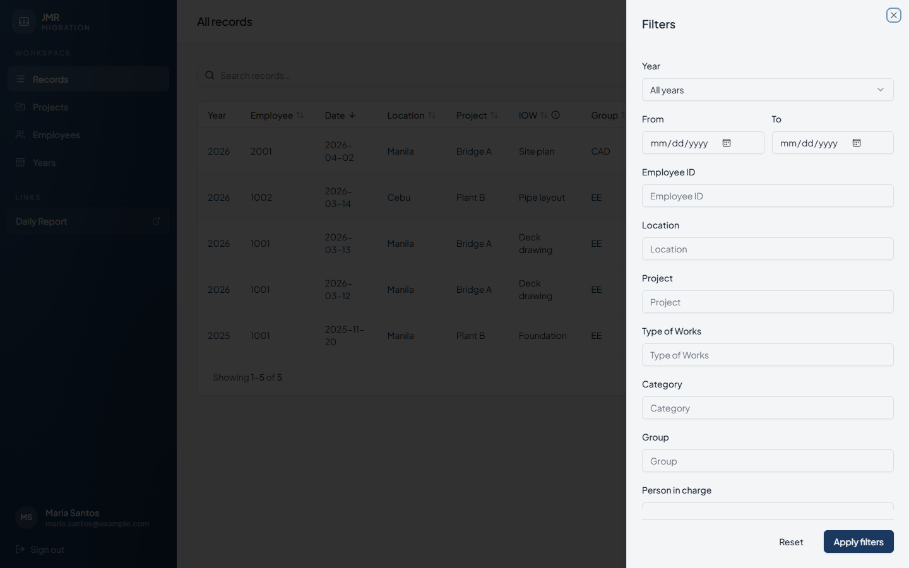
Picture 4. The Filters panel. Fill in what you know, then click Apply filters.
Upload history appears at the top only after a year is selected. It opens the list of files uploaded for that year. You can look at the list. You do not upload from that page.
To read one line in full, click View.
The entry page shows the date, the hours, and the type at the top. Under that you can read the employee, location, project, item of works, group, person in charge, status, and the drawing details: 2D/3D, member, number of sheets, paper size, progress, and revision. The path at the top, such as Records / 2026 / Entry, takes you back.
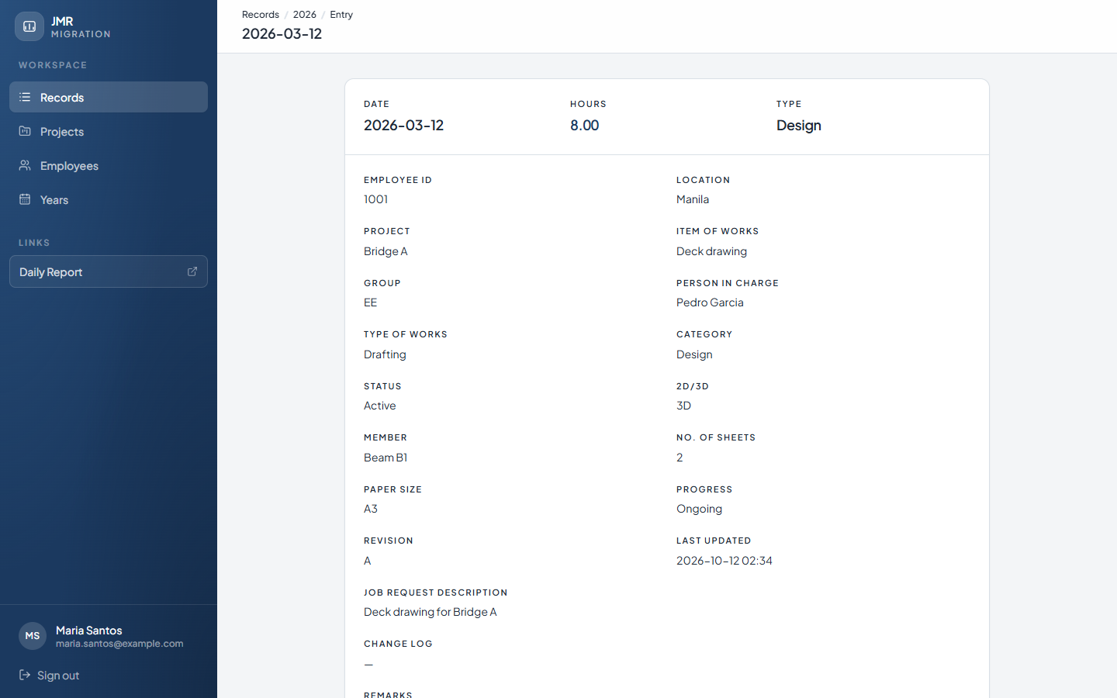
Picture 5. One record, opened with View.
5. Look at a project
1. Click Projects.
2. The page opens on the latest year. Each row is a project. The months show the active hours.
3. Click the project name, such as Bridge A, to see the tasks inside it.
4. On the project page, IOW is the task, JRD is the description, and TOW is the kind of work. The months are on the right.
5. Click Back to projects to return.
6. Click Export if you need the month table in a spreadsheet.
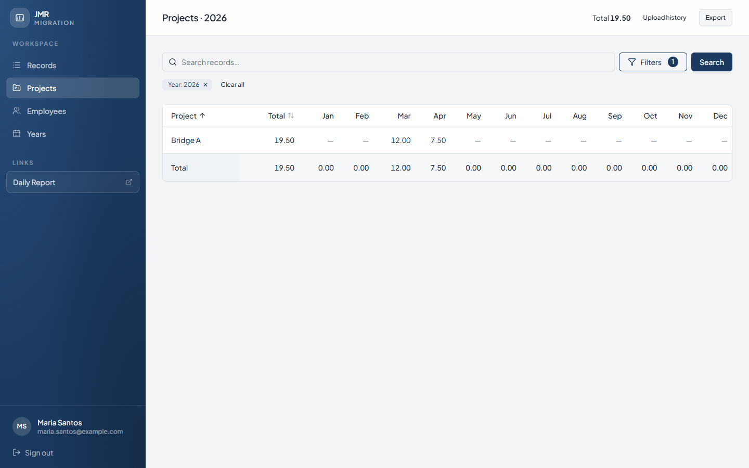
Picture 6. Projects for 2026. Click the project name to open it.
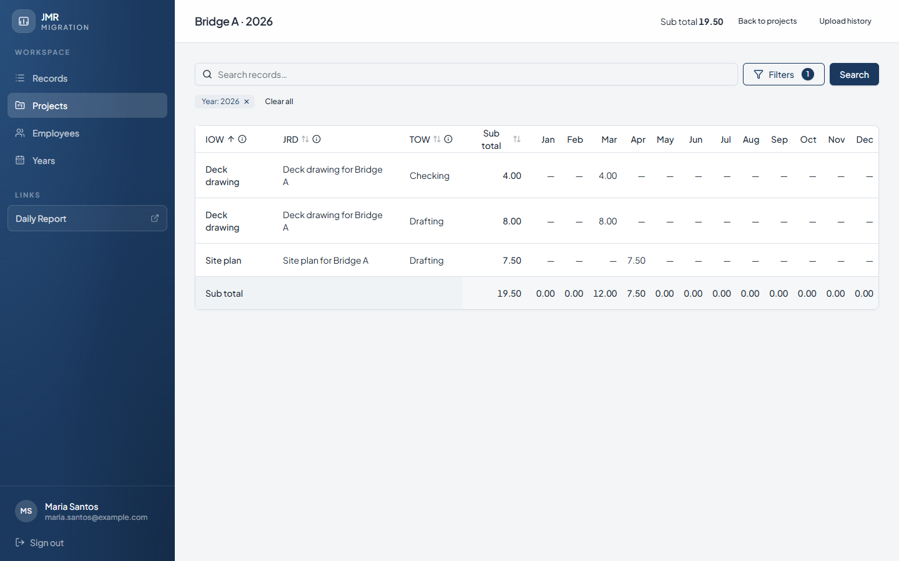
Picture 7. Inside Bridge A. Hours are split by task and by month.
6. Look up a person
1. Click Employees.
2. Search by employee ID or name, then click Search.
3. The table shows Group, Designation, how many entries they have, and their active hours.
4. Click View hours on the person’s row.
5. The card at the top shows the username, group, designation, and role.
6. Click Back to employees when you are done.
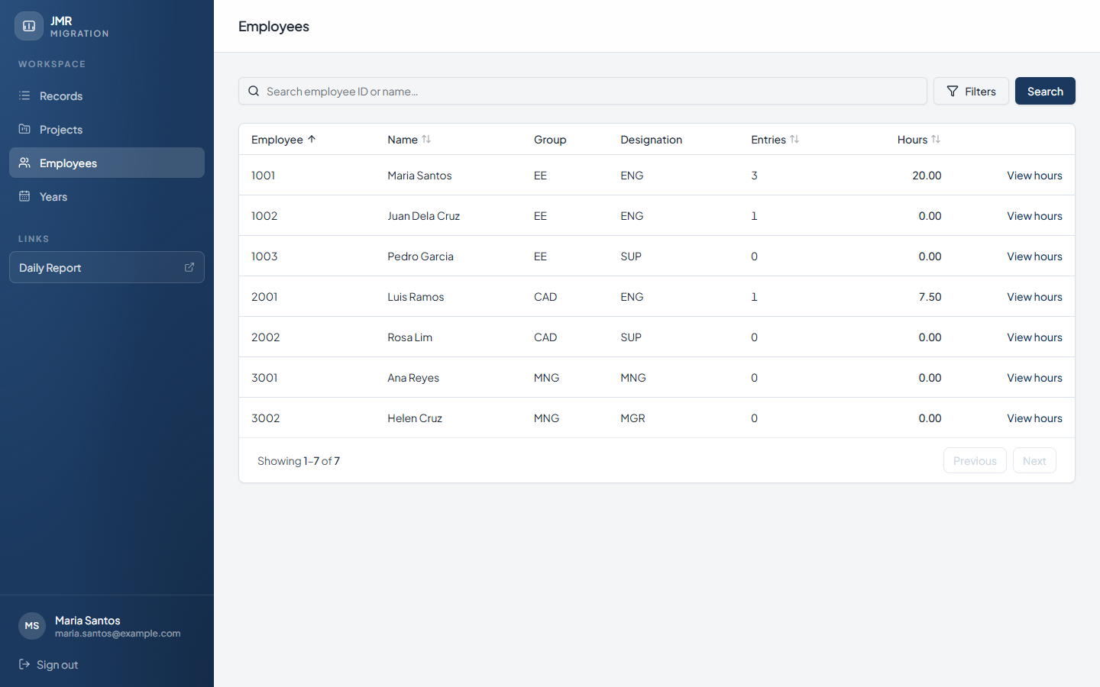
Picture 8. The employee list. View hours opens that person’s lines.
On the hours page, Status is a switch. Active means the hours count. Inactive means they do not. Anyone who can open that employee can use the switch. A leader can open only the people in their own group. Juan’s list total is 0.00 because his only line is inactive. The entry is still there. It is just not counted.
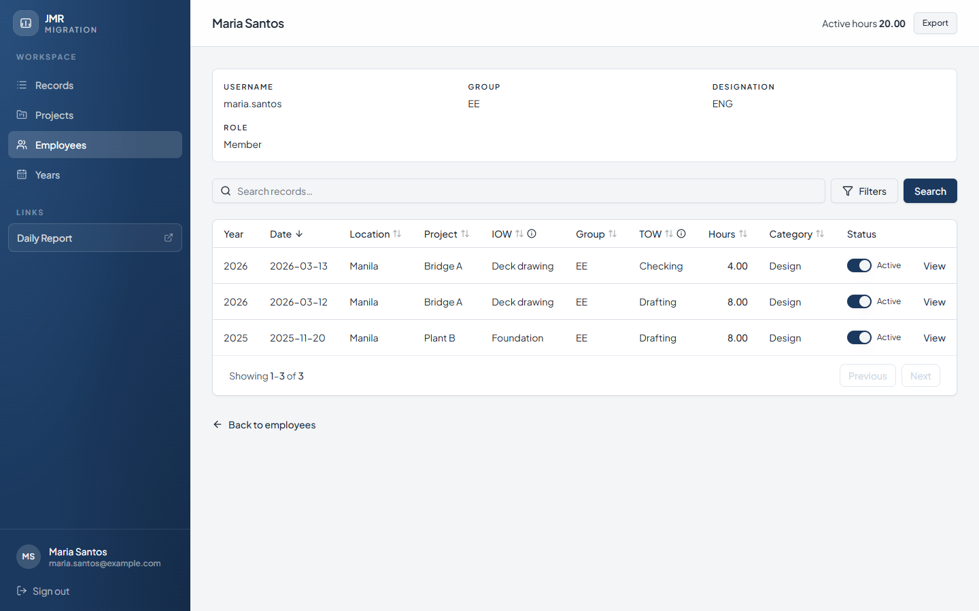
Picture 9. Maria’s hours. The Status switch marks a line Active or Inactive.
7. Open a year
1. Click Years.
2. Each card is one year. Entries is how many records are in that year. Last upload is the date of the latest file, when one has been recorded.
3. Click the card, or click Open.
4. The site takes you to Records for that year. You will see a Year chip, the matching total, and Upload history.
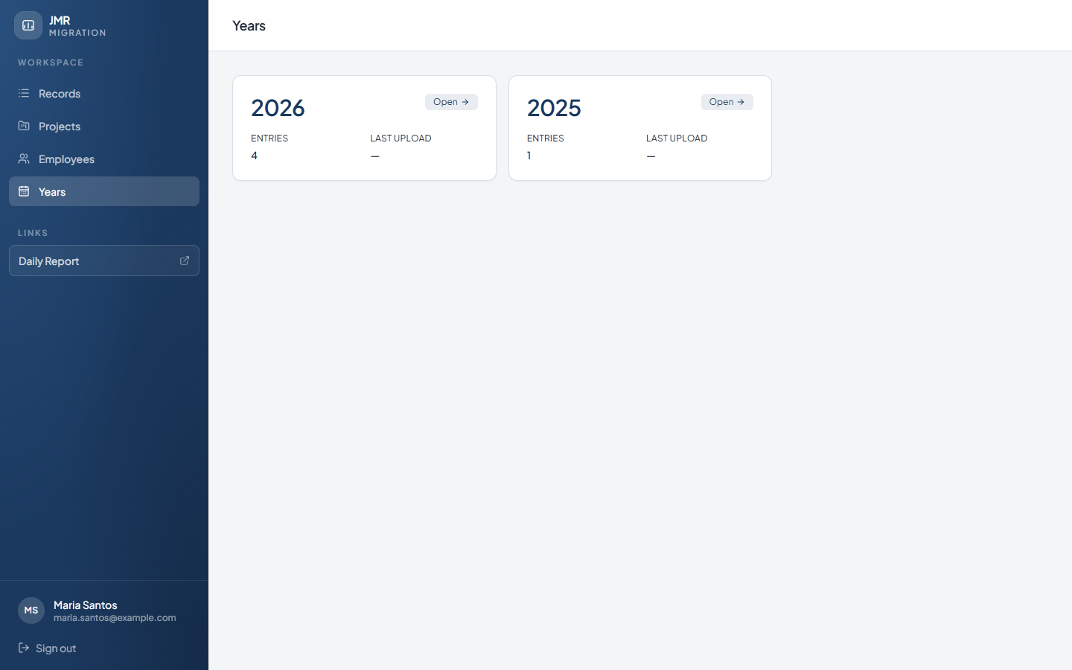
Picture 10. The Years page for a member. There is no Upload button.
8. Leaders: your own group, and Control
A leader uses the same Records, Projects, and Employees pages, but only for their own group. In the sample, Pedro is the leader of EE. He does not see the CAD line that Maria can see. This is expected. He has not lost any data.
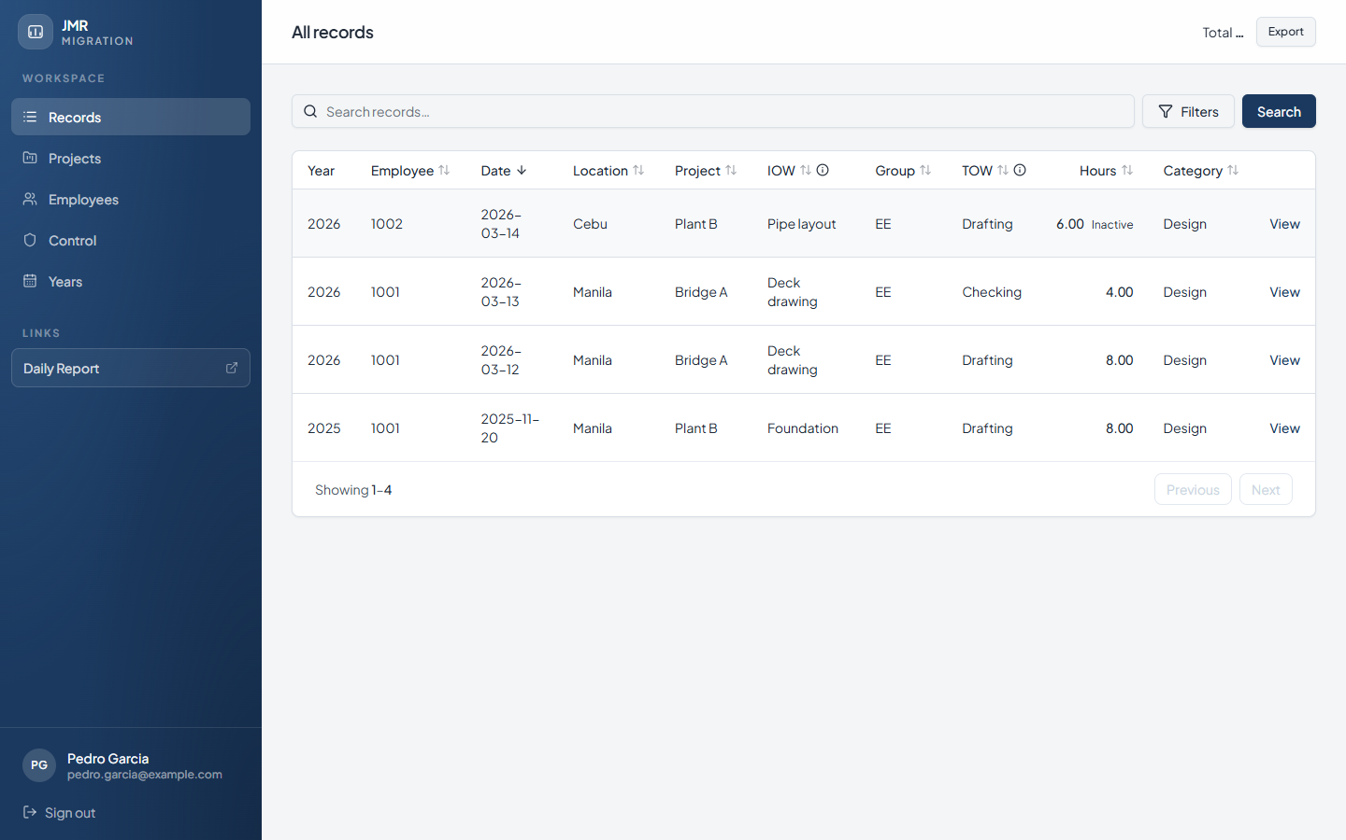
Picture 11. Pedro’s records. Only the EE group is listed.
Leaders also have Control in the menu.
1. Click Control.
2. You only see members in your own group. You do not see other leaders, managers, or yourself.
3. The sentence under the title tells you the limit. Pedro’s page says he can grant edit access to members in EE.
4. Use Search if the list is long.
5. For a member, turn Edit access to Allowed or Off. The change saves as soon as you click the switch.
6. Leave Group as it is. A leader cannot change a person’s group.
7. Leave Role as it is. A leader cannot change Member to Leader. That is a manager’s job.
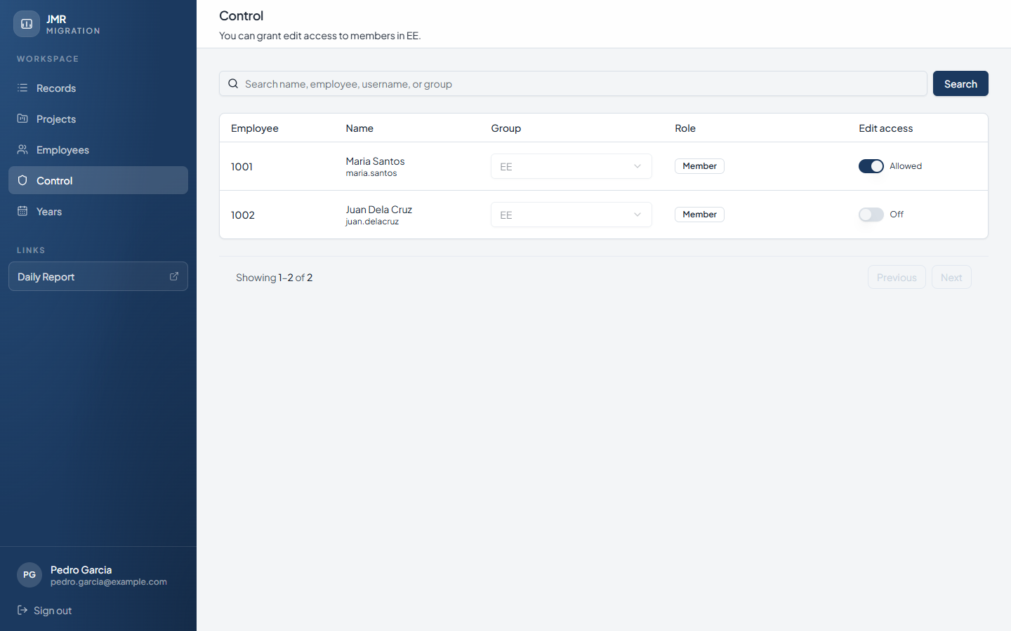
Picture 12. A leader’s Control page. Only members in that leader’s group, and only the Edit access switch.
Edit access is the Allowed / Off switch on Control. It is stored on that member’s account. The Active / Inactive switch on the hours page is separate. Teach them as two different switches.
9. Managers: every group, and roles
A manager sees every group on Records, Projects, and Employees. The menu includes Control and does not include Upload.
On Control, the sentence says you can control leaders and members in every group.
1. Click Control.
2. Search by name, employee ID, username, or group.
3. To change what someone can do, open Role and choose Member or Leader.
4. For a member, set Edit access to Allowed or Off.
5. A leader’s row says Included. There is no Edit access switch for a leader.
6. Do not try to change Group. The group box stays locked for a manager. Only the developer can change a group.
Some people already count as Management because their group or designation is MNG, IT, or SYS. Their Role shows Management, and you cannot change it on this page. You also cannot edit your own row.
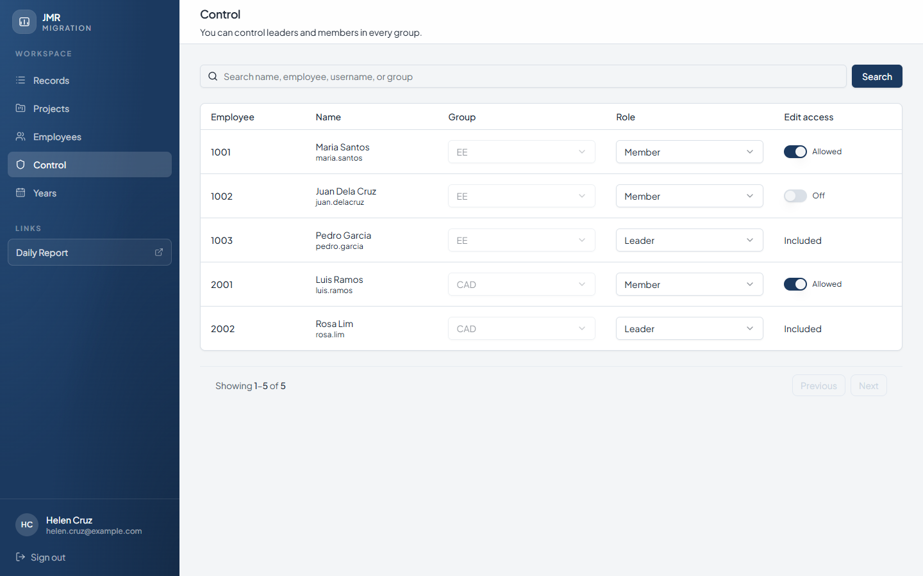
Picture 13. A manager’s Control page. Role can be changed. Group stays locked. Leaders show Included.
When you teach your department, show parts 1 to 7. Show this Control page only to other managers, and show the leader’s Control page only to leaders. Members do not have Control, and that is normal.
10. The developer: the only person who uploads
If you do not see Upload in the blue menu, you cannot upload. Ask the developer. Do not send XML files through email as a substitute unless the office tells you to.
The developer sees two extra things: Upload in the menu, and an Upload button on Years.
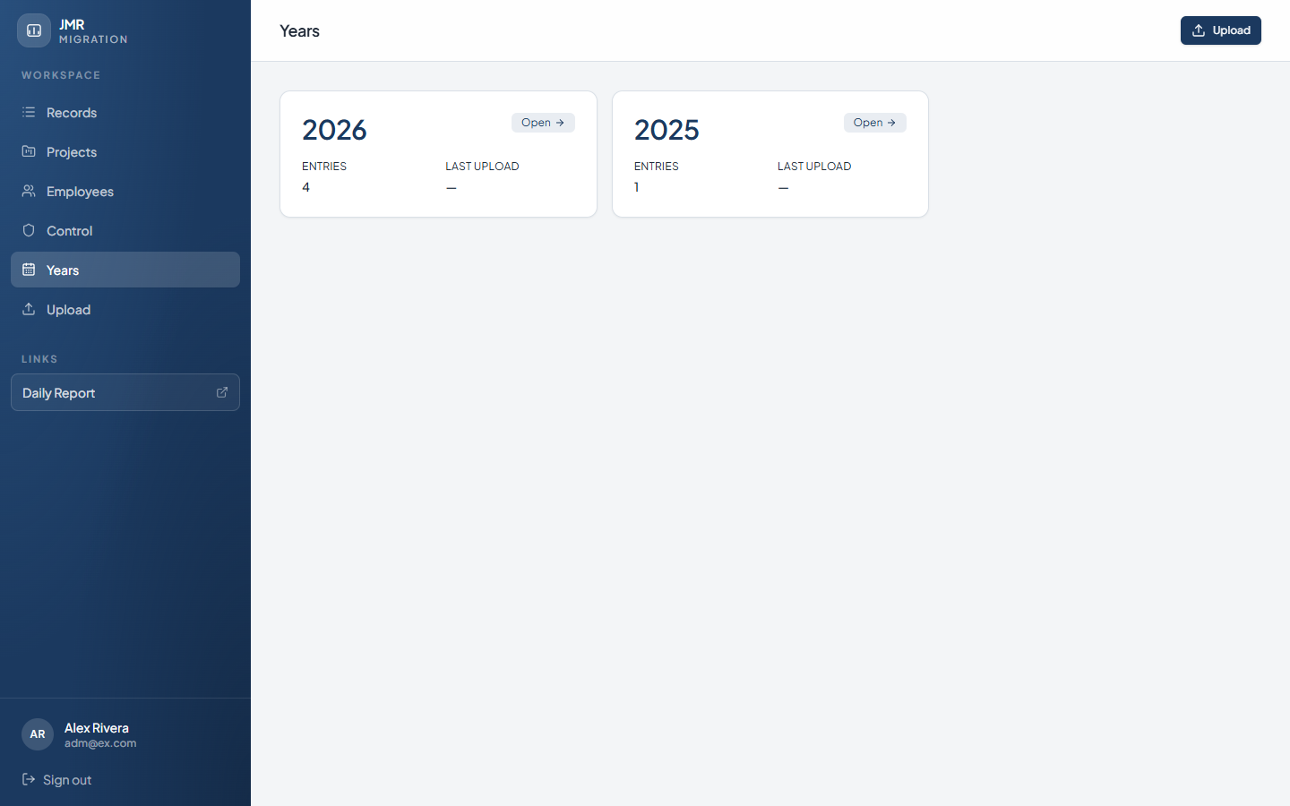
Picture 14. Years, as the developer. The Upload button is at the top right.
To upload man-hour files:
1. Click Upload.
2. Click Choose Files and select the XML files.
3. Name each file with the year and the employee ID, such as 2017_1042.xml.
4. You can choose many files. The page allows up to 500 files, and 50 MB each.
5. Click Continue.
6. Click Cancel if you want to go back to Years without uploading.
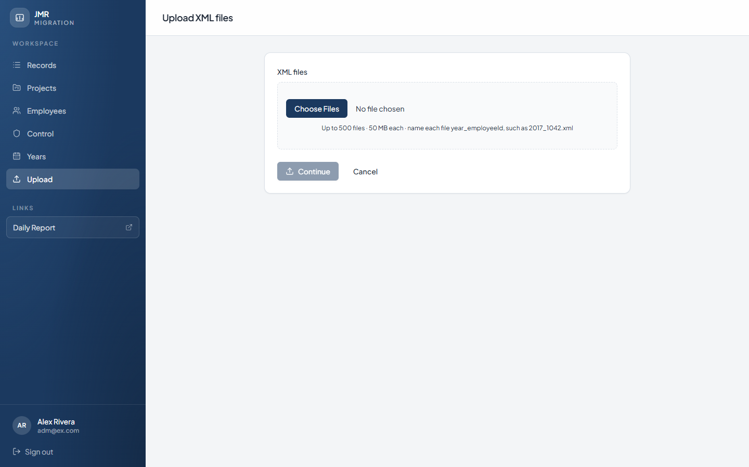
Picture 15. Upload XML files. Choose the files, then click Continue.
Employee names, groups, and designations come from a different file. On Employees, the developer has a button called Upload employee details. Other people do not see that button.
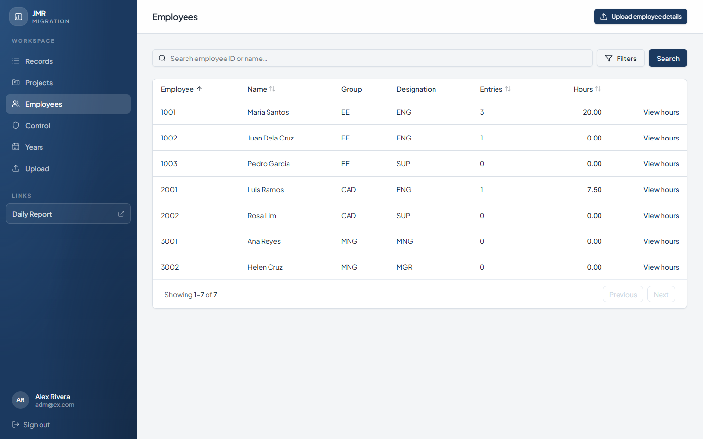
Picture 16. Employees, as the developer. Upload employee details is at the top right.
On Control, the developer can change a person’s group as well as their role.
• The page says: You can control every account.
• Group can be changed from the group box.
• Role can be changed between Member and Leader.
• The developer’s own row is marked You. That row cannot be edited.
• A person whose group or designation is MNG, IT, or SYS shows Management. That role is not changed from the dropdown.
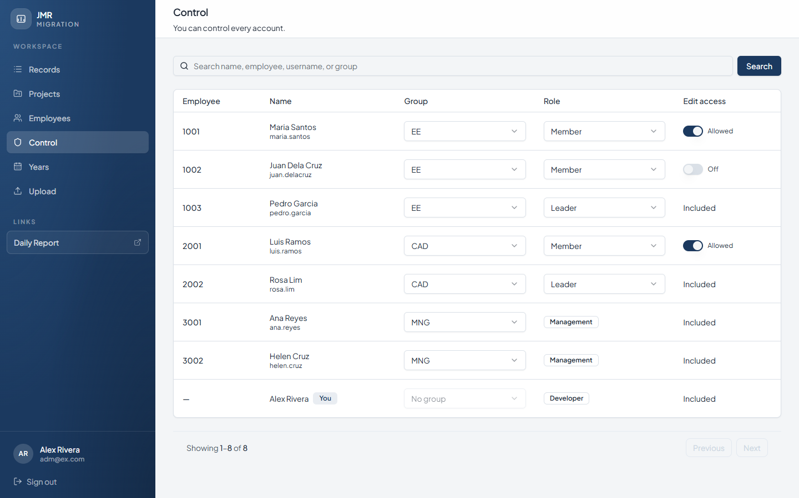
Picture 17. The developer’s Control page. Group can be changed. The developer’s own row says You.
11. A 15-minute class
Use this order when you teach the department. Stay on each step until someone else can do it.
1. Open the office link in Edge. Point to the blue menu.
2. On Records, search for a project your group knows.
3. Open Filters, choose this year, and click Apply filters. Then click Clear all.
4. Click View on one row and read the hours together.
5. Open Projects and click one project name.
6. Open Employees, find one person, and click View hours. Show Active and Inactive.
7. Open Years and click the current year.
8. Show Sign out, then stop. Control and Upload are not part of this class unless that person needs them.
12. If something looks wrong
• The Sign in page will not accept the password. Stop and ask the office. Do not keep trying.
• The list is empty. Click Clear all. A filter may be hiding the rows.
• A leader cannot see another group. That is correct. A manager can see every group.
• Control is missing. Members do not have Control.
• Upload is missing. Only the developer has Upload.
• An hour total looks too small. Look for the word Inactive. Those hours are on purpose left out of the total.
• The Group box will not change. Only the developer can change a group.
• Daily Report opens a different website. Use the blue menu to come back to Records.
Keep this file. You can add your own pictures, or write your office link on the line in part 1, before you print it.

