
Department Of Information Technology
National Institute Of Technology
Karnataka, Surathkal
14th November 2016

REPORT
on
MULTI-PURPOSE ALARM CLOCK

SUBMITTED TO:
Ms. Deepthi
Ms. Sangeetha

SUBMITTEED BY:
1. Harichandana B. S. S. (15IT118)
2. Raut Kajal Dattatray (15IT153)
3. Padala Preethi (15IT225)
4. Navya W Prakash (15IT222)

CONTENTS

- Certificate ......................... 3
- Acknowledgement .......................... 4
- Introduction .......................... 5
- Working ........................... 6
- Commands used ........................... 7
- Output ........................... 9
- Applications .......................... 13

CERTIFICATE

This is to certify that the seminar entitled “MULTI-PURPOSE ALARM CLOCK” has been presented by, Harichandana B. S. S. (15IT118), Raut Kajal Dattatray (15IT153), Padala Preethi (15IT225) and Navya W Prakash (15IT222), students of second year B.Tech (IT), Department of Information Technology, National Institute of Technology Karnataka, Surathkal, on 14 November 2016, during the odd semester of the academic year 2016 - 2017, in partial fulfilment of the requirements for the award of the degree of Bachelor of Technology in Information Technology at NITK Surathkal.

Place: Surathkal
Date: 14/11/2016 (Signature of the Examiner)

Acknowledgement

We would like to thank each and everyone who has helped and contributed to this project. We would like to express special gratitude to our teachers Ms.Deepthi and Ms. Sangeetha for giving us this opportunity to do the project in UNIX. Your support, motivation and advice helped us to finish the project in the prescribed time.
We are thankful to the Department of Information Technology for giving us this opportunity to do the project.

Introduction
This project uses shell scripting to create an alarm clock which has multiple features. The program can be used to set alarms, send emails, execute commands and also open web-pages. All of the features are time based, i.e., the user can define when the execution should occur. This allows the user to define when the mail should be sent, when the output should be displayed or even open the web-page after a certain interval of time.
The aim of this project is to make good use of the multiple processing capability of the system. It allows the user to execute multiple processes at the same time.

Working of the program:
main2.sh:
This script opens a dialogue box which consists of 5 options:
1) alarm clock
2) send a mail
3) execute a command
4) open a website
5) exit
Each of these options is handled by a switch – case which opens the respective bash script.
This continues until the user enters the exit option.

alarm.sh:
This script asks the user to enter the time at which the alarm is to be set and the snoozing time.
After taking the input the script is designed to calculate the time in seconds and the difference between the time at which the alarm is set and the current time. This is handled by the “dc” command. After calculating the time lag, the countdown is shown until the alarm rings.
The user can snooze the alarm or stop the alarm as per his wish.
As soon as the alarm is stopped a good morning message is displayed in a colourful text.

mail.sh:
This script takes the input of the time at which the mail is to be sent, subject, address of the recipient and the content of the mail. After taking the user input, the content of the mail is stored in a file. The script is then made to run in the background and sleeps until the required time, and then the mail is sent to the required recipient at that time.

command.sh:
This script takes the input from the user as to which command has to be executed and at what time. It then calculates the time difference between the required time and the current time and sleeps for that amount of time, which is done in the background using the “&” command. The output of the command is shown on the terminal when it stops sleeping.

web.sh:
This script takes the input of the time of execution and the URL that needs to be opened.
Then the script is sent to the background for the required amount of time. The URL is opened in the Firefox browser after that.

Commands used:
ALARM.SH
1] By default “awk” splits input lines into fields based on whitespace, i.e., spaces and tabs. You can change this by using the -F option to awk ,fields delimited by colons.
2] The “dc” (desk calculator) utility is stack-oriented and uses RPN ("Reverse Polish Notation").A reverse-polish calculator stores numbers on a stack. Entering a number pushes it on the stack. Arithmetic operations pop arguments off the stack and push the results
‘p’ - Prints the value on the top of the stack, without altering the stack. A newline is printed after the value.
‘r’ - Reverses the order of (swaps) the top two values on the stack. (This can also be accomplished with the sequence SaSbLaLb.)
-e script, --expression=script Add the commands in script to the set of commands to be run while processing the input.
3] sleep - sleep for the specified number of seconds
4] disown - built-in command is used to remove jobs from the job table, or to mark jobs so that a SIGHUP signal is not sent to them if the parent shell receives it (e.g. if the user logs out).
5] kill is a command that is used in several popular operating systems to send signals to running processes in order to request the termination of the process.
6] In most Unix-like operating systems, the ps program (short for "process status") displays the currently-running processes.
PID - Process ID number
PPID - ID number of the process′s parent process
7] -o format: Write information according to the format specification given in format. This is fully described in the STDOUT section. Multiple -o options can be specified; the format specification shall be interpreted as the <space>-separated concatenation of all the format option-arguments.
To see every process on the system using BSD syntax: ps ax
a - show processes for all users
x - also show processes not attached to a terminal

8] Ampersand Operator (&) - The function of ‘&‘is to make the command run in background. Just type the command followed with a white space and ‘&‘. You can execute more than one command in the background, in a single go.
9] Toilet – It does much as the command figlet but with more features. If specifying a font using the ‘-f’ option toilet produces the same output as figlet. Fonts are located in the same /usr/share/figlet directory as .flf files.

MAIN2.SH
1] “dialog”- a utility for creating professional-looking dialog boxes from within shell scripts.
--menu box: Displays a list of choices.
--title: Sets a "title string” to be displayed at the top of the dialog box.
The form dialog displays data entry form which consisting of labels and fields. You can set the field length. An operator can use up/down arrows to move between fields and tab to move between windows. The syntax is as follows:
dialog --form text height width form height [ label y x item y x flen ilen ]
where,
The field length flen and input-length ilen tell how long the field can be. If ‘flen ‘is zero, the corresponding field cannot be altered. and the contents of the field determine the displayed-length. If ‘flen ‘is negative, the corresponding field cannot be altered, and the negated value of ‘flen’ is used as the displayed-length. If ‘ilen’ is zero, it is set to flen.

BUZZER.SH
The play command from the sox package will play any file format supported by sox using the default audio device. (SoX - Sound eXchange for audio manipulation)

MAIL.SH
mail - Send and receive mail.
Syntax:
mail [OPTION...] [address...]
-s, --subject = SUBJ Send a message with a Subject of SUBJ.

OUTPUT

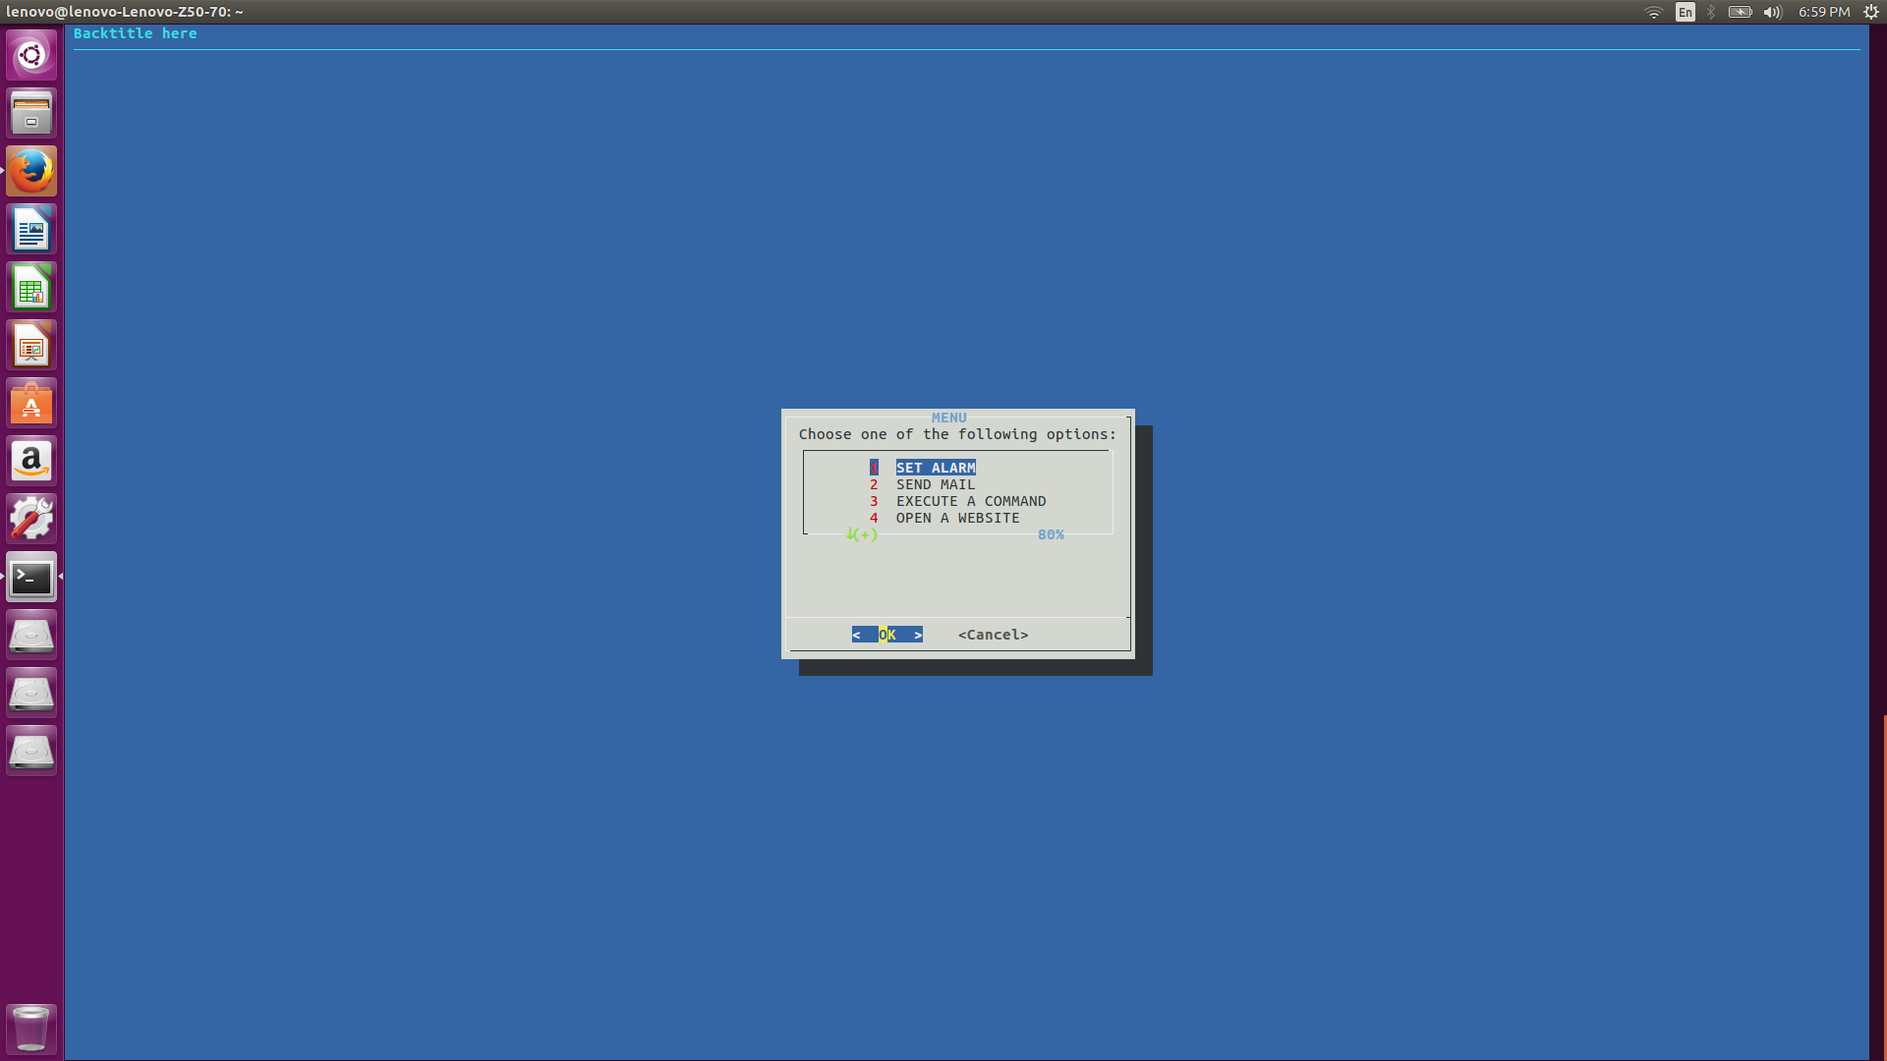

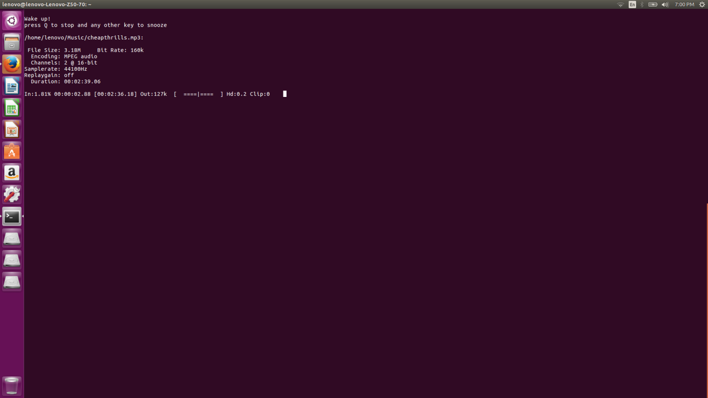

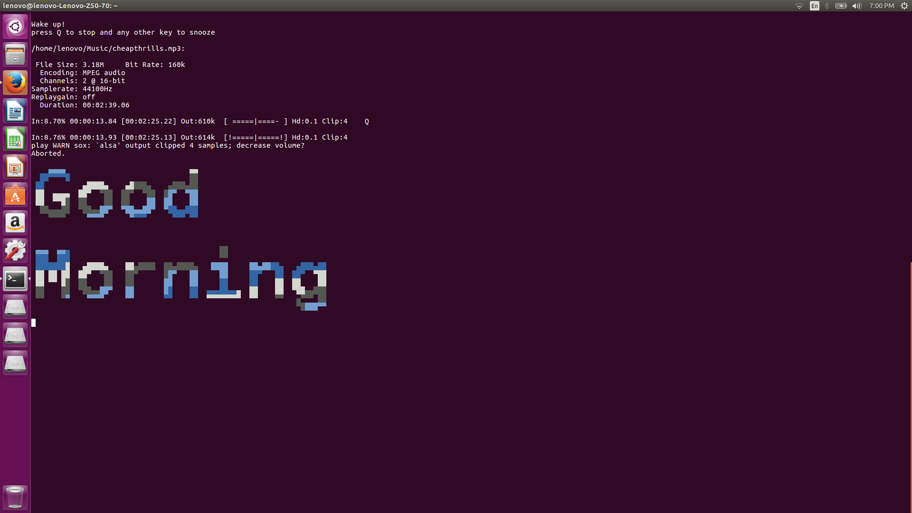

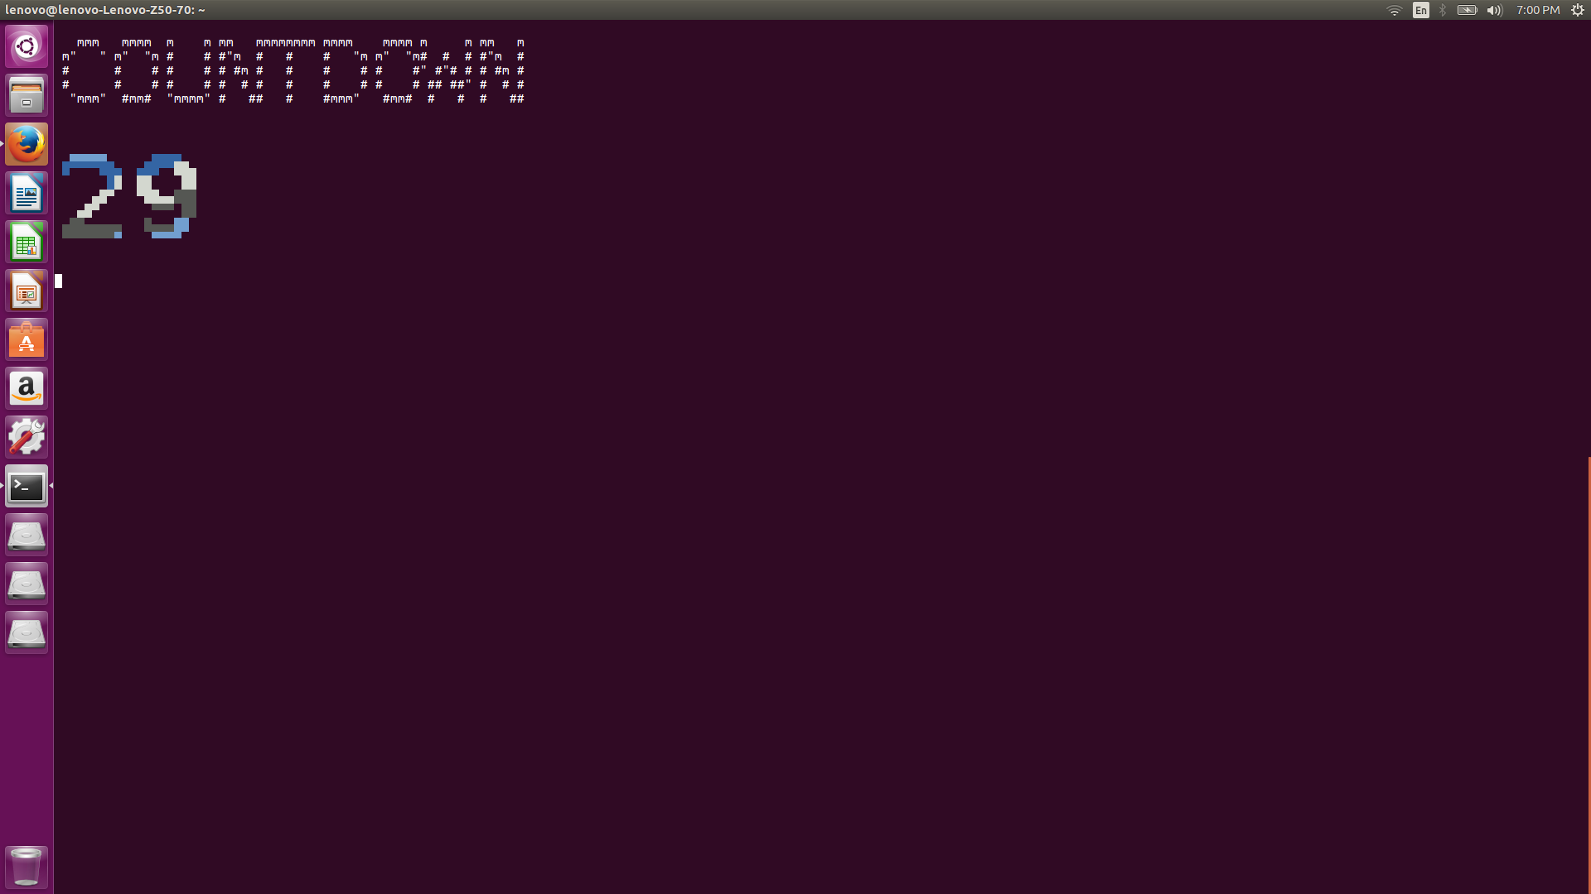
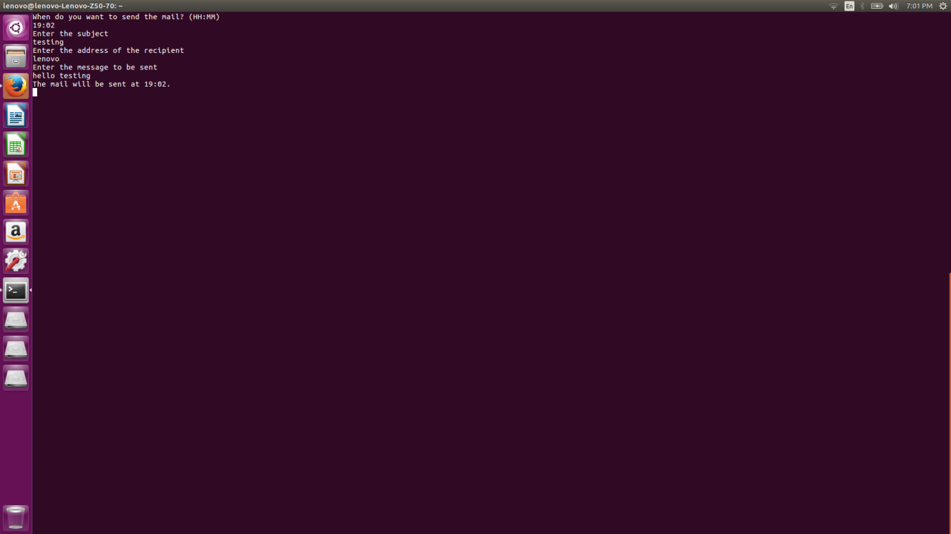

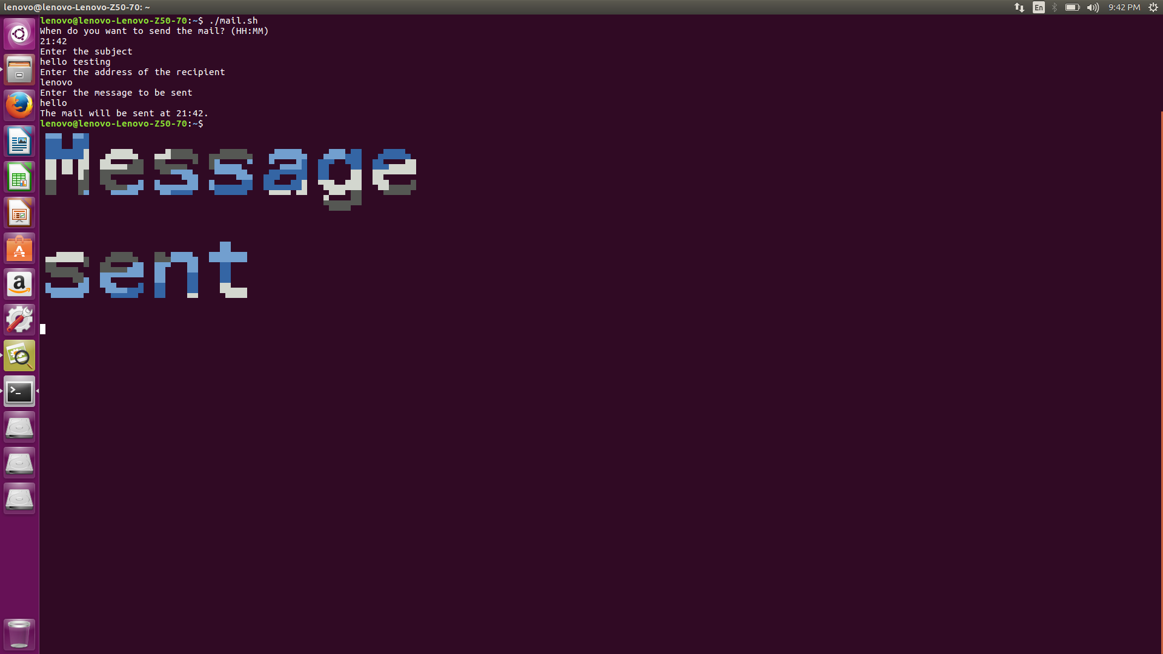

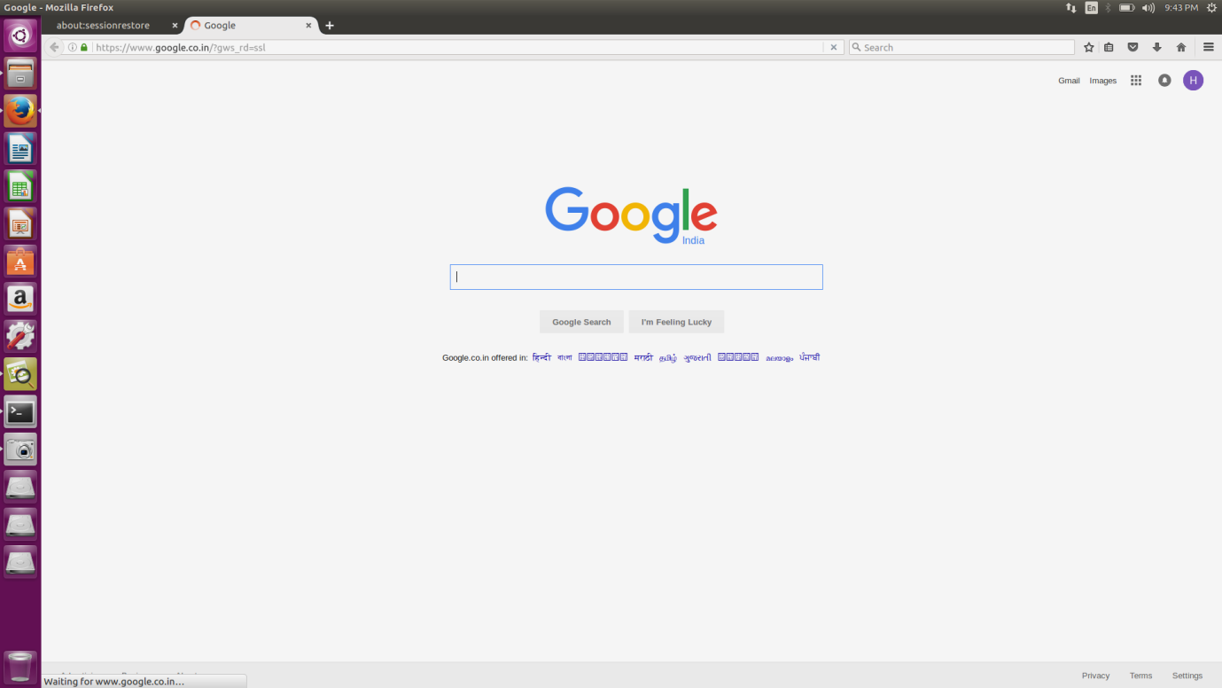

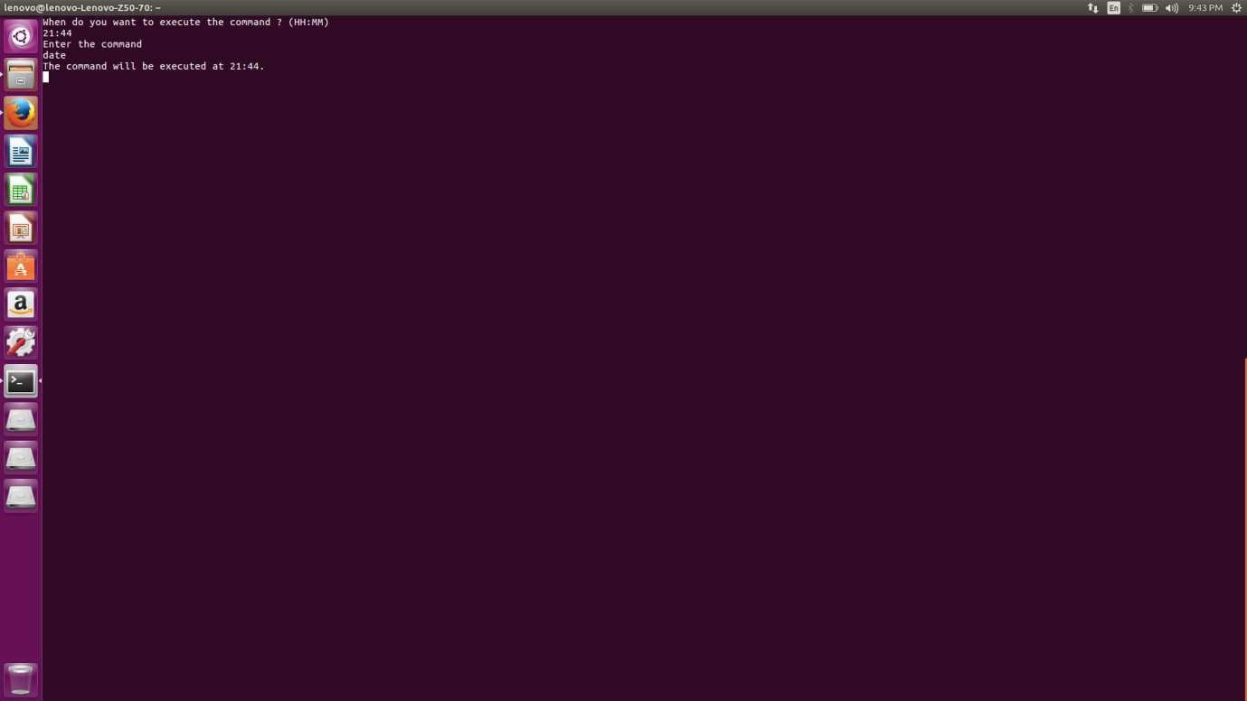

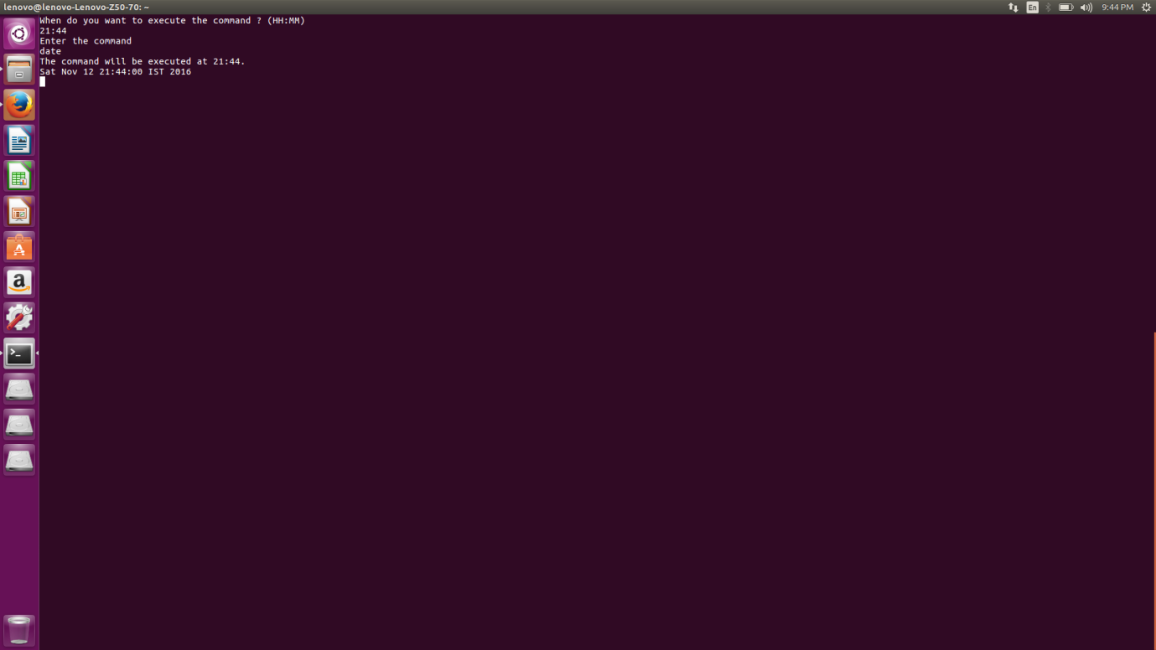

Applications:
- Alarms can be set and also snoozed.

- Mails can be sent at any time by the user. This allows the user to define the sending time for the mail, hence mails can be sent beforehand itself. This can prove to be an added advantage for users when they have to commute.

- Any command can be executed by the user. Since the kernel is shared by multiple systems, administer can also keep track of idle systems using this feature.

- Web-pages can be opened while executing other features.

