Architecture Document
CollabCodeHub — Real-Time Collaborative Cloud Coding Workspace

1. Application
1.1 Architecture Type: Event-Driven + Serverless
CollabCodeHub adopts a hybrid Event-Driven and Serverless architecture. The platform is fundamentally event-driven because every user interaction — a keystroke, a chat message, a task drag, or an AI invocation — triggers an asynchronous event that is propagated across the system without polling. The serverless dimension is realized through Supabase, which provides managed PostgreSQL, authentication, and real-time pub/sub without requiring the team to provision or maintain dedicated backend servers.
This architecture was chosen over a traditional monolithic approach because CollabCodeHub must handle highly concurrent, bi-directional data streams (real-time code sync) while maintaining independent scalability of each service layer. A monolithic server would become a bottleneck under simultaneous multi-room editing loads.
1.2 Microservices Decomposition
While not a traditional containerized microservices deployment, the system is logically decomposed into independently operable service boundaries:
• Authentication Service: Handled entirely by Supabase GoTrue. Issues JWTs, manages OAuth providers, and auto-provisions user profiles via PostgreSQL triggers.
• Collaboration Service: Powered by Liveblocks + Yjs CRDT engine. Manages WebSocket rooms, presence tracking, and conflict-free document state replication.
• Persistence Service: Supabase PostgreSQL with Row-Level Security (RLS). Stores rooms, memberships, messages, and tasks with fine-grained authorization policies.
• AI Intelligence Service: The aiAgent.ts middleware routes prompts to the HuggingFace Inference API (Qwen2.5-7B-Instruct) and parses deterministic JSON responses into workspace file operations.
• Execution Service: Express.js server providing a Liveblocks auth endpoint and a WebSocket-based PTY terminal for remote code execution via xterm.js.
1.3 Event-Driven Flow
Events in the system are categorized as follows:
• CRDT Events: Keystroke deltas captured by Yjs, broadcast via Liveblocks WebSocket to all room peers. These are the highest-frequency events (~50ms cycle).
• Realtime Database Events: Supabase Realtime listens on the 'messages' and 'tasks' tables via PostgreSQL publications. Any INSERT or UPDATE triggers an instant WebSocket push to subscribed clients.
• AI Agent Events: User-initiated prompts trigger a synchronous HTTP POST to HuggingFace. The returned file operations are applied as CRDT mutations, which then cascade as standard CRDT events to all peers.
1.4 Serverless Components
• Supabase Auth (GoTrue): Serverless identity management. Zero backend code required for user registration, login, or session validation.
• Supabase PostgreSQL: Fully managed database with automatic backups, connection pooling, and built-in REST/GraphQL APIs.
• Liveblocks: Serverless real-time infrastructure. WebSocket room management, presence, and CRDT storage are handled by the Liveblocks cloud without any server provisioning.

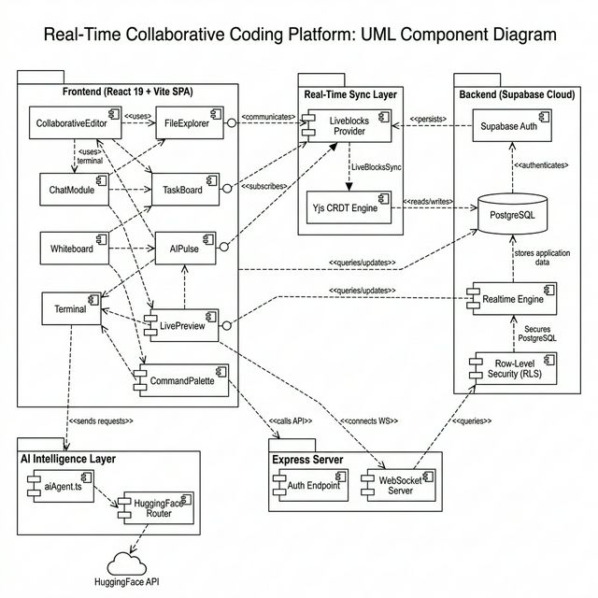
Figure 1: Component Diagram — System Module Decomposition

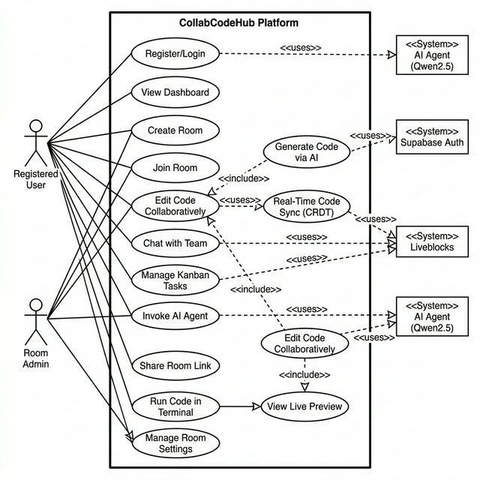
Figure 2: Use Case Diagram — Actor-System Interactions

2. Database
2.1 ER Diagram
The database layer is built on Supabase-managed PostgreSQL. The Entity-Relationship model comprises five core entities with clearly defined foreign key constraints and role-based access enforcement.
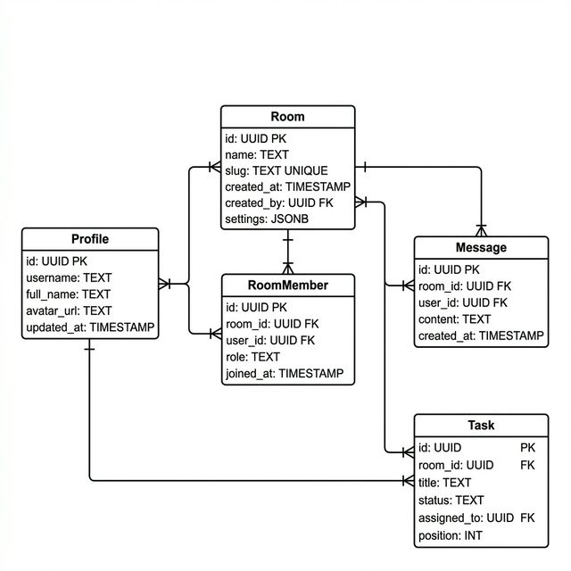
Figure 3: ER / Class Diagram — Database Entity Relationships
2.2 Schema Design
The schema is designed with the following tables:
• profiles: Stores user identity data (id, username, full_name, avatar_url). Primary key references auth.users via ON DELETE CASCADE. Auto-populated by a PostgreSQL trigger (handle_new_user) upon registration.
• rooms: Defines collaborative workspaces (id, name, slug, created_by, settings). The 'slug' field is UNIQUE to enable human-readable room URLs. 'settings' is a JSONB column for flexible room configuration.
• room_members: Junction table linking users to rooms with role-based access (admin/member). Enforces UNIQUE(room_id, user_id) to prevent duplicate memberships.
• messages: Stores real-time chat data per room. Subject to RLS policy requiring the sender to be a verified room member via the is_room_member(room_id) helper function.
• tasks: Kanban task cards with status tracking (todo, in-progress, done, archived). Supports drag-and-drop ordering via a 'position' integer column.
Security Implementation:
All five tables have Row-Level Security (RLS) enabled. A SECURITY DEFINER helper function is_room_member(r_id UUID) encapsulates the membership check to prevent infinite recursion in policy evaluation. This function returns TRUE only if the requesting user (auth.uid()) exists in the room_members table for the given room_id.

3. Data Exchange Contract
3.1 Frequency of Data Exchanges
The platform operates across three distinct frequency tiers:
• Ultra-High Frequency (~20-50ms): CRDT deltas for collaborative code editing. Every keystroke generates a Yjs update event that is broadcast via Liveblocks WebSocket to all connected peers in the room. This is the most latency-sensitive channel.
• High Frequency (~100-500ms): Supabase Realtime subscriptions for chat messages and task state changes. These piggyback on PostgreSQL's NOTIFY/LISTEN mechanism via the supabase_realtime publication.
• On-Demand (~2-5 seconds): AI Agent requests to HuggingFace. These are user-initiated, synchronous HTTP calls that occur only when the user explicitly invokes the AI Pulse interface.
3.2 Data Sets
The following data sets are exchanged across service boundaries:
• Authentication Tokens: JWT (JSON Web Token) containing user ID, email, and session metadata. Issued by Supabase Auth, consumed by all protected endpoints.
• CRDT State Vectors: Binary-encoded Yjs document states containing the full edit history of all files in a workspace. Exchanged between Yjs local instances and the Liveblocks persistence layer.
• Chat Payloads: JSON objects containing room_id, user_id, content, and timestamp. Inserted into the messages table and broadcast via Supabase Realtime.
• Task Payloads: JSON objects containing room_id, title, description, status, assigned_to, and position. Synchronized via Supabase Realtime on the tasks table.
• AI Agent Payloads: The request payload contains a system prompt (workspace context) and user command. The response payload follows a strict AgentResponse schema: { message: string, files: AgentFileOp[] } where each AgentFileOp contains action (create/update/delete), name, and content.
3.3 Mode of Exchanges
• WebSocket (WSS): Primary transport for real-time collaboration (Liveblocks CRDT sync) and database change streams (Supabase Realtime). Provides persistent, bidirectional, full-duplex connections.
• REST API (HTTPS): Used for Supabase database queries (SELECT, INSERT, UPDATE), authentication endpoints, and the HuggingFace Inference API. All REST calls are authenticated via Bearer JWT tokens.
• Internal Function Calls: The aiAgent.ts module communicates with the Yjs local document via in-memory JavaScript function calls within the browser context. No network transport is needed for applying AI-generated file operations to the local CRDT state.

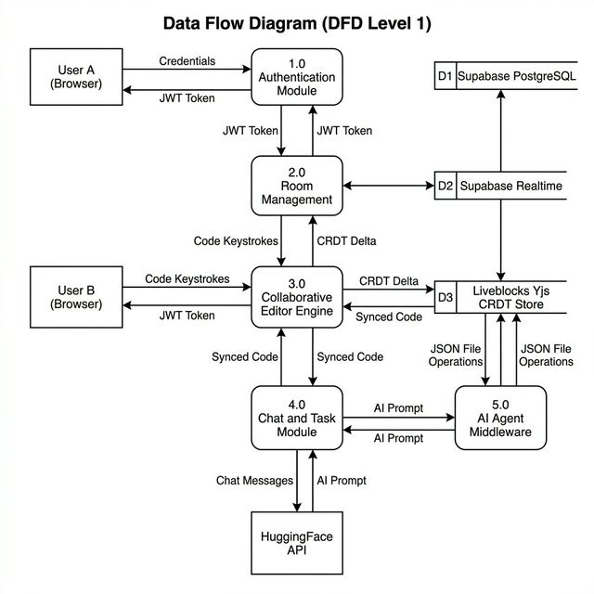
Figure 4: Data Flow Diagram (Level 1) — System Data Exchange Flows

4. Supporting Diagrams
4.1 Sequence Diagram
The following sequence diagram illustrates the complete lifecycle of a user session: from authentication through collaborative editing to AI-assisted code generation. It traces every message exchange between the browser clients, the CRDT engine, the Liveblocks WebSocket infrastructure, Supabase services, and the HuggingFace AI backend.
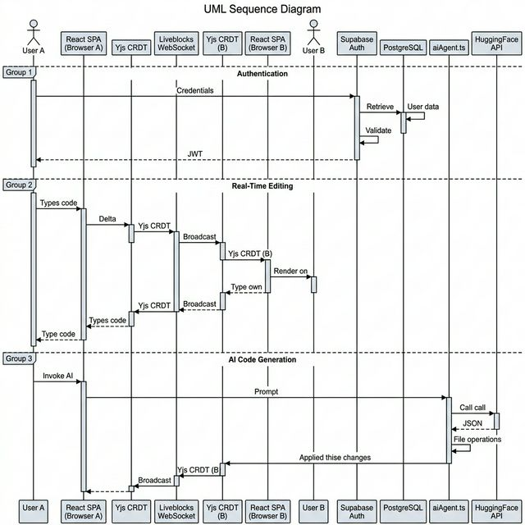
Figure 5: Sequence Diagram — Authentication, Real-Time Editing, and AI Agent Flow

4.2 Deployment Diagram
The deployment diagram maps the logical components to their physical or cloud-hosted deployment targets. Client-side components execute within the user's web browser. The Liveblocks, Supabase, and HuggingFace services are externally managed cloud platforms. The Express.js server can be deployed on a local machine or a VPS for terminal execution capabilities.
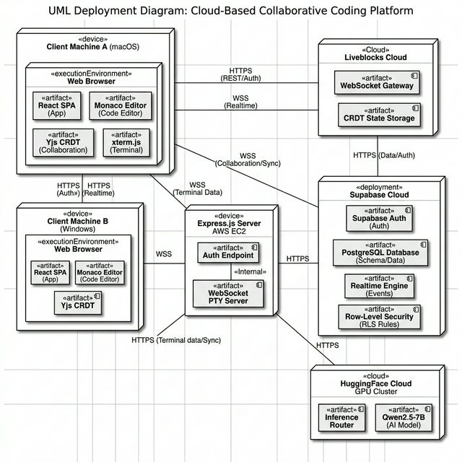
Figure 6: Deployment Diagram — Physical Infrastructure and Cloud Service Mapping

