ExilantHire(eHire)
Software Requirements Specification


EXILANT Technologies Private Limited
#27 & 27/1, P. Kalinga Rao Road
Bangalore 560 027, INDIA

Document Details

Document-ID | 1
Version # & Date | 0.2 -- 03/Nov/2015
Prepare by | Exilant Technologies

Document History

Version # | Date | Reviewed by | Approved by
0.1 | 16/Oct/2015 | Srilatha S | Srilatha S
0.2 | 03/Nov/2015

Table of Contents

1 Overview
1.1 Purpose 4
1.2 Scope 4
1.3 Business context 4
1.4 Current system 5
1.5 Proposed system 6
1.6 References 6
2 Functional Requirements 7
2.1 Technology 7
2.2 Date 7
2.3 Candidate details 7
2.4 Technical/personality skill rating 7
2.5 Overall assessment on Technology 7
2.6 Overall assessment of candidate 7
2.7 Search for candidate information 8
2.8 Input Validation 8
2.9 Accessibility 8
3 Non Functional Requirements 8
4 Dependencies 8
5 Requirements discussed but deferred 9
6 User Stories 9
7 Use Cases 10
8 Flow Chart 17
9 Screen shots 18
  - Welcome Page 18
  - Add Date Page 18
  - View candidate page 19
  - Technical interview feedback page 19
  - Managerial round feedback page 20
10 Open items 20

Introduction

Purpose
eHire is a comprehensive system to manage the recruitment process of an organisation. Currently the organisation relies on capturing all the interview details of a candidate, like skill sets, assessment from all rounds of interviews, etc. on paper. This leads to accumulation of piles of paper and also requires lot of intermediate coordination. eHire application can successfully free the organisation from all the paper work related to the recruitment process by automating the interview feedback process and bring down the coordination effort to a large extent. This will also help the organisation to become more eco friendly by saving paper which is a valuable resource.

Scope
This application will be a centralised system that will enable various departments such as HR, technical & management to have a seamless recruitment process. This application allows the user to capture various details & perform tasks related to an interview, such as:

- Candidate's details like name, skill, experience and performance during the interview.
- Append the interview feedback from all rounds
- Search for a candidate's details based on name, skill and date.

Business Context
Currently, the organisation relies on a manual recruitment feedback system. This consumes more of organisation’s revenue and valuable time for the following reasons:
- Candidate’s details and interview feedback are entered manually by each department (Technical/HR/Management) that conducts the interview
- The paper work is passed to the next interviewer by hand
- For future references, the candidate details have to be maintained and searched in the hard copies
- Usage of lot of paper for maintaining the recruitment information.

eHire can help the organisation in the following ways:-
- Structure and systematically organise the entire recruitment processes.
- Avoid intermediate coordination that is required for passing the information from one interviewer to another
- Maintain the data of all candidates for future needs, which will be easily searchable in the system
- Become more eco friendly, by reducing the usage of paper.
- Avoid many of the oversights & information misses that is possible in a manual process

Current System
As the current business process is not automated, the company needs to cope up with several problems. Below points identify the drawbacks of the current system.

Performance:

- Often paper work is slow, which adds a delay to the recruitment process.

Information Redundancy, Security & Storage:

- Redundant information: Candidate's information is stored in many places.

- Candidate's information is exposed to unauthorised agents during transit.

- Due to the large number of manual files, data organisation and future reference becomes cumbersome.

Economics:

- Manual handling of data is expensive as compared to an automated system. Effort and materials required for tasks add to the cost.

Efficiency

- Saving & retrieving information take considerable time.

Services

- Data ambiguity introduced by an any interviewer could lead to wrong decisions.

- Recruitment activities are prolonged since the existing system is manual.

Proposed System
The proposed system automates the feedback process which has following features:-
- Application saves time, as the reports are done by the system and helps to make certain
decisions quicker since it is possible to cross check information easily.
- Digitally manage the candidate's records for quicker access.
- Candidate information will be captured only once and the updates to the candidate's record are shared among other interviewers electronically.

- Less/ no paper work is required, which results in faster recruitment process.

- Less prone to errors, as it captures the input accurately using forms, rating boxes and also applies validation to most of the input.

References
Manual Interview Feedback Forms.

Functional Requirements

The Functional requirements of the application have been identified as follows:
Requirement ID | Module | Sub - module | Description
Ehire_Req_1.1 | Technology | Add one or more technologies | The user can add one or more technologies for which the candidate are to be interviewed
Ehire_Req_1.2 | Technology | Delete Technology | The user can remove an existing technology
Ehire_Req_2.1 | Date | Add one or more dates under a technology | The user can add one or more technologies for which the candidate are to be interviewed
Ehire_Req_2.2 | Date | Delete Date | The user can remove an existing technology
Ehire_Req_3.1 | Candidate | Add one or more candidate | The user can add one or more candidate details of the candidate(s) planned to be interviewed on a particular interview date
Ehire_Req_3.2 | Candidate | Modify Candidate | The user can modify candidate's details listed under a date
Ehire_Req_3.3 | Candidate | Delete Candidate | The user can delete one or more candidate(s) record(s)
Ehire_Req_4.1 | Feedback | Technology/  Personality Rating | The user can rate a candidate's technical skills and personality skills (The rating for each Technology/Personality skill can be captured by selecting the required number of ⭐s to convey - “Excellent”, “Very Good”, “Good”, “Satisfactory” or “Not Satisfactory”.)
Ehire_Req_4.2 | Feedback | Overall Assessment of Technology | The user can enter the overall assessment on technology in the 'Comments' field. Here the user can document the questions asked and the responses given by the candidate (The rating for this section will be captured by selecting the required number of ⭐s to convey - “Excellent”, “Very Good”, “Good”, “Satisfactory” or “Not Satisfactory”)
Ehire_Req_4.3 | Feedback | Overall Assessment of Candidate | The user can enter the overall assessment of the candidate in the 'Overall Assessment' field. Here the user can document the questions asked and the responses given by the candidate (The rating for this section can be captured by selecting the required number of ⭐s to convey - “Excellent”, “Very Good”, “Good”, “Satisfactory” and “Not Satisfactory”)
Ehire_Req_4.4 | Feedback | Search for candidate information | The user can search for a candidate based on one or more of his/her details which are name, date of interview, skills and experience

Non Functional Requirements

Performance :
- The application shall fasten the process of capturing the feedback and improve clarity.
- The application shall respond to searches on candidate details within milli seconds.

Usability :

- The application shall be user friendly, so that a user who has basic computer knowledge can use the application and give feedback.
- The application shall prevent users from committing many errors during filling feedback forms.
- The navigation labels are self explanatory so that a user can understand easily.

Availability:

- The application in its operational state shall be available for use 24 hours per day and 365 days per year.

Dependencies

- Talent Acquisition
- HR
- Interviewers

Requirements discussed but deferred

The following requirement(s) have been discussed but are deferred:

• Integrating the application with centralised server to retrieve the data.
- Email notification to the next interviewer.
- Final closure of the record by management, after which this record becomes view only.
- Authentication & authorisation of the user who can access this application. Allow only an authorised user to use the application.
- Allow file attachments - Candidate's photo, screenshot of the sample programs written by the candidate.

User Stories
The following User Stories are written by referring the Exilant (manual) Interview Feedback Forms and considering the needs of the user (Interviewer/HR) during the selection process.
User Story | 1
As a | HR
I want | To add the details of a new candidate into the eHire application
So that | I can start the interview process of the candidate.

User Story | 2
As a | Technical Lead
I want | To assess the technical/personality skills of the candidate
So that | I can capture the following about the interviewed candidate – Ratings on technical/personality skills & overall assessment on technology/candidate

User Story | 3
As a | Manager
I want | To assess the technical/personality skills of the candidate
So that | I can capture the following about the interviewed candidate – Ratings on technical/personality skills & overall assessment on technology/candidate

User Story | 4
As a | HR
I want | To assess the candidate's overall performance in the interview
So that | I can take a decision on the candidate's offer of employment.

Use cases

Use Case Element | Description
Use Case Number | 1
Application | eHire
Use Case Name | Add or Remove a Technology
Use Case Description | Application provides a list of technologies by default for the user. If user wants to add one or more technologies, which are not available by default then user adds a new technology to the existing list of technologies. User can delete a technology from the existing list of technologies.
Primary Actor | Interviewer/ Manager/ HR
Precondition | None
Trigger | User clicks on '+'/'-' button below the Technology table.
Basic Flow | - User launches the application.  - The list of existing technologies will be shown to the user.  - To add a new technology user presses the '+' button below the 'Technology' table.  - User Enters/Selects (TBD) the technology to be added and presses 'Save' button.  - To remove an existing technology, user selects the technology and presses the '-' button.  - Technology gets deleted after confirmation from the user.
Alternate Flows | N/A

Use Case Element | Description
Use Case Number | 2
Application | eHire
Use Case Name | Add/Delete Date(s) of interview under a Technology
Use Case Description | User adds the date of interview under a particular technology. User can also delete a date of interview from under the technologies list.
Primary Actor | Interviewer/ Manager/ HR
Precondition | eHire is launched
Trigger | (TBD)
Basic Flow | ADDING DATE  - User selects a Technology from the existing list of Technologies available.  - User presses '+' button (TBD) and selects a date of interview which is to be added under a Technology.  - User saves the entry and this date of interview will be listed under the selected technology.  DELETING DATE  - User selects a Technology from the list of Technologies available.  - User selects a date that is to be removed from under the selected technology.  - User presses the '-' button.  - After the confirmation from the user to delete a date, the date is deleted from the list.
Alternate Flows | N/A

Use Case Element | Description
Use Case Number | 3
Application | eHire
Use Case Name | Add/Delete a Candidate
Use Case Description | User selects a date of interview from the listed Technologies. The list of candidates for that particular 'date of interview' is shown. If the required candidate is not present in the list of candidates, the user adds the candidate's details to the list. If a candidate's details are no longer required, user deletes the candidate's details from the list.
Primary Actor | HR
Precondition | The required Technology & Date should be selected
Trigger | User clicks on '+'/'-' button below the Candidate details table.
Basic Flow | ADDING CANDIDATE  - The user selects a Technology and Date under which the candidate is to be added.  - To add a new candidate, user presses the '+' button and fills the candidate's details.  - The user 'Save's the details of the candidate (in the sheet TBD).  - The new candidate's details are added under the selected Technology and Date of interview.  DELETING CANDIDATE  - The user selects a Technology and Date of interview.  - The user selects a candidate from the list of candidates from which the candidate is to be deleted  - User presses '-' button to delete a candidate from the list of candidates.  - Upon confirmation from the user, candidate's details are deleted from the list.
Alternate Flows | N/A

Use Case Element | Description
Use Case Number | 4
Application | eHire
Use Case Name | Edit a Candidate Details
Use Case Description | User selects a date of interview from under the listed Technologies. For the selected date, the user is shown the list of candidates and user selects the candidate whose details are to be edited.
Primary Actor | HR
Precondition | One technology and one date should be selected  One Candidate should be selected from the list of Candidates shown
Trigger | User has to double click on the row to be edited(TBD)
Basic Flow | - User selects a Technology from the list of Technologies shown  - User selects a date that is listed under the Technology  - User selects the candidate from the list of candidates available whose details are to be edited.  - User double clicks on the candidate information that is to be edited (TBD)  - User edits the candidate's details and 'Save's the details.  - The candidate's details are updated.
Alternate Flows | N/A
N

Use Case Element | Description
Use Case Number | 5
Application | eHire
Use Case Name | Technical Lead Feedback Entry
Use Case Description | The user updates the feedback from the technical round of interview by filling in the following details:  - Rating on technical/personality  - Comments and rating for overall assessment on technology  - Comments and rating for overall assessment on candidate
Primary Actor | Technical Lead
Precondition | Required candidate record is present in the system.  User clicks on 'Add feedback' button to open the feedback screen/form of the candidate. (TBD)
Trigger | User has to select Technical Lead tab
Basic Flow | - User presses on the '+' button below the 'Rating on Technical/Personality' table, to add a new row.  - For each row/skill, user provides a rating by selecting the required number of stars.  - Based on the number of stars selected, the corresponding label will be updated with Excellent/Very Good/Good/Satisfactory/Not Satisfactory.  - User provides comments on candidate's overall assessment on technical skills.  - User rates the candidate's technical skills by selecting the stars provided for the same.  - User provides comments for overall assessment of the candidate.  - User rates the candidate's technical skills by selecting the stars provided for the same.  - User puts forward his recommendation by selecting any of the checkboxes(Shortlisted/Rejected) and provides a suggestion in the 'Position/Designation' field.  - User fills in his/her name in the 'Interviewed by' field.
Alternate Flows | N/A
N

Use Case Element | Description
Use Case Number | 6
Application | eHire
Use Case Name | Manager Feedback Entry
Use Case Description | The user updates the feedback from the technical round of interview by filling in the following details:  - Rating on technical/personality  - Comments and rating for overall assessment on technology  - Comments and rating for overall assessment on candidate
Primary Actor | Manager
Precondition | User clicks on 'Add feedback' button to open the feedback screen/form of the candidate. (TBD)
Trigger | User has to select Manager tab
Basic Flow | - User presses on the '+' button below the 'Rating on Technical/Personality' table, to add a new row.  - For each row/skill, user provides a rating by selecting the required number of stars.  - Based on the number of stars selected, the corresponding label will be updated with Excellent/Very Good/Good/Satisfactory/Not Satisfactory.  - User provides comments for the overall assessment of the candidate's technical skills.  - User rates the candidate's technical skills by selecting the stars provided for the same.  - User provides comments on candidate's overall assessment on candidate's personal skills.  - User rates the candidate's personality skills by selecting the stars provided for the same.  - User puts forward his recommendation by selecting any of the checkboxes(Shortlisted/Rejected) and provides a suggestion in the 'Position/Designation' field.  - User fills in his/her name in the 'Interviewed by' field.
Alternate Flows | N/A
n Functional Requirement

Use Case Element | Description
Use Case Number | 7
Application | eHire
Use Case Name | HR Feedback Entry
Use Case Description | The user(HR) updates the feedback from the final round (HR) of interview by filling in the following details:  - Recommendation/specific feedback  - Total IT Experience  - Notice period  - Expected package
Primary Actor | HR
Precondition | User clicks on 'Add feedback' button to open the feedback screen/form of the candidate. (TBD)
Trigger | User has to select HR tab
Basic Flow | - User selects a Technology from the list of Technologies shown.  - User selects a date that is listed under the Technology  - User selects the candidate for whom the interview is to be conducted.  - User clicks on 'Add feedback' button to access the candidate's previous rounds of interview details (TBD).  - User fills in all the basic required fields like, 'Total IT experience', 'Official Notice Period', 'Current Annual Salary', and 'Expected Annual Salary', etc.  - User provides comments for the 'Recommendation/Specific Feedback' field.  - User fills in the date of interview conducted in the 'Date' field.  - User fills in his/her name in the 'Interviewed by' field.
Alternate Flows | N/A

8.Flow Chart
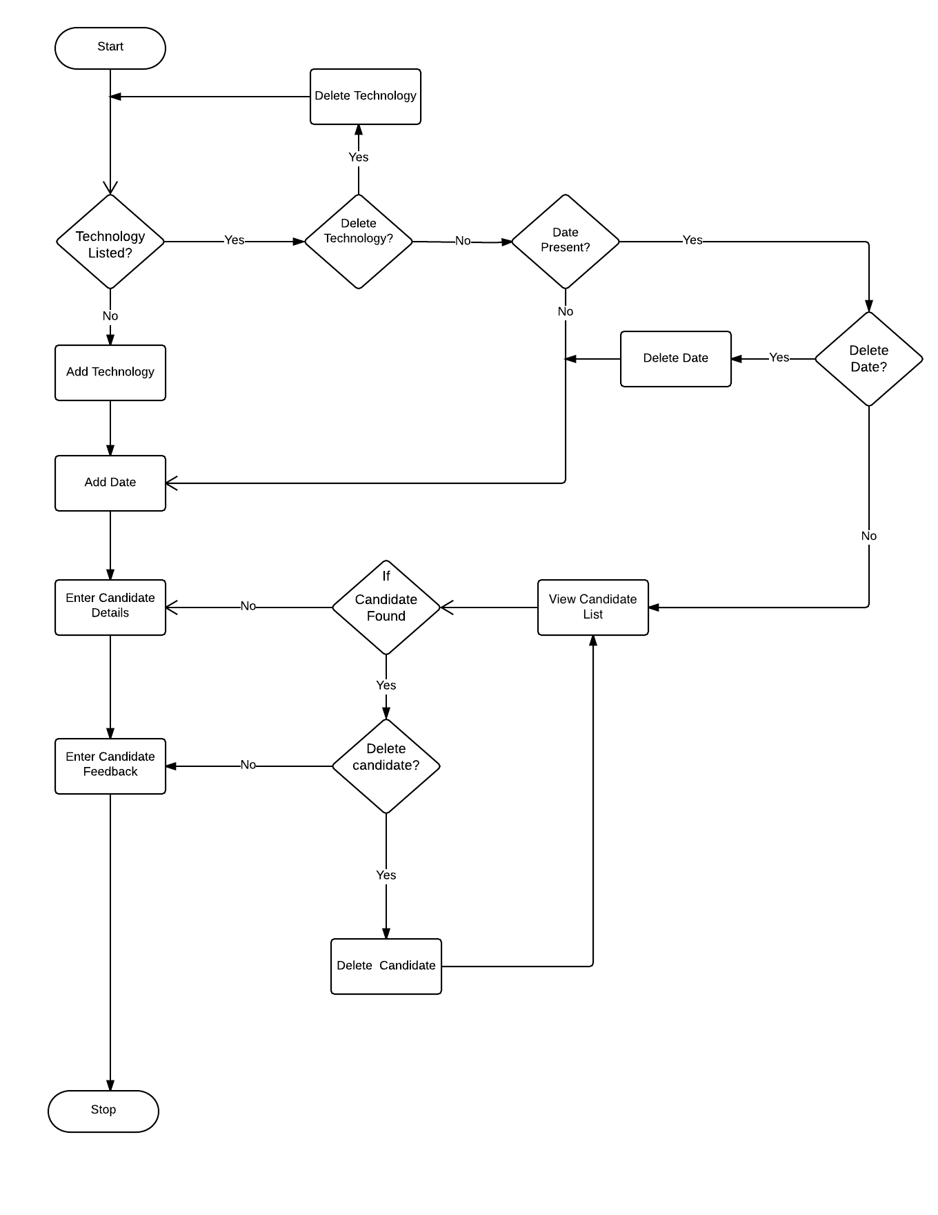

9. Screen shots
Screenshots of the application can be found below.

  - Welcome page
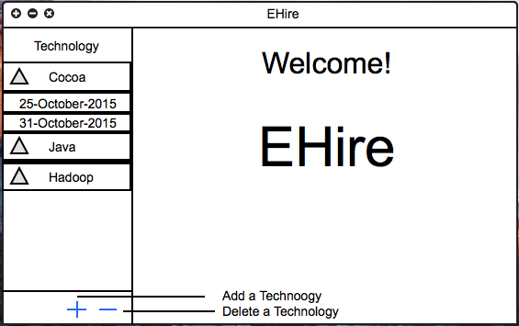

  - Add Date Page
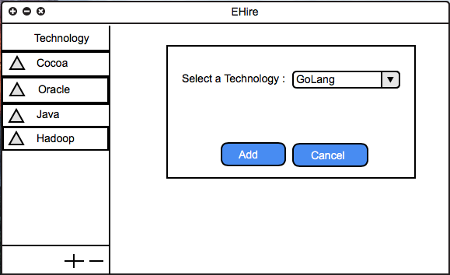

  - View Candidates page
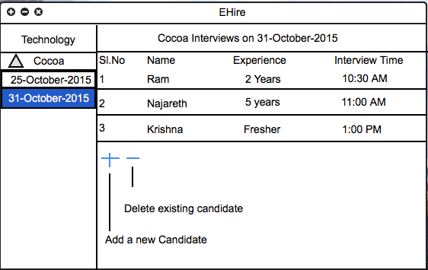
  - Technical interview feedback page
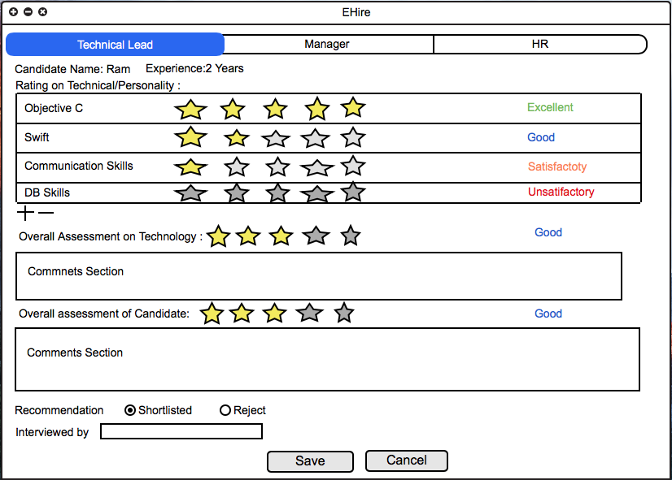
  - Managerial round feedback page
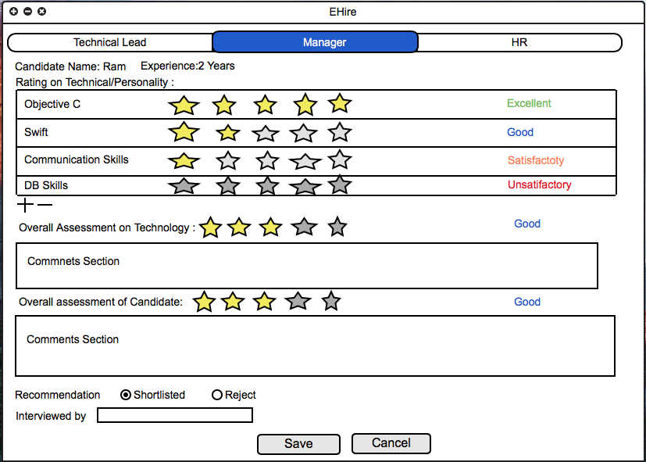

10 Open items

10.1 Discussion required regarding the kind of menu options required.

