OFIGEN

Image generator tool for optical flow based object detection.

Péter Ádám Bánkuti

2018

Contents

Overview 2

What is this for? 2

What is the output? 2

How does it work? 2

How to 3

How to use the add-on? 3

How to create an OBJ model? 12

# Overview

## What is this for?

This tool generates photorealistic images for training optical flow based object detection. These images are complemented with spatial data of the visible objects such as size and position and orientation.

## What is the output?

Each sample consists of an:

* image pair, with minimal differences between them, such as: camera, object or background movement/rotation.
* Another image pair, practically the same as the previous pair, but in this one instead of the models you can see patterned bounding objects, such as spheres and boxes.
* Then these differences are stored in a JSON file.

## How does it work?

The tool was developed as an add-on for Blender v2.78. By enabling this add-on, you will be able to see a control panel for setting up an iterative run with many configurational parameters. After running the iteration, the image pairs (plus the data) will be placed in the specified folder.

# How to

## How to use the add-on?

1. First download git.
2. Create a bitbucket account.
3. Get access rigth to the project by asking an admin to add your bitbucket user to the project.
4. Open git bash, change directory where you want to keep the project:

cd *directory*

1. Clone the repository from bitbucket onto your local machine:

git clone <https://padamban@bitbucket.org/padamban/ofigen.git>

1. Familiarize yourself with the downloaded file structure. (You are bound to use the **.py** files but not the folders, only follow the nomenclature of the files inside the folders.)

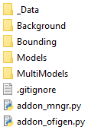

The output folder.

Background images.

Bounding objects.

Add-on for installing Ofigen (very useful during coding)

Ofigen add-on.

Models. (preferably OBJ)

1. Download blender v2.79 (others should work too).
2. 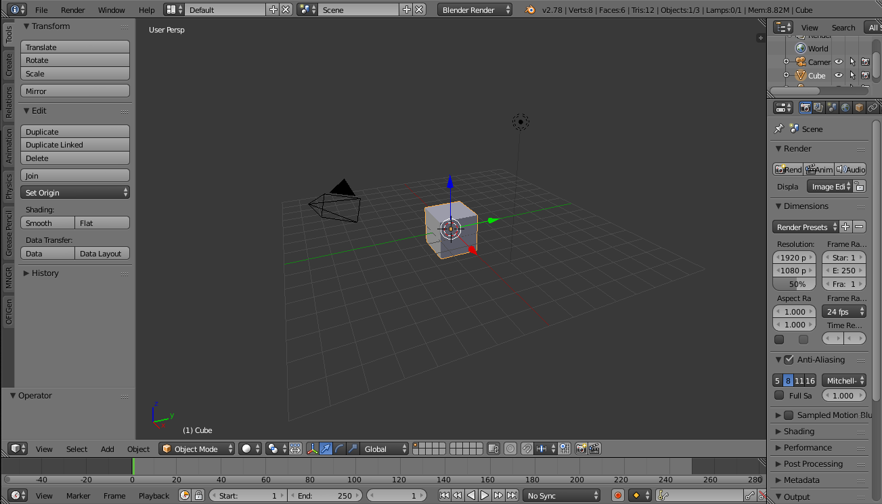Open blender.

1. 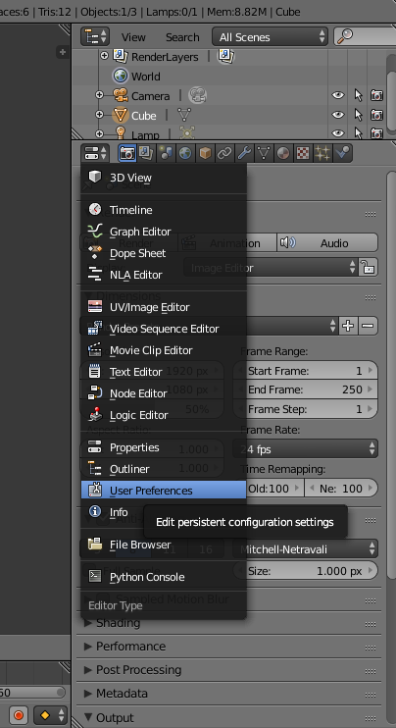Each panel has this corner button. The panel selector.   
   We will use **3D View** and **User preferences**.  
   Swith one of the panels on the right to the user preferences.
2. 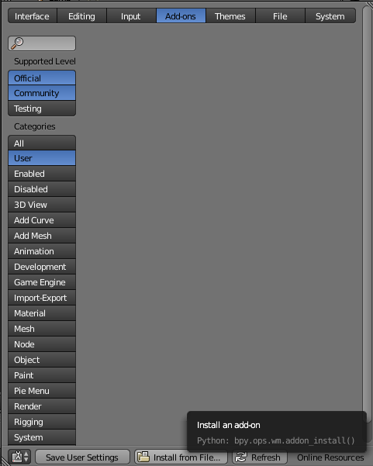Select **Add-ons**. If you click on **Users**, you will see all the add-ons that you have added. ( None so far.)
3. 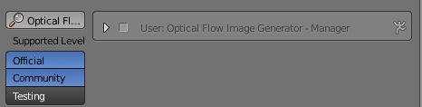On the bottom click on **Install from File…**, than find the directory where you have downloaded the OFIGEN, and select **addon_mngr.py** file.  
   A new add-on will appear, which will be used to install ofigen.
4. You can expand the Add-on, it has some useful properties. Tick-box to enable it, a location, and a remove button.

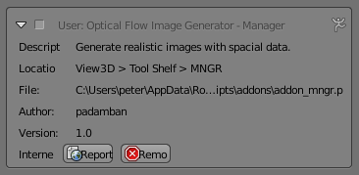

1. Let’s find the add-on.   
   Its on a View3D panel (step 9. 3D View), on tool shelf, and it is called MNGR.  
   Click on it.

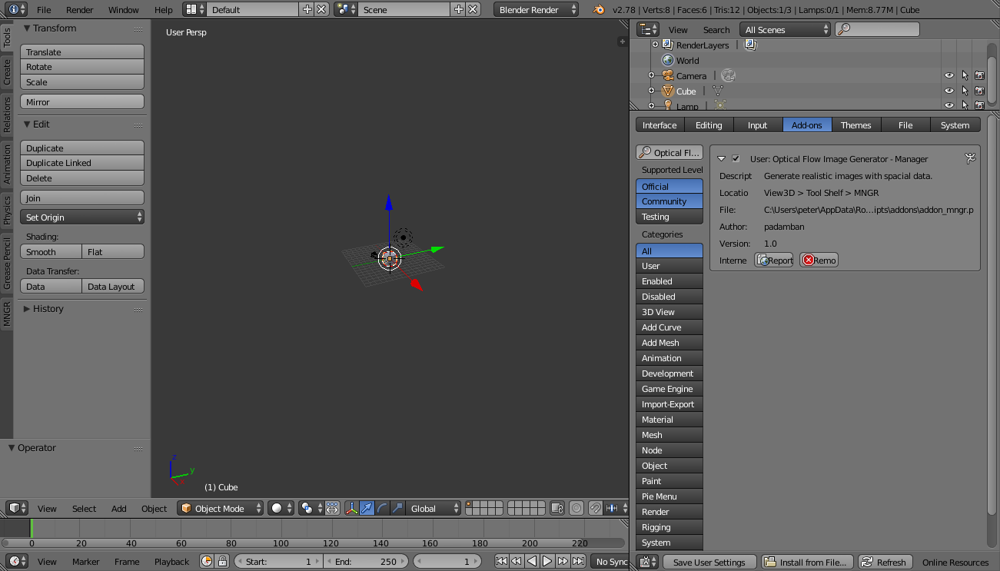

1. Click on the folder icon and go to the Ofigen folder and select the **addon_ofigen.py** file. And click on **Reload OFIGEN**.

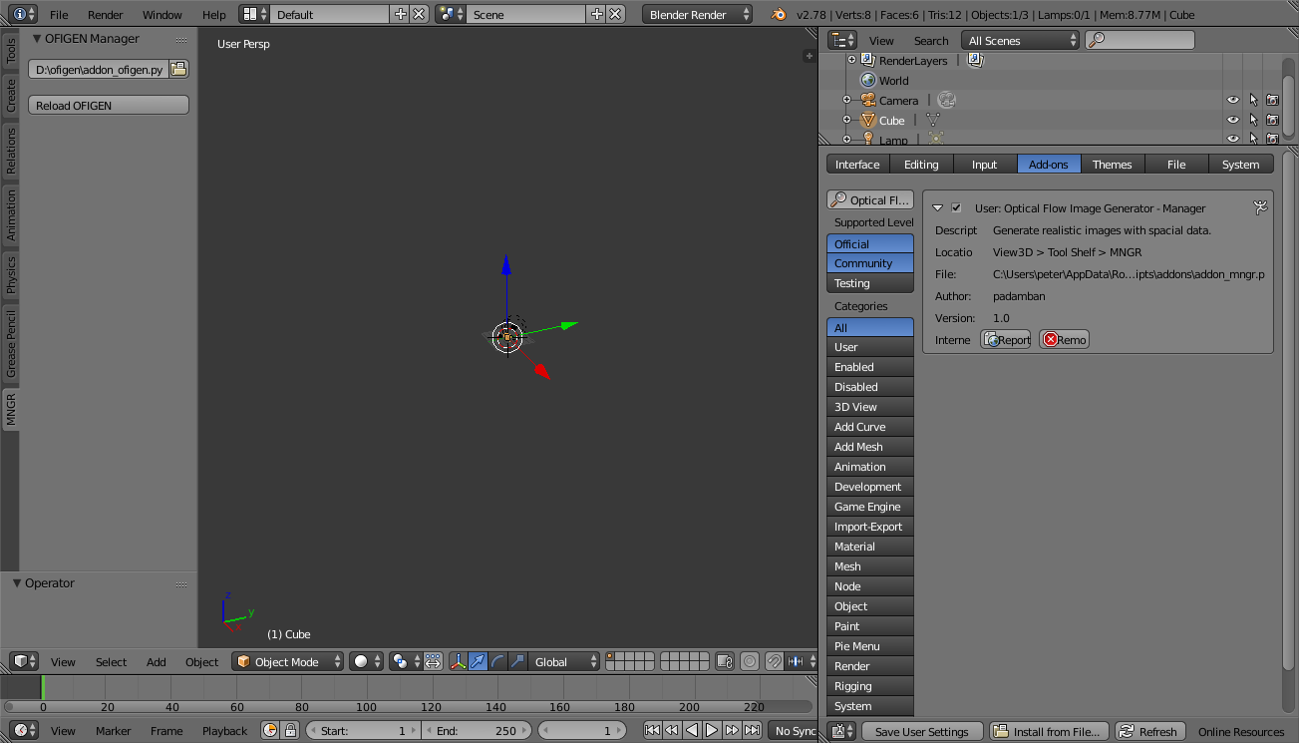

1. The OFIGEN addon will appear.

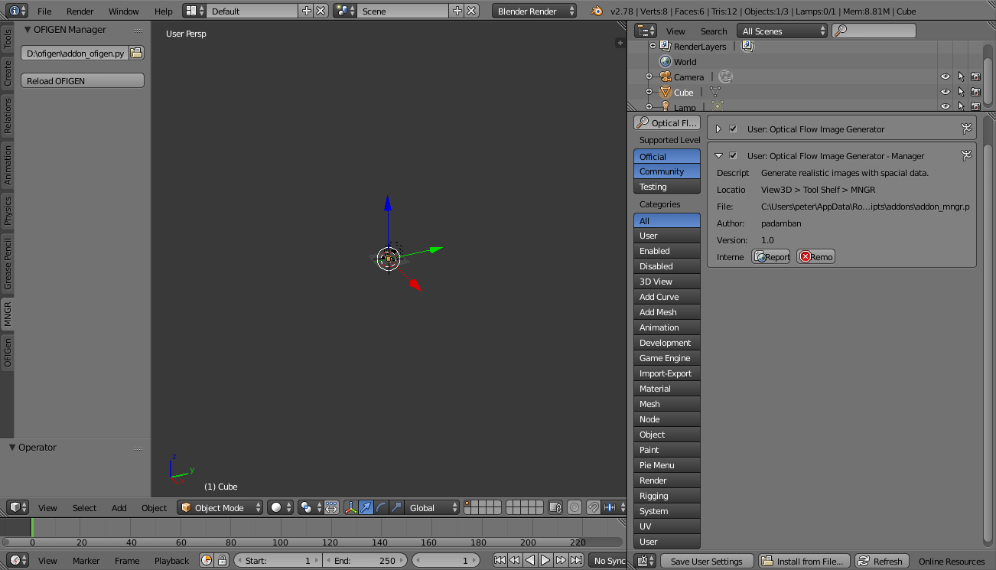

1. 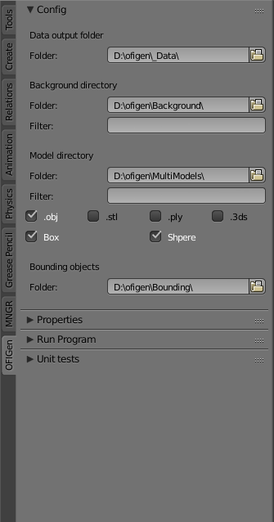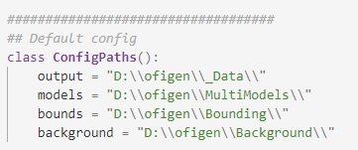First setup the paths. (You can edit the beginning of the **addon_ofigen.py** file to store your paths, this way you don’t have to set up everytime manualy.)
2. If you write something in filter box it will use only sources containing that substring.
3. You can also specify what kind of model types you allow.   
   (recommended: OBJ)
4. Now let’s setup the constraints and parameters. You can hover over each parameter to get some detailed explanation.

* **Field of view coef**: modifies the field of view, 0 is no modification, + narrows and – expands the field of view.
* **Proximity coef**: imagine that each object placed in the scene is in a bubble (bouning sphere), if the coef is 1 than these bubbles can only touch not overlap, if it is bigger than 1 than the bubbles cannot even touch, if is 0 than even full overlap could happen.
* **Random use of …**: if is unchecked the the use of the sources (from the specified folder and with the consideration of the filters) will be used iteratively. E.g: let’s say we have files A B C and we itarate five time, than the usage of this files will be the following: A B C A B.   
  If the tickbox is checked than the usage will be random.
* **(Max) number of models**: even if we didn’t checked in random number of models, the tool might generate less models than specifed. This happens because when it places a new object it needs to find it a place, which happens randomly. This place searching has limited amount of atempts, and if it couldn’t find a suitable location than the object will not be deployed.

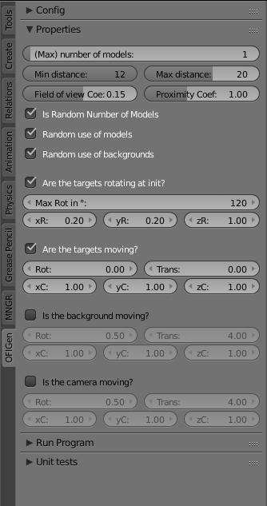

1. Iterations: number of image pairs (+data) you want to generate.   
   (one iteration is around 4s)
2. 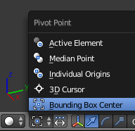Before running. (remedy for a bug)   
   At the bottom of the 3D View set the pivot point setting to Bounding BoxCenter.
3. 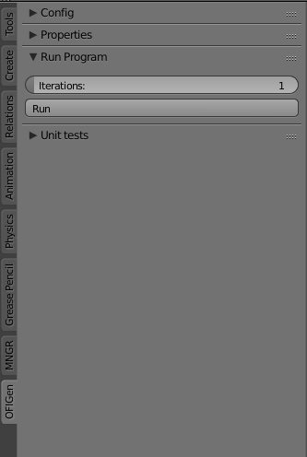Now you can run it.
4. Wait until the cursor and button returns permanentely to its original state.
5. Check out the output folder.

## How to create an OBJ model?

The easiest way.

1. Go to blendswap.com and register.
2. Find a simple model (must be Render:internal which is rare).

* 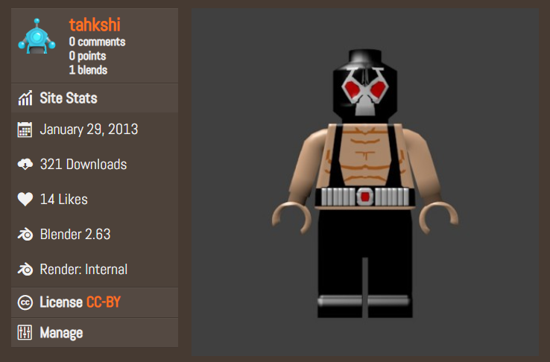There are two render modes in v2.79, Blender Render(internal) and Cycles. (Future releases will have a newer one too, called Eve.) I have chosen the internal because it renders the images much faster, and the quality of the images are still good enough.

1. Download and open the .blend file.
2. Remove all objects, except except the model that you want to use. Save the .blend file.
3. Now go to File > Export > Wavefront (.obj)
4. Select the model folder.
5. Give a name to the object. Tha name must end with _SPH or _BOX. This will signal the bounding shape that the object resambles. These shepes have a respective model in the bounding folder.
6. Save the file.