Elovizsga:  
  
<https://discord.com/channels/517029181154918410/735886588558704691/1183813620069580830>  
  
gyakorlati megoldasok:  
  
<https://discord.com/channels/517029181154918410/735886588558704691/1193242387783368714>  
  
  
  
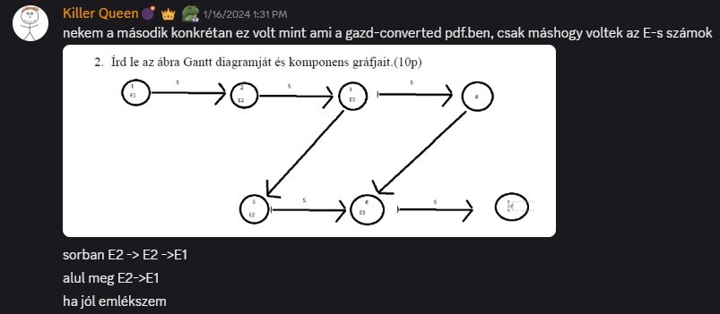  
  
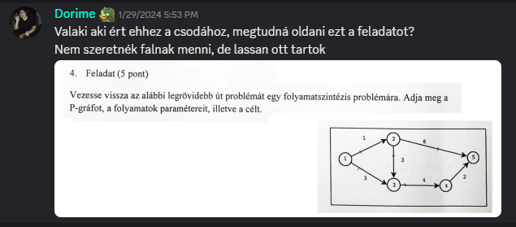  
  
<https://discord.com/channels/517029181154918410/735886588558704691/1201829408370081792>  
