Report

## 4/4분기 매출현황

4/4분기에는 코로나의 영향으로 매출이 감소하였습니다. 전분기 대비 30% 감소하였습니다.

summary(cars)

## speed dist   
## Min. : 4.0 Min. : 2.00   
## 1st Qu.:12.0 1st Qu.: 26.00   
## Median :15.0 Median : 36.00   
## Mean :15.4 Mean : 42.98   
## 3rd Qu.:19.0 3rd Qu.: 56.00   
## Max. :25.0 Max. :120.00

## Including Plots

You can also embed plots, for example:

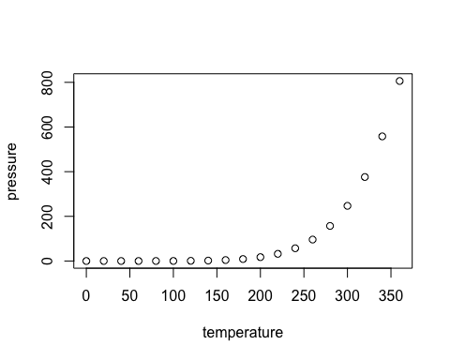

Note that the echo = FALSE parameter was added to the code chunk to prevent printing of the R code that generated the plot.