**District-level coverage and unmet need for medical and traditional circumcision among men aged 10-29 years in sub-Saharan Africa**

Patrick O’Toole1, Matthew L Thomas1,2, Oliver Stevens1, Kevin Lam1,3, Katharine Kripke4, Rachel Esra1, Ian Wanyeki5, Lycias Zembe5, Jeffrey W Eaton1

1 MRC Centre for Global Infectious Disease Analysis, School of Public Health, Imperial College London

2 Joint Centre for Excellence in Environmental Intelligence, University of Exeter & Met Office

3 Department of Statistics, University of British Columbia

4 Avenir Health, Takoma Park, MD, USA

5 Joint United Nations Programme on HIV/AIDS (UNAIDS)

**Introduction**

**Background**

* HIV remains the largest cause of years of life lost for 10-49 year old men in Eastern and Southern Africa (ESA) (global burden of disease study 2013) *(does this need to be updated? Can't seem to find something like it in the same study from 2019)*
* Voluntary Male Medical Circumcision (VMMC) reduces the risk of female-to-male HIV acquisition by 60% (references from Matt's paper)
* In 2016 UNAIDs targeted 90% male circumcision (MC) coverage for 10-29 year olds by 2021 in 14 priority countries in sub-Saharan Africa (SSA) (reference)
* Efficient, cost-effective, one-time procedure for preventing HIV transmission.
* Potential entry point for adolescent boys to engage in health-seeking behaviour.
* Substantial variation across SSA in:
  + traditional male circumcision (TMC) practises, and
  + implementation of VMMC

**Aims**

* Produce detailed district-level circumcision coverage estimates, in order to:
  + Assess recent and current progress, and
  + Identify remaining gaps

towards VMMC HIV prevention targets, in continental SSA.

* Understand how patterns of TMC and medical male circumcision (MMC) vary across SSA, to assist in future VMMC planning.

**Methods**

**Data**

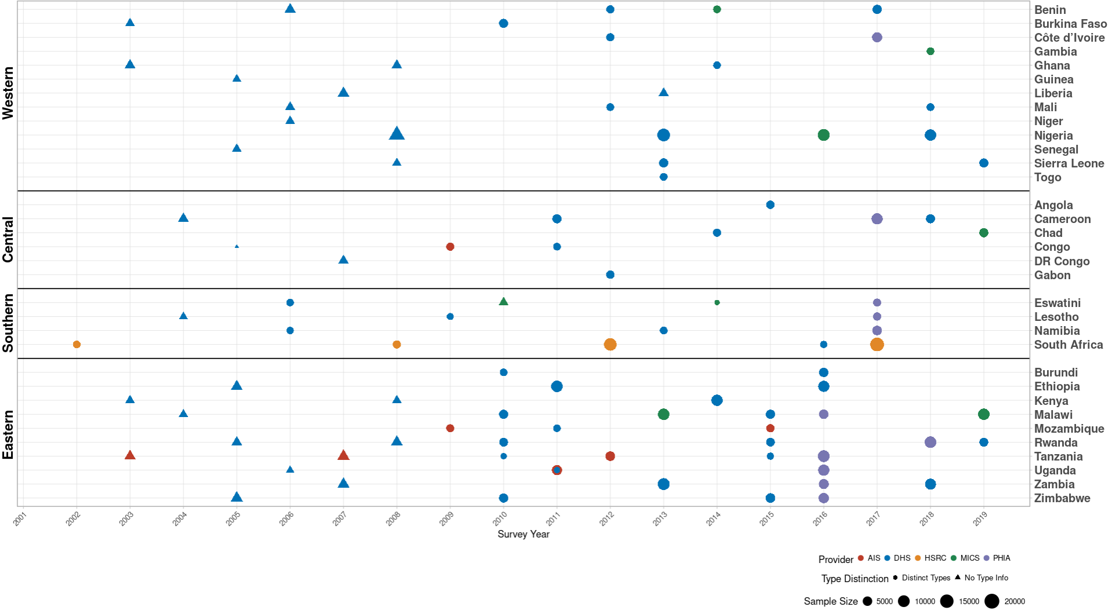

*Figure 1: Household surveys detailing circumcision patterns in SSA. The colour and size of points are determined by the provider and sample size of each respective survey. Triangular points have no information on circumcision type.*

* 120 household surveys conducted in 33 SSA countries 2002-2019
* Self-reported circumcision:
  + Status (MC vs uncircumcised),
  + Type (MMC vs TMC),
  + Year, and
  + Age

recorded

* Sub-national populations from WorldPop (*reference*)

**Model**

* Bayesian spatio-temporal, competing-risks, time-to-event model
* Stratified by age, location and time
* Rates of TMC and medical male circumcision (MMC) estimated
* Coverage in 2020 projected assuming continuation of estimated age-specific rates with probabilistic uncertainty
* Important assumption: Probability of traditional male initiation ceremonies (TMICs) constant over time *(needed? Might lead to a lot of questions!)*

**Results**

1. **Male Circumcision Coverage among 10-29 year olds in SSA, 2010-2020**

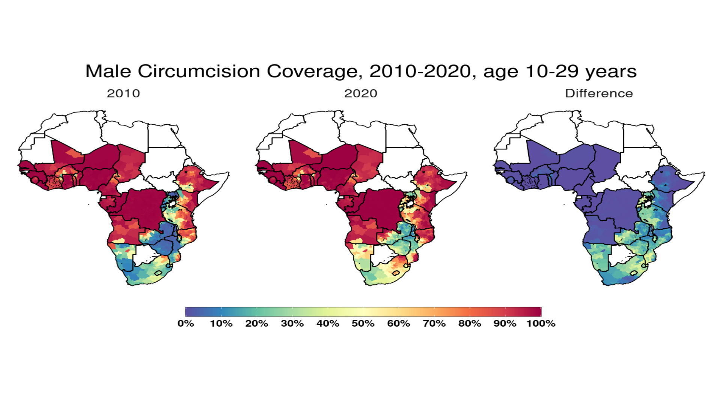

*Figure 2a: Estimated percentage of men aged 10-29 years who were circumcised sub-nationally in 33 SSA countries. Missing from map are Guinea Bissau, Equitorial Guinea, Central African Republic and Botswana, for which no usable surveys have currently been found*

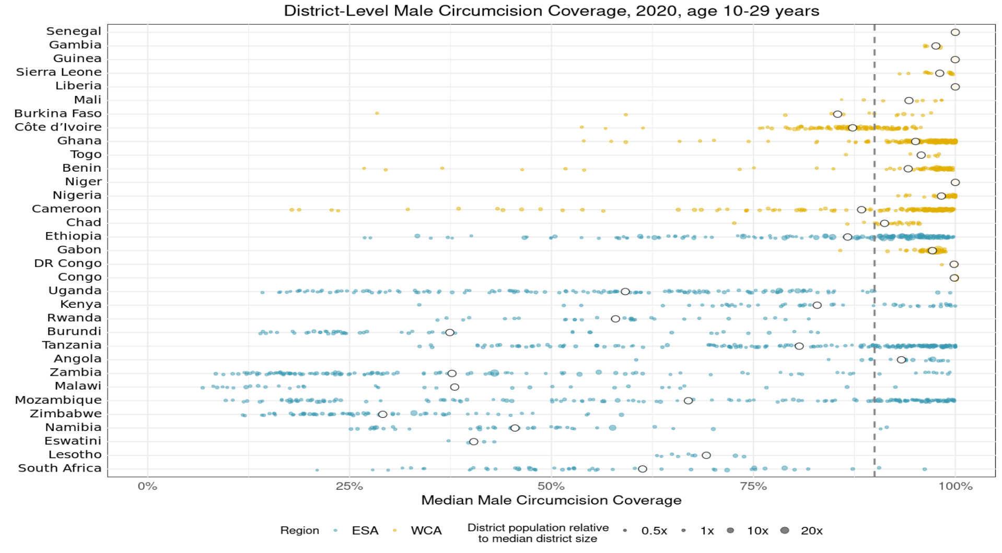

*Figure 2b: District-level median percentage of men aged 10-29 years who were circumcised in 2020 in 33 SSA countries. Each point is a district, sized by district population relative to average district size and coloured by the African region their country falls under (Eastern and Southern Africa (ESA) and Western and Central Africa (WCA), respectively). Each white dot represents the national median. A vertical dotted line signifies the UNAIDS target of 90% national MC.*

Across 33 SSA countries, from 2010 to 2020, amongst 10-29 year old men:

* An estimated 52.98 million men (95% CI 49.5-58.6 million) were newly circumcised.
* MC coverage in 2020 ranged from 100% (99.5%-100%) in Niger to 29.8% (19.5%-49.1%) in Zimbabwe.
* The largest percentage increase in MC coverage was 43.3% (37.0%-51.2%) in Rwanda, from 14.8% (14.5%-15.2%) to 58.1 (51.4%-66.4%).
* Within countries, the median difference in MC coverage between the districts with lowest and highest coverage in 2020 was 39.4%, with the largest variation in Zambia (8.7% to 98.9%).
* From 2019 to 2020, 5.46 million (4.46-6.75 million) circumcisions were performed.
* 27.5 million additional circumcisions are required to reach 90% coverage in all countries.

1. **Medical & Traditional Male Circumcision Coverage among 10-29 year olds in SSA, 2010-2020**

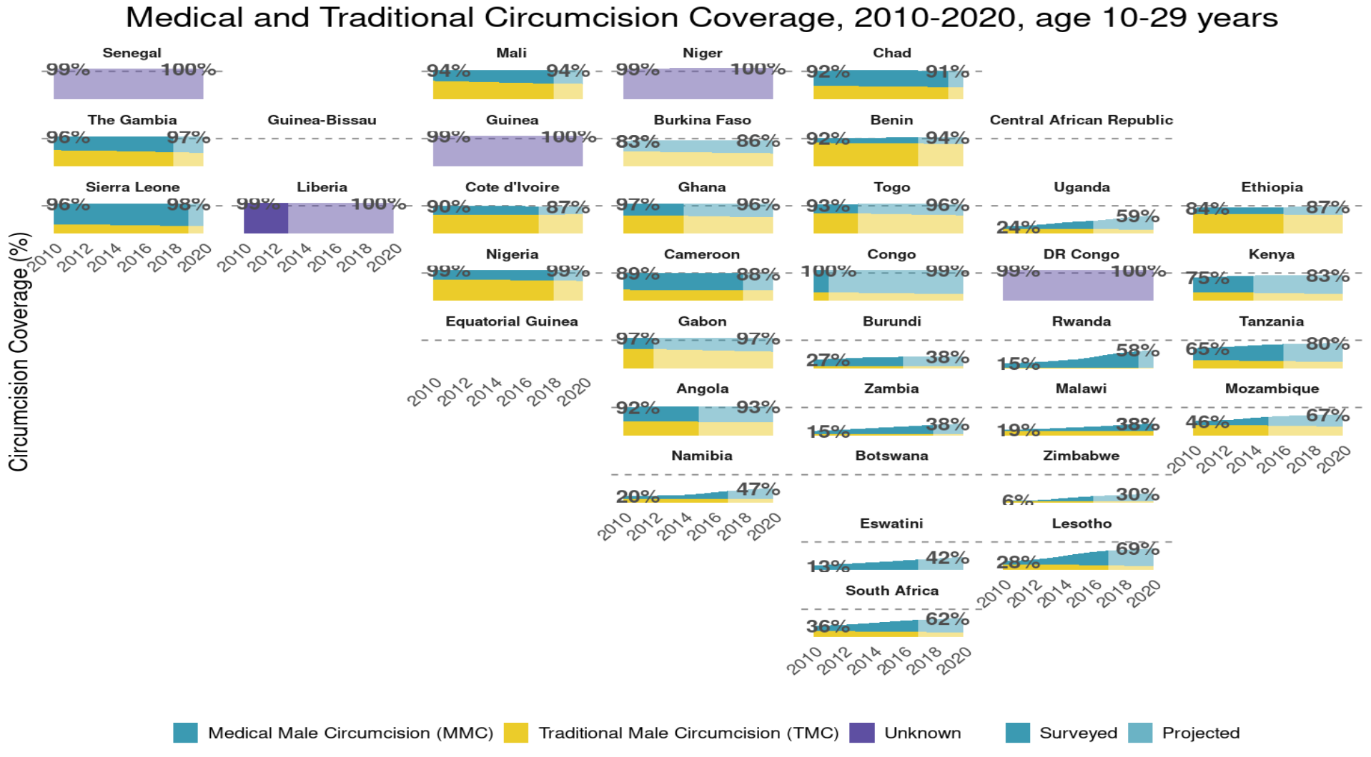

*Figure 2: Percentage of men aged 10-29 years who were medically circumcised and traditionally circumcised over time between 2010 and 2020. The horizontal grey dashed line indicates the 90% circumcision coverage by 2021 target established by the UNAIDS Fast Track strategy. The lighter shaded area represents projection after the most recent household survey. Purple areas represent countries where circumcision type could not be ascertained from surveys.*

Across 33 SSA countries, from 2010 to 2020, amongst 10-29 year old men:

* 31.65 million (25.18-43.52 million) MMCs were performed, along with 11.25 million (5.0-13.4 million) TMCs.
* In 2020, MMC ranged from 76.1% (51.9%-91%) in the Republic of the Congo to 22.5% (19.1%-25.4%) in Benin.
* The country with the lowest level of TMC in 2020 was Eswatini, at 0.8% (0.6%-1.1%).
* The largest percentage increase in MMC coverage was 47.0% (35.9%-57.1%) in Lesotho, from 10.5% (9.7%-11.4%) to 57.5% (45.5%-68.5%).

1. **Progress towards 90% 10-29 year old VMMC Targets in 14 Target Countries, 2020**

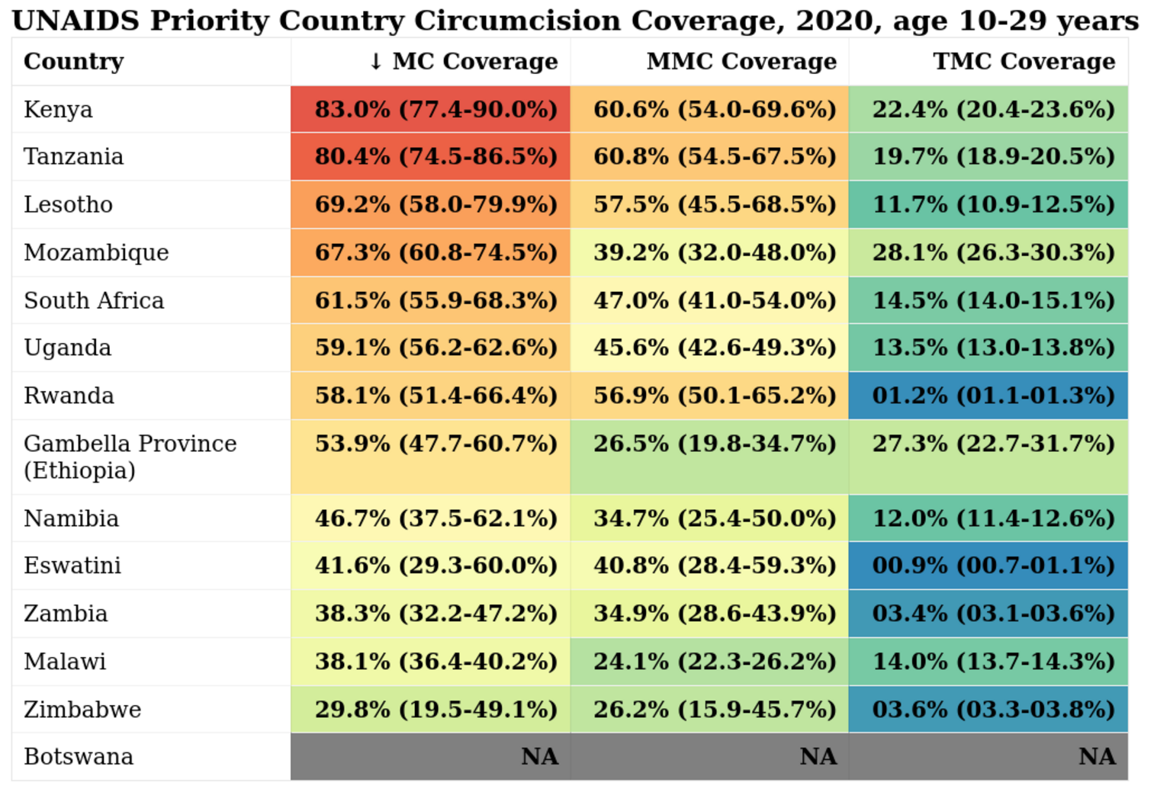

*Figure 3: Table of circumcision coverage in 2020 amongst 15-29 year olds in 14 UNAIDS Fast-Track strategy priority countries. Upper and Lower 95% Credible Interval estimates are also given. Note that only Gambella Province is targeted in Uganda.*

* As of 2020, just one of the 14 priority countries, Kenya, has an estimated MC range in which falls the 90% MC target set for 2021.
* This belies significant variation within countries in MC, with 205(122-279) out of 885 districts within the target countries having achieved 90% MC by 2020.
* 20 million additional circumcisions by 2021 are required order to achieve this goal. From 2010 to 2020, 18.90 million (15.79-22.87 million) MCs were performed in these 14 countries.
* From 2019 to 2020, 1.80 million (1.00-2.78 million) circumcisions were performed.
* 20.056 million additional circumcisions are required by 2021 in order to achieve the UNAIDS Fast-Track strategy target.

**Conclusions**

* VMMC programmes have made substantial, but uneven, progress towards male circumcision targets.
* Granular district and age-stratified data provide information for focusing further programme implementation.

**References**

TODO!