
WEEDINATOR Control Hardware

This is a collection of customisable hardware units that form the electric / electronic building blocks of an agricultural robot. One of the units, Box 1, is designed to control steering, throttles, engine start, engine stop, glow plugs, warning beacons and sounders and dozens of hydraulic solenoids as well as being able to receive cm level GPS coordinates. Box 2 is similar to Box 1 and will typically be used to add extra encoder channels but also a small board computer (SBC) such as a Jetson Orin Nano and a multi camera deserialiser board.

Other hardware units include a 3 camera system based on Raspberry Pi SBCs which uses Ai object detection to help the robot avoid collision with a large set of defined objects, most especially people.

The overall system has an easy, low effort entry pathway for both beginners and experts alike with the main MCUs able to be coded in popular IDEs such as Arduino and STM Cube. Furthermore, there is no complicated circuitry as most of the connections are left unrouted, a bit like an extremely sophisticated bread board with an almost infinite number of ways to configure, just by connecting wires to the onboard WAGO spring lever terminal blocks.

The best way to start with this system is with Box1 and it should be viewed as being a toolkit and people are strongly advised to start with a completely blank canvas. Start by blinking the onboard LEDs and then connect up a RC module and get the RC to fire off the LEDs. Progress through logical self guided steps until you can control rotary motors for steering and linear actuators for throttles. Everything is onboard for steering a small agri robot including support for 5V quadrature encoders and 12V induction sensors for indexing. Maybe have a go at starting the engine using RC? (Be sure to put the drive wheels up on blocks when experimenting) Now control the throttle using RC? Prototyping using the WEEDINATOR system will be rapid and efficient.

We built several agri robots from Iseki and Ransomes tractors and mowers and ended up with what we call the WEEDINATOR control system with the ultimate goal of creating an autonomous weeding / cultivation machine. We found that if we made our control hardware as flexible as possible, there was no need to keep redesign PCBs and in most cases a control box could be removed from one prototype and quickly reconfigured for another one. As time has gone on, new units have been developed to add functionality and safety to the machines.

The units we have developed so far are as follows:

Box 1: Primary robot control including RC and GPS
Box 2: Communication with Internet through 4G plus multiple cameras for crop detection.
Safety Cameras: A 3 camera set up based on Raspberry Pis, with one set at the front and another at the back.

We also work intensively with hydraulic systems but do not offer any hardware in this realm, other than the facility to switch solenoid valves and read encoders.

For up-to-date parts lists and downloadable content visit: https://weedinator.uk/

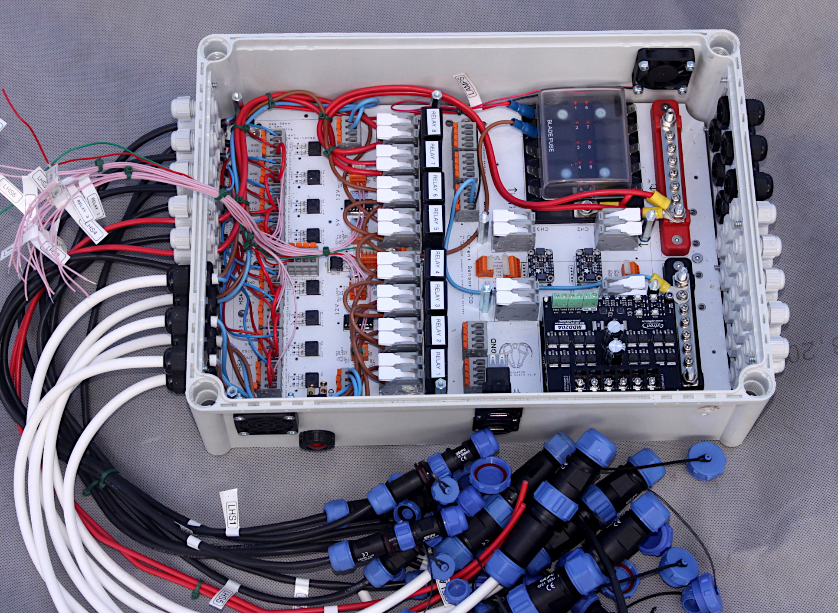
This system is designed to enable small hydrostatically driven agricultural vehicles such as mowers and tractors to be controlled by RC (Radio Control) and 4G derived instructions by interacting with online databases. Typically, RC is used for general maneuvering such as driving the machine out of it’s building to the fields, after which control can be switched to interactive databases.

There are various PCBs available that can be stacked up on the LHS to enable extra relays and / or high side switches depending on way people require. Normally, an agri-robot with complex hydraulic equipment will require at least one additional high side switch PCB layer in the stack.

Notably, most of the PCBs contain very little in the way of set circuits, offering the very greatest flexibility for people to create their own systems. For example, the MCU PCB only has dedicated circuits for 3 LEDs, an SBUS connection for the RC and a 5V power bus for the MCU itself. There is also an onboard 3V3 regulator that powers a GPS daughter board. There are a few very simple ‘helper’ circuits such as bank of voltage dividers which are useful when using 12V sensors and a bank of logic level shifters which are essential for reading 5V quadrature encoders.

As far as coding is concerned, the is no sample code available as, again, only a very few connections are made between the 144 pins on the MCU and any onboard components. However, having said this, it’s advisable to use the following pins for quatrature encoders:
TIM7: PD12 and PD13
TIM6: PE9 and PE11
TIM5: PA0 and PA1
There are probably more options, but this is all we have found so far.
WEEDINATOR Control Hardware – Box 1
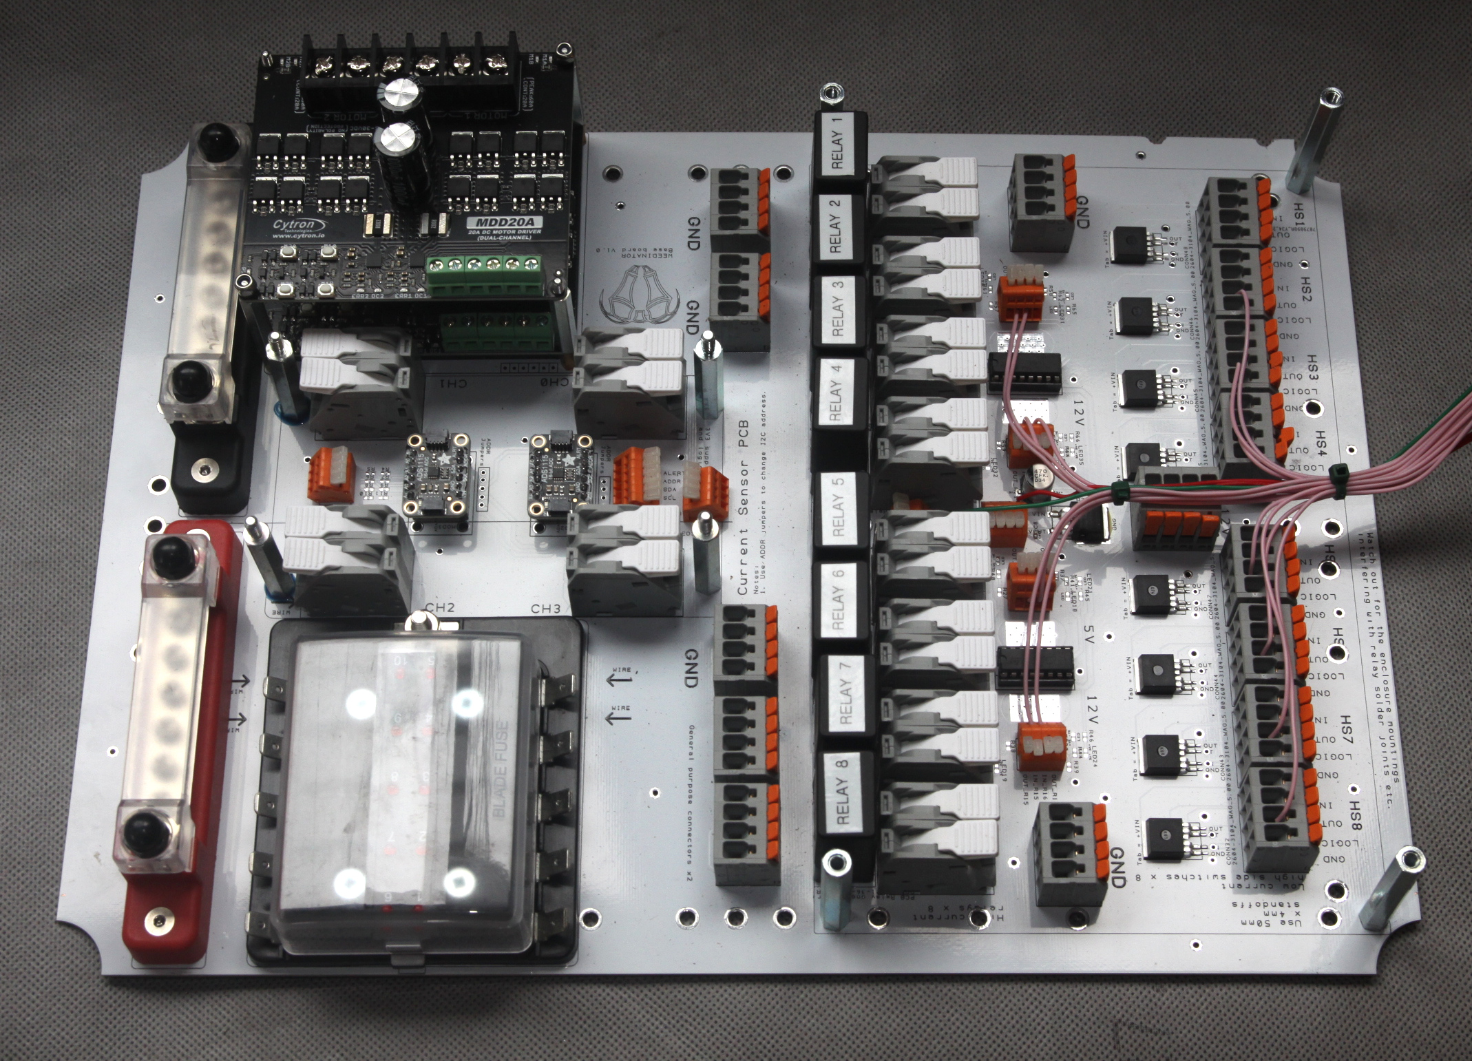
This is the first board of the stack and sits neatly in the bottom of the control panel enclosure. The main features include:

8 x 40A removable automotive relays for operating glow plugs, starter motor relays etc.
8 x High side switches for actuating hydraulic solenoids, signal beacons etc.
4 channel digital current sensor.
Stackable 2 channel 20A motor controllers.
Automotive style 10 way fuse box with LED blown fuse warnings.
Heavy duty 12V bus bars.
Auxillary connectors for ground x 3 and unrouted x 2.

The relays themselves are driven by 4 channel L293D chips, which themselves receive 3.3V logic signals direct from the MCU.

The PCB itself is not designed for high current, but is upgraded by soldering heavy copper wires on the reverse side (see next photo).

Apart from the motor controllers, most of the PCB stacking occurs on the RHS of the above image and it’s vital to screw in the correct sized metal standoffs before screwing the base board into the enclosure as they cannot be changed later without disassembling the whole system.

The base board is specifically designed for the enclosure mentioned in the list of components and, when all the components shown in the photo above are fitted, can be screwed into the bottom of the enclosure by means of the brass inserts. The enclosure mounting holes need to be drilled with the exact correct drill bit ie 5.80 mm for the 6mm insert or else the mounting screws will be too tight or the inserts will come loose. Some experimenting away from the enclosure is recommended.

1. Base Board PCB
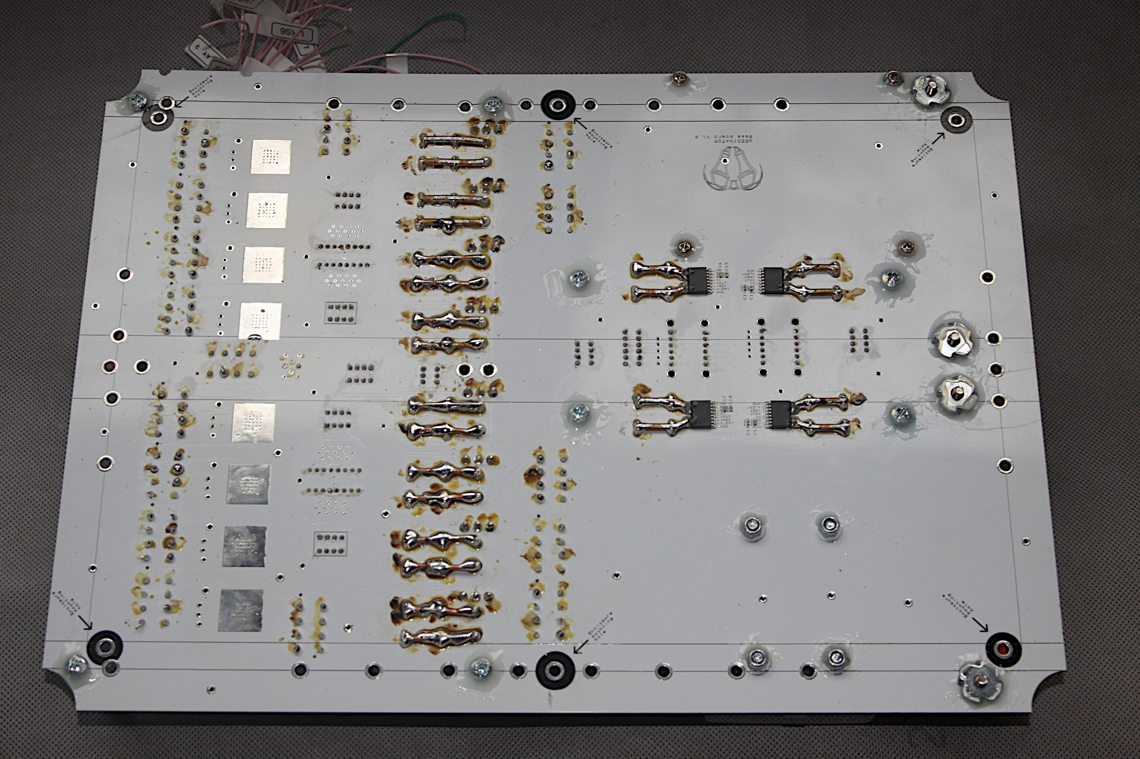
The photo above shows the reverse side of the Base Board with the heavy copper wire soldered across the connections for the relay housings and the large WAGO spring lever operated heavy duty connectors. There are also thick copper wires soldered to the current sensing chip ‘in’ and ‘out’. The soldering itself requires a heavy duty iron and typically requires at least 300W of power.

Before the next PCB in the stack can be screwed on, all the wiring underneath this next PCB must be completed as there will be no further access to this layer. Obviously, if a relay malfunctions, the layers would have to be peeled off, but this would be a very rare occurrence.

The next photo shows the wiring completed for the Base Board. All the thin pink wires going up to the MCU level need to be long enough to connect anywhere on the MCU PCB and should be meticulously labeled with it’s function eg ‘RELAY1’. Each relay also has heavy wire connections which exit the enclosure via either 12mm or 16mm nylon glands. Never try to use connectors that fix onto the enclosure – the external inline connectors are much more practical and easier to use. Each heavy cable, with it’s associated inline connector, is labeled with the exact same label as the thin pink wire that would activate it.

The motor controllers are not wired up at this stage as they get sigals from the MCU board which is normally at the top of the stack on the LHS in the photo below:
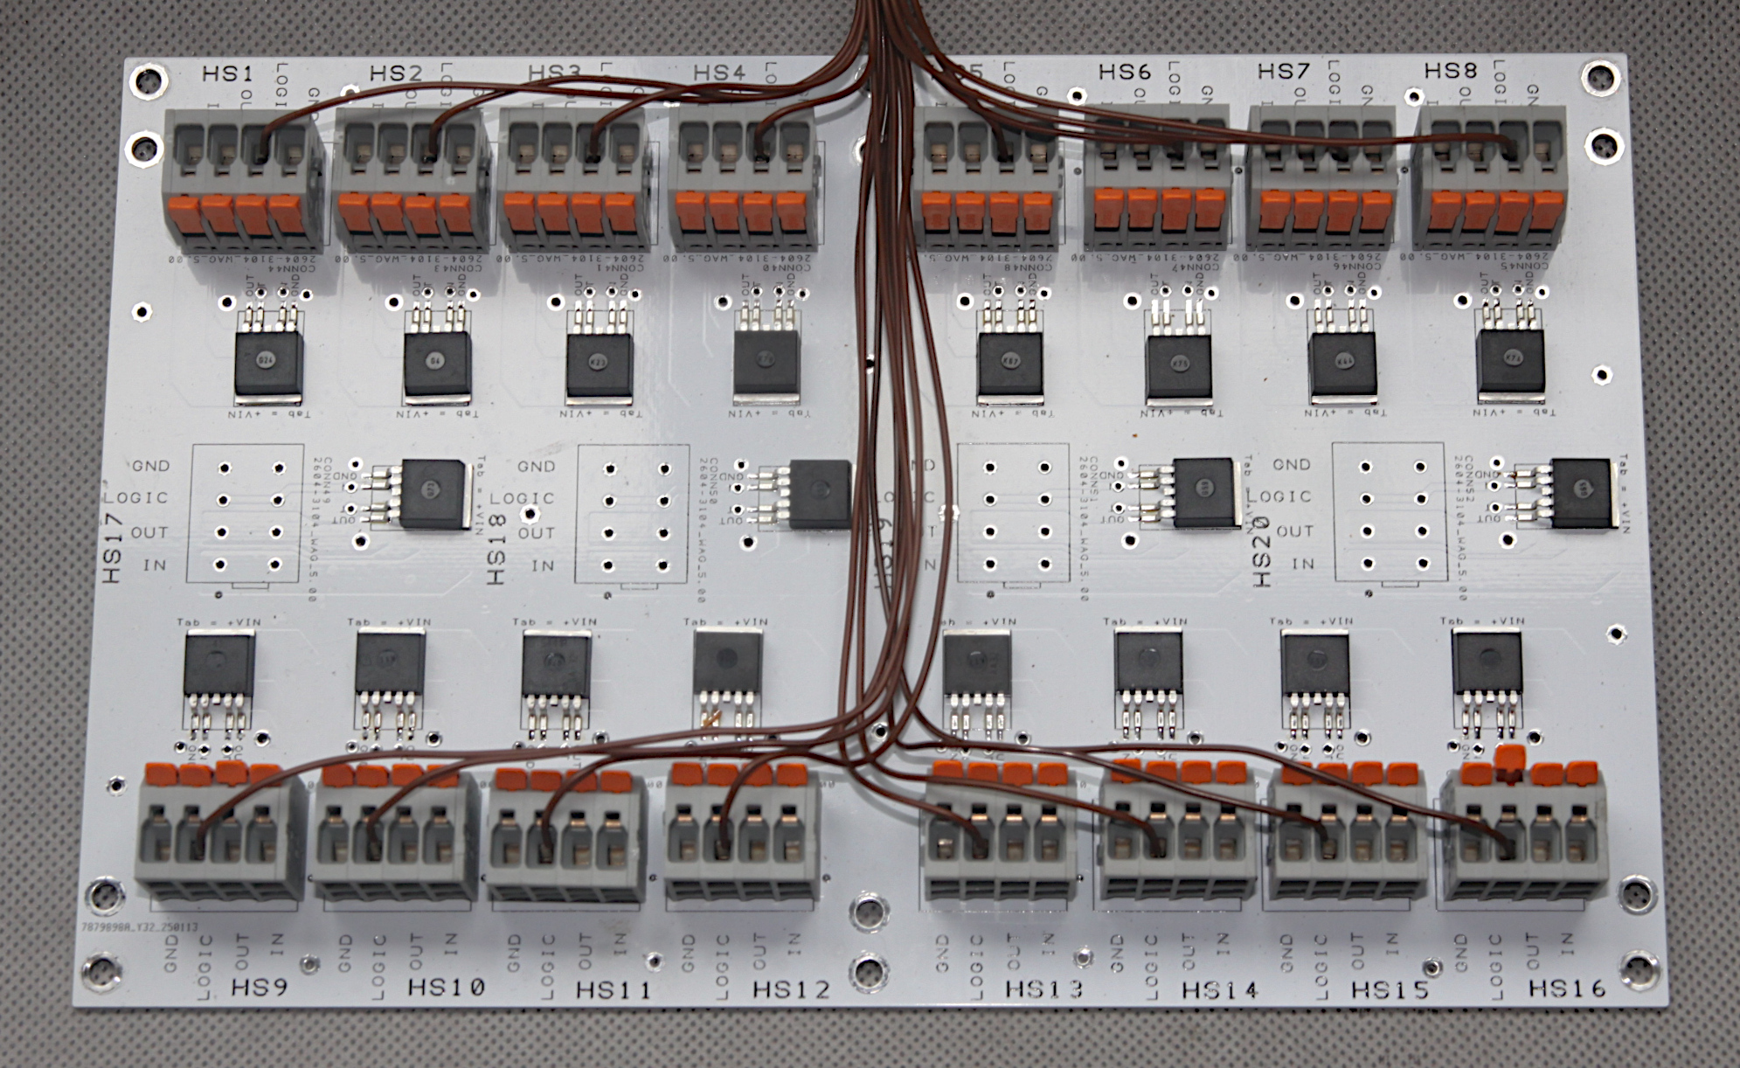
Note the positions of the two fans in the enclosure in the photo above. These positions should not be changed as the fans can interfere with electrical signals if they are in other locations. The enclosure requires at least one USB connection to the outside, which is used for programming and serial communication with small board computers (SBCs) in other control boxes.

2. High Side Switch Board.
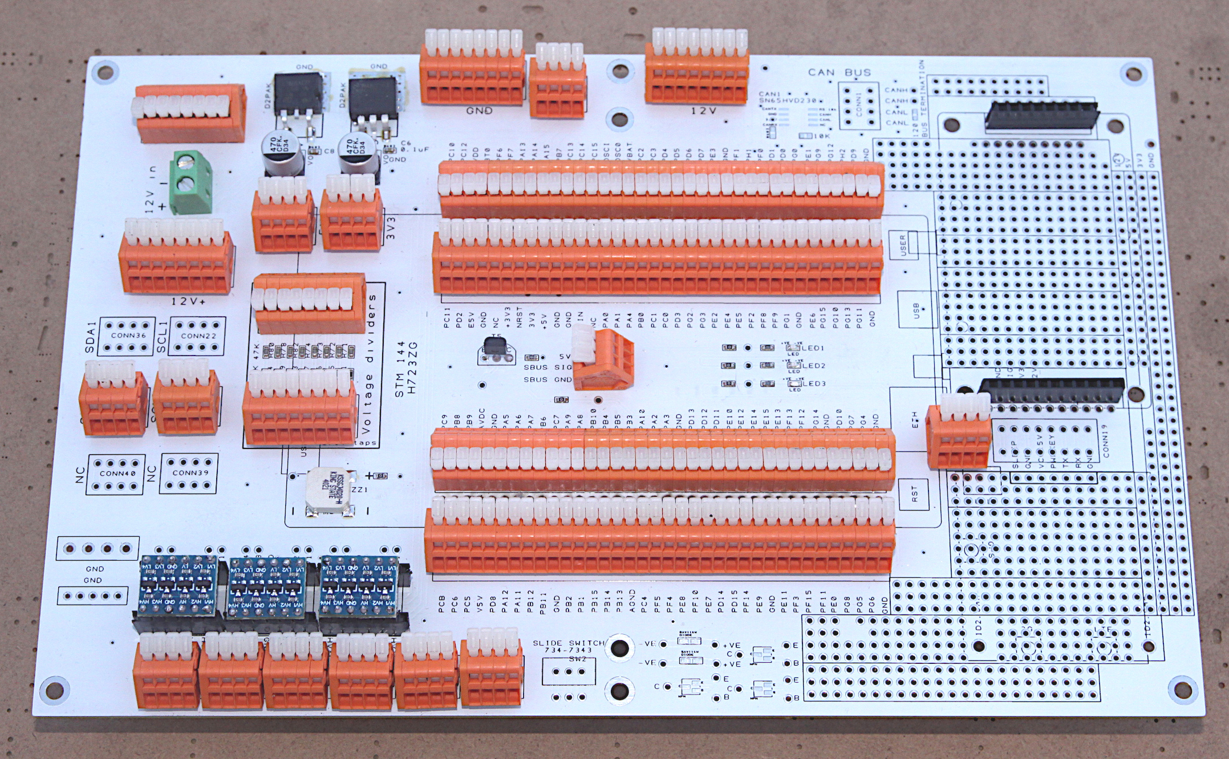
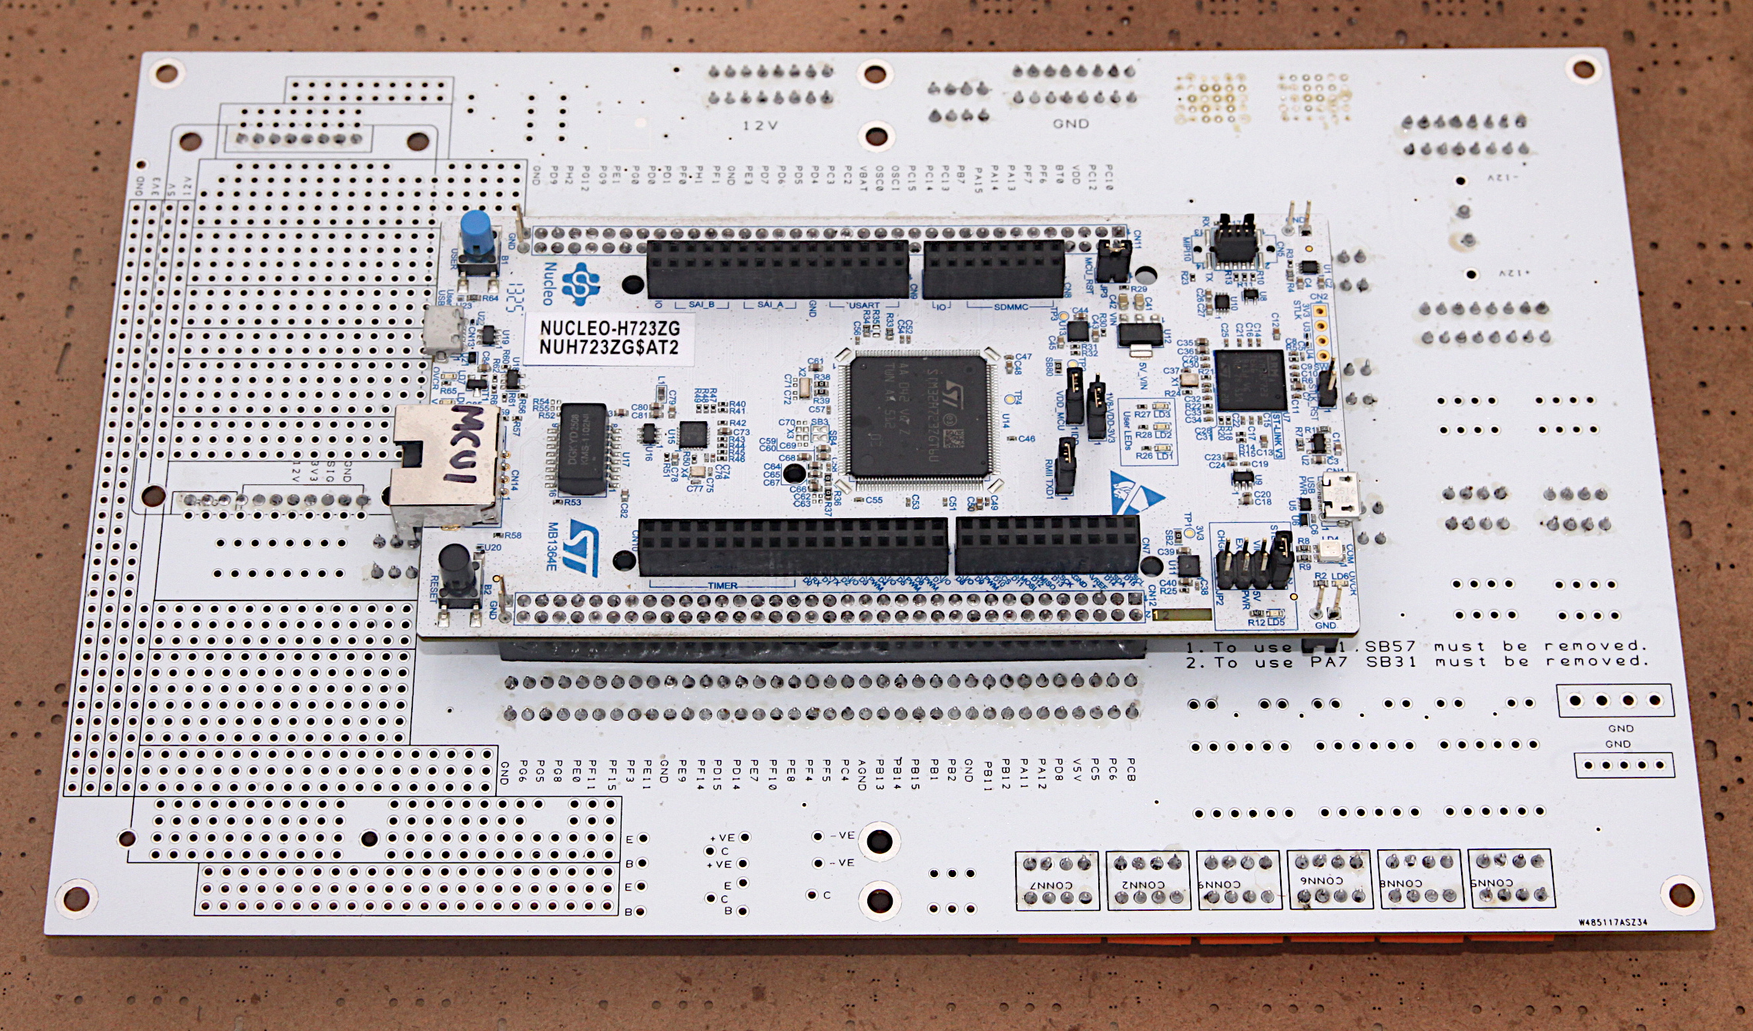
This board offers an addition 20 channels of switching that is perfect for hydraulic solenoids and 12V beacons.
These high side switches require no additional components on the PCBs other than connectors and makes them
extremely easy to use. If the next layer in the stack is to be the MCU board, then the standoffs selected should be long enough to allow clearance for the MCU, which under hangs this next board.

3. MCU Board.
Top:
Bottom:
This the main brain power in Box 1 and features the STM Nucleo H723ZG. Each of the 144 connections of the MCU are brought out to the orange WAGO spring lever release connectors and only a few have connections on the PCB via zero Ohm resistors, notably 3 LEDs, one buzzer and one SBUS circuit for RC.

Additionally, there is a bank of voltage dividers for taking 12V signals from 12V sensors such as induction sensors and converting them to 3.3V friendly ones. There are also 12 channels of bi-directional logic level shifting that converts signals between 5V and 3.3V which is essential for interaction with many quadrature and motor controllers.

There are two voltage regulators on the PCB, one for 12V to 5.0V and the other for 12V to 3.3V.

There are two black headers on the LHS for accepting a daugher board for the Ublox GPS modules and a 4 pole connector for powering the daughter board and receiving UART signals.

On the lower side is mounted the MCU, allowing the top surface to be latively unclutters, with plenty of room around the 144 orange WAGO connectors.

