# Login Form

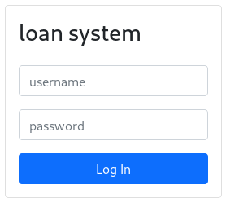

# Customer View

## View/Search loans

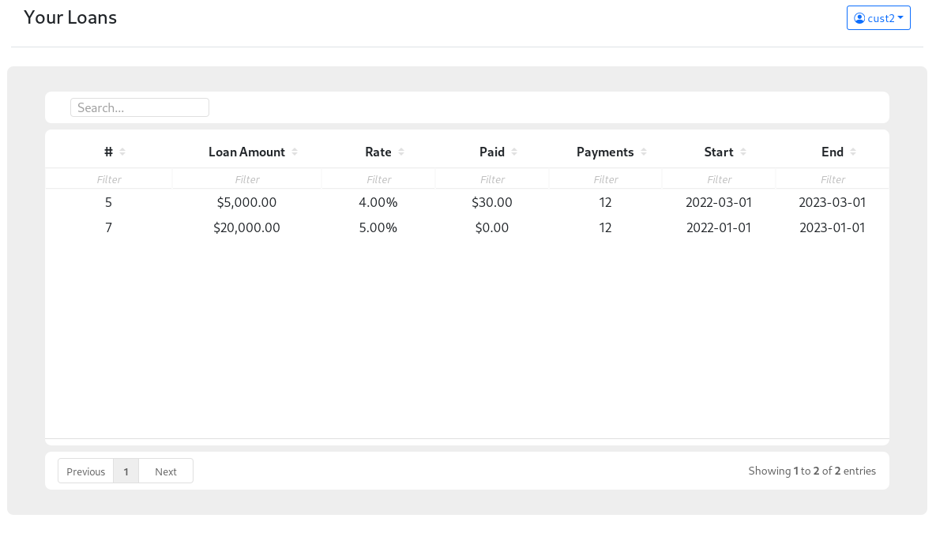

# Admin View

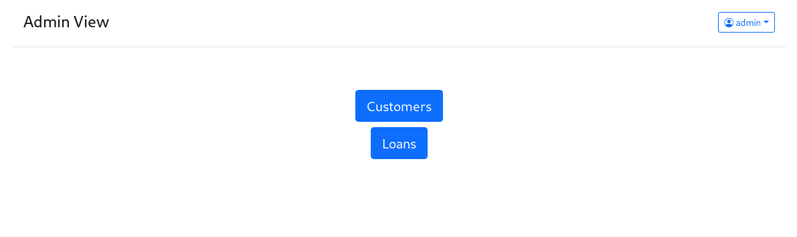

## View/Search Customers

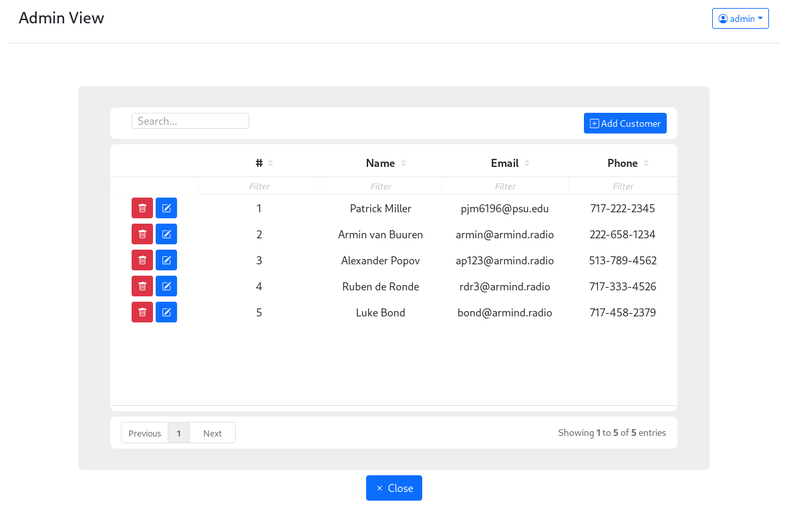

## Add/Edit Customer

## View/Search Loans

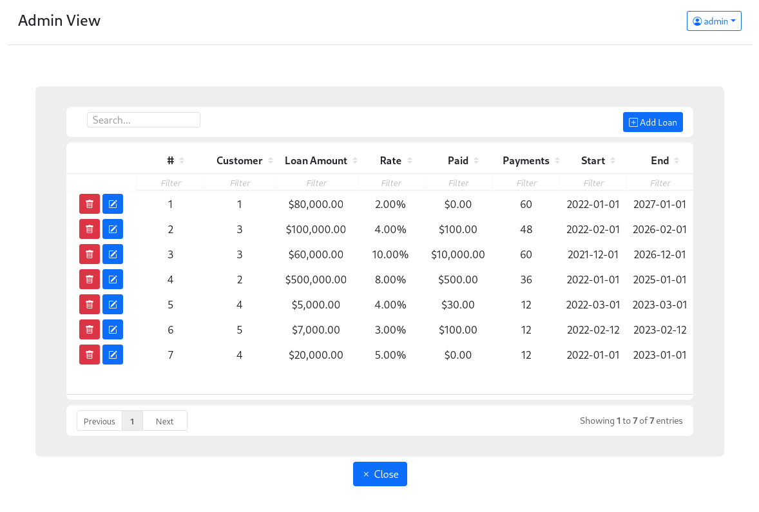

## Add/Edit Loans