Table Structure for Database & Backup Database

Diego Sanchez
Assigned Tables:
Incident (user enters data, entered data on index.html on 11/22) State (done) Location (done)
Location_Detail (done)
Incident_Officer (user enters data) Officer_Assignment (done)
Officer_Call_Type (done)
Officer_Status (done)
Officer_Dept_Type (done)
Officer_Department (done)
Officer (user enters data, entered data on index.html on 11/22)
Race (done)
Created ERD’s for assigned tables & integrated tables to main & backup database (master_db_shot.sql.)
Last Revised by DS 12/10/15.
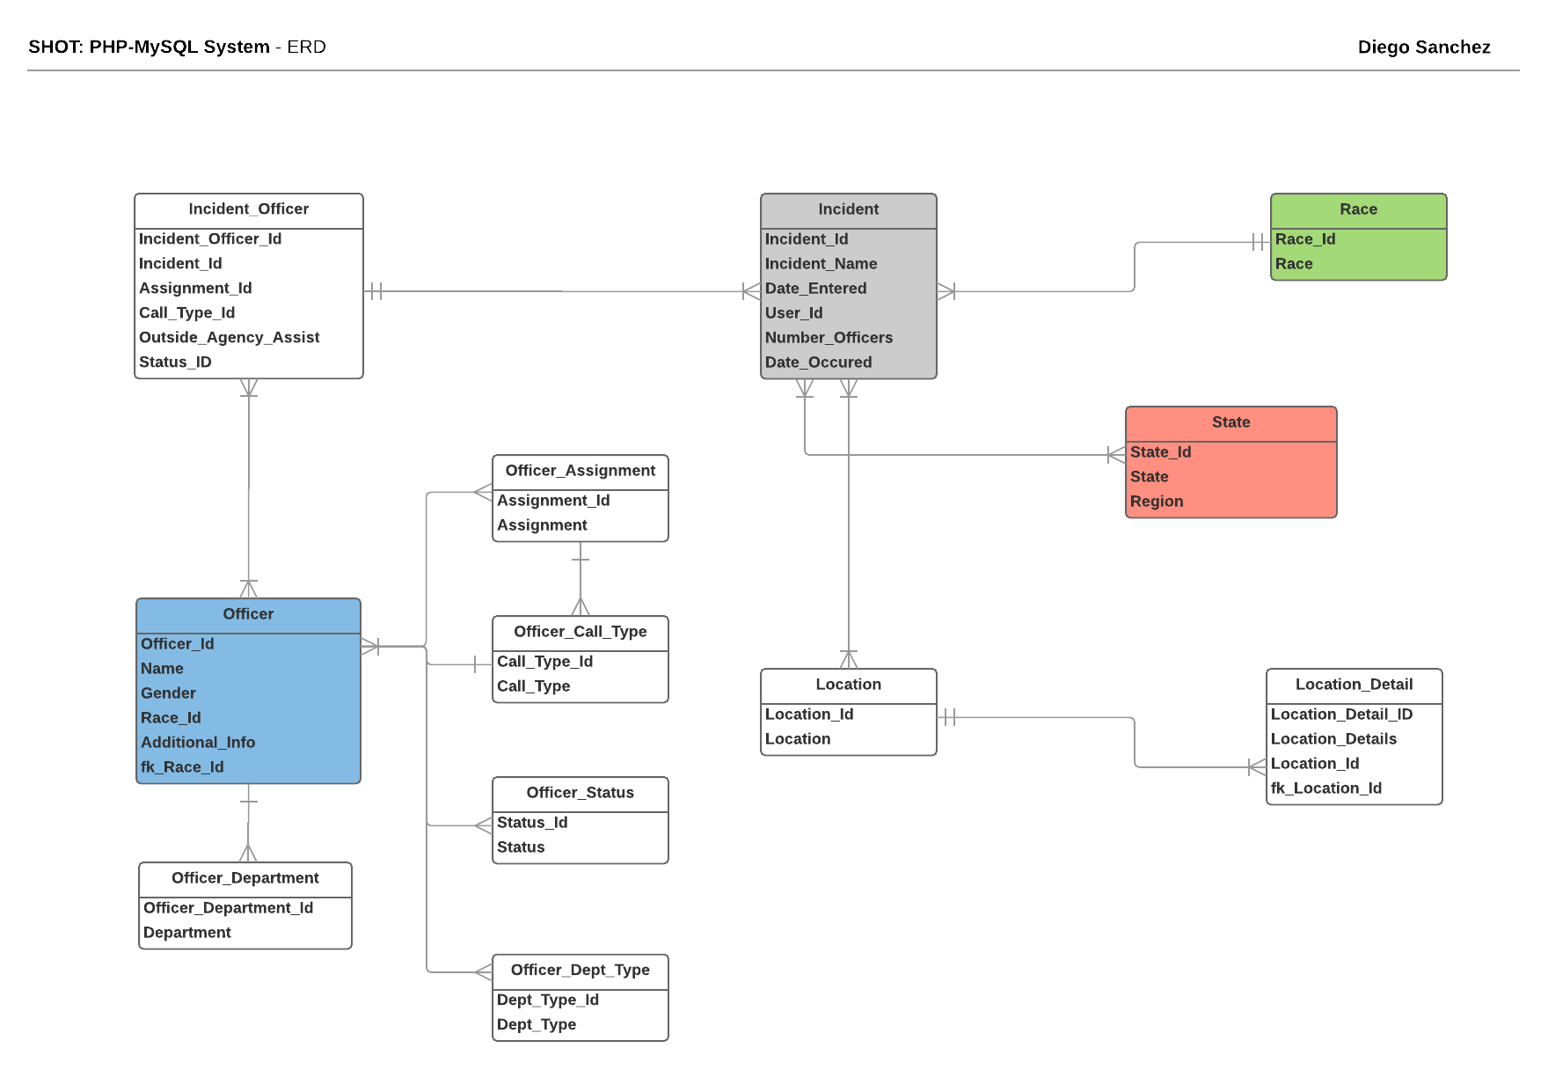
NIKHITA
Officer_Mapping (done)
Incident_Suspect (user enters data)
Mental_States (done)
Weapons (done)
Aggression_Type (done)
Suspect (user enters data)
Suspect_Mapping (user enters data)
Incident_Shot (user enters data)
Target_Area (done)
Incident_Source (user enters data)
Source_Type (done)
Newspapers (done)

