SHOT Database System

**Pace University**

Capstone Project Team 6

Brenden O'Reilly CS691

Joseph Gentile IT691

Nikhita Gopidi CS692

Colin Rose IT691

Diego Sanchez CS691

**Table of Contents:**

**Pg 3:**

I: Purpose

II: Home Page

III: Initializing the System

**Pg 4:**

IV: Menu Bar

**Pg 5:**

V: Creating an Incident

**Pg 6:**

VI: Updating/ Deleting an Incident

**Pg 7:**

VII: Database Maintenance

VIII: Database Reports

**Pg 8:**

IX: Environment

**Pg 8:**

X: Installation

**Pg 8:**

XI: Additional Information

**I: Purpose**

* Objective: This project is to develop a web-enabled database to collect, edit, query and analyze police shootings.
* Why: Violence involving police shooting has taken the spotlight in the media in the United States.
* Currently, there is no national database for police shootings.

**II: Home Page**

* To initialize the SHOT System please visit the following link:

**~**[***https://vulcan.seidenberg.pace.edu/~f15-cs691-shot/html/SHOT_System/app.html***](https://vulcan.seidenberg.pace.edu/~f15-cs691-shot/html/SHOT_System/app.html)

**III: Initializing the System**

* The following screen will appear, click submit to start.

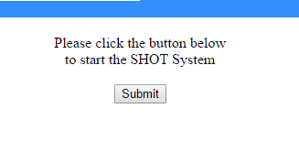

**IV: Menu Bar**

* You will see a screen that looks like the following:

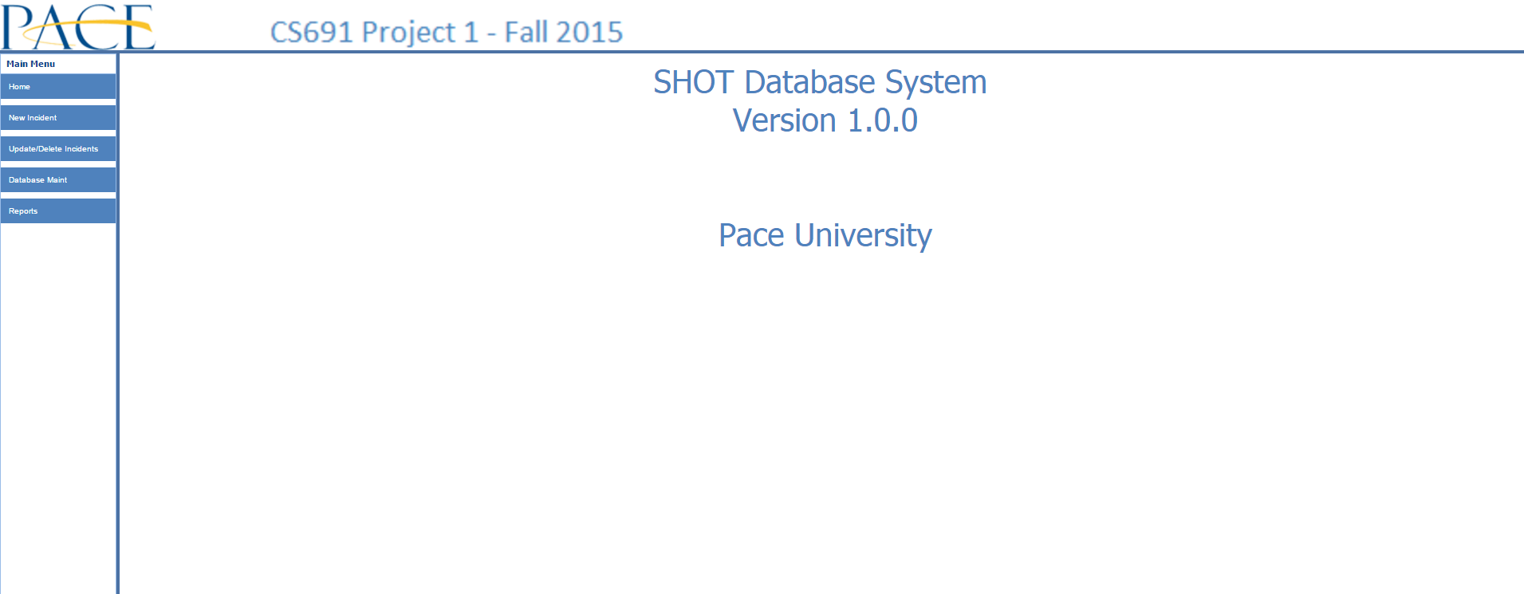

* Note the menu bar on the left hand panel.

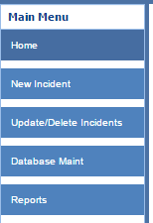

* This serves as the main navigation window for the shot system.
* To use a feature simply click on the name.

**V: Creating an Incident**

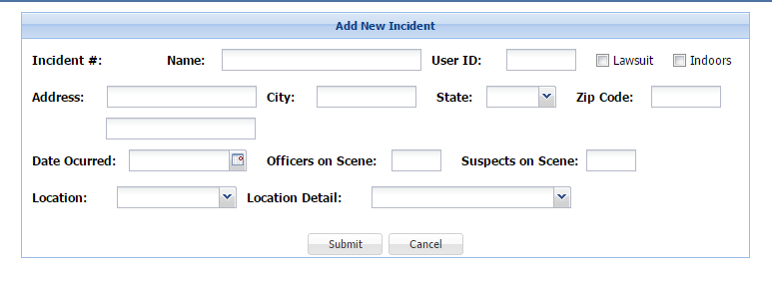

* To Create an incident fill out the following information in the appropriate box:
* Name of the incident.

**Ex:** *The Miami Shooting*

* The user ID (OF WHO?)
* The address of the person involved in the shooting.
* City, State and Zip Code of the person involved in the shooting.
* The date of the incident.
* The total number of officers on scene.
* The total number of suspects on scene.
* The location of the incident with further detail location.

**VI: Updating/ Deleting an Incident**

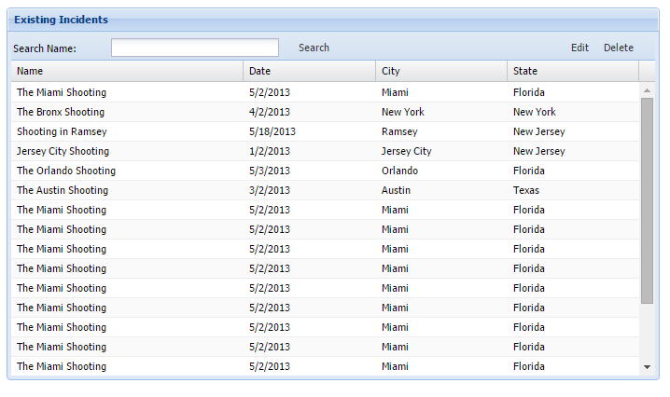

* **To Edit and incident simply select the one you wish to edit and click the edit button. (Click the delete button for deletions)**
* **You will see a window that looks like the following. Correct whatever information and click “submit”.**

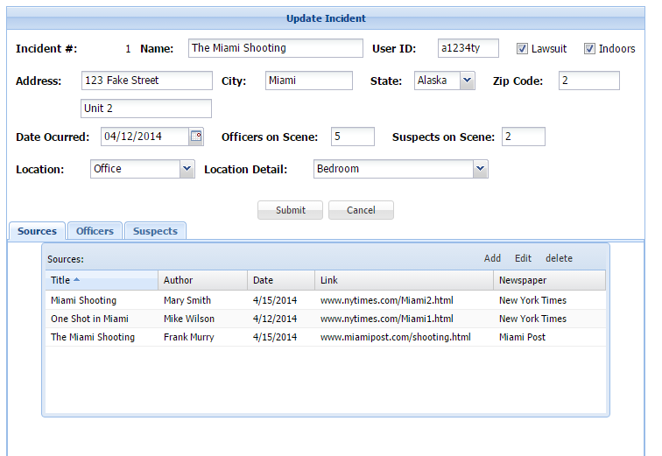

**VII: Database Maintenance**

* Coming Soon!

**VIII: Database Reports**

* Coming Soon!

**XV: Environment**

The SHOT Database System can run in either Windows or Unix. The user interface and PHP scripts can run in Apache HTTP server, and the database must run in MYSQL server 5.0 or higher. Also the application can run in any modern browser, such as Internet Explorer, Chome or Firefox.

**X: Installation**

In order to install the user interface and PHP scripts onto the web server, please copy the SHOT_System folder to under the root HTML folder of the Apache HTTP server and then start the Apache HTTP server.

**XI: Additional Information**

The user interface is written in EXTJS 4.1. This is a freely downloadable JavaScript API. A quick tutorial on EXTJS can be found at the following URL:

http://docs.sencha.com/extjs/4.1.3/#!/guide/getting_started

.