Mike Harris, Mihir Padechiya

mjharris@binghamton.edu

mpadech1@binghamton.edu

Abstract

A process that enables potential and existing New York State small business owners to obtain immediate services from the New York State Small Business Development Center.  
Revision Draft 1.4 - 8/14/2018



Real time Clint in take  
(RTCI)

**Revision History**

**Change Record**

|  |  |  |  |
| --- | --- | --- | --- |
| **Date** | **Author** | **Version** | **Change reference** |
| 08/05/2018 | Mihir Padechiya | 0.1 | Initial Version |
| 08/14/2018 | Mihir Padechiya | 0.2 | Adding architecture and software’s used |
| 08/21/2018 | Mihir Padechiya | 0.3 | Updating the document as per Mike response for clarifications. |
| 08/26/2018 | Mihir Padechiya | 0.4 | Updating the document as per discussion with Al and Proff. Merwyn |
| 12/22/2018 | Mihir Padechiya | 0.5 | Updating the document as per discussion during the final demo of SBDC in Fall 2018 with Proff. Jones, Mike, Rochelle,Kubiley |
| 04/21/2019 | Mihir Padechiya | 0.6 | Updated the final version – things marked in yellow are implemented, other need to be done. |

**Reviewers**

|  |  |  |  |
| --- | --- | --- | --- |
| **Name** | **Version approved** | | **Date** |
| Mike |  |  | |
| Rochelle |  |  | |
| Al Scher |  |  | |

Table of Contents

**PURPOSE** 2

**SCOPE** 2

**CURRENT PROCESS FLOW** 2

3

**NEW ADDITIONAL PROCESS FLOW** 4

**RELATIONSHIP TO MQS** 6

**SYSTEM INTERFACE** 8

**SOFTWARE INTERFACE** 8

**USER INTERFACES** 8

**COMMUNICATIONS INTERFACES** 8

**MEMORY CONSTRAINTS** 9

**SOFTWARE LOGIC AND FUNCTIONS** 9

**USER CHARACTERISTICS** 9

**ASSUMPTIONS AND DEPENDENCIES** 9

**data REQUIREMENTS and uses** 9

Master Table 10

Child Table 10

**SOFTWARE PROCESS FLOW WITH SCREENS** 10

Client Software Process Flow 10

Advisor Software Process Flow 14

**OPERATIONS** 17

**PROJECT TEAM** 17

# PURPOSE

The purpose of this project is to provide an alternative intake method to the existing process to facilitate client connection to the SBDC program by enhancing and, to some extent, accelerating development or initiation of an inquiry becoming a client. By more quickly engaging with the client on a ‘case specific’ basis through technology that allows the SBDC to begin the ‘advisement conversation’, to personalize responses directly addressing client raised questions, concerns or issues, and, to provide more immediate follow-up information to the potential client. The goal is to create a mechanism using software that allows potential and existing NY State small business owners to obtain immediate services from the SBDC without scheduling an appointment and coming into a SBDC center.

Note: throughout this document “Client” will refer to the small business owner and “client” will refer to a device accessing a server.

# SCOPE

The software will utilize existing SBDC staff throughout the state to facilitate the initial intake via either text or video chat. The software will also provide a way to assist the advisor, structure the intake meeting, identify the tools that will be provided to the Client, collect information necessary (ie the required fields) to create a separate WebMQS (MQS) case, and compose the recap email that includes the SBDC advisement tools discussed with a blind copy to the appropriate Regional Director. RTCI will Compose templated email to the 3 entities:

client, advisor, regional director. Test data

# Current Process Flow

The current process flow provides three methods for potential Clients to access SBDC services

1. Walk In - If a Client walks into a SBDC office, they are presented with a paper form 641. They fill out the form and then meet with an Advisor. The Advisor inputs the 641 into the MQS system creating the case.
2. Call In – If a Client calls into a SBDC office, the Admin takes their information, assigns it to an Advisor, and schedules the first meeting. When the Client shows up for the first meeting, they complete the paper form 641. The Advisor inputs the 641 into the MQS system creating the case.
3. Online Email – If the Client visits the nyssbdc.org website, they can access services by completing an Online Intake form. Submitting the information on the form creates an inquiry in MQS and sends an email to the Regional Director. Regional Director converts the Inquiry to a Case and assigns an Advisor. The Regional Director sends an introduction email with attachment tools introducing the SBDC Advisor. The assigned Advisor communicates with the Client to set up a meeting. The Advisor updates MQS after the meeting.

The existing process flow is depicted in the flow chart below.

# 

# New Additional Process flow

1. The additional new process flow adds a real time advising option. The process starts with the RTCI online intake form. After completion, the Client is given the option of either a Text Chat or a Video Conference/Chat. This prompts an online Advisor to begin a chat session. If no Advisor is available, the user is prompted with an option allowing them to make an appointment for meeting on-line. 🡪 I would envision a pop screen giving them an option to specify a date/time/method for an advisor to contact them and a link taking them to the existing on-line intake form

At http://www.nyssbdc.org/selector/ReqForCons/formo.aspx

Perhaps the request for call back should be another table so when the next advisor logs in, they are aware of the call back request. Also, if an admin logs in, they should be able to see all of date/time/method call back requests not answered/completed

1. The online Advisor performs an Intake Session. This session collects the remaining information needed to create a case in MQS as well as the scope of the project, SBDC services, and needs assessment. The system provides a way for the Advisor to send a follow up email to the Client with attached tools to get the Client started.
2. Where do we get Inquiry case no?

For the time being, our project will create this number. I would recommend using a nextnum table and some radomizer to ensure unique case numbers. Eventually MQS may be the provider of this number – but not anytime soon.

1. Where will system gets all these tools – Scope of the project, SBDC services, needs assessment.?

These are not tools. These are the subjective determinations by the Advisor. The Advisor listens to the Client’s situation, makes an initial assessment of what tools can help the Client, and attaches those documents to the email.

1. These tools will be sent manually by advisor along with follow up email or system should do it? The Advisor will manually select which tools (documents) to attach to the email.

Follow up email would be a templated text as shown below in “screenshot named – SBDC Online Client Intake Emailer” (please scroll at the end of this document to cull out the mentioned screenshot) This is a prototype of what the screen could look like to the Advisor. The Client and Regional Director would receive the text and attachment in their email inbox.

At the same time the system also sends a blind copy email (BCC) to the appropriate Regional Director.

1. Assumption: The email mentioned in previous point would be sent by system to appropriate Regional director in BCC?

The system should have a look up table based on zip code of the Client. For example, if the Client zip code is 13903, the system would determine that the email should go to Rochelle who is the Regional Director for Binghamton. There are 22-23 Regional offices throughout the state. Al may have some logic that does this already. If not, the SBDC will provide you with the zip code to SBDC region cross reference.

The Advisor manually creates a new case record in MQS. The Regional Director follows the existing procedures at this point.

**The new process flow is depicted in the flow chart below.**

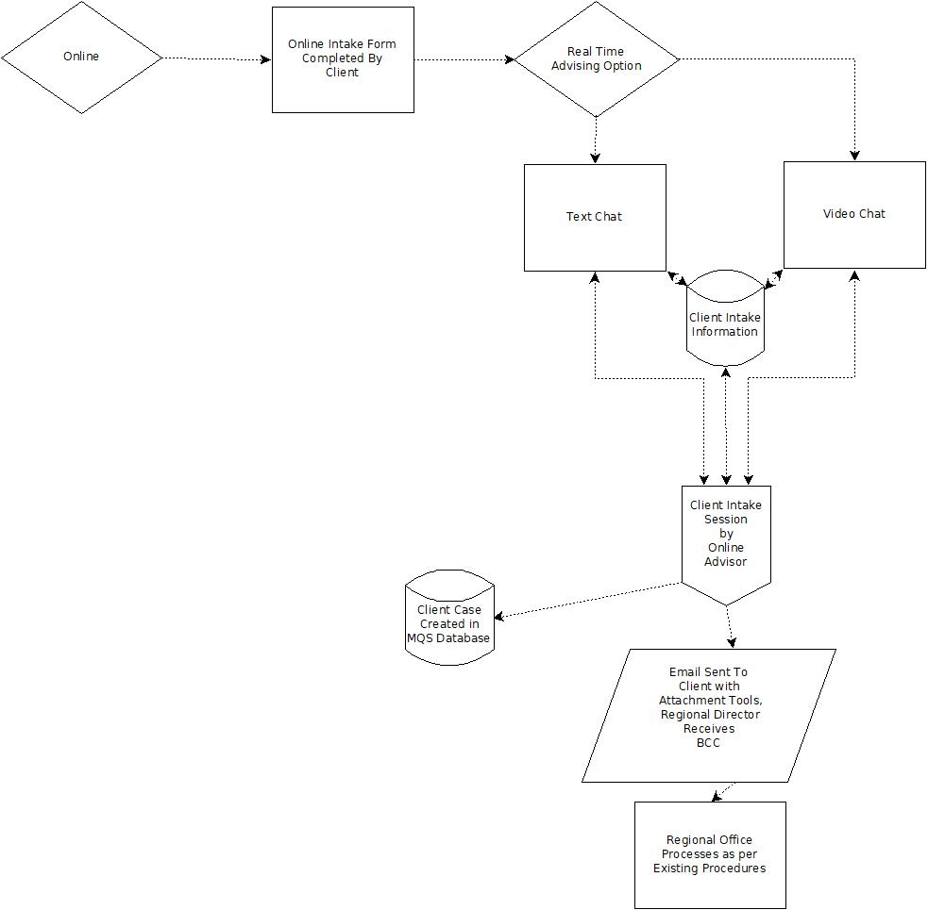

# RELATIONSHIP to mqs

RTCI will have no technical relationship to MQS. The MQS system is the NYSSBDC Client relationship management tool. It is software based with a browser user interface. It uses Microsoft Active Server Pages (.aspx), runs on the Microsoft IIS webserver, and uses Microsoft SQL for the database. It is used to capture inquiries, create cases with Client profiles with a system generated unique Client number, uses narratives to document all Client contact (date stamped), captures Advisor time spent on professional development as well as center specific projects, acts as a portal to external forms and documents, and provides robust client, Advisor, Center reporting.

Below is a screen capture of the landing page when an Advisor logs in:

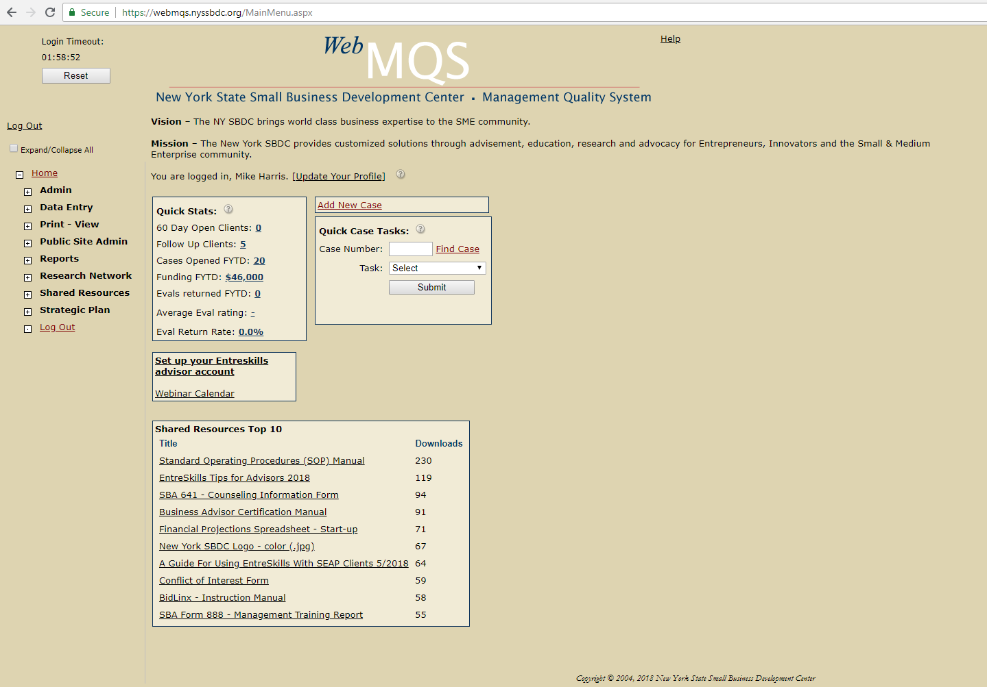

1. All of the current functionality of MQS remains the same with the new additional process flow. The MicroSoft .Net framework (IIS, .aspx, MS Sqlserver) will be used to create RTCI. The code, server location, and database for RTCI will be external to MQS.

RTCI will capture this information in a database with one to many records for text chats.

I think the answer to that is whatever would give the best performance. However, since everything is happening on the server side my guess is that the performance limiter would mostly be the querys to the DB. So writing all to the DB at the end of the conversation would be best. To mitigate any problems (like loss of network) during the conversation you should keep everything somewhere in real time though.

For both text and video sessions, the start and end time of the session will be captured.

1. The outgoing email text with the Advisor’s instructions to the client will be captured. Assumption: This is talking about the templated email content which gets auto populated by RTCI?

It says it will be captured – what does it mean?

ANSWER: Free form text area with the option of addition pre-determined paragraphs (like Quick Parts)

1. A set of reports will be available to monitor Client and Advisor activity.

A set of Reports will be generated by RTCI.

Can you give brief idea on what all it should display?

To start with, let’s just go with more of a log of activity. We will need to get input from the Admin and Directors as to what will be useful for them. For example, average call time, calls per Advisor, peak demand time and day, etc

Reports and logs will be queries from the RTCI database.

Below is a network diagram showing the relationship between MQS and RTCI:



# ARCHITECTURE

Software’s to be used: ASP.net Framework – 4.7.2 with MVC 5, VB.net as a server-side language

Client side: jQuery, json, bootstrap and other extensions included in Visual studio 2017.

Back end: SQL

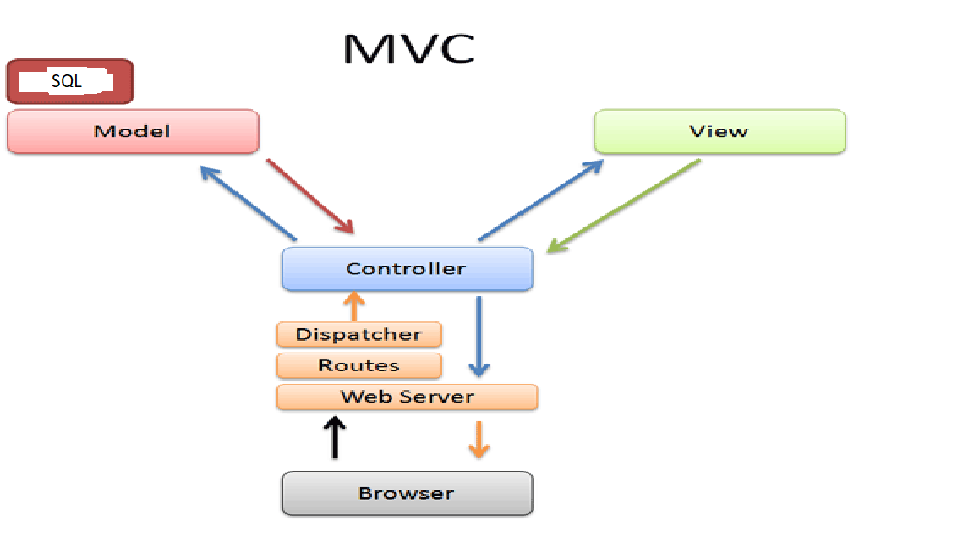

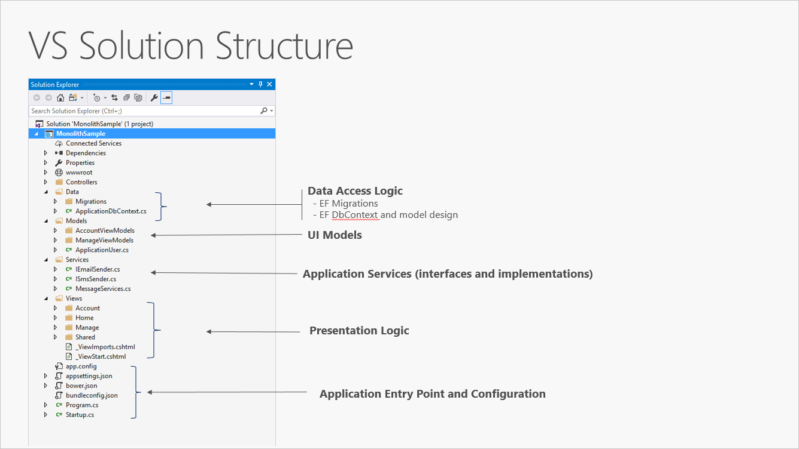

Sample structure of the project

# SYSTEM INTERFACE

This will not be an integrated system and there will be no interface between the two systems via software. Only the advisor currently uses MQS. RTCI will be able to interface to MQS via some API’s(eventually).

# SOFTWARE INTERFACE

RTCI will create a record in the RTCI database and handle prompting an available Advisor to respond to the request. RTCI will capture text chat data (one to many), time data, and email content. RTCI code will execute the send mail function with attachments to both the Client and the appropriate Regional Director.

# USER INTERFACES

All user interfaces with the system will be browser based. Browser support will be defined and limited to at least the top 4 available browsers (Chrome, Edge, Safari, Firefox, etc). The interface should be device and OS independent. Whenever possible, all code should be server-side based with as little, if any, client/OS specific executable code.

# Email templating

The email screen (pop up) should have a text area that allows free flow keying/typing as well as input from various pre-defined text paragraphs. These pre-defined paragraphs will be like Outlook Quick Parts. These paragraphs would be stored server-side and may warrant another database table. It should throw pop-up window with the ability to create and select paragraphs to be inserted into the main screen. The email screen should also have an easy way to display and select possible attachments. There could be multiple attachments with different file formats (.pdf, .doc, .jpg, etc). The 2 most important recipients are the client and the blind copy (BCC:) to appropriate regional director. The email could be sent to the online intake advisor for their records. One another requirement is the user can click into the text area, select all, copy, and then paste somewhere else (specifically into the MQS system).

# VALIDATIONS

* When multiple advisors are available, pick the advisor for chat who is online for a longer duration
* If an advisor is already engaged with one of the clients, then another client should not be able to view that advisor as available.
* The application should work with all browsers.
* **Advance phase of the project**: It should work with all OS

# Client Options:

* When client clicks on the video/text chat, then a pop up would display the following message:

“The discussion with advisor would take approximately 30 minutes. Do you want to continue?”

If he says Yes, “than it will take connect them to one of the available advisors”

* If No, then a calendar scheduler will be shown to client to schedule an appointment at a later time.
* Once done, it will say display a message “Thank you for contacting SBDC, someone would be in touch with you shortly for all the assistance you need and resolving queries”

# COMMUNICATIONS INTERFACES

Communications for the text chat will be server-side software.

Video/Audio communications will require both the Advisor and Client to have a client device with a webcam and microphone.

Communications for video/audio chat should be server side software using technology such as WebRTC. This open source platform (webrtc.org) is completely browser based and does not require the client device to download any software.

WebRTC will prompt the user to grant access to the device’s microphone and webcam.

# MEMORY CONSTRAINTS

The RTCI server, webserver, and database should be sized to accommodate at least 150 simultaneous users.

Although there are no plans at this time to capture video of the sessions, space sufficient for video file storage should be consider for training purposes.

# Software logic and FUNCTIONS

The software should prompt the user with forms, accept user input, provide data formatting validation, insert data into a database, provide two-way video communication, and generate reports. The software will also handle ques of available and assigned Online Advisors. Error checking should be part of every user input function. SSL should be used for all network communications and all logs and data should use encryption.

# USER CHARACTERISTICS

The intended groups of users for RTCI is the Advisors and the general public with a very wide spread of educational level, experience, disabilities, and technical expertise. The system should be straight forward to use, extremely easy to operate, and require little or no training.

# ASSUMPTIONS AND DEPENDENCIES

RTCI is independent of MQS. The case information and narrative associated with the initial real time intake will be captured in MQS manually by the Online Intake Advisor. It will be assumed that the Online Intake Advisor has a workstation and access to both systems.

data REQUIREMENTS and uses

Single Client Information table which cosists of client intake form.

Rtci_intake/Client_Info

ID – Unique, Index number created by RTCI, provides unique master record ID

CaseID (unique MQS case ID) – Indexed, inserted it database

Client_First_Name – inserted into database, passed to the chat and email Advisor forms

Client_Last_Name – inserted into the database, passed to the chat and email Advisor forms

Client_Email_Address – inserted into the database, passed to the Advisor email form

Client_Zip_Code – inserted into the database, passed to the Advisor email form, used to determine correct Regional Director

Business_Description – inserted into database, available for the Advisor to see

Advisor_Name – inserted into database

Session_Start_Time – system generated date/time stamp, inserted into database

Session_End_Time – system generated date/time stamp, inserted into database

**MASTER Tables:**

1. Advisors/ADMIN? – Currently list of Advisors From Binghamton

ID – Unique number for each advisor

Fname – First Name

Lname – Last name

Zip Code – Zip information

Designation

YEArs of Experience

Field expertise

1. Directors – CURRENT dIRECTOR LIST

ID – Unique number for each advisor

Fname – First Name

Lname – Last name

Zip Code – Zip information

Designation

YEArs of Experience

Field expertise

1. Pre-Defined EMAIL template

ID

Name

SUBJECT

CONTENT

**OTHER TABLES**

RTCI_EMAIL_DATA

1. CLIENT_ID
2. ADVISOR_ID
3. DIRECTOR_ID
4. NAME
5. SUBJECT
6. CONTENT
7. Client Fname
8. Client Lname
9. Advisor Fname
10. Advisor Lname
11. Director Fname
12. Director Lname
13. Client Zip
14. Advisor Zip
15. Director Zip
16. TO:
17. CC:
18. BCC:
19. Time_Stamp

RTCI_CLIENT_CALLBACK

1. ID
2. Client ID
3. Client Fname
4. Client LName
5. DateTime
6. Phone
7. Email
8. Way to Contact
9. Business Query

RTCI_TEXT_CHAT

1. ID
2. Client ID
3. Advisor ID
4. Chat_data
5. Session_id
6. Date
7. Start_time
8. End_Time

RTCI_AUTH

1. USER_ID
2. ROLE
3. PRIVILEGE
4. Fname
5. LName
6. Login ID?
7. Password?

Report LOGS

1. Client_Id
2. Advisor_Id
3. Director_Id
4. Call duration
5. Pending work list
6. Calls Per average
7. Peak demand time
8. Current status

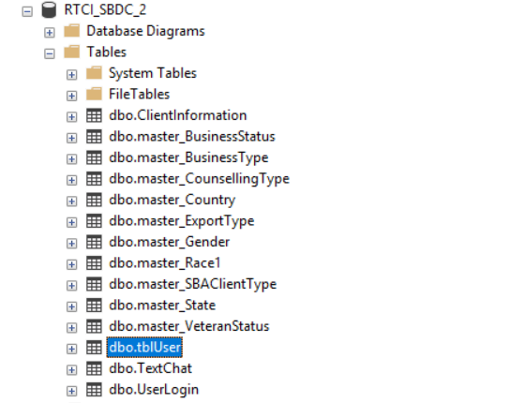

Following new data elements would exist in RTCI page:

* **Call back request**

Significance**:**

* + If no Advisor is available, the user is prompted with an option allowing them to make an appointment for meeting on-line. A pop screen giving client an option to specify a date/time/method for an advisor to contact them and a link taking them to the existing on line intake form at <http://www.nyssbdc.org/selector/ReqForCons/formo.aspx>
  + Perhaps the request for call back should be another table so when the next advisor logs in, they are aware of the call back request. Also, if an admin logs in, they should be able to see all of date/time/method call back requests not answered/completed

Fields?

* **Pre-Defined Email Template**

Significance:

The email screen should have a text area that allows free flow keying/typing as well as input from various pre-defined text paragraphs. These pre-defined paragraphs will be like Outlook Quick Parts. These paragraphs would be stored server-side and may warrant another database table. It would throw a pop-up window with the ability to create and select paragraphs to be inserted into the main screen. The email screen should also have an easy way to display and select possible attachments. There could be multiple attachments with different file formats (.pdf, .doc, .jpg, etc). The 2 most important recipients are the client and the blind copy (BCC:) to appropriate regional director. The email could be sent to the online intake advisor for their records. One another requirement is the user can click into the text area, select all, copy, and then paste somewhere else (specifically into the MQS system).

Fields?

* **Advisor List**

Significance:

A master table containing the list of advisors.

Fields?

* **Text chat**

Significance:

All the text chat data with client

Fields?

* **Client info**

Significance:

All the client information

Fields?

* **Report logs**

Significance: A set of reports will be available to monitor Client and Advisor activity.

Fields?

# software process flow with screens

There will be two tracks of for the flow: Client and Advisor.

## Client Software Process Flow

1. Client visits <http://nysbdc.org/appointment.html> and sees

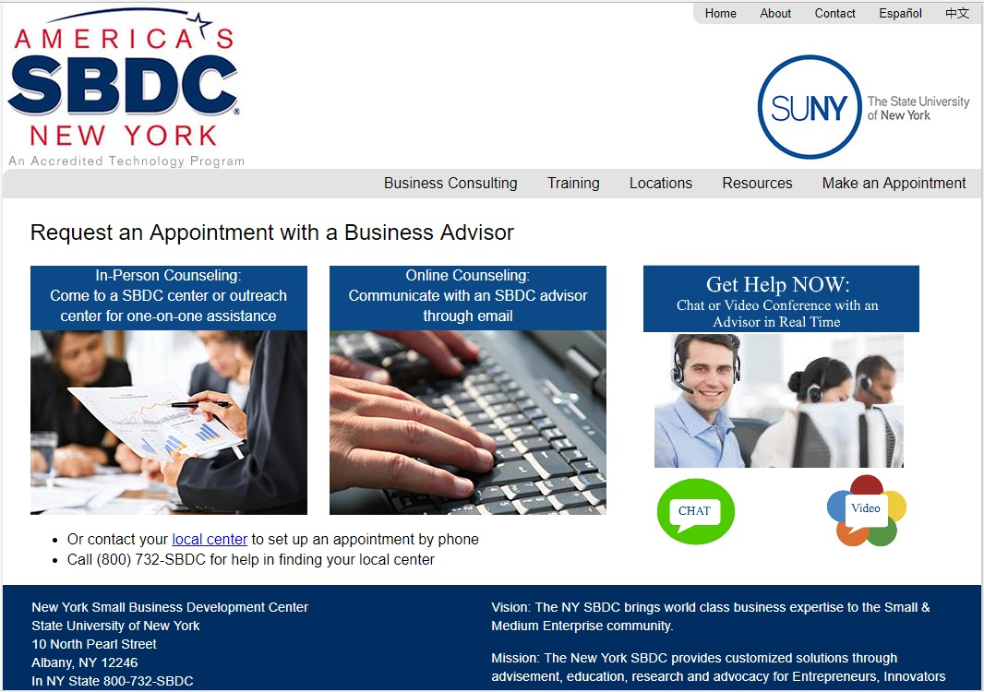

1. Client fills out form at http://nysbdc.org/selector/ReqForCons/formo.aspx

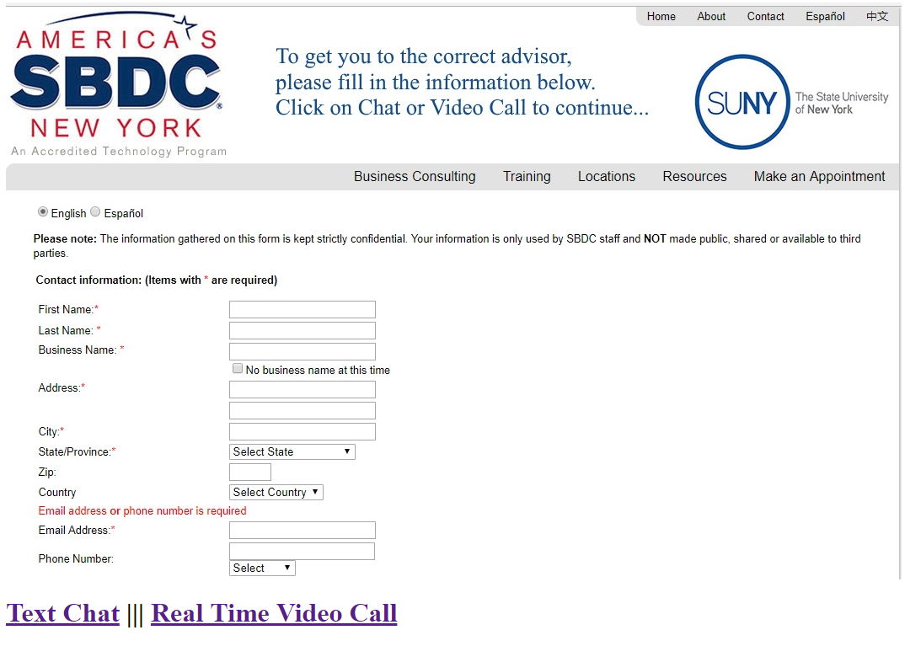

1. If the Client chooses Text Chat, this window opens:

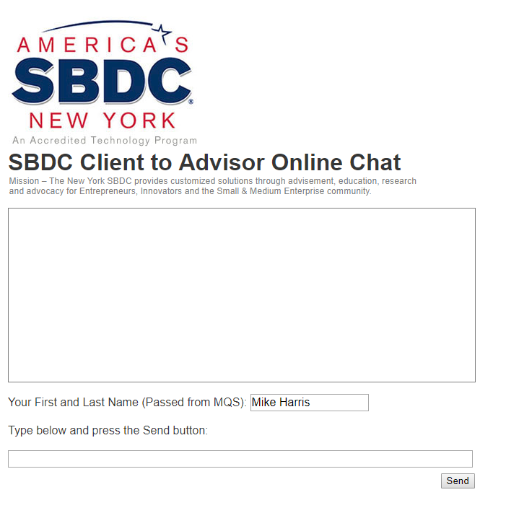

1. If the Client chooses Real Time Video call, they are prompted with:

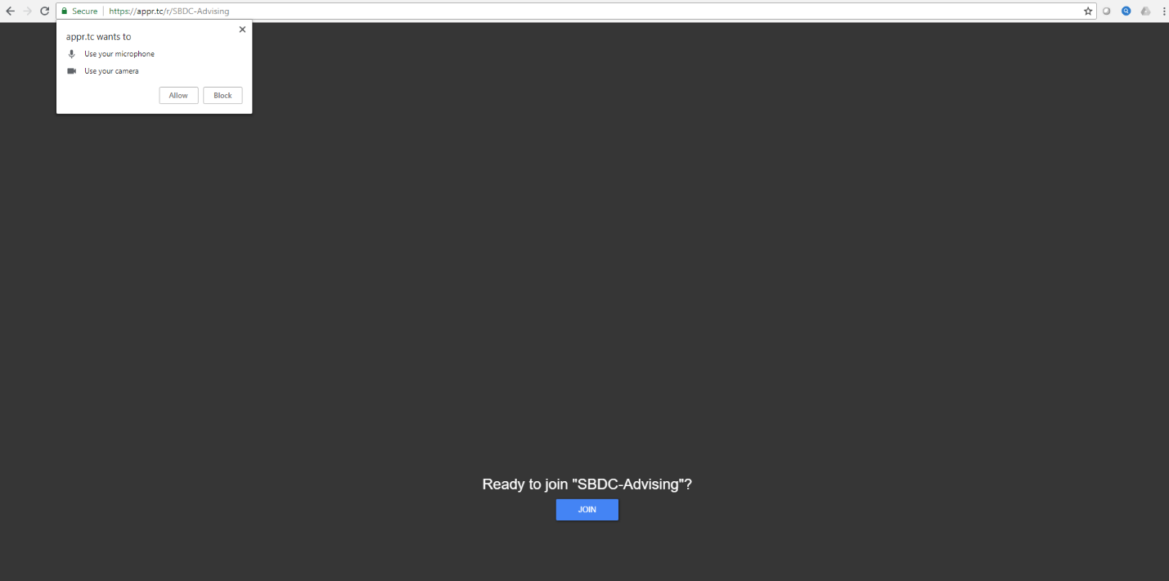

1. The Video/Audio session begins with the Online Intake Advisor present in the window

## Advisor Software Process Flow

1. The Online Intake Advisor logs into the system. The system is then aware of an available Advisor. The Advisor would also log into MQS. The following screens appear:



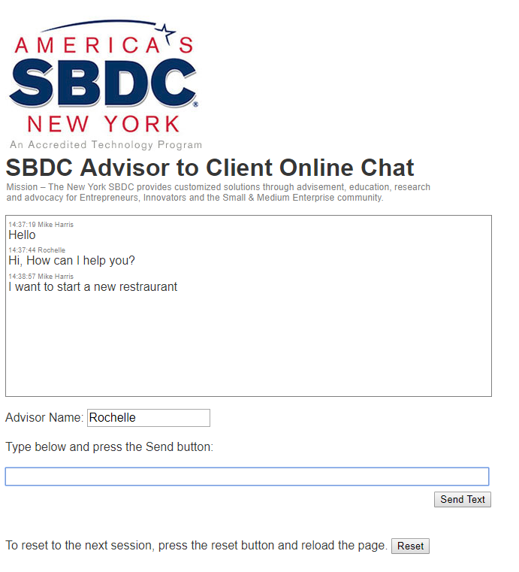

Note: the Intake Advisor Creates a new Case in MQS and can copy and paste the entire chat session into MQS

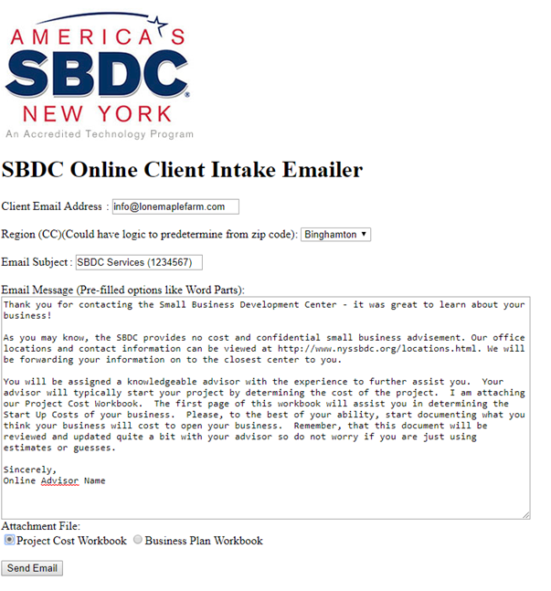

Advisor sends email after needs assessment. The Regional Director is Blind Copied. The Online Intake Advisor copies and pastes the email into MQS.

# OPERATIONS

Three environments should be created:

1. Development – this environment is accessible only to the developers, a project manager, and the server admin
2. Test – this environment is accessible only to a limited number of testers, a project manager, and the server admin
3. Production – this environment is accessible to Advisors and Clients

A clear and documented procedure should be used to move code between the environments.

The NYSSBDC will own and be the sole administrators of the RTCI system.

The developers will provide documented source code, database schema, all triggers/queries/procedures, training on the code logic transferred to the NYSSBDC, and be available during the testing phase.

# Project team

The following roles will be defined for this project:

1. NYSSBDC Central Coordinator– TBD
2. Creator and Project Lead – Rochelle Layman
3. Project Manager - TBD
4. Business / System Analysis – Mike Harris
5. Development Manager – TBD
6. Development Team – Mihir Padechiya, Kubilay Ozata
7. Database Administrator – TBD
8. QA / Test Manager – TBD
9. Training & Support Manager - TDB
10. Server Administrator - TBD

# CODE LINKS

SBDC Project Code link

<https://github.com/padechiya2014/RTCI_SBDC>

SBDC Project Hyperlink

<https://rtci.azurewebsites.net>