3W Dataset

Feature Engineering & Model Architecture Methodology
A physics-informed, spatio-temporal mixture-of-experts approach to early detection of undesirable events in offshore oil wells
Prepared for the 3W early-detection initiative
Scope: 3W Dataset 2.0.0 (Petrobras) · multivariate time-series fault detection

Contents

1. Introduction and dataset framing
This document specifies a feature-engineering strategy and a model architecture for early detection of undesirable events in the 3W Dataset, the realistic, expert-labelled benchmark of multivariate time series collected from offshore oil wells and released by Petrobras.
The dataset comprises instances drawn from three sources — real, simulated, and hand-drawn — hence the name 3W (undesirable events occurring in oil Wells). The first version (2019) described eight process variables and eight event types¹; the current version 2.0.0, whose schema this methodology targets, adds further instances, a richer variable set, and a new operational-status label.²
The schema supplied for this analysis lists twenty-nine signal columns plus two labels (class and state). Two design choices encoded in the property file shape the entire methodology and are discussed next.

2. Data characteristics that drive the methodology

2.1 The transient offset signals an early-detection objective
The property file defines TRANSIENT_OFFSET = 100: every undesirable event carries a separate transient label equal to its code plus one hundred, marking the onset window before the fault stabilises. The dataset is therefore built to reward anticipation, not merely post-hoc classification. Both the feature set and the training objective must preserve and exploit this onset signal.

2.2 Transient versus steady-state events require different representations
Each event type is flagged TRANSIENT = True/False. Step-like events (DHSV closure, abrupt BSW increase, hydrates, productivity loss) present a discernible onset, whereas sustained oscillatory regimes (severe slugging, flow instability) have no clean step and are defined by their temporal texture. Statistical moments capture the former; frequency-domain descriptors are required for the latter.

2.3 Rarity and sensor pathologies
Undesirable events are rare relative to normal operation, and the signals exhibit frozen sensors, missing channels, and large well-to-well baseline differences. The methodology addresses these through explicit quality channels, within-instance normalisation, class-balanced objectives, and self-supervised pretraining on the abundant normal data.
Published baselines establish the landscape: random forests over windowed statistics³, stacked autoencoders for gas-lift wells, and the modular MAIS platform combining wavelet and statistical features with tree-structured Parzen-estimator hyperparameter search.⁴ The proposal below advances past flattened-window statistics toward physics-aware, topology-aware representations.

3. Feature taxonomy and the derivation table
The twenty-nine sensors sit on a physical topology: downhole gauge, tubing, Xmas tree, production choke and flowline, with a parallel gas-lift/annulus path and a service line. The governing principle is that differentials across components, not absolute readings, carry the fault signal, and that raw pressure levels vary so strongly across wells and depths that using them directly harms cross-well generalisation.
The table below specifies each engineered feature, its derivation, the source variables it consumes, the event(s) it targets, and the physical rationale that justifies it.
Engineered feature | Derivation | Source variables | Target event(s) | Physical rationale
Differential pressure across PCK | dP_CKP = P-MON-CKP − P-JUS-CKP | P-MON-CKP, P-JUS-CKP | Quick Restriction (6), Scaling in PCK (7) | Rises for a fixed choke opening when the bore restricts.
Differential pressure across GLCK | dP_CKGL = P-MON-CKGL − P-JUS-CKGL | P-MON-CKGL, P-JUS-CKGL | Flow Instability (4) | Characterises gas-lift choke behaviour and injection drive.
Joule–Thomson cooling at PCK | dT_CKP = T-MON-CKP − T-JUS-CKP | T-MON-CKP, T-JUS-CKP | Hydrate Prod. Line (8) | Abnormal cooling across the choke is the classic hydrate precursor.
Normalised choke coefficient | Cv_eff = Q / (open · √ΔP) | QGL/QBS, ABER-*, dP_* | Restriction (6), Productivity Loss (5) | Near-invariant under normal flow; drifts sharply under fault.
Downhole–tree pressure gradient | dP_grad = P-PDG − P-TPT | P-PDG, P-TPT | Abrupt BSW Increase (1) | Tracks fluid-column density; rises as water cut grows.
Thermal gradient | dT_grad = T-PDG − T-TPT | T-PDG, T-TPT | BSW (1), Productivity Loss (5) | Density / heat-capacity shift confirms composition change.
Hydrate margin | m_hyd = dist((T,P), eq-curve) | T-TPT, P-TPT, T-JUS-CKP, P-JUS-CKP | Hydrate Prod. (8), Service (9) | Distance to the hydrate-formation curve; small = high risk.
Spectral descriptors | f_dom, H_spec, band-power | P-PDG, P-TPT, PT-P, QGL | Severe Slugging (3), Flow Instability (4) | Sustained oscillatory regimes are invisible to moments.
Oscillation envelope | amp, period of detrended signal | P-PDG, PT-P | Severe Slugging (3) | Amplitude and period separate slugging from instability.
Valve-transition flags | Δstate, time-since-change | ESTADO-DHSV, ESTADO-* | Spurious DHSV Closure (2) | Transition timing, not level, carries the signal (W=180,S=15).
Quality indicators | is_missing, is_frozen, gap_len | all sensor channels | robustness (all classes) | Encodes sensor pathologies instead of silently imputing them.
Within-instance detrend | x' = (x − μ_inst) / σ_inst | all continuous channels | cross-well generalisation | Removes well/depth baselines so models learn physics, not levels.
Notation: open denotes the relevant choke opening (ABER-CKP / ABER-CKGL); ΔP the matching differential; μ_inst and σ_inst are per-instance statistics computed over normal segments.

4. A modular, multi-model decomposition
Faults are localised to physical subsystems, which motivates a mixture-of-experts design in which each expert consumes only its relevant channels and engineered features. Each expert then sees a cleaner, lower-dimensional signal; an expert can keep operating when sensors outside its subsystem are frozen; and predictions remain interpretable to engineers because they map onto the well's real instrumentation. This extends the modular philosophy already validated by the MAIS platform.
Specialised expert | Channels consumed | Faults targeted
Expert A — Production path | ABER-CKP, P-MON/JUS-CKP, T-MON/JUS-CKP, PT-P, P-TPT, T-TPT, P-MON-SDV-P, ESTADO-M1/W1/SDV-P | Quick restriction, scaling, production-line hydrate, rapid productivity loss.
Expert B — Downhole | P-PDG, T-PDG, ESTADO-DHSV | Spurious DHSV closure; abrupt BSW increase inferred from the downhole–tree gradient.
Expert C — Gas-lift / annulus | ABER-CKGL, QGL, P-ANULAR, P-MON/JUS-CKGL, ESTADO-M2/W2/SDV-GL/XO/PXO | Severe slugging and flow instability — oscillatory regimes best seen in the gas-lift drive.
Expert D — Service line | QBS, P-JUS-BS | Hydrate in the service line, tied to the service-pump channels.
A second, orthogonal split is temporal: a change-point detector tuned for step-like onsets and a regime classifier tuned for oscillatory faults. These differ enough in optimal window length and feature emphasis that a single monolithic classifier is a compromise for both. The architecture in Section 6 realises both decompositions jointly.

5. A novel topology-aware approach
Most published 3W work flattens windows and discards the spatial relationships between sensors. The novel contribution proposed here is a physics-informed spatio-temporal graph network:
- Graph representation. The well is modelled as a graph whose nodes are sensors/components and whose edges are the real hydraulic connections (PDG → TPT → tree → PCK → flowline, with parallel gas-lift and service paths). Crucially, the engineered differentials (ΔP, ΔT, Cv_eff) become edge features, placing the physics where it physically belongs.
- Localisation. Because the model reasons over the topology, it can indicate where in the well an anomaly originates — exactly the diagnostic question an operator asks — and it generalises across wells that share topology but differ in absolute baselines.
- Self-supervised pretraining. Encoders are pretrained with a masked-reconstruction or forecasting pretext task on the abundant normal data plus the simulated and hand-drawn instances, then fine-tuned on the rare labelled faults. This directly attacks class rarity and is consistent with the dataset authors' note that 3W is well suited as a foundation for transfer-learning frameworks.

6. Recommended model architecture
The recommended model is a four-stage pipeline that realises both the subsystem and the temporal decompositions. The diagram below summarises the data flow from raw parquet through to the multi-task heads.
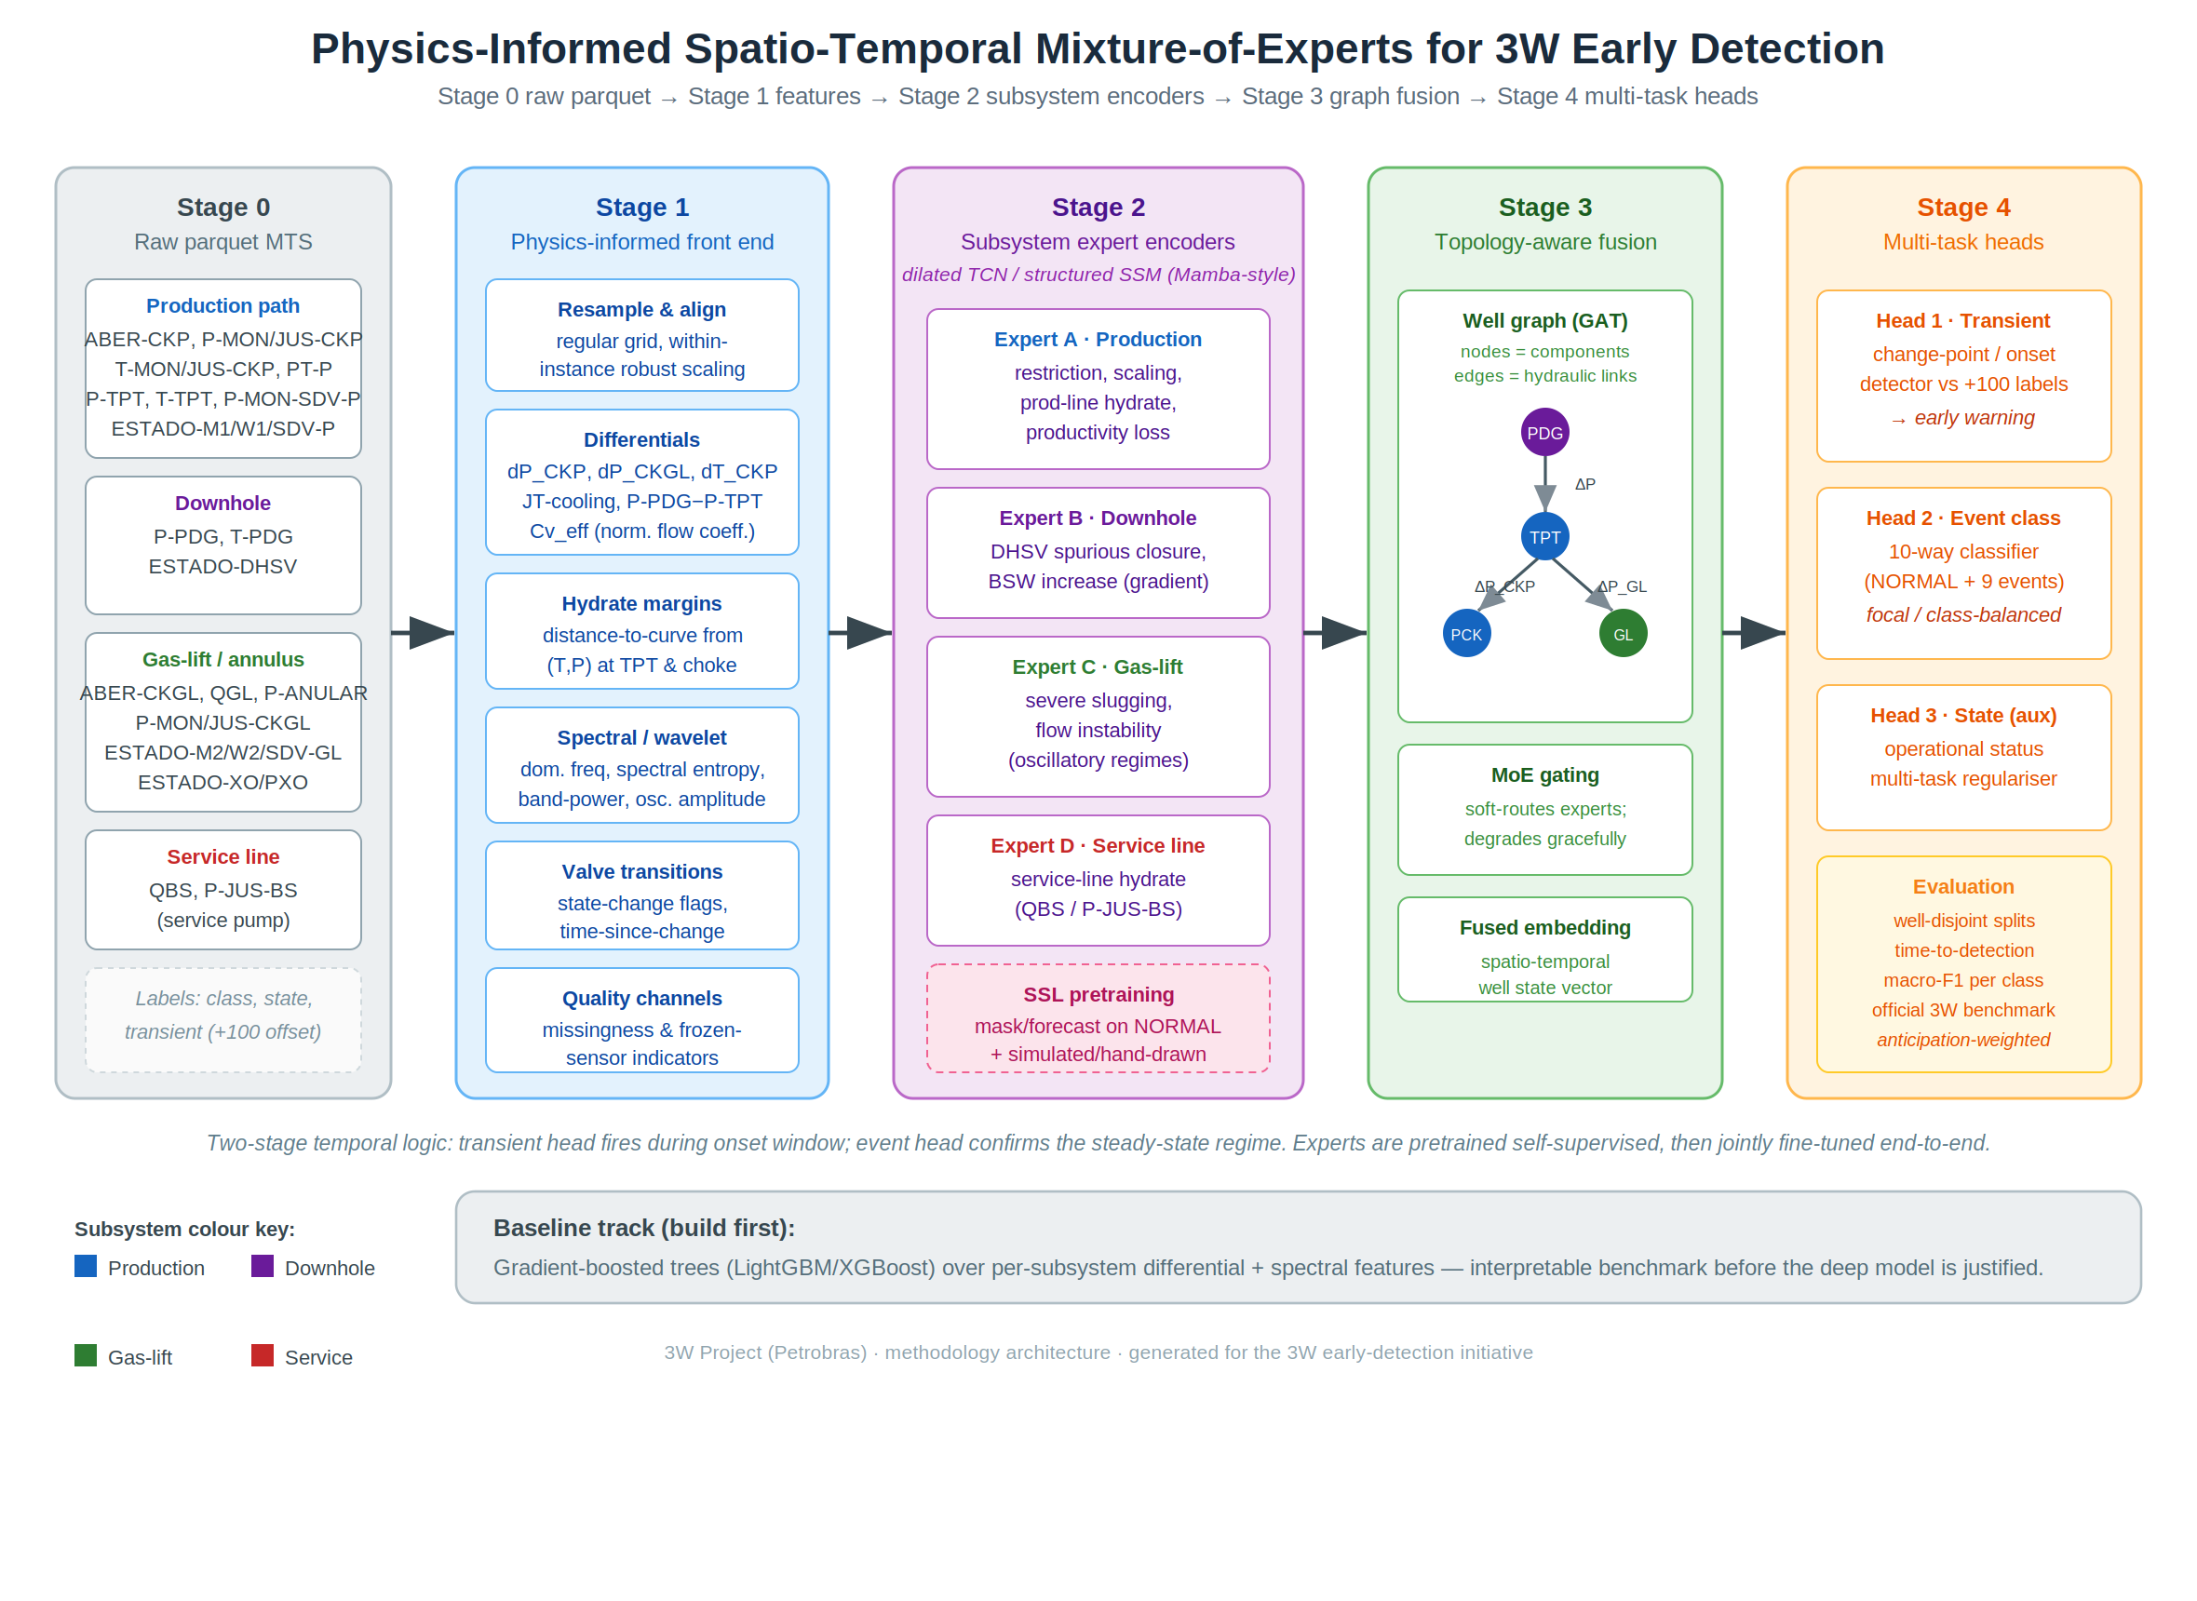
Figure 1. Physics-informed spatio-temporal mixture-of-experts architecture for 3W early detection.

6.1 Stage 1 — physics-informed front end
Resamples each instance to a regular grid, applies within-instance robust normalisation, and constructs the differential, hydrate-margin, spectral, valve-transition, and quality features of Section 3.

6.2 Stage 2 — per-subsystem temporal encoders
One encoder per subsystem — a dilated temporal convolutional network or a structured state-space model (Mamba-style) — with a receptive field long enough to cover slugging periods. State-space encoders are attractive for long oscillatory windows at low computational cost. These encoders are the experts pretrained self-supervised on normal data.

6.3 Stage 3 — topology-aware fusion
A graph-attention layer over the well graph fuses the subsystem embeddings along the physical edges, with a mixture-of-experts gating layer that soft-routes the experts and degrades gracefully when channels are missing. The output is a single spatio-temporal well-state vector.

6.4 Stage 4 — multi-task heads
- Head 1 — transient/change-point detector trained against the +100 transient labels to fire during the onset window (the early-warning signal).
- Head 2 — event classifier over the ten classes (normal plus nine events), trained with a focal or class-balanced loss.
- Head 3 — operational-status (state) head as an auxiliary multi-task regulariser.

6.5 Baseline track (build first)
Before the deep model is justified, establish a strong, interpretable baseline: gradient-boosted trees (LightGBM or XGBoost) over the per-subsystem differential and spectral features. This benchmark validates the feature set independently of the network and provides the reference against which the full architecture must demonstrate gains.

7. Evaluation protocol and pitfalls
- Well-disjoint splits. Train and test on different wells, or metrics will be inflated by memorised well-specific baselines rather than learned fault physics. This is the most common reproducibility failure on 3W.
- Anticipation-weighted metrics. Report time-to-detection on the transient window alongside macro-F1 per class, and align with the official 3W benchmark definitions so results are comparable with the literature.
- Imbalance-aware aggregation. Use macro-averaged and per-class scores; global accuracy is misleading under severe rarity.
- Robustness checks. Evaluate under simulated sensor freeze and channel dropout to confirm the mixture-of-experts degrades gracefully.

8. References
1. Vargas, R. E. V., et al. (2019). A realistic and public dataset with rare undesirable real events in oil wells. Journal of Petroleum Science and Engineering. doi:10.1016/j.petrol.2019.106223.
2. Vargas, R. E. V., et al. (2025/26). 3W Dataset 2.0.0: a realistic and public dataset with rare undesirable real events in oil wells. Scientific Data. doi:10.1038/s41597-026-07225-z; arXiv:2507.01048.
3. Marins, M. A., et al. (2020). Fault detection and classification in oil wells and production/service lines using random forest. Journal of Petroleum Science and Engineering. doi:10.1016/j.petrol.2020.107879.
4. Dias, et al. (2024). A modular multivariable approach to fault classification (MAIS), combining wavelet and statistical features. SPE Journal.
5. Petrobras 3W Project repository: github.com/petrobras/3W.

Vargas et al. (2019), A realistic and public dataset with rare undesirable real events in oil wells, J. Petroleum Science and Engineering, doi:10.1016/j.petrol.2019.106223.
Vargas et al. (2025/26), 3W Dataset 2.0.0, Scientific Data, doi:10.1038/s41597-026-07225-z; arXiv:2507.01048.
Marins et al. (2020), Fault detection and classification in oil wells and production/service lines using random forest, J. Petroleum Science and Engineering, doi:10.1016/j.petrol.2020.107879.
Dias et al. (2024), MAIS modular multivariable approach combining wavelet and statistical features, SPE Journal.

