Name and section:

Instructor's name:

**Multiple Choice**

1. Which is a hyperbola?

A.

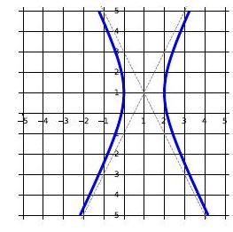

B.

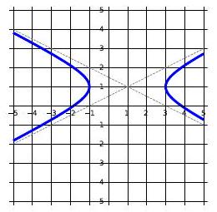

C.

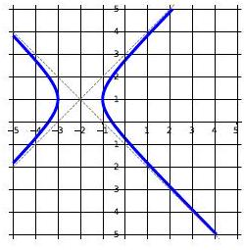

D.

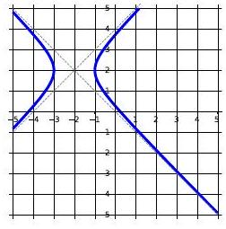

1. What are the foci of the hyperbola ?  
   A.   
   B.   
   C.   
   D.
2. Tell me about   
   A.   
   B.   
   C.   
   D.
3. Tell me about   
   A.   
   B.   
   C.   
   D.
4. Tell me about   
   A.   
   B.   
   C.   
   D.
5. Tell me about   
   A.   
   B.   
   C.   
   D.

**True / False**

1. __ The major axis of a (non-circular) ellipse is always longer than the minor axis.
2. _ The transverse axis of a hyperbola is always longer than the conjugate axis.
3. __ The foci of an ellipse are on the minor axis.
4. The focus of the parabola is the lowest point on the parabola.
5. __ The graph of fits entirely inside the graph of
6. _ The directrix of a parabola is perpendicular to the axis of symmetry.
7. __ The distance between two foci of an ellipse or a hyperbola is .
8. __ The eccentricity of an ellipse can be .
9. __ A circle is just an ellipse with .
10. The graphs of and have the same asymptotes.