# Math 10 Derivatives Test

1. Let $f\left(x\right)=\sqrt{x}$. What is the equation of the tangent line to $f$ at the point $\left(4,2\right)$?
$y=\frac{1}{4}x+1$

$y=-\frac{1}{2}x+3$

$y=\frac{1}{2}x$

$y=2x-6$

2. What is the derivative of $s\left(t\right)=cos\left(t^{2}+1\right)$?
$-2tsin\left(t^{2}+1\right)$

$-\left(t^{2}+1\right)sin\left(t^{2}+1\right)$

$cos\left(2t\right)$

$-sin\left(2t\right)$

3. If $f$ and $h$ are nonzero differentiable functions, then the derivative of $\frac{f}{h}$ is
$\frac{f^{'}h-fh^{'}}{h^{2}}$

$\frac{f^{'}h+fh^{'}}{h^{2}}$

$\frac{fh^{'}-f^{'}h}{h^{2}}$

$\frac{f^{'}}{h^{'}}$

4. The line tangent to the curve $y=\sqrt{16-x}$ at the point $\left(0,4\right)$ has slope
$\frac{-1}{8}$

5. 4
$\frac{1}{8}$

$-4$

6. If $y=6ln\left(3x\right)$ then what is $y^{'}$?
$\frac{6}{x}$

$\frac{2}{x}$

$\frac{1}{3x}$

$\frac{18}{x}$

7. What is the value of
$$\lim_{Δx→0}\frac{2{\left(x+Δx\right)}^{2}-2x^{2}}{Δx}$$

$4x$

$Xx$

8. 4
9. 2
10. If $w\left(t\right)=\sqrt{t^{2}-1}$ what is the value of $w^{'}\left(4\right)$?
$\frac{4}{\sqrt{15}}$

$\frac{2}{\sqrt{15}}$

$\frac{1}{\sqrt{15}}$

$\frac{1}{2\sqrt{15}}$

11. At which $x$ value does the graph of $y=3x^{2}-10x+15$ have a horizontal tangent line?
$\frac{5}{3}$

$\frac{-3}{5}$

$\frac{3}{5}$

$\frac{-5}{3}$

12. If $h\left(x\right)=f\left(x^{2}+1\right)$ then which of the following is true?
$h^{'}\left(x\right)=2xf^{'}\left(x^{2}+1\right)$

$h^{'}\left(x\right)=f^{'}\left(2x\right)$

$h^{'}\left(x\right)=2xf^{'}\left(2x\right)$

$h^{'}\left(x\right)=f^{'}\left(x^{2}+1\right)$

13. If $f\left(x\right)=sin\left(2x+1\right)$ and $g\left(x\right)=f^{'}\left(x\right)$, find $g^{'}\left(x\right)$
$g^{'}\left(x\right)=-4sin\left(2x+1\right)$

$g^{'}\left(x\right)=2sin\left(2x+1\right)$

$g^{'}\left(x\right)=4sin\left(2x+1\right)cos\left(2x+1\right)$

$g^{'}\left(x\right)=-4xcos\left(2x+1\right)$

14. The graph of a continuous differentiable function $f$ is shown below.  
    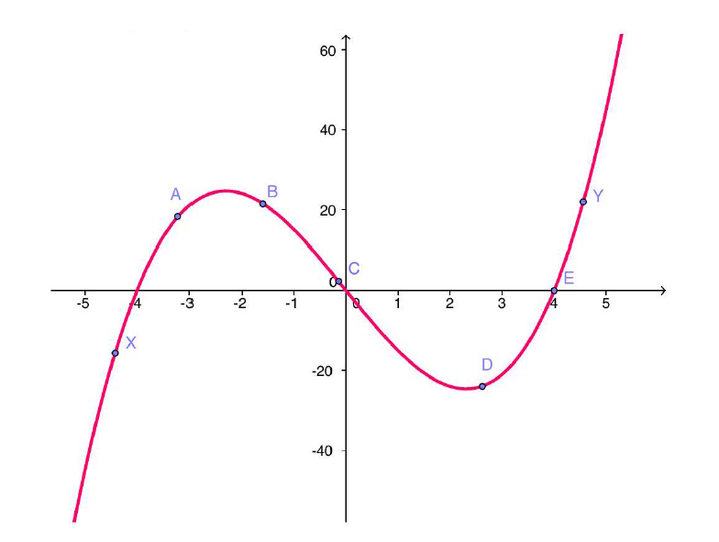  
    Using the above graph, select the one true statement below.
$f'\left(C\right)<f'\left(D\right)<f'\left(Y\right)$

$f'\left(A\right)<f'\left(B\right)<f'\left(C\right)$

$f'\left(X\right)<f'\left(Y\right)<f'\left(C\right)$

$f'\left(X\right)<f'\left(B\right)<f'\left(E\right)$

15. Let $f\left(x\right)=x^{3}-6x^{2}+10$. At which point(s) on the graph of $f$ is the tangent line parallel to the line $15x-y=11$?
16. $\left(5,-15\right)$ and $\left(-1,3\right)$
17. $\left(2,-6\right)$ and $\left(-2,22\right)$
18. $\left(2,-6\right)$ and $\left(-2,-22\right)$
19. $\left(5,-15\right)$ and $\left(2,-6\right)$
20. If $y\left(x\right)=\frac{sin\left(2x\right)}{x^{2}}$ find $y'\left(x\right)$
$\frac{2xcos\left(2x\right)-2sin\left(2x\right)}{x^{3}}$

$\frac{2cos\left(2x\right)}{x}$

$\frac{x^{2}cos\left(2x\right)-sin\left(2x\right)}{x^{3}}$

$\frac{x^{2}sin\left(2x\right)+2cos\left(2x\right)}{x^{4}}$

21. Calculate $\frac{d}{dt}\left(ln\left(e^{2t}\right)-2t\right)$
22. 0
$\frac{1}{2t}-2$

$\frac{2}{e^{2t}}-2$

$\frac{1}{2e^{2t}}-2$

23. The values of $f,g,f',g'$ are given for selected $x$ values below.  
    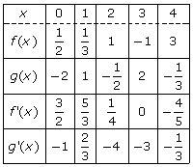  
    Using the table above, evaluate the following:
24. $\frac{d}{dx}\left(f\left(x\right)+g\left(x\right)\right)$ at $x=4$
25. $\frac{d}{dx}\left(f\left(x\right)g\left(x\right)\right)$ at $x=1$
26. $\frac{d}{dx}\left(\frac{f\left(x\right)}{g\left(x\right)}\right)$ at $x=0$
27. $\frac{d}{dx}\left(f\left(g\left(x\right)\right)\right)$ at $x=3$
28. $\frac{d}{dx}\left(g\left(x+f\left(x\right)\right)\right)$ at $x=3$