# Curve Sketching

1. Locate the absolute extrema on the given intervals (if any exist) for $f\left(x\right)=x^{2}-2x$.
$\left[-1,2\right]$

$\left(1,3\right)$

$\left(0,2\right)$

$[1,4)$

2. Find the critical numbers for $f\left(x\right)=x\sqrt{4-x},x<3$.
3. Find the critical numbers for $f\left(x\right)=2sinx-cos2x$ on the interval $\left[0,2π\right]$.
4. Find increasing and decreasing intervals for $f\left(x\right)=x^{4}-\frac{16}{3}x^{3}-10x^{2}+2$
5. Find the absolute max and min of $f\left(x\right)=sinx+\frac{x}{\sqrt{2}} on \left[0,2π\right]$
6. Find relative extrema of $g\left(x\right)={\left(x^{2}-1\right)}^{\frac{2}{3}}$
7. Find the absolute max and min of $f\left(x\right)=e^{x}sinx$ on $\left[-2π.2π\right]$
8. Find where the graph of $f\left(x\right)=\frac{lnx}{x},x>0$ is increasing. Justify your answer.
9. Here is a graph of f’(x)

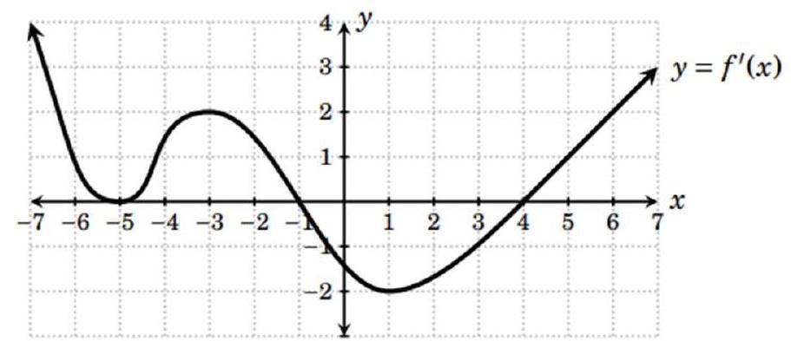

1. State the intervals on which $f\left(x\right)$ increases.
2. State the intervals on which $f\left(x\right)$ decreases.
3. List all critical points of $f\left(x\right)$.
4. At which of its critical points does $f\left(x\right)$ have a local maximum?
5. At which of its critical points does $f\left(x\right)$ have a local minimum?
6. Based on this information, sketch a possible graph of $f\left(x\right)$ above.

## Concavity

1. Find the intervals where $f\left(x\right)=\frac{1}{3}x^{4}-8x^{2}+8$ is concave up and concave down. Find all inflection points.
2. Find the intervals where $f\left(x\right)=\frac{x}{x-1}$ is concave up and concave down. Find all inflection points. Justify your answers.
3. Let $f$ be a function defined for all $x≠0$ such that $f\left(4\right)=-3$ and the derivative of $f$ is given by $f^{'}\left(x\right)=\frac{x^{2}-2}{x}$.
4. Find all values of $x$ for which the graph of $f$ has a horizontal tangent, and determine whether $f$ has a relative maximum, a relative minimum, or neither at each of these values. Justify your answers.
5. On what intervals, if any, is the graph of $f$ concave up? Justify your answer.
6. Write the equation of the tangent line of at .
7. A graph of a function

   Description automatically generatedDoes the line tangent to the graph of $f$ at $x=4$ lie above of below the graph of f(x) when $x>4$. Why?
8. See the graphs of $f'\left(x\right)$ and $f″\left(x\right)$
9. Determine the critical numbers of $f$.

1. Where is $f$ increasing?
2. Where is $f$ decreasing?
3. At what values of $x$ does $f$ have a local max?
4. At what values of $x$ does $f$ have a local min?
5. Where is $f$ concave down?
6. Where is $f$ concave up?
7. At what values of $x$ does $f$ has points of inflection?