# Parametrics and Polar Test

## Parametric Equations

1. Eliminate the parameter and find a rectangular equation for the following parametric equations. Show all work.
   1. [3pts] and
   2. [3pts] and
2. Graph the curve whose parametric equations are given, indicating the orientation of the curve with arrows. Clearly label the axes on your graph paper before graphing.
   1. [3pts] and where
   2. [3pts] and where

## Polar Equations

1. [2pts] Convert to polar coordinates with
2. [2pts] Convert to polar coordinates with
3. [2pts] Convert to rectangular coordinates
4. [2pts] Convert to rectangular coordinates
5. 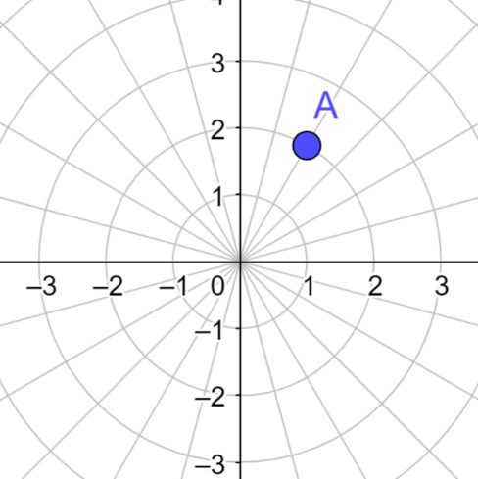[2pts] Which of the following is **not** a possible coordinate for point **A**?
6. [2pts] Which of the following *polar coordinate* points is furthest from the origin?
7. [2pts] Convert to polar:

1. [2pts] Convert to rectangular:
2. [2pts] Convert to rectangular

**Questions 10-12 Refer to the graphs below. The scale in the “r” axis is 1 unit per circle.**

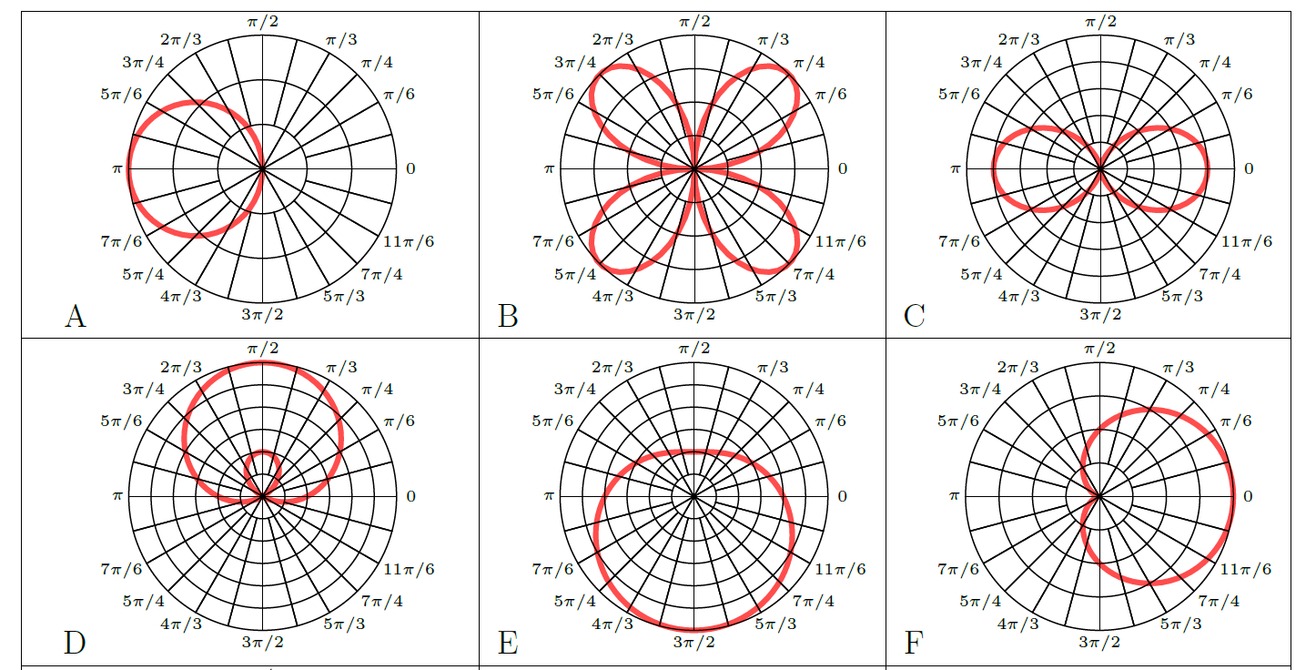

10. [2pts] Which of the above (A-F) is the graph of ? _______

11. [2pts] Which of the above (A-F) is the graph of ? _______

12. [2pts] Which of the above (A-F) is the graph of ? _______

## True/False

1. _______ [1pt] It is possible for a single point in the plane to have the same coordinates in both rectangular and polar representations.
2. _______ [1pt] A function cannot intersect itself
3. _______ [1pt] In a polar graph, the value of *r* is always non-negative.
4. _______ [1pt] Arrows on a parametric graph indicate the direction of increasing *y* values.
5. _______ [1pt] Every point in the plane has infinitely many polar coordinate representations.

## Free Response

A baseball pitcher throws a baseball with an initial speed of 138 feet per second at an angle of 20° to the horizontal. At time , the ball leaves the pitcher’s hand at a height of 4 feet above the ground.

1. [1pt] Find four parametric equations that describe the position and velocity of the ball as a function of time. (Assume the ground has a -coordinate of 0).
2. [1pt] Set up but do not solve an equation to answer: How long is the ball in the air?
3. [1pt] Set up but do not solve an equation to answer: At what time does the ball reach its maximum height?
4. [1pt] What is the height of the ball after 5 seconds?
5. [1pt] Does the ball fly for more than 8 seconds?