# Stats Quiz 1

## True False

1. Dropping a rubber ball and measuring how far it bounces on three successive rebounds is an experiment.
2. In an experiment where 10 coins are flipped (in order) and the (ordered) string of heads and tails that landed is recorded, the sample space size is 1024.
3. In an experiment where 10 coins are flipped (in order) and the (ordered) string of heads and tails that landed is recorded, every outcome is equally likely, assuming the coins are fair and the tosses are independent.
4. In an experiment where 2 different colored dice are rolled and the sum of the pips showing on the two dice is recorded, the sample space size is 36.
5. In an experiment where 2 different colored dice are rolled and the sum of the pips showing on the two dice is recorded, every outcome is equally likely.
6. The expected value of a probability distribution is the element in the sample space that is most likely to be observed.
7. The variance of a distribution or a list of samples is always non-negative
8. The standard deviation of a distribution is always less than or equal to the variance.
9. Adding a constant $c$ to every element in a list will increase the variance by $c^{2}$.

$$\left(\begin{aligned}12345678 \\ 2345678\end{aligned}\right)=\left(\begin{aligned}12345678 \\ 10000000\end{aligned}\right)$$

## Multiple Choice

1. Given the list of values: 10, 12, 12, 14, 15, 16, 16, 16, 18, 19, 22, the ratio between the mean and the standard deviation is

* A. 4.485 : 1

1. An insect population is observed to have body mass that is normally distributed with a mean of 32.4g and a standard deviation of 2.1g. What body mass corresponds to a Z-score of $Z_{2.3}$

* A. 37.23

1. Here is a graph of the results from a recent class poll. You want to analyze the hypothesis “fewer students are born on Tuesday than other days” by using a binomial distribution Bin[n,p]. What are the appropriate values of n and p to use.

* A. n=110 and p = 1/7

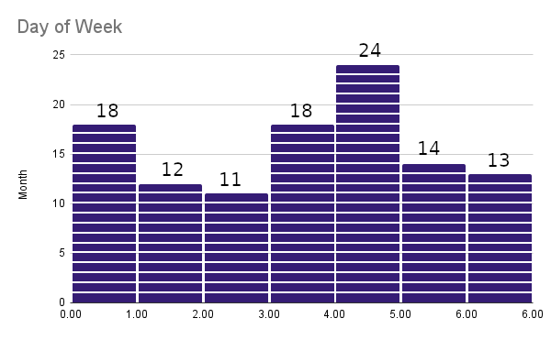

1. Continuing the previous problem, if $k$ represents the number of students born on Tuesday, which of the following statements, if it were true, would support that hypothesis? (Sunday is theleftmost day of the chart).

* A. Pr(k <= 11) =0.03)

1. A single marble is drawn from a hat containing 5 red marbles and 9 blue marbles. Its color is recorded and the marble is returned to the hat. This experiment is repeated 8 times. What is the probability of observing exactly 3 blue marbles?

* A. $\left(\begin{aligned}14 \\ 3\end{aligned}\right){\left(\frac{9}{14}\right)}^{3}{\left(\frac{5}{14}\right)}^{5}$

## Free Response

In an election in Elbonia the votes are soon to be tallied. In the entire population of 1,000 Elbonians, 520 of them favor the candidate with blue hair, while 480 favor the candidate with a pet duck.  
  
Elbonians vote by goat. That means, if they support the candidate with the blue hair, they tie a white goat to their front doorpost. If they support the candidate with the pet duck, they tie a black goat to their doorpost. The Elbonian electoral college tallies the votes and determines the winner. Yet it was determined recently that the time and expense in traveling to each of the 1000 households in Elbonia was too costly. Thus the college determined to implement a cost saving measure: they will randomly sample 100 households only and tally those 100 goats. What could go wrong? This is a great idea, and there was much rejoicing.  
  
You have been contracted by the Elbonian Disenfranchisement Bureau to analyze this voting methodology. Is it really fair? To answer them, you calculate the probability that the candidate with 480 supporters actually ends up winning. What is your report to the EDB?