# Sequences and Series

## Useful formulae

## Practice with arithmetic and geometric sequences

Write the following sequences in sigma notation

For each of the sequences 1-6 find the term

For each the sequences 1-6 find the sum

For each of the sequences 1-6 find the sum

For the convergent geometric sequences determine

For the convergent geometric sequences determine the first index for which

For sequence 1, solve the equation

For sequence 2, solve the equation

If a geometric sequence has and find the common ratio and the term

If an arithmetic sequence has and , write a formula for and the sum of the first 12 terms, starting with

## Sums of powers

The sums and in general fascinated mathematicians for centuries. We will derive some of these formulas in this section.

First, the following formulas you should be able to verify on your own

The next is not obvious

But by inferring the pattern in the last 3 formula you should be able to complete

(These formulas involving “falling and rising factorials” are easily established using a branch of mathematics called *discrete calculus*)

Now your job is to find the equations for and by manipulating the above formulas.

Though messy, this procedure can be continued to find for any . These lead to the famous *Bernoulli Numbers*.

## Sums of Cubes

We close with a “proof without words” relating the formulas for and ,a.k.a Nichomachus’ Theorem.

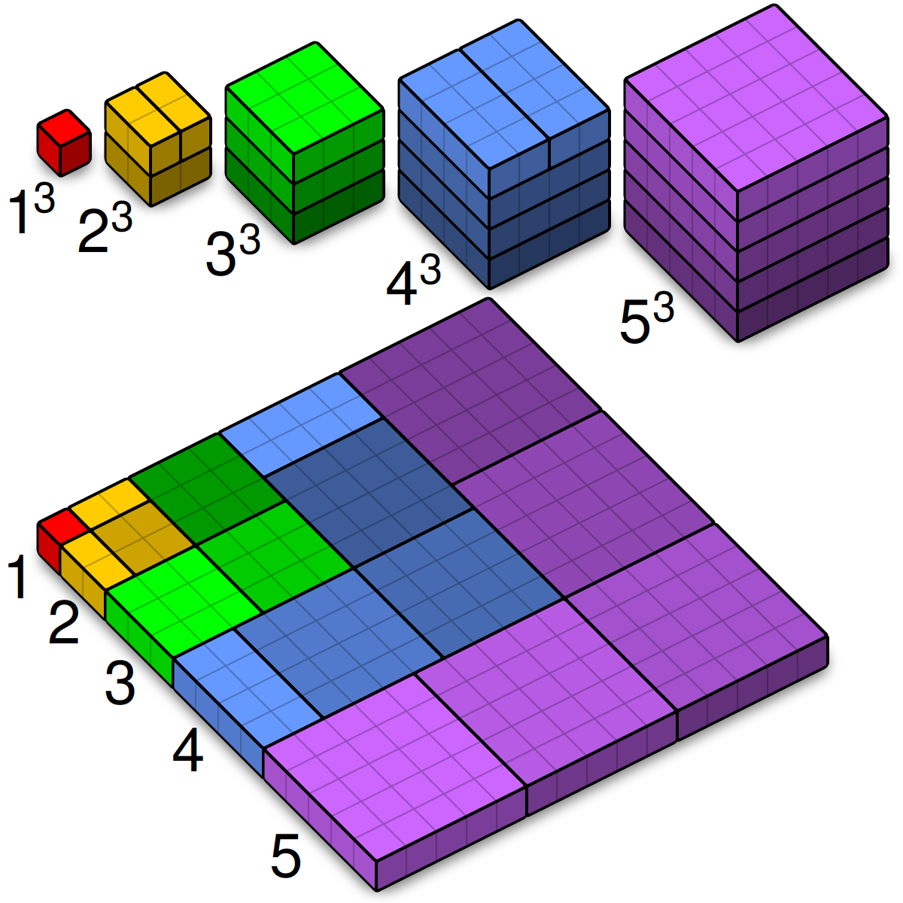

Nichomachus’ Theorem