# Logistic Growth

Differential equations (which model a function based on the rate of change of the function) are commonly used to model populations, because population growth *rates* are usually dependent, at least in part, on the population *size* at any time.

We will review a simplistic growth model, the exponential model, and next introduce an extension of the exponential model call the logistic growth model.

In the following we will assume time $t$ is an independent parameter, the population $y\left(t\right)$ is dependent only on time and certain constants. Population must be non-negative, but time can be positive or negative, with negative time simply indicating a time before the, often arbitrary, initial $t=0$.

## Exponential Growth

If one cell splits into two cells, then four, then eight, without bound, we have a simple growth model: the number of new cells in a given time interval equals the number of current cells. Extended to a differential equation

$$\frac{dy}{dt}=ky\left(t\right)$$

is an exponential growth model with growth constant $k$. This equation can be solved using separation of variables

$$y\left(t\right)=Ce^{kt}$$

where $y\left(0\right)=C$ is the initial population.

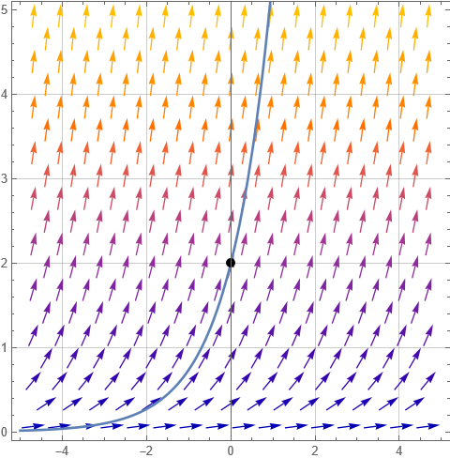

Slope field for $y′=y$

The above plot shows a slope field and its particular solution with initial population $y\left(0\right)=2$. The solution, $y\left(t\right)=2e^{t}$ exhibits unbounded exponential growth. These models work well in some cases over a limited time span. Yet all such models eventually break down because unlimited growth will always meet some impediment.

## Logistic Growth

One simple impediment we can add to the equation is an upper bound on the population. If the growth rate starts out as an exponential but then slows down as the population reaches a maximum value, how can we model this mathematically?

Start by considering the asymptotes of $y′=ky$. The equation $y′=0$ tells us when this slope field has an asymptote. $y′=0→ky=0→y=0$. The limiting population of exponential growth is simply $y\left(t\right)=0$– the lower bound. How can we add an upper bound?

Consider the equation $y′=ky\left(L−y\right)$ Solving $y′=0$ now has two solutions, $y\left(t\right)=0$ and $y\left(t\right)=L$. The population would have asymptotic limits at these two values, 0 a minimum and $L$ a maximum. Additionally, if $0<y<L$ then $y′>0$, so the growth rate is positive. If $y>L$ then $y′<0$ and the growth rate is negative. As $y$ approaches $L$, the growth rate approaches 0. The slope field for $y′=0.1y\left(5−y\right)$ is shown below

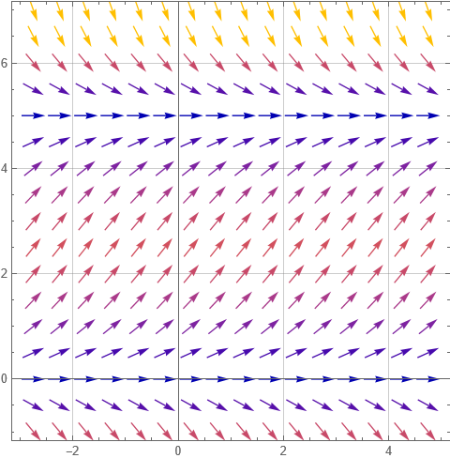{ width = 50% }

The logistic differential equation can also be solved by separation of variables. First (for no reason other than convention), the equation is rewritten

$$\frac{dy}{dt}=ky\left(1−y/L\right)$$

(This equation still has the same zeros at $y=0$ and $y=L$ but $k$ will be different. This doesn’t matter since $k$ is an undetermined constant).

The general solution to the above form of the logistic differential equation is

$y\left(t\right)=\frac{L}{1+be^{−kt}}$

You can verify algebraically that as $t→∞$, then $y\left(t\right)→L$ and as $t→−∞$ (which we allow), then $y\left(t\right)→0$. In this general solution $b$ is determined by the initial population (or really any fixed starting point $y\left(t\right)$ and then $k$ is determined by the growth rate.)

Graphed below are three particular solutions to the above differential equation, corresponding to three separate initial populations. Notice that in each case, the resulting curves are the same, only shifted in the $t$ dimension.

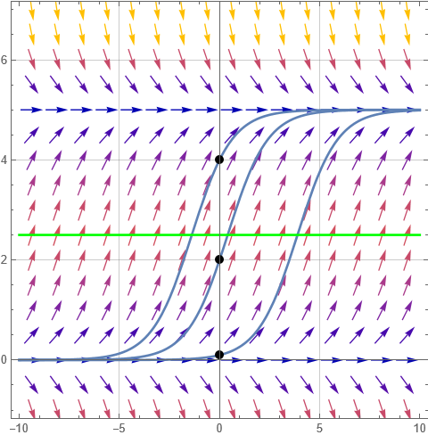{ width = 50% }

The green line indicated on the graph, at $y=L/2$ is of particular significance. At this population

* the growth rate is maximized (*i.e* the slope is the largest)
* the population has an inflection point (the growth rate changes from increasing to decreasing)
* the value $L/2$ has no dependence on initial conditions!