AOS Math 10, Spring 2024
Applications of Derivatives Test (#15)
_______/ ______
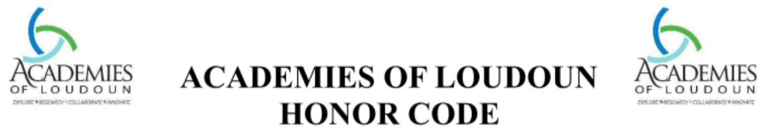
Honesty and integrity are the foundations of good academic work. Whether you are working on a problem set, lab report, project, presentation, or paper, do not engage in plagiarism, unauthorized collaboration, cheating, or facilitating academic dishonesty. Our expectation is for our students to be successful while being trustworthy. The honor code is not intended to be punitive, but rather a guide for all students and faculty to follow. For these reasons, the Academies of Loudoun will uphold the following Honor Code:
On my honor, I have not accepted or provided any unauthorized aid on this test, quiz, or assignment.
As an Academies of Loudoun student, you agreed to uphold the Academies Honor Code. Please write the Honor Code Pledge below and sign this document.

May 24, 2024
Student Signature Class Date

Print Name:

