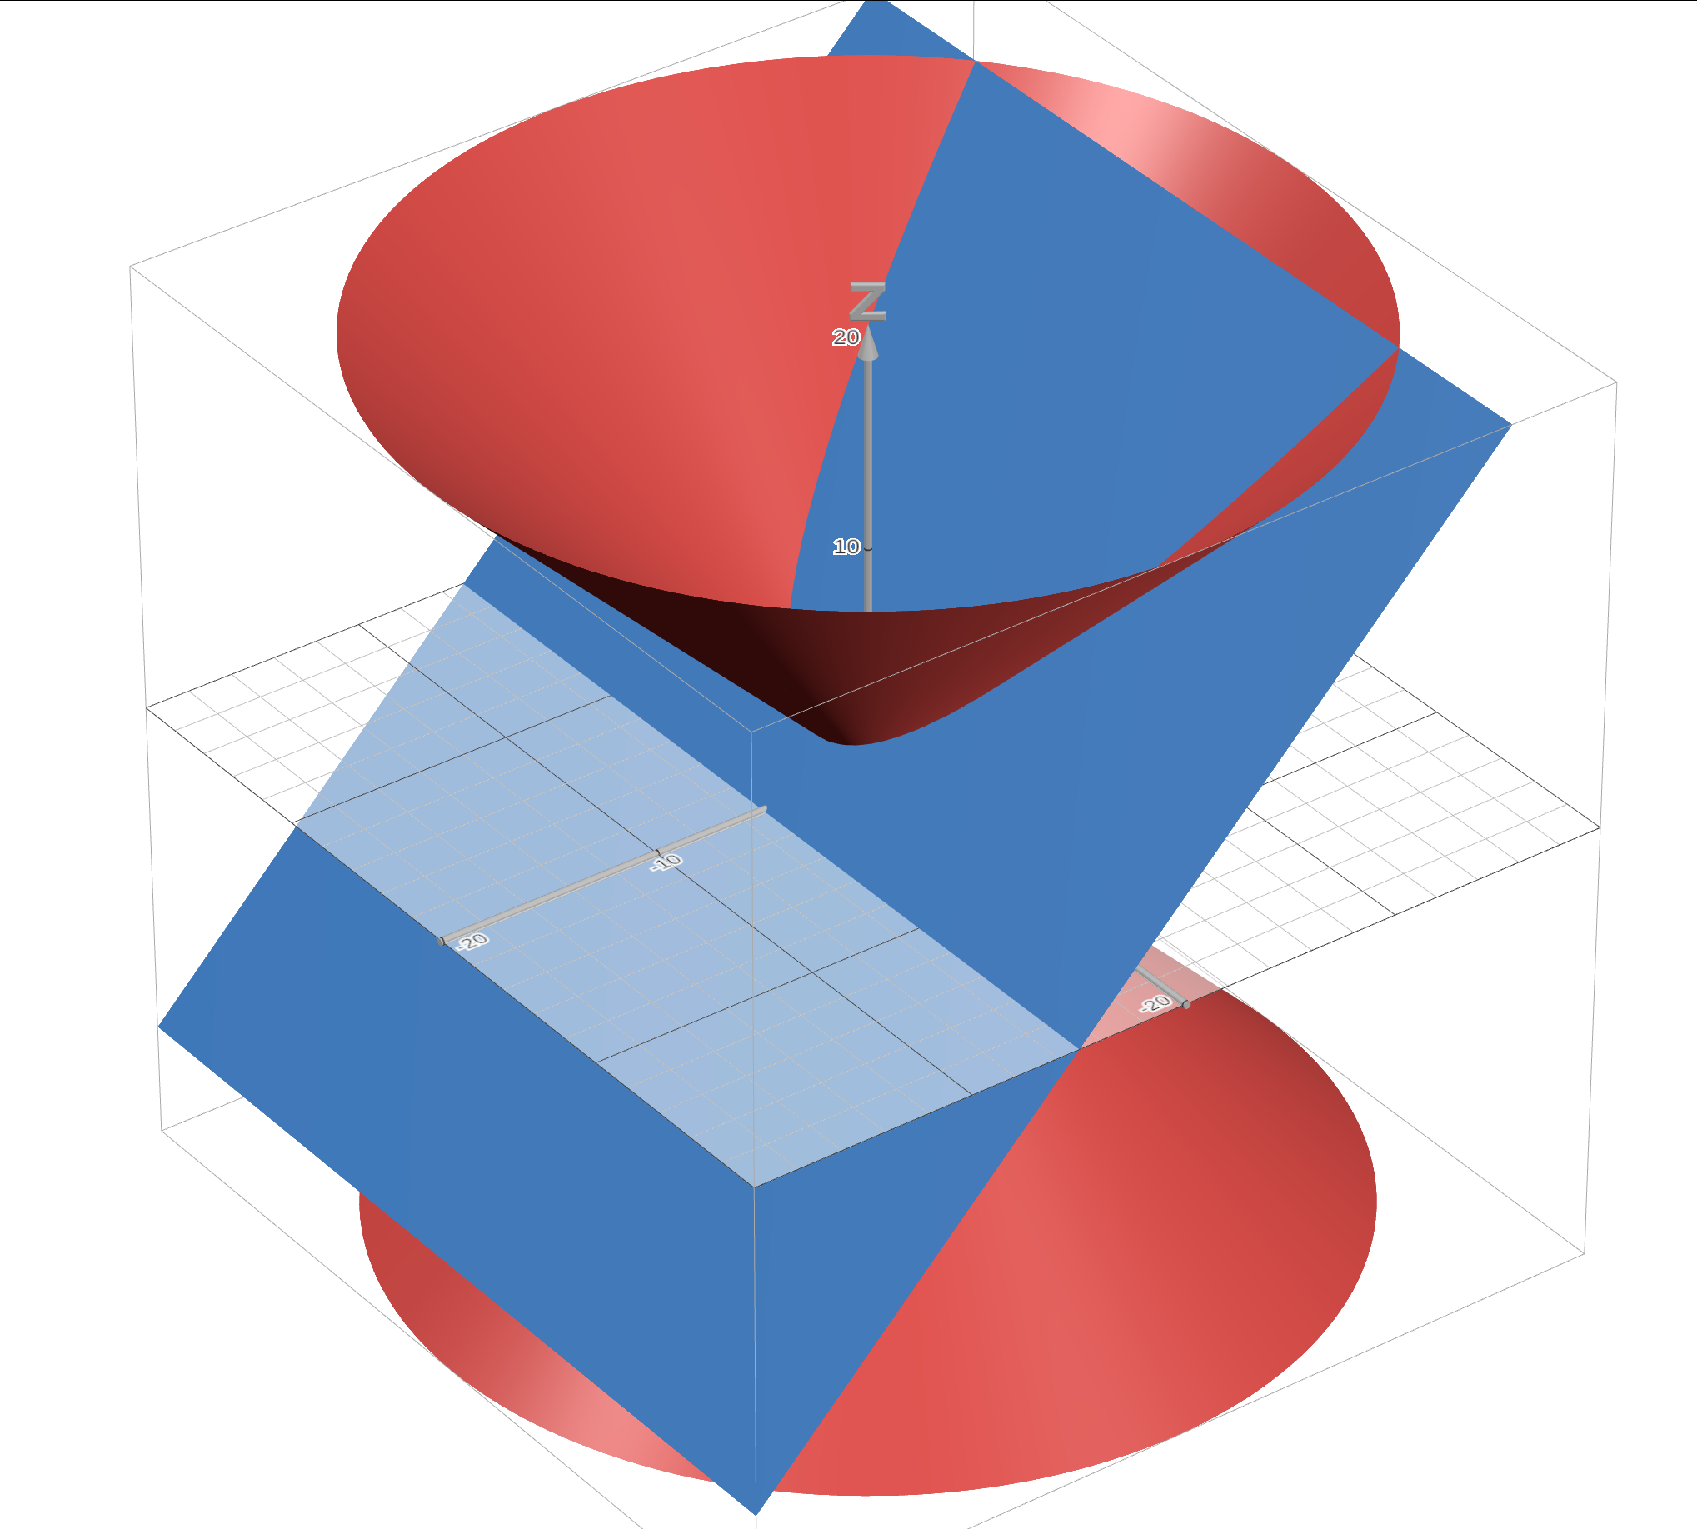
Conic Sections Intro
Conic sections are plane curves formed from the intersection of a plane and a double cone. You are going to explore the graphs and equations of conic sections using Desmos in this activity.

Preliminaries
The conic sections are circle, ellipse, parabola and hyperbola. There are also degenerate conic sections including a point, a line, and two intersecting lines. The general equation of a (non-rotated) conic section is . The equation of a double cone is and the general equation of a plane is .

Finding Intersections
Use Desmos 3d (http://desmos.com/3d) to graph a double cone and a plane using the equations above. When prompted, create sliders for and . To simplify things, set the “step size” for each slider to 0.1. By adjusting the parameters, explore the types of intersection you can create. The intersection of two surfaces in 3D will usually be a curve. Look at the intersections and see what kinds of curves you can create. Sketch some of the curves below.

Finding the Conics
The standard conic sections have the following characteristics:
- circle: looks like a circle!
- ellipse: a circle, but stretched
- parabola: a curve. has one branch and one line of symmetry, and is unbounded in one direction
- hyperbola: sort of like 2 parabolas. has 2 branches and lines of symmetry. unbounded in all directions
Try to find values of that result in each of the above conics. Describe the types of plane intersections that result in each conic and give specific examples. Try to sketch the intersections.
Circle
Ellipse

Parabola

Hyperbola

Finding Degenerates
A point, line, and two lines are also possible intersections. See if you can find them and describe what geometric property they all have in common. Describe the intersections that generate each one.
Point

Line

Two Lines

Conic equations
The equations of non-generate conics are given here. Label each one as a hyperbola, circle, parabola or ellipse. Use Desmos 2D as needed.
- or

