**PYTHON MINIPROJECT**

**SAHITYA K, 2017108041**

**GITHUB LINK:** [***https://github.com/padfo-ot/SIR-MODEL.git***](https://github.com/padfo-ot/SIR-MODEL.git)

**BUILDING SIR MODEL OF EPIDEMICS USING PYTHON**

**INTRODUCTION:**

As the world grapples with the threat of the rising pandemic, many people across the globe have constructed various models that will estimate the size of the spread. In this mini project, I have tried to develop an SIR model to predict the progress of the infection. This is an attempt to develop an interactive model (graph) using python wherein the user will be able to decide the parameter values.

**PROBLEM STATEMENT:**

The no of cases reported globally for COVID 19 has now crossed over 2 million and is rising. The entire world has gone into an extended lockdown period in an attempt to stop the spread. This study aims to predicts the duration of the infection in various scenarios and analyze the effects on it when changing the parameter values.

**SCOPE OF THE STUDY:**

This study aims to develop a generic SIR model that can predict the duration of any epidemic. The model is accompanied with the basic assumptions that are assumed in theory. The model is just estimation and not an actual representation of how the infection will pan out. This model does not predict the second wave of infection.

In order to make it more realistic, in this study I have also considered SIRD model which includes the stock of people who die because of the infection. With the help of available resources online, this study can be used to model real life situations with greater accuracy.

The dynamics of an epidemic, for example, the flu, are often much faster than the dynamics of birth and death, therefore, birth and death are often omitted in simple compartmental models.

**SIR MODEL:**

The **SIR model** is one of the simplest compartmental models, and many models are derivatives of this basic form. The model consists of three compartments: **S** for the number of **s**usceptible, **I** for the number of **i**nfectious, and **R** for the number of **r**ecovered or deceased (or immune) individuals.

These variables (**S**, **I**, and **R**) represent the number of people in each compartment at a particular time. To represent that the number of susceptible, infected and recovered individuals may vary over time (even if the total population size constant), we make the precise numbers a function of *t* (time): **S** (*t*), **I** (*t*) and **R** (*t*). For a specific disease in a specific population, these functions may be worked out in order to predict possible outbreaks and bring them under control.

**THEORY:**

The equations of the SIR model are:

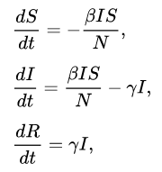

Where,

S - The stock of people who will be susceptible to the infection

I - The stock of people who will be infected

R – The stock of people who will be recovered/ removed

**SIRD MODEL**:

This model involves categorizing the removed compartment into two- those who recovered and those who dies. The equations for it are as follows

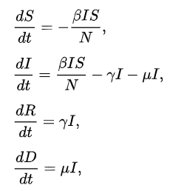

Where β, γ and μ a{\displaystyle \beta ,\gamma ,\mu } arare the rates of infection, recovery, and mortality, respectively

**IMPLEMENTATION:**

* The basic SIR model is constructed using python.
* The libraries numpy, scipy and pandas are used to generate the equation values.
* The library matplotlib is used to construct the graph.
* The library plotly is used to derive an interactive plot

Alongside this, I have also collected the patient data of India’s COVID-19 patients and have plotted them to compare the trend.

**RESULTS:**

This study was done at a time when a pandemic was peaking. The model is explained with Chennai as an example. The ongoing pandemic COVID-19 is taken as the infection being spread. All technical details regarding the pandemic are obtained from various government and other credible and trustworthy websites cited in the reference.

**SIR MODEL:**

Assumptions made:

* No lockdown scenario
* Reproductive rate (R0) and transmissibility rate (β) are assumed based on the information obtained from various credible articles in the internet.
* The average population of Chennai is around 70.9 Lakhs. Therefore, N is assumed to be 8M.

N =800000

R0 =2.69

γ = 0.13

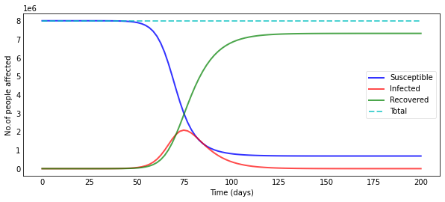

We can see that around the day 75, almost 2 Million people are affected. The infection is expected to last for around 125 days. This does not show the second wave that is normally encountered in an infection.

Modifying this, if we enforce lockdown after 60 days, we get

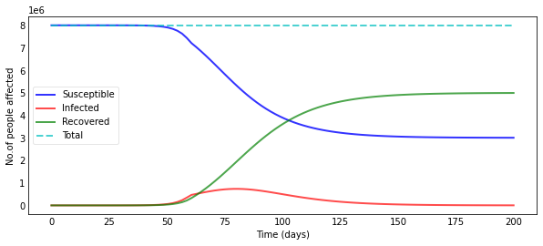

It is clearly evident that a lockdown will help reduce the infection rate. The lockdown considered here is not of enhanced quarantine stage. It is say, a city wide blockade barring non essential activities. If the lockdown enforced can be of much stricter nature, the infection rate will further go down.

**SIRD MODEL:**

N = 8000000

R0 = 2.69

γ = 0.13

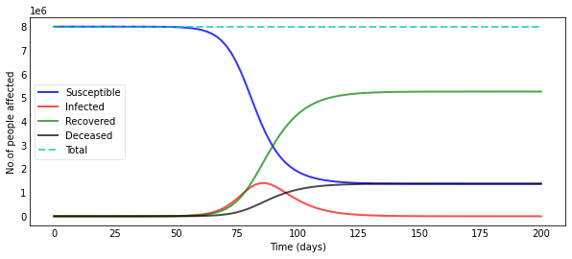

As you can see, the estimated death toll here is as high as 1.5 M.

With a city wide lockdown after 60 days, we get

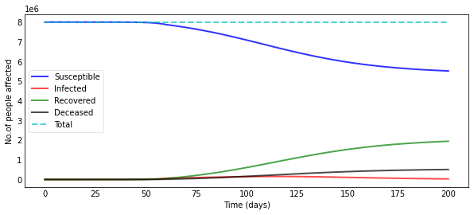

The death toll and the infection rate are considerably reduced.

The real life data (Time series patient data of COVID patients, INDIA) when plotted show:

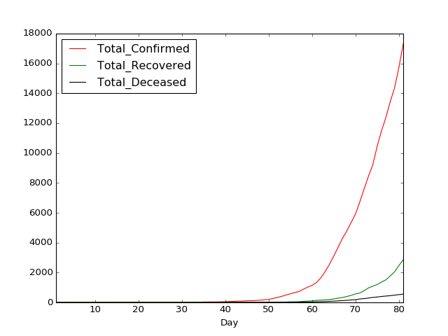

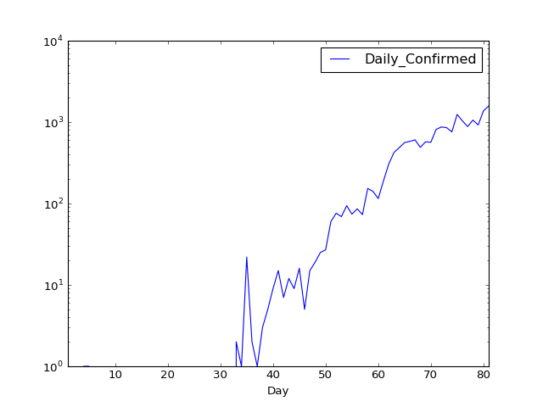

The cases have been steadily increasing, but in the past few days the curve displaying the no cases confirmed is appearing to flatten.

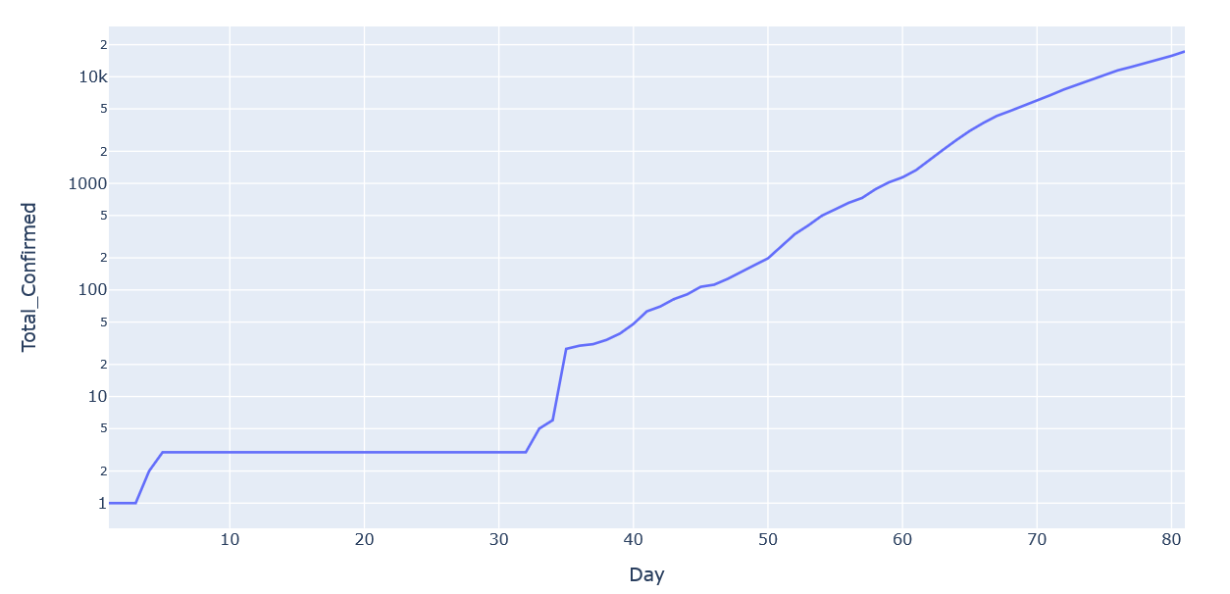

The infection seems to be coming under control. Applying the real life restrictions that were applied here in India (Chennai in particular),

Taking the day the first ever COVID case reported in our country as Day 1,

N = 8000000

T1 = 46 (Day 46- When the TN govt closed schools and colleges and restricted unwanted movement)

T2 = 53 (Day 56 – When the enhanced quarantine was imposed. Nationwide lockdown came into effect)

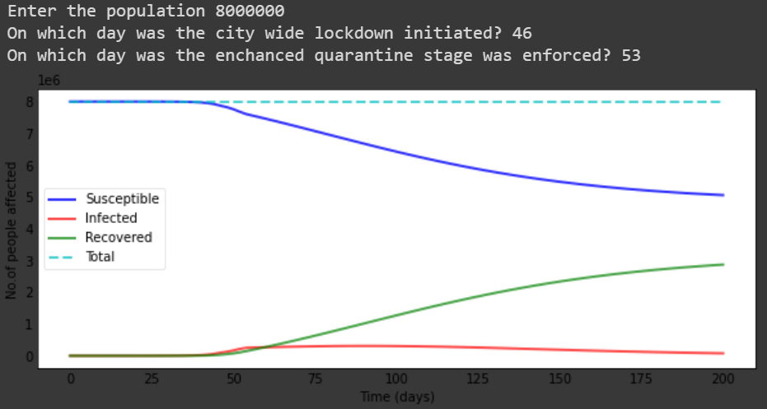

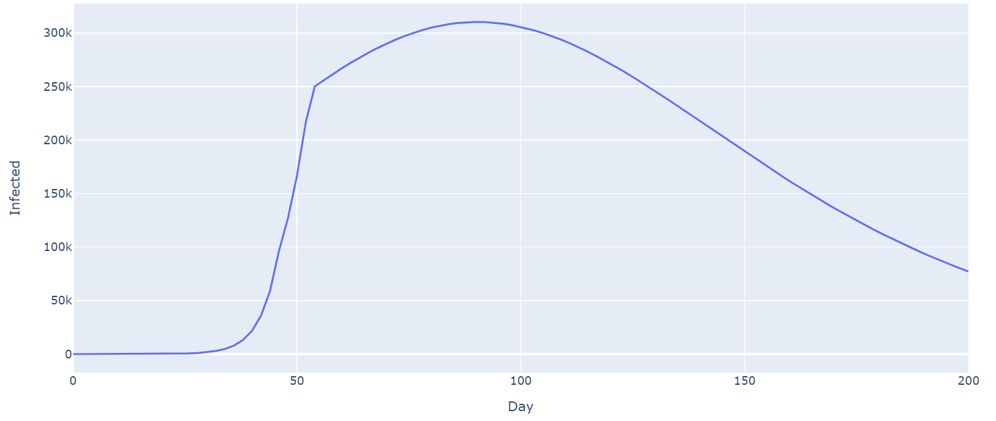

The second graph shows the infected curve. The infection peaks around Day 70-80 with around 300k+ cases.

**CONCLUSION:**

This model can be used for approximate estimation of the spread of any disease under certain assumptions. This model can be further developed to include various other parameters to create an environment that is more similar to the reality.

The fact that we haven’t recorded as many cases as estimated in the model may be due to us not having enough testing facility to test a large number of people. It may also indicate the increased awareness about the disease due to multiple warnings issued by the government and otherwise before the infection peaked.

As said earlier, this model is only an approximation. Since this is a predictive model, if formulated during the early onset of an infection, it can be extremely useful to estimate the size of the impending epidemic and take necessary precautions.

**REFERENCES:**

1. <https://scipython.com/book/chapter-8-scipy/>
2. <https://www.covid19india.org/>
3. <https://plotly.com/>
4. Infectious Disease Modelling: Beyond the Basic SIR Model- <https://towardsdatascience.com/infectious-disease-modelling-beyond-the-basic-sir-model-216369c584c4>
5. <https://www.youtube.com/watch?v=WntYcgs_Jn0&t=308s>
6. <https://www.youtube.com/watch?v=Kas0tIxDvrg&t=127s>
7. <https://www.youtube.com/watch?v=gxAaO2rsdIs&t=4s>