# Technical Design Document

## 1. Introduction

The Placement Eligibility App is a web-based application built using Streamlit, Python, and MySQL. It allows placement teams to input eligibility criteria and query a dataset of student information to display eligible candidates. Additionally, the app provides insightful visualizations using Matplotlib and Seaborn.

## 2. System Architecture

The system follows a three-tier architecture:

• Frontend: Streamlit-based web UI.

• Backend: Python-based logic with MySQL for data storage.

• Database: MySQL database storing student and placement-related data.

## 3. Components

3.1 Frontend (Streamlit Application)

• placement_eligibility_checker.py: Displays input fields for eligibility criteria, fetches eligible students, and visualizes insights.

3.2 Backend (Python Processing)

• generate_student_data.py: Generates fake student, programming, soft skills, and placement data and inserts them into MySQL.

• StudentDatabase.py: Manages MySQL database connection, creates tables, and loads student data.

3.3 Database Schema (MySQL)

• Students Table: Contains student details like Name, Age, Gender, and Contact Information.

• Programming Table: Stores programming skills and performance metrics.

• SoftSkills Table: Maintains students' soft skill ratings.

• Placements Table: Records placement readiness and company information.

## 4. Deployment & Environment Variables

• .env file stores MySQL connection details:

MySQL_host=''  
MySQL_username=''  
MySQL_password=''  
MySQL_database=''

• Run the Streamlit app using:

streamlit run placement_eligibility_checker.py reload

## 5. Functional Features

5.1 Placement Eligibility Checking

• Users input eligibility criteria via Streamlit UI and retrieve a list of eligible students.

**OUTPUT SCREENSHOT**

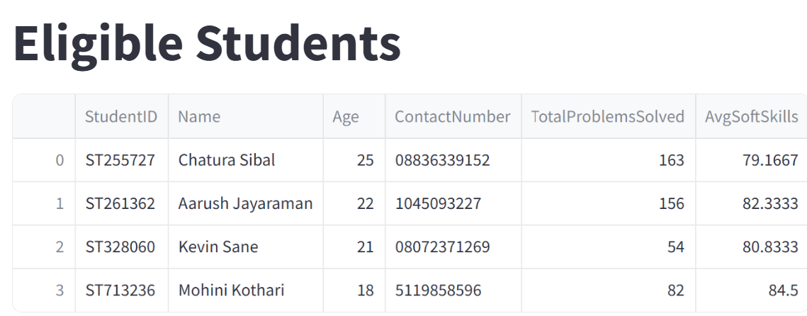

5.2 Data Insights

• Various insights such as top students, placement readiness distribution, programming language trends, and more.

1. Top 5 students ready for placement.

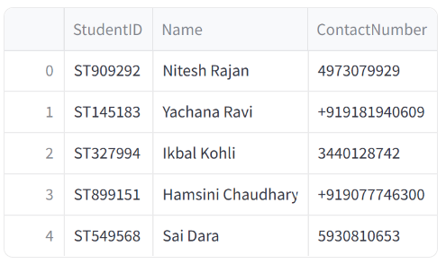

1. Placement Readiness Distribution

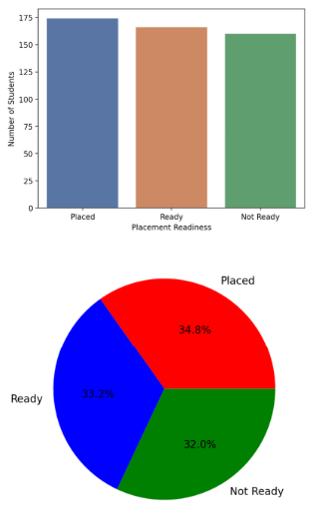

1. Soft Skills Average Scores

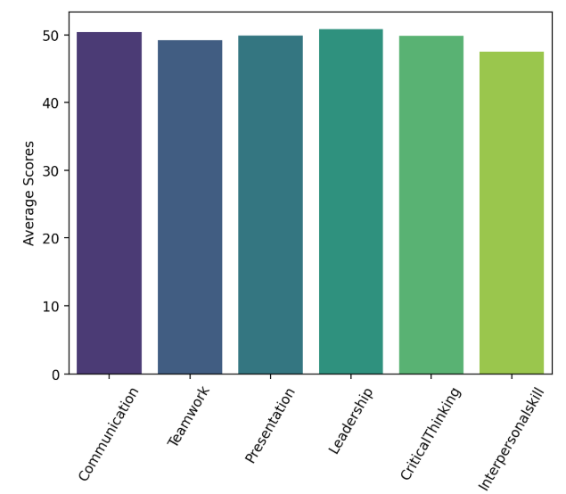

1. Most Popular Programming Languages

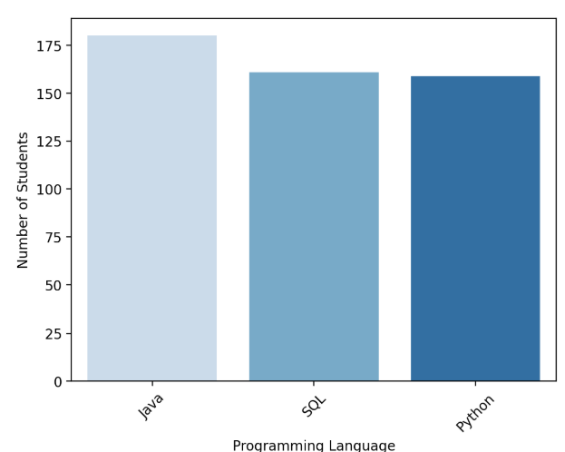

1. Top 5 Coders

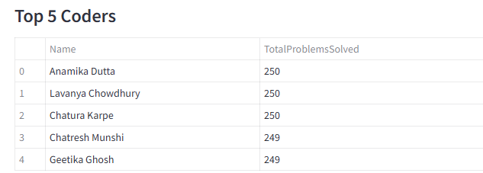

1. Students with Highest Internship Experience

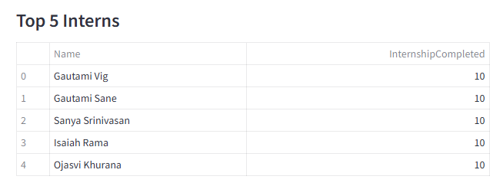

1. Correlation Between Mock Interview Score ,Internship completed and Placement Readiness

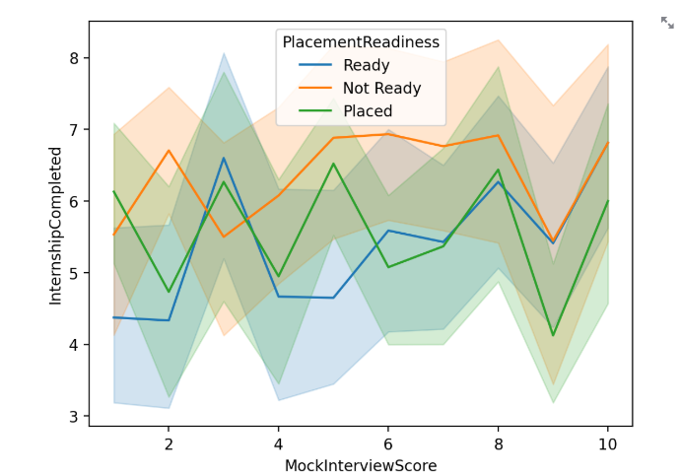

1. Cities with Most Placed Students

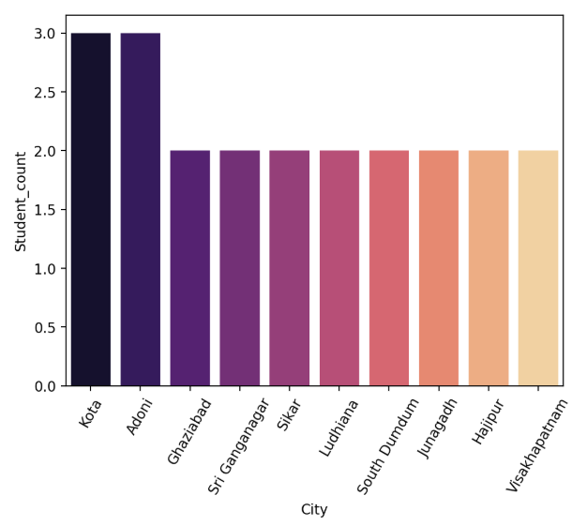

1. Genderwise Placement Distribution

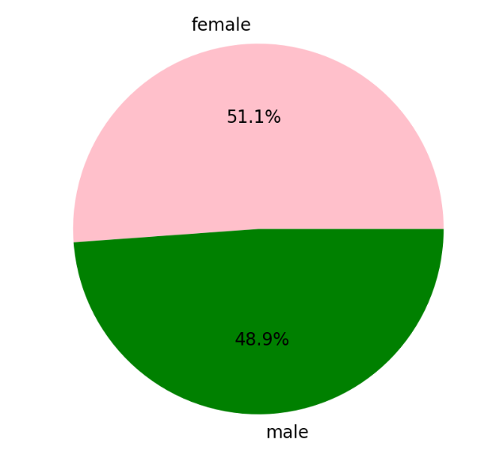

1. student placed per graduation year

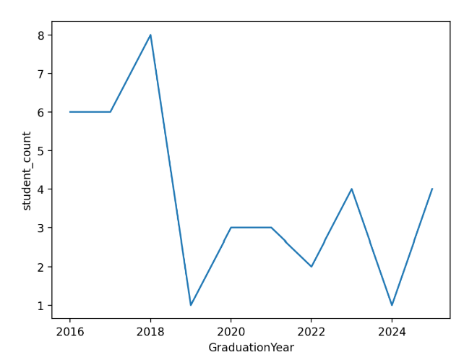

## 6. Future Enhancements

• Improve database query optimization.  
• Implement authentication.  
• Add an admin dashboard with advanced analytics.

## 7. Conclusion

This design document outlines the structure, functionality, and database architecture of the Placement Eligibility App. The system leverages Python, MySQL, and Streamlit to provide a robust solution for placement analysis and student eligibility assessment.