Ideation Phase
Brainstorming & Ideation Phase

Date | 28 SEPTEMBER 2026
Team ID | 6ab220cfbee0b08a2d2c63cd
Project Name | Auto Ticket Classification using FLOW DESIGNER
Maximum Marks | 4 Marks

Brainstorm & Idea Prioritization
In this phase, discussions were held to find an effective solution for the manual processes handled by the school IT helpdesk. Key ideas were brainstormed to eliminate human errors and reduce time consumption.
1. Core Problems Identified:
- The school IT helpdesk receives multiple incident requests daily from students and teachers regarding Wi-Fi issues, projector failures, password problems, and slow computers.
- Previously, IT staff manually reviewed each ticket to select the correct category and subcategory, which was a time-consuming and inefficient process.
2. Proposed Solution:
- Conceptualized an automated ticket classification approach using ServiceNow Flow Designer by analyzing keywords within the short description and description fields of the incident.
- When students raise a ticket, they do not need to manually select a category; the system will automatically assign the appropriate category and subcategory based on keywords (e.g., WiFi, Projector, Password, Slow) found in the short description.

3. Key Objectives & Scope:
- No-Code Automation: To develop a no-code, easily maintainable, and scalable solution without relying on complex scripting.
- Dependent Choice Logic: To implement a dependency relationship between Category and Subcategory choices to capture accurate data.
- Automated Communication: To send an automated email notification to the caller immediately upon ticket creation.
Step 1: Team Gathering, Collaboration
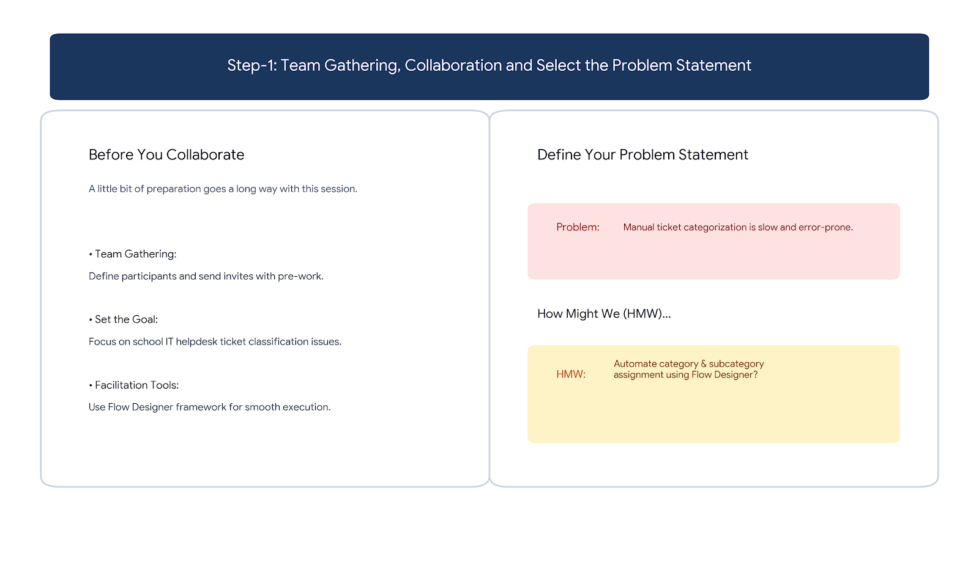

Step 2: Brainstorm, Idea Listing and Grouping
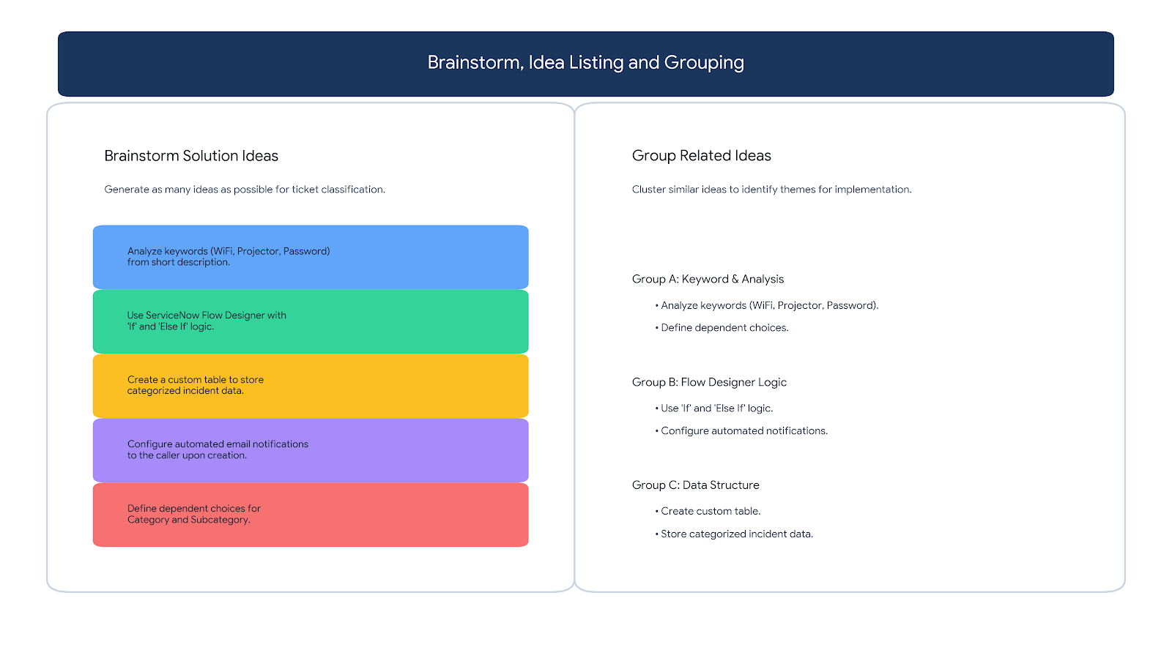
Step 3: Idea Prioritization


