One Page Abstract for OTST 2026 Conference
Phil Mc Phillips¹, George Georges¹, Daniel Danielson², David Davidson², Walter Gurtle²
¹Center for Unicorn Research, Circumference Institute, Narnia, CC 92120, USA
²School of Old Timey Research, The University of the Southern Hemisphere, South NN 8675309, Antarctica

Active, high-speed manipulation of terahertz (THz) radiation is a fundamental requirement for advancing next-generation systems in communications, spectroscopy, and imaging. Optically-controlled metasurfaces, which utilize a pump laser to dynamically alter the free-carrier concentration in a semiconductor substrate, have emerged as a powerful platform for achieving ultrafast modulation without the need for complex electrical biasing [1]. However, designing the sub-wavelength geometry of the metasurface to simultaneously optimize the optical pump absorption and the THz wave interaction presents a significant, non-intuitive challenge in electromagnetic design.
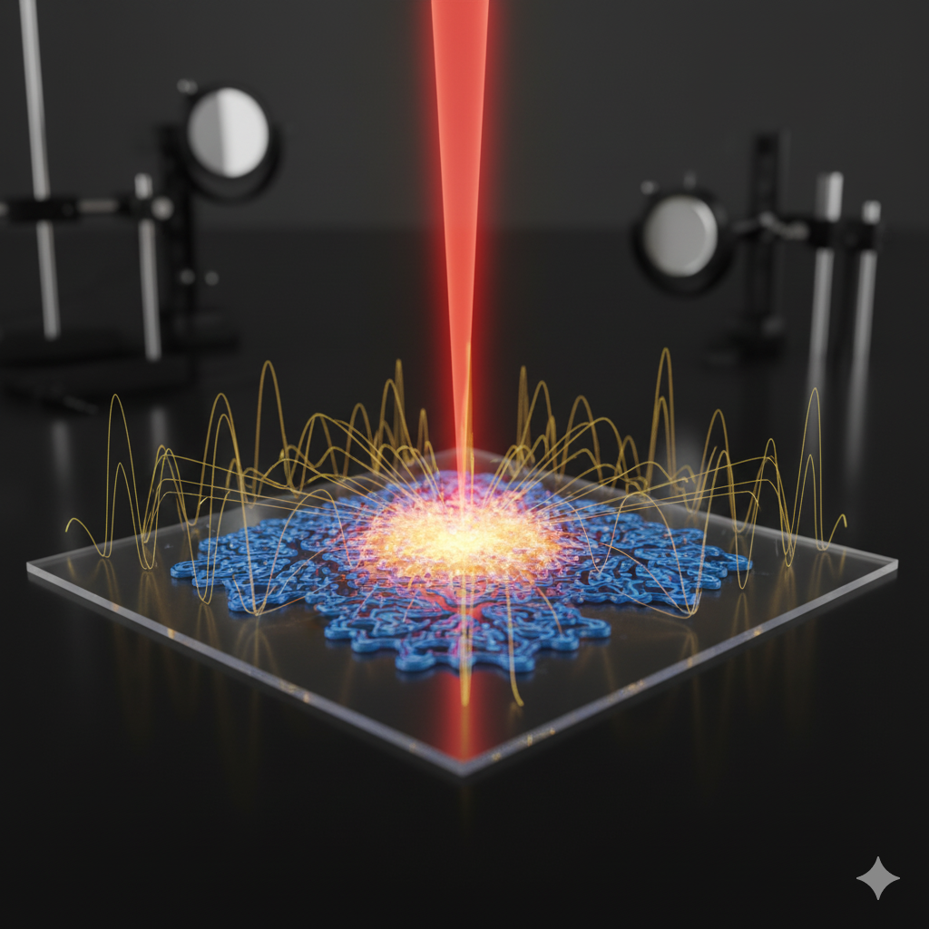
Fig. 1 Inverse designed all-dielectric metasurface for THz generation.
In this work, we demonstrate an artificial intelligence-driven approach to inversely design a high-efficiency, all-dielectric THz modulator. We focus on the topic of artificial electromagnetic materials, utilizing a tandem deep neural network (DNN) architecture to design a silicon-based metasurface. The network is trained to bypass traditional, computationally expensive FDTD simulations. The inverse-design network (generator) is tasked with producing a metasurface geometry that achieves a specific set of user-defined performance metrics—namely, maximum transmission (>90%) at 1.0 THz in the 'off' state (no optical pump) and maximum absorption (>95%) in the 'on' state when illuminated by a 1550 nm pump laser with a fluence of 40 µJ/cm² [2].
Our DNN-generated design consists of a complex, non-intuitive pattern of coupled resonators that efficiently confines the THz field and maximizes its overlap with the photogenerated carriers. Simulated results predict a modulation depth approaching 20 dB, with an insertion loss of less than 0.5 dB. The device is predicted to support modulation speeds limited only by the carrier recombination lifetime of the high-resistivity silicon, potentially exceeding 1 GHz [3]. We will present the full design methodology, simulated field profiles, and preliminary experimental characterization of the fabricated device using an optical-pump THz-probe (OPTP) system.
This AI-driven inverse design framework represents a significant leap forward in the development of bespoke THz components. It enables the rapid creation of highly complex, high-performance optical-THz devices, paving the way for programmable metasurfaces, spatial light modulators, and ultrafast beam-steering systems [4].

References
- H.T. Chen, W.J. Padilla, J.M.O. Zide, A.C. Gossard, A.J. Taylor, and R.D. Averitt, "Active terahertz metamaterial devices," Nature, 444, 597–600 (2006).
- P. R. Wiecha, A. Arbouet, C. Girard, and O. L. Muskens, "Deep learning in nanophotonics: a review of inverse design and data-driven methods," Nanophotonics, 10(4), 1317-1334 (2021).
- M. T. Man, S. L. G. de Oliveira, et al., "All-optical ultrafast terahertz modulator based on a hybrid graphene–silicon metasurface," Advanced Optical Materials, 7(19), 1900508 (2019).
- S. Zhang, J. Zhou, Y. S. Park, J. Rho, R. Singh, S. Nam, A. K. Azad, H. T. Chen, X. Yin, A. J. Taylor, and X. Zhang, "Photoinduced handedness switching in a chiral terahertz metamaterial," Nature Communications, 3, 942 (2012).

