
School of Mechanical Engineering
SASTRA Deemed to be University
MINI PROJECT REPORT
DESIGN AND SIMULATION OF A DUAL-ARM ROBOTIC MANIPULATOR WITH COORDINATE MOTION CONTROL IN NVIDIA OMNIVERSE
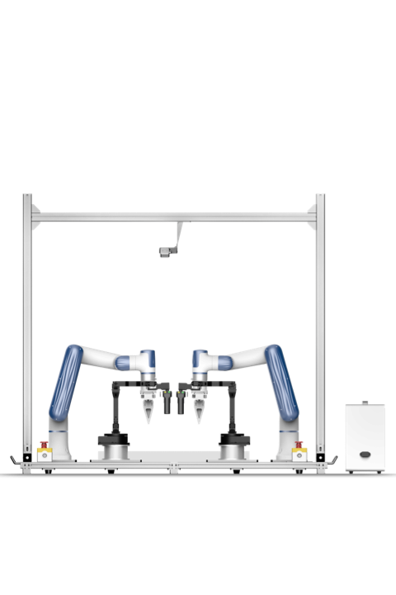
Figure 1: Dual-arm manipulator on a mobile base (project hardware)
Submitted by
Perugu Venkata Aditya
B.Tech – Mechanical Engineering (Digital Manufacturing)
Project Guide
Dr. Hari Krishnan R
Assistant Professor – III, School of Mechanical Engineering

Acknowledgement
I express my sincere gratitude to my project guide, Dr. Hari Krishnan R, Assistant Professor – III, School of Mechanical Engineering, SASTRA Deemed to be University, for his constant guidance, technical suggestions and encouragement throughout this mini project.
I also thank the School of Mechanical Engineering and the laboratory staff for providing access to the dual-arm manipulator hardware and the computing facilities needed to build and validate the digital twin. Finally, I thank my friends and family for their support during the project work.
Perugu Venkata Aditya
Mechanical Engineering (Digital Manufacturing)

Abstract
Dual-arm manipulators are increasingly used in digital and smart manufacturing because they can perform two-handed tasks such as assembly, handling and collaborative operations. Developing and testing control software directly on such hardware is time-consuming and risky: wrong joint commands or poorly tuned dynamics can cause collisions or damage. This project addresses the problem by building a digital twin of a dual-arm robotic manipulator in NVIDIA Omniverse (Isaac Sim) that can be controlled in real time through ROS2.
The workflow starts with a SolidWorks CAD model of the robot, assignment of links, joints and coordinate frames with the Denavit–Hartenberg (DH) convention, and conversion of the model to URDF using the SW2URDF exporter, including link mass, inertia, joint type, joint limits and dynamic properties such as friction and damping. The URDF is imported into Isaac Sim, the articulation root is configured and joint motion is verified in the PhysX Physics Inspector. ROS2 is integrated with Isaac Sim, and action graphs are developed for joint-level control of both arms and for movement of the mobile base. The simulated environment and sensors are then added.
The twin was validated against the real robot by commanding both with identical inputs and comparing recorded joint parameters and end-effector positions. The comparison gave an average positional accuracy of 96.6 % for the right arm and 96.2 % for the left arm over four trials. Major difficulties – arms collapsing under gravity, wrong end-effector positions and joint misalignment – were traced to incorrect mass and inertia values, improper joint axes, frame misalignment and missing damping, and were corrected. The validated twin is a platform for future inverse-kinematics control, synchronisation with the physical robot and monitoring/training through simulation.
Keywords: Digital twin, dual-arm manipulator, NVIDIA Omniverse, Isaac Sim, ROS2, URDF, PhysX, Denavit–Hartenberg, digital manufacturing.

Contents
Acknowledgement 2
Abstract 3
1. Introduction 5
2. Objectives and Scope 7
3. Theoretical Background 8
4. Methodology 11
5. Implementation 13
6. Results 17
7. Accuracy Analysis 21
8. Challenges Faced and Fixes 24
9. Future Work 25
10. Conclusion 26
Appendix A – Demo Video Links 27
Appendix B – Joint Parameter Vectors 27
References 28
Report at a glance
Table 1: Project summary
Item | Detail
Platform | NVIDIA Omniverse – Isaac Sim (PhysX)
Middleware | ROS2
CAD / export | SolidWorks, SW2URDF (URDF)
Robot | Dual-arm manipulator, 6 revolute joints per arm, mobile base
Validation | Hardware vs simulation, 5 end-effector trials per arm
Average accuracy | Right arm 96.6 %, Left arm 96.2 % (4 trials)

1. Introduction

1.1 Background
Industrial manipulators have long been used for repetitive single-arm tasks such as welding, palletising and machine tending. Modern digital manufacturing, however, demands flexible cells in which robots handle parts with both hands, hold a workpiece with one arm while the other performs an operation, and work next to people. A dual-arm manipulator mounted on a mobile base is a natural platform for such tasks because it combines human-like bimanual reach with the mobility to serve several stations.
Controlling a two-arm system is harder than controlling a single arm. Twelve joints must be coordinated, the two end-effectors must not collide, and any error in the kinematic or dynamic model shows up as a wrong tool position. Before software is released on the real machine it needs to be tested in an environment that behaves like the machine – this is the role of a digital twin.

1.2 Problem statement
Testing joint commands directly on the hardware is slow and risky. A mistake in a joint limit, a frame definition or a control gain can make an arm swing into its partner or the structure. The project therefore requires a physics-accurate virtual model of the dual-arm manipulator that can be driven by exactly the same ROS2 commands as the hardware and whose joint and end-effector behaviour is verified against the physical robot.

1.3 Motivation
- Safety: faulty commands are tried on a virtual robot first.
- Speed: simulations can be restarted instantly and run without hardware availability constraints.
- Repeatability: identical experiments can be repeated to compare control strategies.
- Training: operators and algorithms (inverse kinematics, learning-based control) can be developed on the twin.

1.4 Relevance to digital manufacturing
For a student of Mechanical Engineering (Digital Manufacturing), this work sits at the intersection of CAD, robotics, simulation and industrial communication. The same CAD → URDF → simulator → middleware pipeline can be reused for virtual commissioning of robotic workcells, offline programming, layout evaluation and the creation of digital twins of other machines in a smart factory.
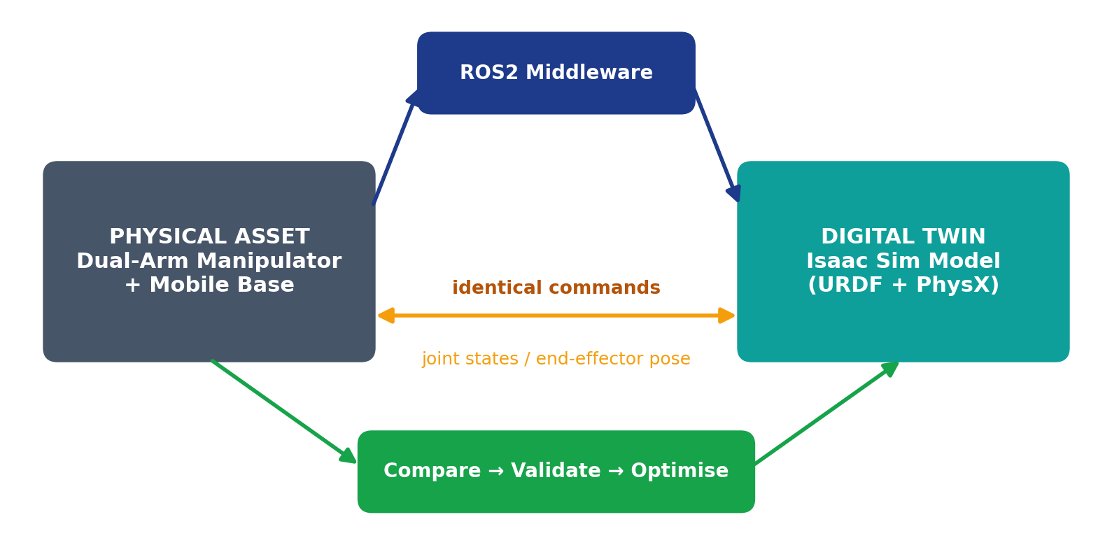
Figure 1: Digital twin concept – the physical robot and its virtual model exchange commands and state through ROS2

2. Objectives and Scope
The overall objective is to develop a digital twin of a dual-arm manipulator for control, validation and training via simulation using ROS2 and a virtual environment. This is broken into three specific goals:
- Real-time simulation and control – both arms and the mobile base are commanded in real time from ROS2 nodes.
- Validation and performance optimisation – the behaviour of the twin is compared quantitatively with the hardware and the model is tuned when differences appear.
- Training and development platform – the validated twin provides a safe sandbox for future control algorithms and operator training.

2.1 Scope of the work
Table 2: Scope of the project
In scope | Out of scope (future work)
SolidWorks modelling of the dual-arm assembly | Inverse-kinematics solver for the twin
DH frame assignment and kinematic definition | Full real-time synchronisation of hardware and twin
URDF generation with mass, inertia, limits, dynamics | Monitoring dashboard and learning-based training
Import and validation in Isaac Sim / PhysX | Dynamic payload and contact-rich manipulation tests
ROS2 control of both arms and the base | —
Hardware-vs-simulation comparison of pose | —

Figure 2: The dual-arm robot cell modelled in this project

3. Theoretical Background

3.1 Digital twin
A digital twin is a virtual representation of a physical asset that is kept consistent with the asset through data exchange. For a robot, the twin contains its geometry, kinematic structure and dynamic parameters and runs inside a physics engine. When the twin and the robot receive the same commands, their joint states and end-effector poses should agree; any difference indicates a modelling error. A twin can therefore be used for design verification, control development, virtual commissioning and operator training.

3.2 Dual-arm manipulators
In this project each arm has six revolute joints (named RL1–RL6 on the right and LL1–LL6 on the left), giving 12 degrees of freedom for the two arms in addition to the motion of the mobile base. Six joints per arm allow arbitrary position and orientation of the end-effector within the reachable workspace. For a dual-arm system the workspaces of the two arms overlap in the region in front of the robot, which is where bimanual tasks are performed.

3.3 Forward kinematics and the DH convention
The Denavit–Hartenberg convention describes the relation between consecutive link frames with four parameters. For link i the transformation from frame i−1 to frame i is the product of a rotation about Z(i−1) by θ, a translation along Z(i−1) by d, a translation along X(i) by a, and a rotation about X(i) by α:
T(i−1→i) = Rz(θᵢ) · Tz(dᵢ) · Tx(aᵢ) · Rx(αᵢ)
Multiplying the six link transforms of an arm gives the pose of the end-effector relative to the base: T(0→6) = T(0→1)·T(1→2)·…·T(5→6). In this project the DH frames were drawn for each arm and used to fix a coordinate axis on every link in SolidWorks, so that the exported URDF joint axes are consistent with the kinematic model.
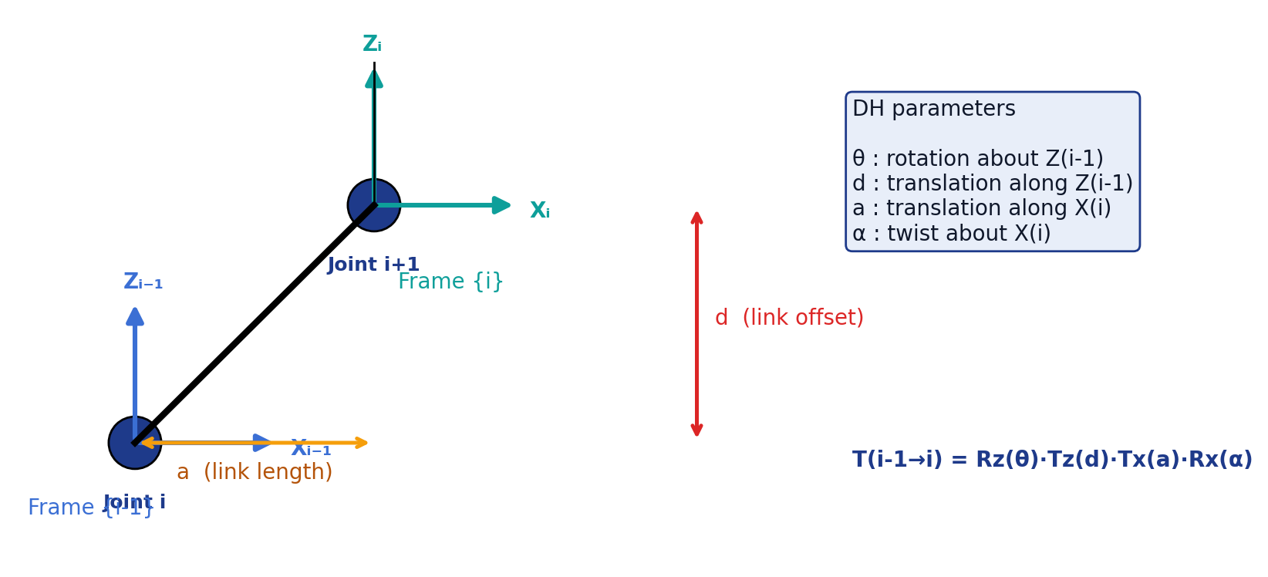
Figure 3: Denavit–Hartenberg parameters between frame i−1 and frame i
Table 3: DH parameters
Parameter | Meaning | Axis of action
θ (theta) | Joint angle | Rotation about Z(i−1)
d | Link offset | Translation along Z(i−1)
a | Link length | Translation along X(i)
α (alpha) | Link twist | Rotation about X(i)

3.4 URDF – Unified Robot Description Format
URDF is an XML format that describes a robot as a tree of links connected by joints. A link carries visual and collision geometry and an inertial block (mass, centre of mass and the inertia tensor). A joint defines its type (revolute, prismatic, fixed, …), parent and child links, axis, position/velocity/effort limits and dynamic properties such as friction and damping. Correct mass and inertia are essential in a physics simulator: they decide whether an arm holds its pose under gravity or collapses.

3.5 NVIDIA Omniverse, Isaac Sim and PhysX
NVIDIA Omniverse is a platform for building and operating 3D simulations based on the Universal Scene Description (USD) format. Isaac Sim is the robotics simulator built on Omniverse. It imports URDF files, represents the robot as an articulation, and simulates rigid-body dynamics with the PhysX engine on the GPU. The Physics Inspector allows each joint to be driven and examined individually, which is how joint limits, drive stiffness and damping were verified in this project.

3.6 ROS2
ROS2 (Robot Operating System 2) is a middleware for robot software. Programs are organised as nodes that exchange messages over named topics using a publish/subscribe model built on the DDS standard. Isaac Sim includes a ROS2 bridge, so the simulated robot can subscribe to command topics and publish its joint states and transforms like a real robot. Because the interface is identical, the same control nodes can later drive the hardware.
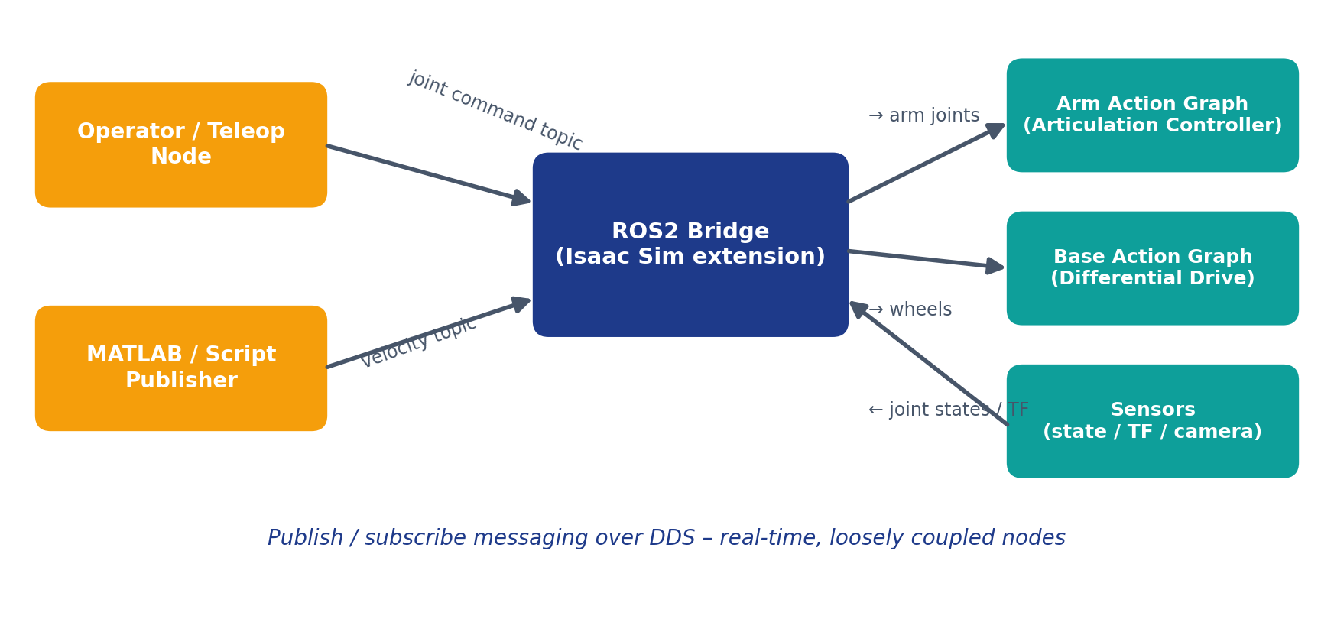
Figure 4: ROS2 communication between control nodes and the Isaac Sim digital twin

3.7 Action graphs
Action graphs (OmniGraph) are node-based visual programs in Isaac Sim. A typical control graph starts with an On Playback Tick node, receives a ROS2 message (for example a joint-state command or a velocity command), and passes it to an Articulation Controller or a Differential Controller that drives the robot joints or wheels. In this project separate graphs were created for the joint-level control of the arms and for the movement of the base.

4. Methodology
The project followed a ten-step workflow, shown in Figure 5. Each step produces an artefact that is the input of the next; the model-validation step feeds back to the URDF whenever the physical behaviour is not acceptable.
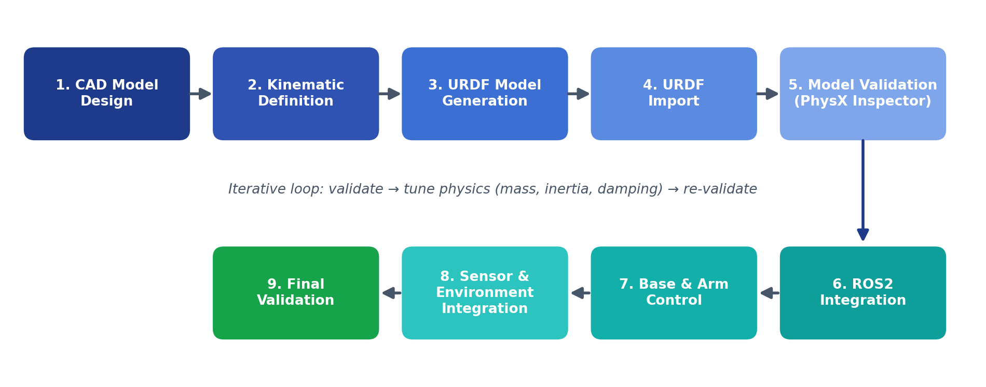
Figure 5: Methodology flowchart
Table 4: Methodology steps and outputs
Step | Activity | Output
1 | CAD model design in SolidWorks | Dual-arm assembly with accurate dimensions
2 | Kinematic definition | Links, joints and DH coordinate frames
3 | URDF model generation | URDF with mass, inertia, limits, dynamics
4 | URDF import | Robot articulation in Isaac Sim
5 | Model validation (PhysX Inspector) | Verified joint motion and limits
6 | ROS2 integration | Communication between control nodes and twin
7 | Base and arm control | Action graphs for arms and mobile base
8 | Sensor and environment integration | Simulated workspace and sensors
9 | Final validation | Hardware-vs-simulation accuracy

4.1 System architecture
The architecture has four layers. The design layer (SolidWorks and SW2URDF) produces the robot description. The simulation layer (Isaac Sim) contains the URDF importer, the PhysX engine, the environment and sensors, the action graphs and the ROS2 bridge. The control layer consists of ROS2 nodes (and MATLAB for experiments) that publish commands and subscribe to feedback. The physical layer is the real dual-arm robot whose joint and end-effector data are logged for comparison.
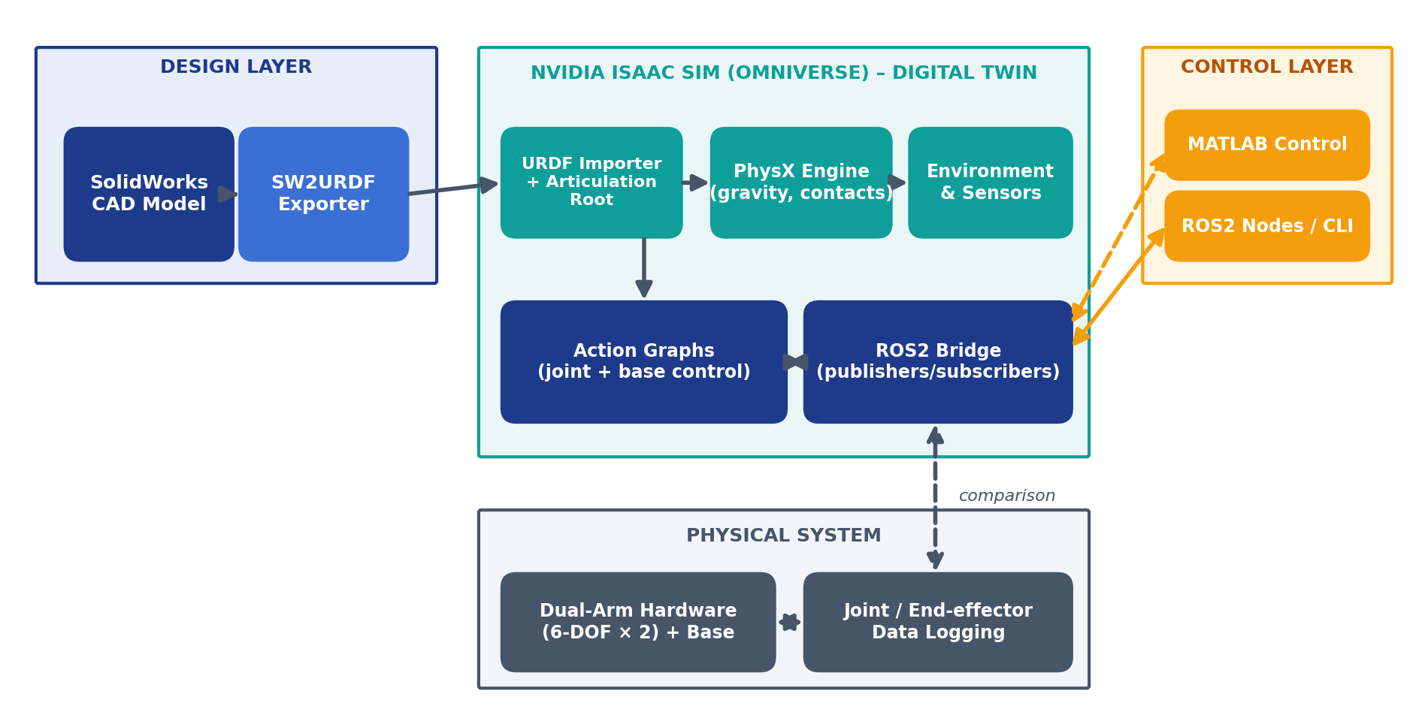
Figure 6: System architecture of the digital twin

5. Implementation

5.1 CAD modelling in SolidWorks
The dual-arm manipulator was designed in SolidWorks with accurate dimensions. Each moving part is a separate link and the assembly mates define the joints. Coordinate axes were fixed for every link so that the joint axes and origins exported to URDF match the intended kinematic structure. Accurate geometry matters because link lengths directly determine the end-effector position that is later compared with the hardware.
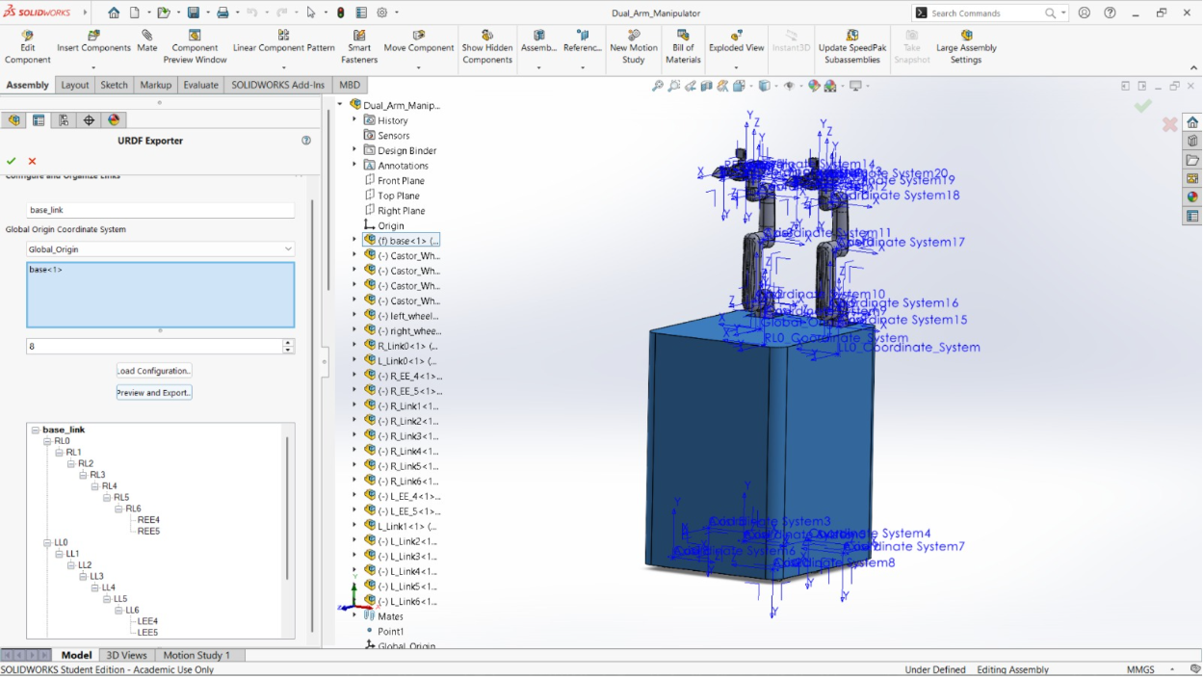
Figure 7: SolidWorks model of the dual-arm manipulator with coordinate axes fixed for each link

5.2 Kinematic definition and frames of reference
Links, joints and coordinate frames were assigned for both arms using the DH convention. The frames for the left and right arms were first drawn by hand (Figure 8) to settle the axis directions, and then implemented in the CAD model. The resulting kinematic structure is a base platform carrying two identical six-joint chains, each ending at an end-effector (tool centre point).
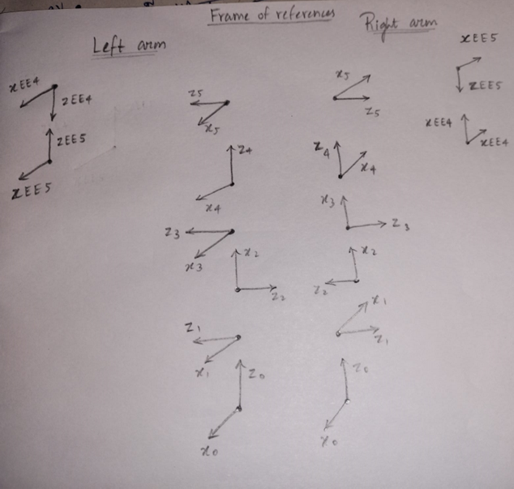
Figure 8: Hand-drawn frames of reference for the left and right arms
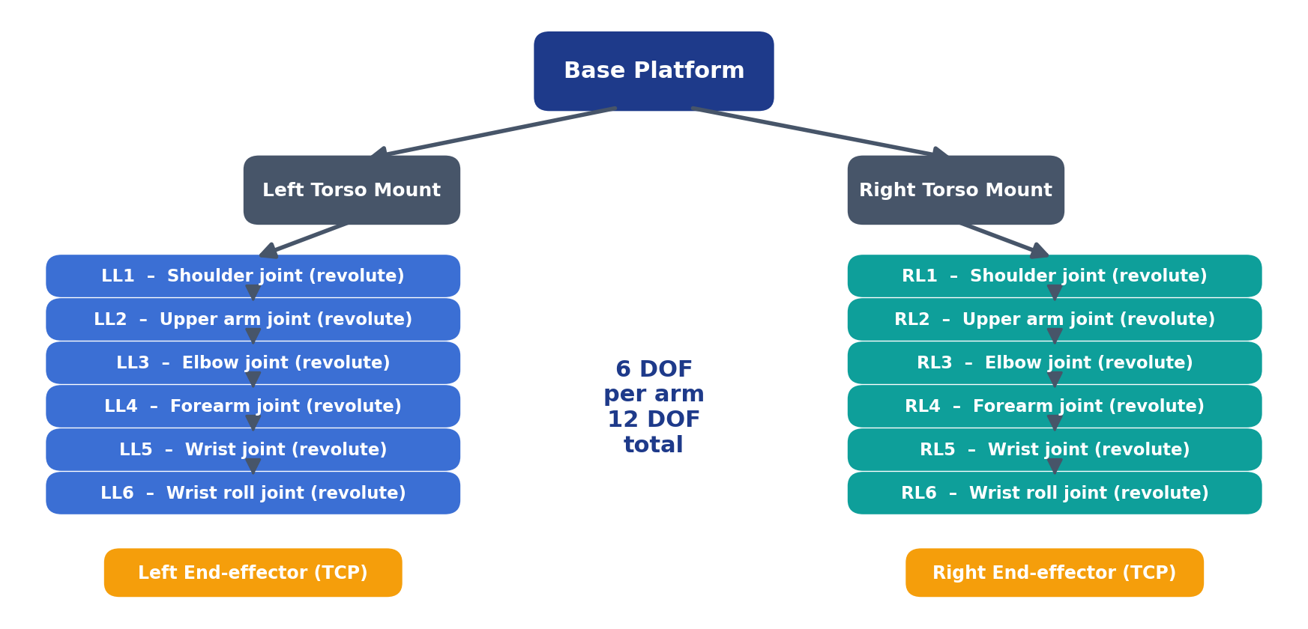
Figure 9: Kinematic tree of the dual-arm manipulator – six revolute joints per arm

5.3 URDF generation with SW2URDF
The CAD model was converted to URDF with the SW2URDF exporter. After export the following parameters were defined and checked for every link and joint:
Table 5: URDF parameters defined for the model
Parameter | Description | Why it matters
Link mass | Mass of each link in kg | Determines gravity load on joints
Inertia | Inertia tensor about the centre of mass | Controls rotational dynamics
Joint type | Revolute or fixed | Defines allowed motion
Joint limits | Position, velocity and effort limits | Prevents unrealistic motion
Dynamic properties | Friction and damping | Stabilises motion and prevents oscillation

The structure of the generated URDF follows the pattern below (values elided):
<link name="link_1">
<inertial>
<mass value="..."/>
<inertia ixx="..." iyy="..." izz="..."/>
</inertial>
</link>
<joint name="RL1" type="revolute">
<parent link="base"/> <child link="link_1"/>
<axis xyz="0 0 1"/>
<limit lower=".." upper=".." velocity=".." effort=".."/>
<dynamics damping=".." friction=".."/>
</joint>

5.4 Import into Isaac Sim and PhysX validation
The URDF was imported into Isaac Sim and the Articulation Root was configured so that the whole kinematic chain is simulated as a single articulation. Joint motion was verified one joint at a time with the Physics Inspector, checking direction of rotation, limits, drive stiffness and damping. Only after every joint behaved correctly was the model used for ROS2 control.
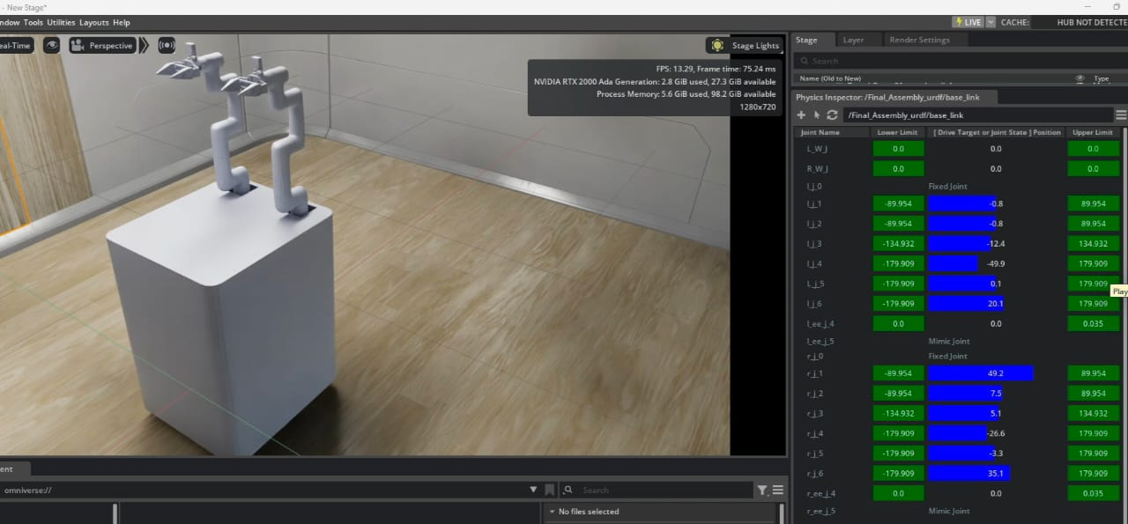
Figure 10: Imported robot in Isaac Sim with the Physics Inspector showing joint drives
Demo video: Arm Movement

5.5 ROS2 integration
ROS2 was integrated with Isaac Sim to enable communication between control nodes and the digital twin. Command topics carry joint targets for the arms and velocity commands for the base; the twin publishes joint states and transforms back. Because the twin behaves like the real robot from the ROS2 point of view, the same control nodes can be reused for the hardware.

5.6 Action graphs for arm and base control
Action graphs were developed for joint-level control and for base movement. The arm graph receives joint commands from ROS2 and passes them to an articulation controller that drives the left and right arm joints. The base graph receives velocity commands and passes them through a differential controller to the wheels.
Table 6: Control graphs
Graph | Input | Processing | Output
Arm control | ROS2 joint command | Articulation Controller | Joint targets of left and right arms
Base control | ROS2 velocity command | Differential Controller | Wheel velocities of the base

5.7 Environment and sensor integration
A virtual workspace was created around the robot and sensors were integrated so that the twin can later be used for perception and monitoring. The environment includes a floor and the supporting structure of the robot cell, which also gives the physics engine the contacts needed for a realistic base.

6. Results

6.1 Model validation
The imported model was validated in the Physics Inspector. The joints responded correctly within their defined limits and the kinematic structure remained stable, i.e. the arms held their poses without drifting or collapsing after the mass, inertia and damping corrections described in Section 8.
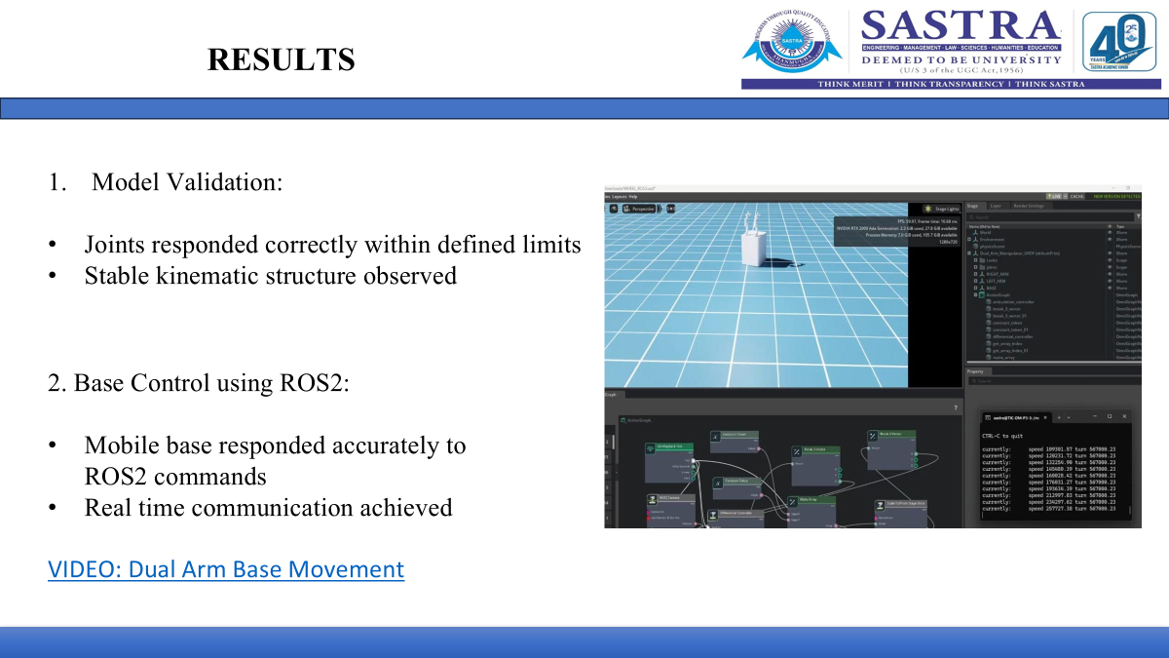
Figure 11: Model validation and control graph in Isaac Sim

6.2 Base control using ROS2
The mobile base responded accurately to ROS2 velocity commands and real-time communication between ROS2 and the simulator was achieved.
Demo video: Dual Arm Base Movement

6.3 Arm control using ROS2
Both arms were controlled successfully with ROS commands. The arm kinematics functioned correctly and control at joint level was validated. Arms and base were also moved together.
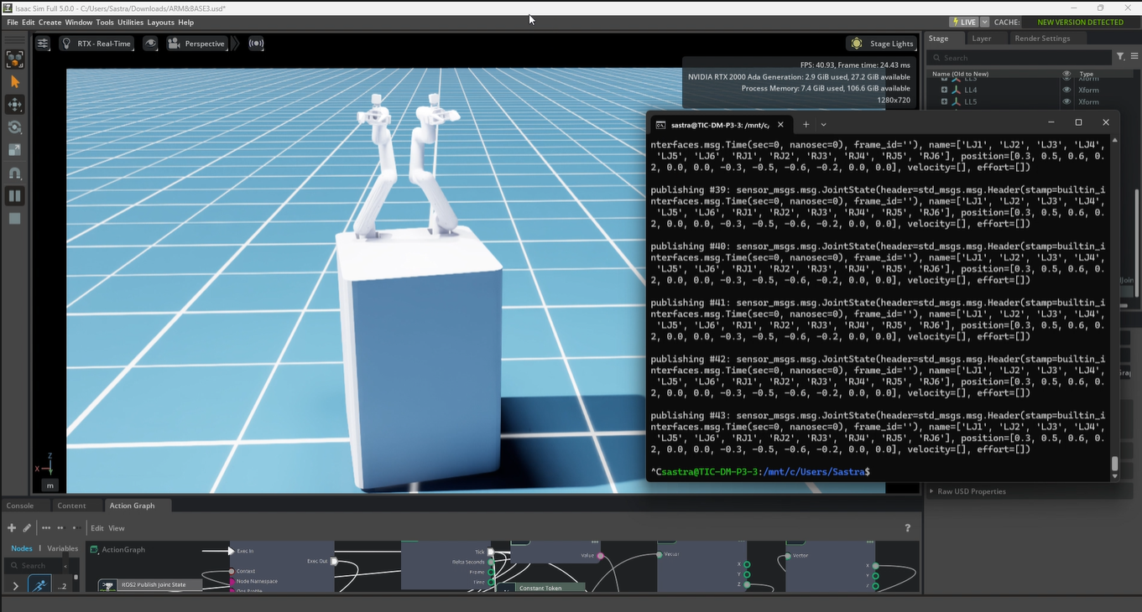
Figure 12: Controlling both arms and the base through ROS2 commands
Demo video: Both Arms and Base Movement

6.4 Hardware versus simulation – arm orientations
The real robot and the digital twin were tested with identical input commands. Joint parameters were recorded in both environments and the end-effector positions were compared. The robot movements closely matched in simulation and hardware, and the arm orientation showed strong similarity in both systems, showing that the digital twin reliably replicates the physical behaviour and is suitable for testing and further development.
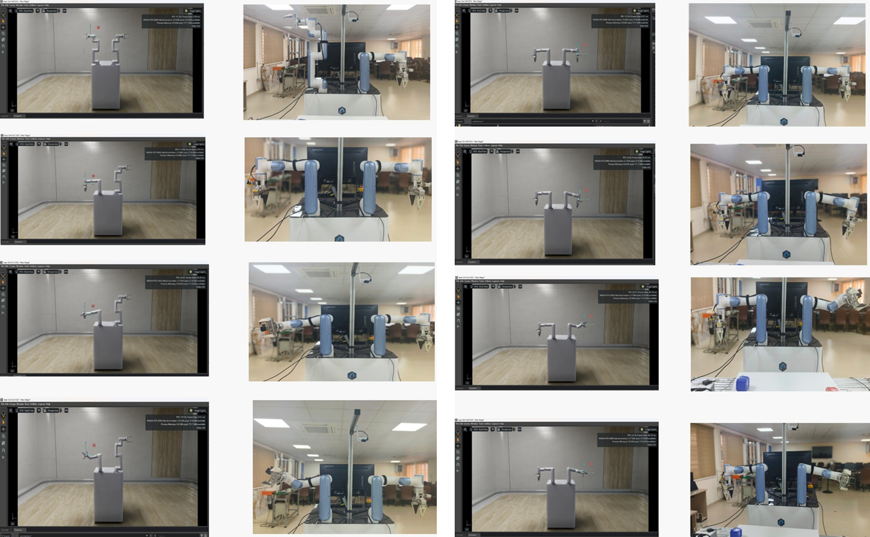
Figure 13: Arm orientations – hardware versus simulation (left: left arm, right: right arm)

6.5 Joint parameters and end-effector positions
Five trials were run for each arm. Table 7 and Table 8 list the end-effector position measured on the hardware (HW) and in simulation (SW). All positions are in millimetres. The joint-angle vectors used for each trial are given in Appendix B.
Table 7: Right arm end-effector position (mm)
Trial | HW X | HW Y | HW Z | SW X | SW Y | SW Z
1 | -1.53 | -205.74 | 847.99 | -7.81 | -181.55 | 840.80
2 | 96.84 | -354.61 | 411.85 | 95.18 | -355.70 | 427.09
3 | 186.12 | -353.36 | 438.07 | 160.43 | -352.75 | 430.43
4 | 187.17 | -335.04 | 526.30 | 161.72 | -334.56 | 517.56
5 | 80.86 | -377.43 | 454.59 | 83.85 | -365.75 | 464.83

Table 8: Left arm end-effector position (mm)
Trial | HW X | HW Y | HW Z | SW X | SW Y | SW Z
1 | -118.00 | -344.00 | 409.00 | -114.00 | -336.00 | 427.00
2 | -119.50 | -317.69 | 351.99 | -114.00 | -319.11 | 369.00
3 | -207.68 | -334.72 | 442.61 | -179.00 | -330.00 | 432.00
4 | -207.62 | -314.48 | 534.65 | -179.00 | -310.00 | 521.00
5 | -104.12 | -364.66 | 465.22 | -103.74 | -347.17 | 469.43

6.6 Trajectory comparison
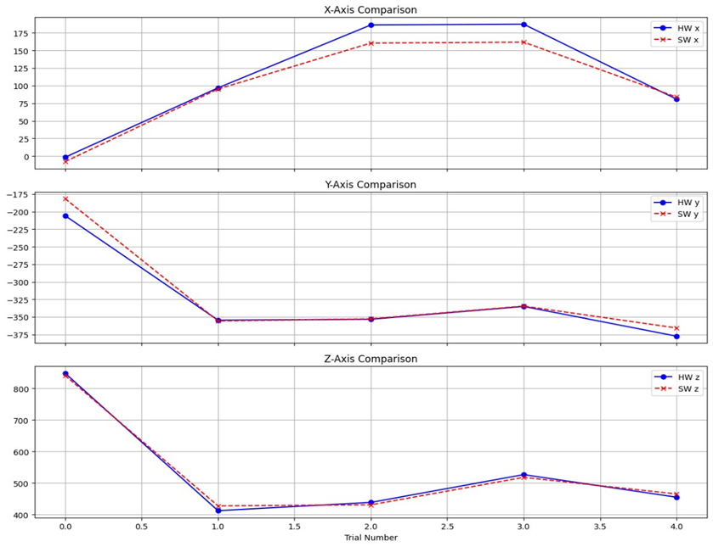
Figure 14: Right arm end-effector X, Y, Z – hardware versus simulation
- Tight trajectory matching: hardware and simulation show near-perfect trend synchronisation across all axes.
- X-axis peak deviation: a significant tracking gap is observed at Trials 2 and 3, where the hardware exceeds the predicted X values.
- High Y-axis precision: minimal deviation between real and virtual paths on the Y-plane.
- Z-axis consistency: smooth alignment on the vertical axis, with the curves overlapping almost entirely.
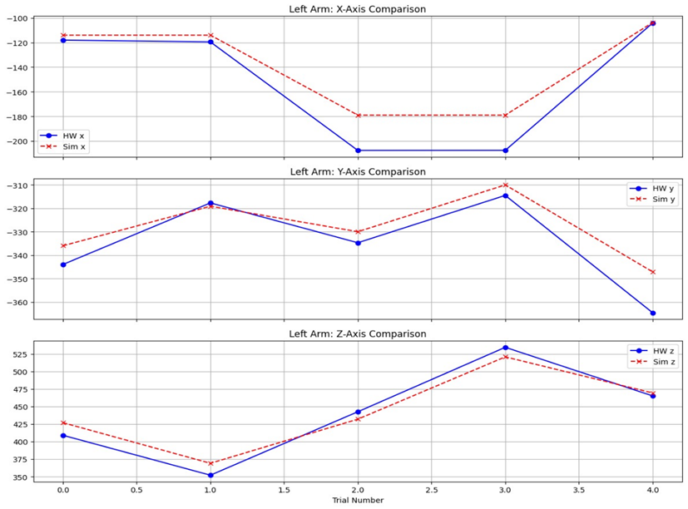
Figure 15: Left arm end-effector X, Y, Z – hardware versus simulation
- High trend correlation: the hardware closely follows the simulated movement pattern in all axes.
- Systemic X-axis offset: the hardware registers lower X values than predicted until the curves converge at Trial 4.
- Synchronised Y-axis: trajectories keep a narrow, parallel gap.
- Z-axis convergence: paths intersect and eventually align, so the initial discrepancies stabilise by the final trial.

7. Accuracy Analysis

7.1 Validation procedure
For each trial the same joint command was sent to the hardware and to the twin, the joint parameters and end-effector positions were recorded, and three quantities were calculated: the Euclidean positional error, the reach magnitude and the percentage accuracy. If the accuracy was unsatisfactory the model parameters were tuned and the trial repeated.
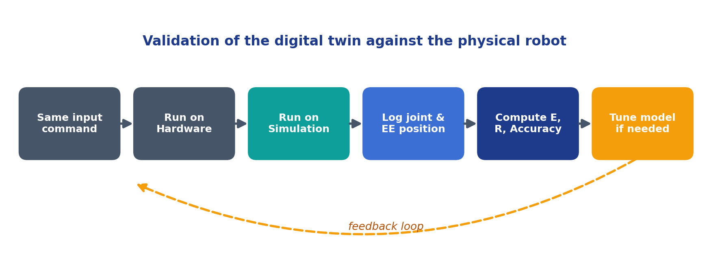
Figure 16: Digital-twin validation workflow

7.2 Formulae
- Euclidean positional error: E = √[(x_hw − x_sw)² + (y_hw − y_sw)² + (z_hw − z_sw)²]
- Reach magnitude: R = √[x_hw² + y_hw² + z_hw²]
- Percentage accuracy: Accuracy (%) = 100 × (1 − E / R)

7.3 Worked example – right arm, Trial 2
Hardware robot (HW): (96.84, −354.61, 411.85) mm. Software robot (SW): (95.18, −355.70, 427.09) mm.
Table 9: Worked calculation for right arm, Trial 2
Quantity | Calculation | Result
Positional error E | √[(96.84 − 95.18)² + (−354.61 + 355.70)² + (411.85 − 427.09)²] = √(2.75 + 1.18 + 232.25) | 15.36 mm
Reach magnitude R | √[(96.84)² + (−354.61)² + (411.85)²] | 552.1 mm
Accuracy | 100 × (1 − 15.36 / 552.1) = 100 × (1 − 0.0278) | 97.2 %

7.4 Accuracy tabulation
Table 10: Accuracy of the digital twin
Trial | Right arm accuracy (%) | Left arm accuracy (%)
Trial 01 | 97.02 | 96.39
Trial 02 | 97.22 | 96.33
Trial 03 | 95.88 | 95.10
Trial 04 | 96.26 | 97.00
Average | 96.60 | 96.20

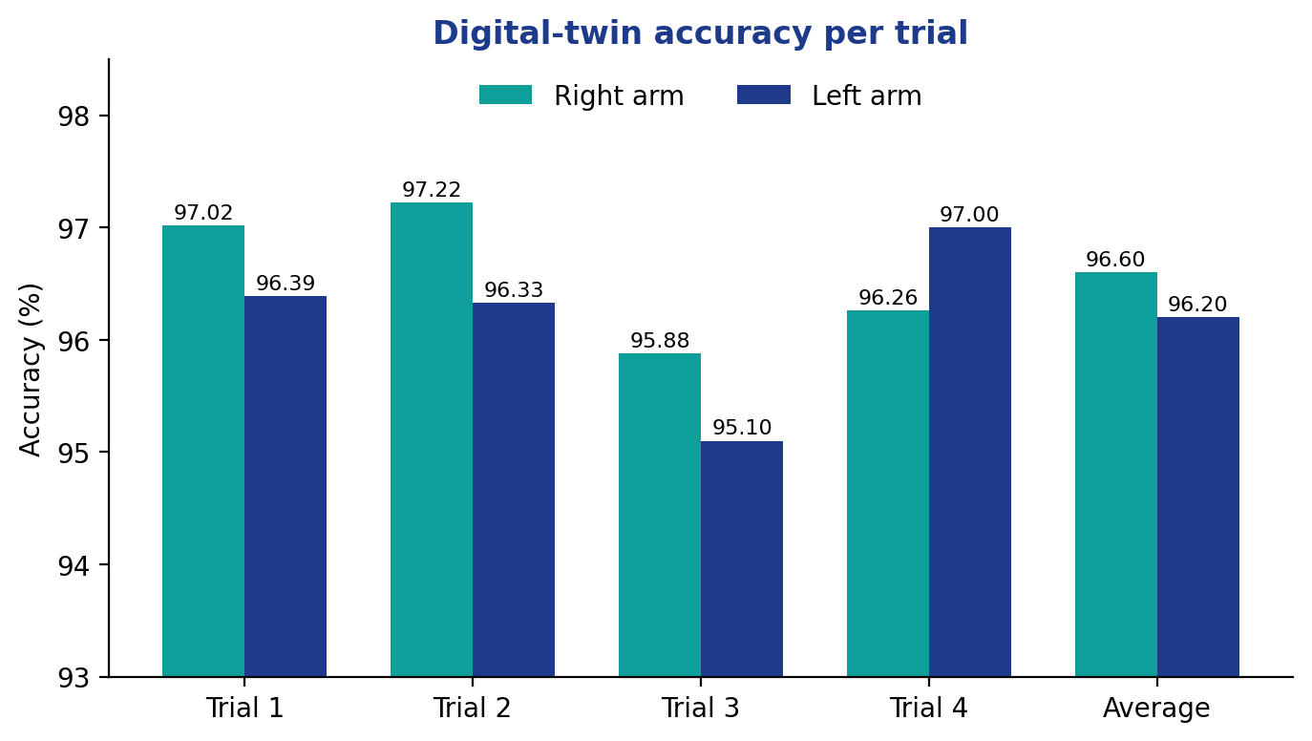
Figure 17: Accuracy of the digital twin per trial

7.5 Axis-wise deviation
To see where the differences arise, the mean absolute difference |HW − SW| was calculated for each axis from the five trials of Tables 7 and 8.
Table 11: Mean absolute axis deviation over five trials (mm)
Arm | X axis | Y axis | Z axis
Right arm | 12.4 | 7.6 | 9.8
Left arm | 13.4 | 7.2 | 12.7

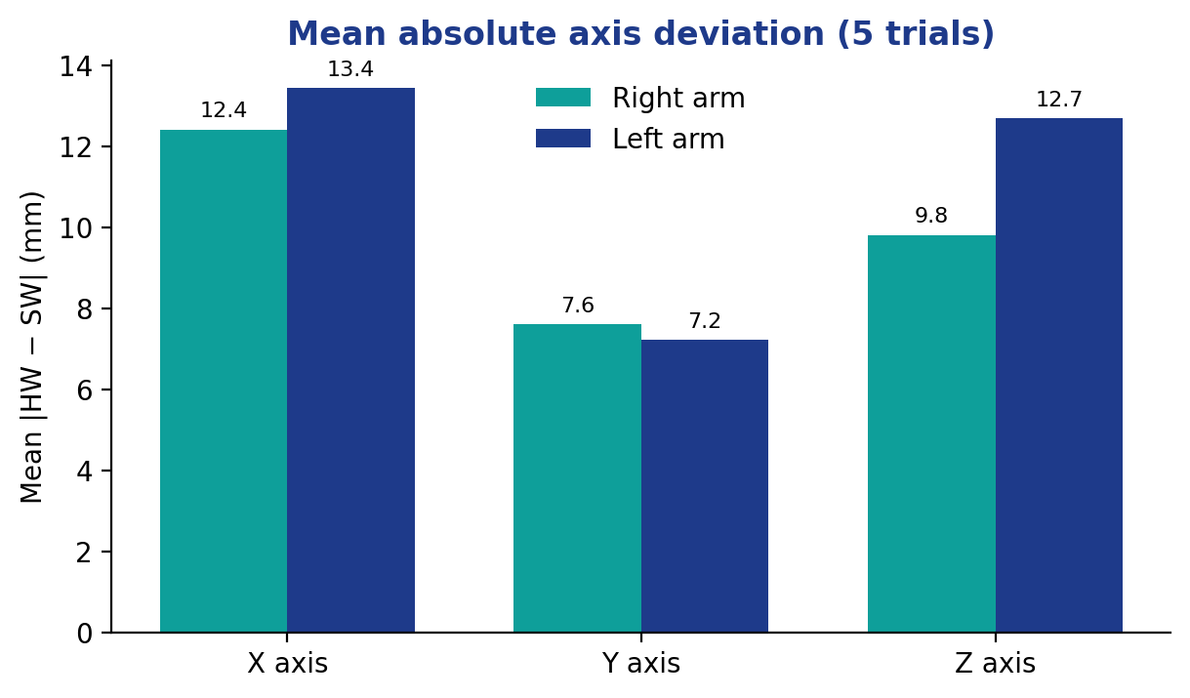
Figure 18: Mean absolute deviation per axis

7.6 Discussion
- Both arms exceed 96 % average accuracy, so the twin reproduces the hardware closely.
- The Y axis shows the smallest deviation and the X axis the largest, which agrees with the trajectory plots in Section 6.6.
- The lowest single accuracy (95.10 %, left arm, Trial 3) falls in the trials with the largest X offset. A systematic X offset points to a small difference in link geometry, calibration or zero position between the model and the hardware rather than to random noise.
- Since accuracy is expressed relative to the reach, a given error in millimetres has a smaller percentage effect at long reach than at short reach; the figures are therefore best compared together with the absolute errors in Tables 7 and 8.

8. Challenges Faced and Fixes
Several problems appeared while bringing the model into the simulator. They are summarised in Figure 19 and Table 12.
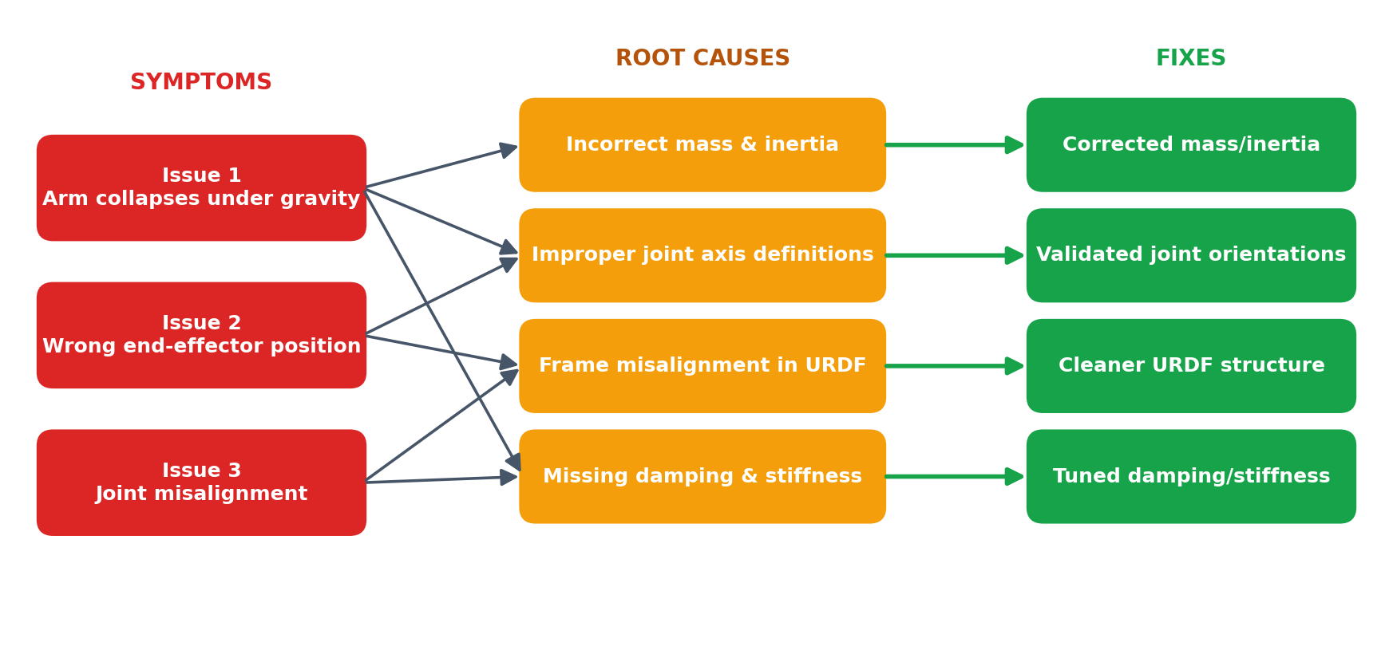
Figure 19: Issues, root causes and fixes
Table 12: Issues, root causes and corrective actions
Issue observed | Root cause | Fix / learning
Arm collapsing under gravity | Incorrect mass and inertia values; missing damping and stiffness | Corrected the inertia and mass distribution; added joint damping and drive stiffness
Incorrect end-effector positioning | Improper joint axis definitions; frame misalignment in the URDF | Validated joint orientations and frame definitions
Joint misalignment | Frame misalignment in the URDF | Improved the URDF structure and re-exported from CAD

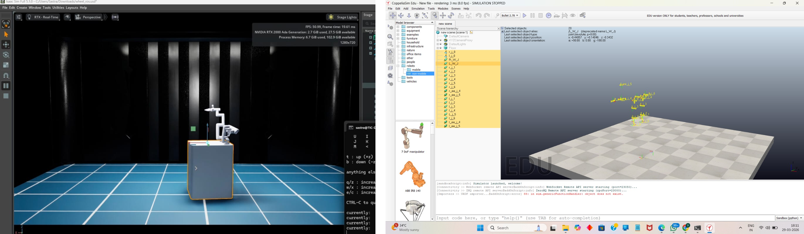
Figure 20: Simulation screenshots from the arm-collapse problem and the debugging process
Demo video: Falling Arms
The main learning is that a URDF that “looks right” is not enough: the physical parameters (mass, inertia, damping, stiffness) and the joint axes must also be right, because a physics engine acts on them every time step.

9. Future Work
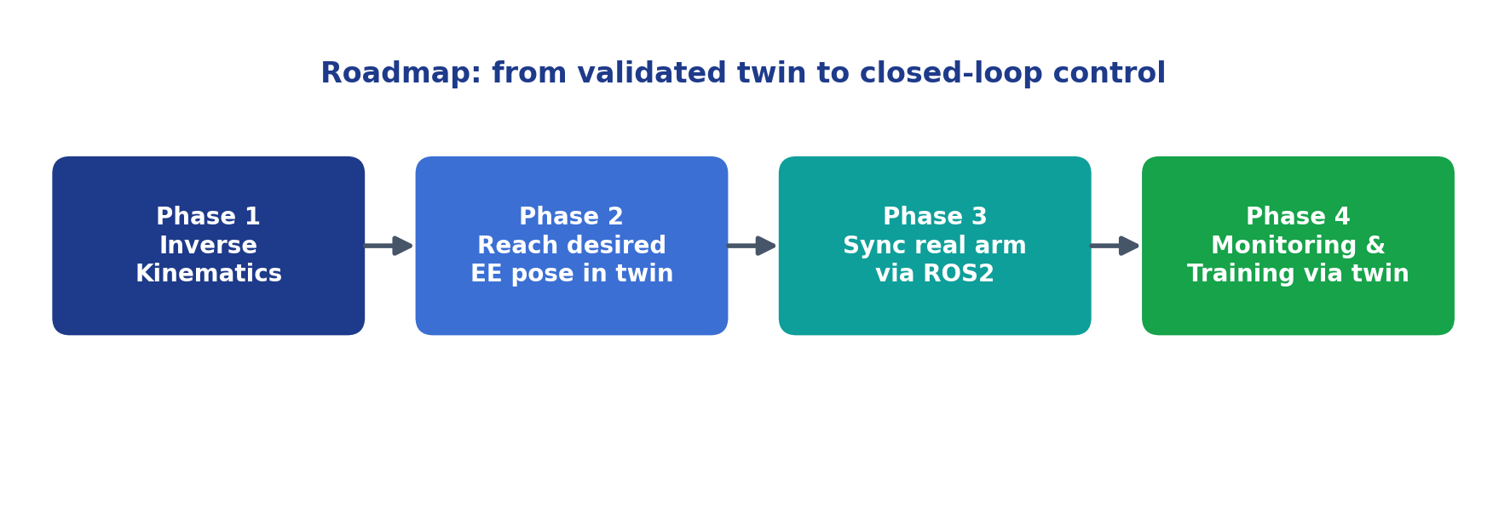
Figure 21: Roadmap for future work
- Inverse kinematics: implement inverse kinematics so that the digital twin can reach a desired end-effector position directly instead of being driven joint by joint.
- Synchronisation: synchronise the actual dual-arm manipulator with the simulation model through ROS2 so that both move together.
- Monitoring and training: enable monitoring and control/training through the digital twin, for example testing new trajectories virtually before executing them on the robot.
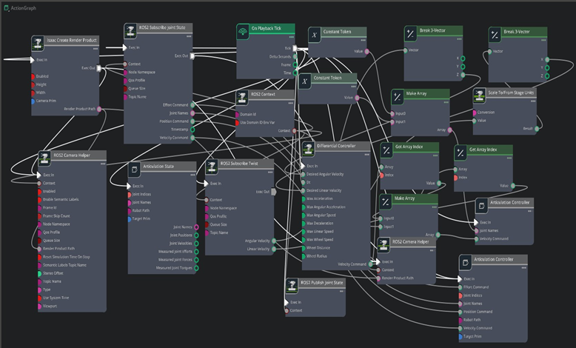
Figure 22: Node-based control graph used in the MATLAB control experiment
Demo video: MATLAB Control

9.1 Suggested plan
Table 13: Suggested plan for future work
Phase | Task | Expected outcome
1 | Derive and implement inverse kinematics for each arm | Twin reaches commanded Cartesian poses
2 | Compute error between commanded and achieved pose in simulation | Measured IK accuracy
3 | Connect the real arms to ROS2 and mirror joint states | Real-time hardware–twin synchronisation
4 | Add monitoring and trajectory pre-validation | Safer hardware execution and training

10. Conclusion
A digital twin of a dual-arm robotic manipulator was designed and simulated in NVIDIA Omniverse (Isaac Sim) with ROS2 control. The CAD → DH frames → URDF → Isaac Sim → ROS2 pipeline was completed, both arms and the mobile base were controlled in real time, and the twin was validated against the real robot. The average positional accuracy was 96.6 % for the right arm and 96.2 % for the left arm. The principal difficulties were caused by incorrect physical parameters and frame definitions in the URDF and were resolved by correcting mass, inertia, joint axes and damping.
The result is a reliable platform for testing control strategies before they are applied to hardware. With the planned inverse-kinematics, synchronisation and monitoring work, the twin can grow into a complete tool for control development and training – an approach directly applicable to virtual commissioning and smart-factory projects in digital manufacturing.

Appendix A – Demo Video Links
The project videos are stored on Google Drive. Click a link (or copy the address) to open it.
Table 14: Project demonstration videos
No. | Video | Link | Used in
1 | Dual Arm Base Movement  Mobile base driven by ROS2 commands in Isaac Sim | Open video on Google Drive  https://drive.google.com/open?id=1fKyOm-ubXvaXNEoTIGf6GvLG79r7juI3 | Section 6.2
2 | Arm Movement  Joint-level movement of the arm after URDF import | Open video on Google Drive  https://drive.google.com/file/d/1ycyGm3u0fEdeDOAn84CNeswvpYgo1QzH/view?usp=sharing | Section 5.4
3 | Both Arms and Base Movement  Coordinated motion of both arms and the base through ROS2 | Open video on Google Drive  https://drive.google.com/file/d/1N0NDK-k6iq3WmjXhqulKEO60IPlrJsgS/view?usp=drivesdk | Section 6.3
4 | Falling Arms  Arm collapsing under gravity before physics tuning | Open video on Google Drive  https://drive.google.com/file/d/16dLQKw2bhulFv47FFlEuDkFdsbtDPjSv/view?usp=sharing | Section 8
5 | MATLAB Control  MATLAB-based control experiment (future work direction) | Open video on Google Drive  https://drive.google.com/file/d/1kedJm6hjxBDsFlY7tUgKxyNVvfptyHF3/view?usp=sharing | Section 9

Appendix B – Joint Parameter Vectors
Joint-angle vectors commanded in each trial (RL1–RL6 for the right arm, LL1–LL6 for the left arm), as recorded during the experiments.
Table 15: Right arm joint parameters (RL1–RL6)
Trial | Joint parameters (RL1–RL6)
1 | (0.55, 0.10, 0.313, −0.469, −0.570, −0.521)
2 | (86.86, 0.80, 90.118, −0.879, −90.43, −90.514)
3 | (86.86, 0.80, 100.429, −0.879, 0.179, −90.514)
4 | (86.86, 0.80, 100.429, −45.094, 0.179, −90.514)
5 | (86.86, 0.80, 100.429, −45.094, −100.061, −90.514)

Table 16: Left arm joint parameters (LL1–LL6)
Trial | Joint parameters (LL1–LL6)
1 | (−90, 0, −90, 0, 90, 90)
2 | (−90.43, 0.654, −101.52, −0.126, 90.27, 90.986)
3 | (−90.43, 0.654, −100.89, −0.226, −0.171, 90.28)
4 | (−90.43, 0.654, −100.50, 45.263, 0.085, 90.986)
5 | (−90.43, 0.85, −100.50, 45.263, 100.57, 90.467)

References
[1] Denavit, J. and Hartenberg, R. S., “A kinematic notation for lower-pair mechanisms based on matrices,” Journal of Applied Mechanics, 22, 1955, pp. 215–221.
[2] Craig, J. J., Introduction to Robotics: Mechanics and Control, 4th ed., Pearson, 2018.
[3] Siciliano, B., Sciavicco, L., Villani, L. and Oriolo, G., Robotics: Modelling, Planning and Control, Springer, 2009.
[4] Grieves, M., “Digital Twin: Manufacturing Excellence through Virtual Factory Replication,” White Paper, 2014.
[5] NVIDIA, Isaac Sim documentation (URDF import, Articulation, ROS2 bridge, OmniGraph action graphs), docs.omniverse.nvidia.com.
[6] Open Robotics, ROS 2 documentation, docs.ros.org.
[7] ROS Wiki, URDF specification, wiki.ros.org/urdf.
[8] NVIDIA, PhysX SDK documentation, nvidia-omniverse.github.io/PhysX.

