INTERNSHIP REPORT
Thermal Management & Refrigeration Cycle Modelling
MATLAB / Simulink (Simscape)

I | Battery temperature variation with conductive & convective heat transfer
II | R-1234yf closed-loop vapour-compression refrigeration cycle
SUBMITTED BY
Perugu Venkata Aditya
Mechanical Engineering (Digital Manufacturing)
SUBMITTED FOR
NoonRay Energy Pvt. Ltd
IIT Madras Industrial Park, Chennai
DATE
24-12-2025

PART I
Battery Temperature: Conduction vs Convection

Aim Show how conductive and convective heat transfer change the temperature of a battery that generates a constant 1 kW of heat.
Two Simulink models
The battery is treated as one lumped thermal mass. Fluid flow and electrochemistry are not modelled.
A. Convective model
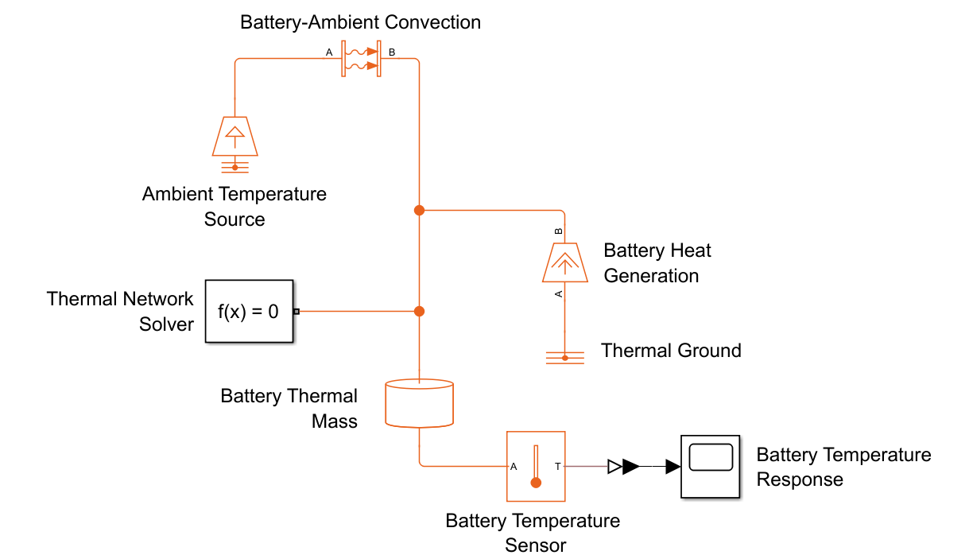
Battery loses heat directly to ambient through convection
B. Conductive model with cold plate
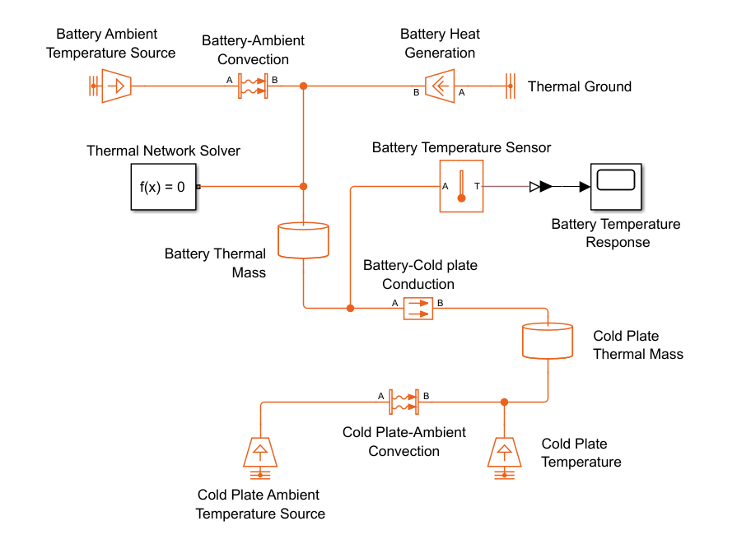
Heat flows by conduction into a cold plate, then convects away
Blocks used
Block | Function | Block | Function
Thermal mass (battery) | Stores battery thermal energy | Thermal mass (cold plate) | Thermal inertia of the plate
Heat flow rate source | Internal heat generation, 1 kW | Temperature source | Ambient or coolant at constant temperature
Convective heat transfer | Surface-to-ambient heat loss | Temperature sensor | Records temperature vs time
Conductive heat transfer | Battery-to-cold-plate path | Solver configuration | Solves the physical network

A. Convective cooling results
313.15 K  Ambient temp | 0.94 m²  Convection area | 300 kg  Battery mass | 1000  Cp, J/(kg·K) | 1 kW  Heat input | 1 hour  Simulated time

h = 5 W/m²·K  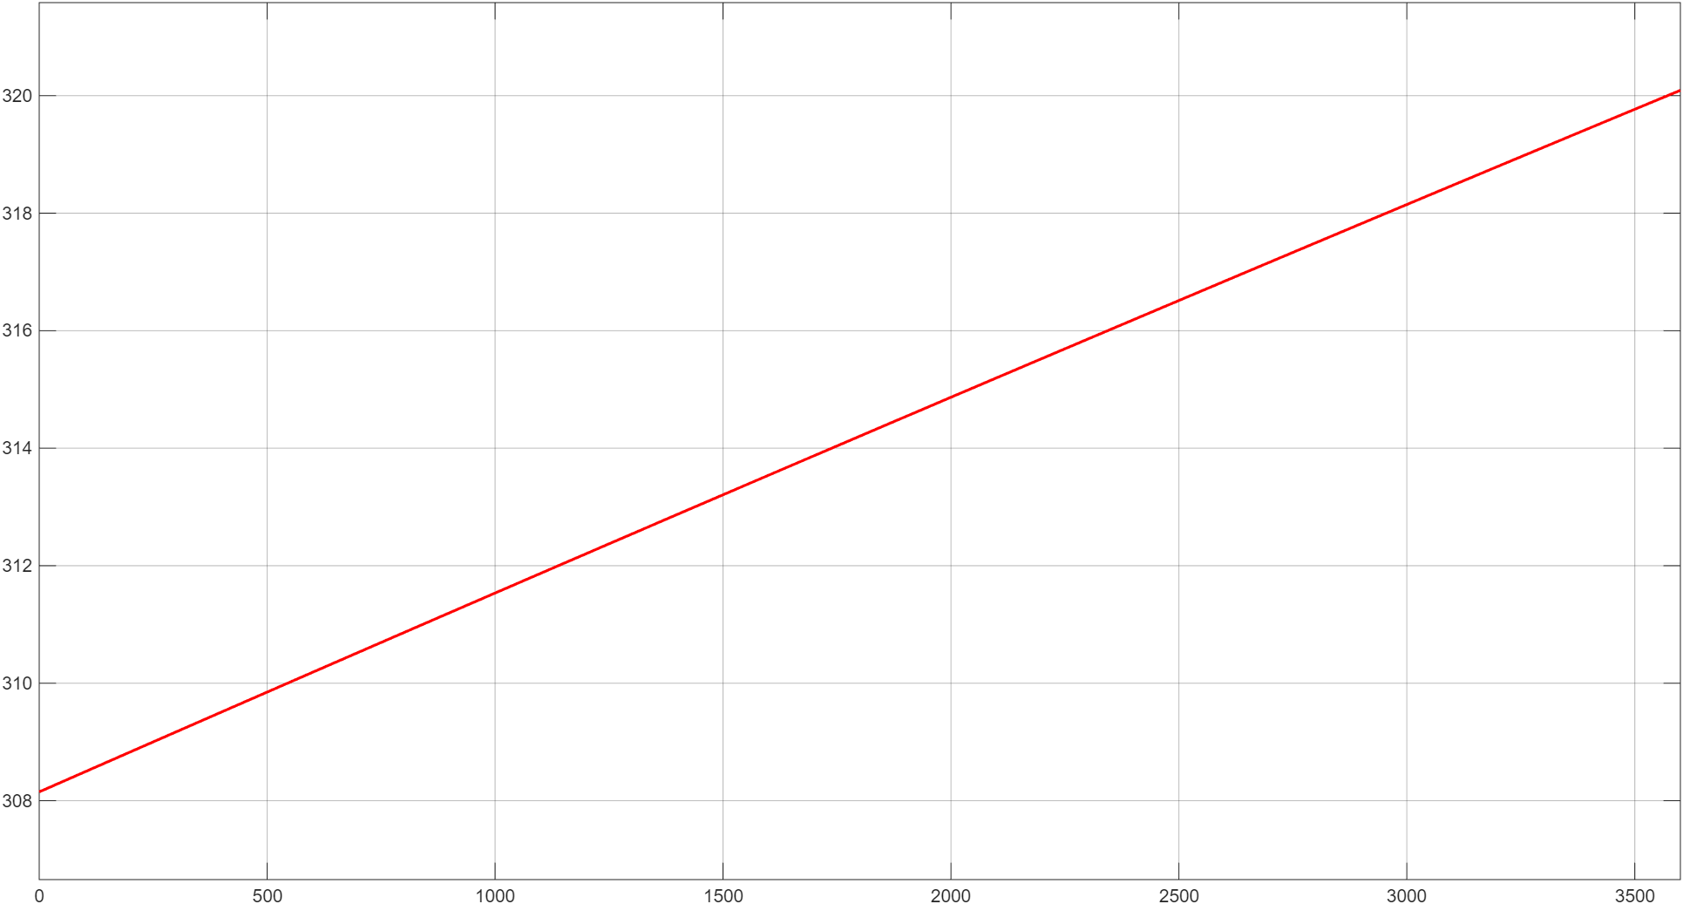  308 → 320 K | h = 100 W/m²·K  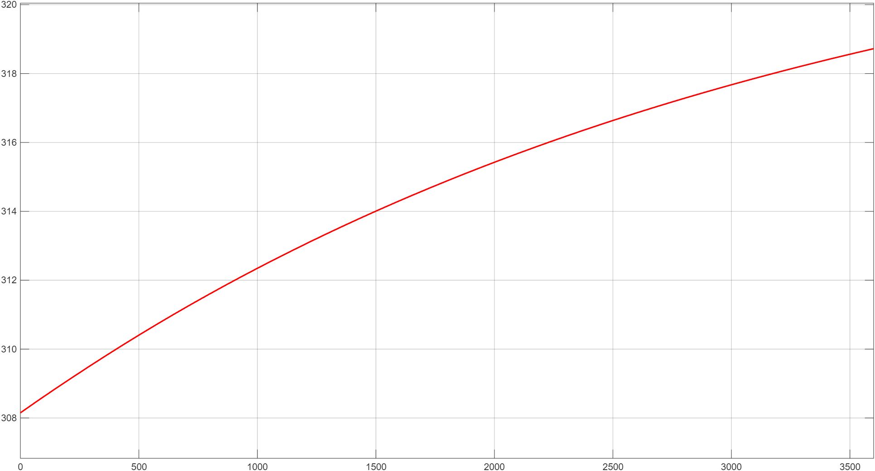  308 → 318.7 K | h = 500 W/m²·K  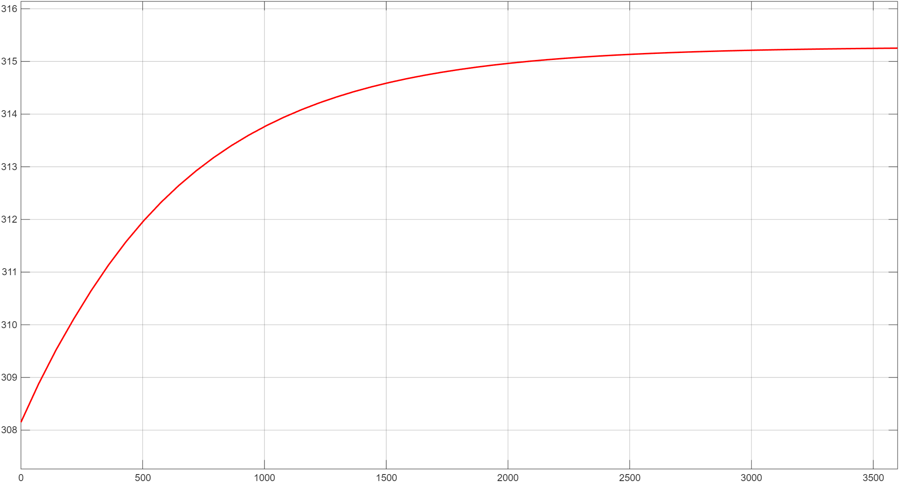  308 → 315.2 K

Takeaway A higher convective coefficient (h) rejects more heat, so the battery ends up cooler. Low h gives the biggest temperature rise.
B. Conductive cooling results (cold plate)
500×400×300  Battery, mm | 5 cm  Cold plate thickness | 237  k, W/(m·K) | 293.15 K  Cold plate temp | 308.15 K  Battery start temp | 1 kW  Heat input

Layer = 8 mm  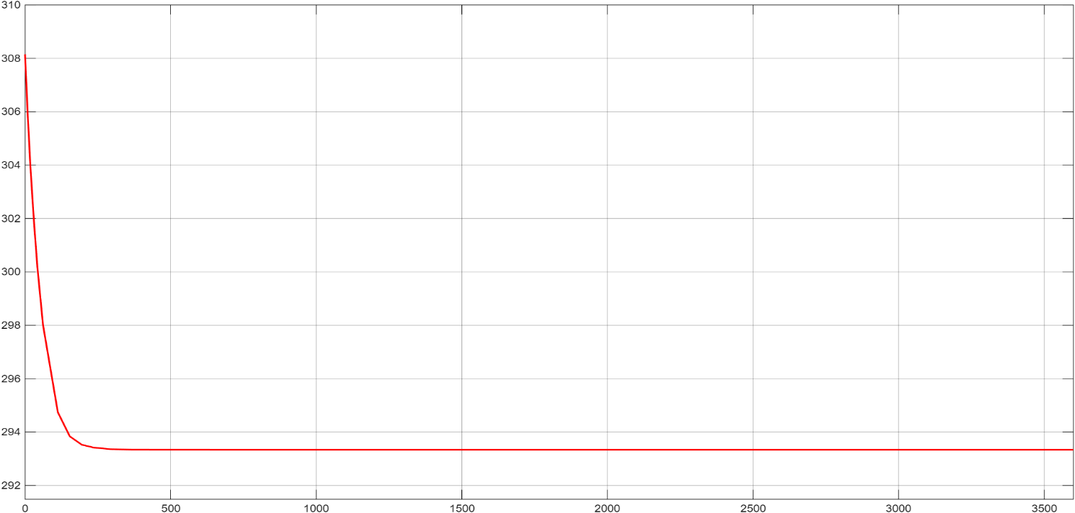  308 → 293.33 K | Layer = 5 mm  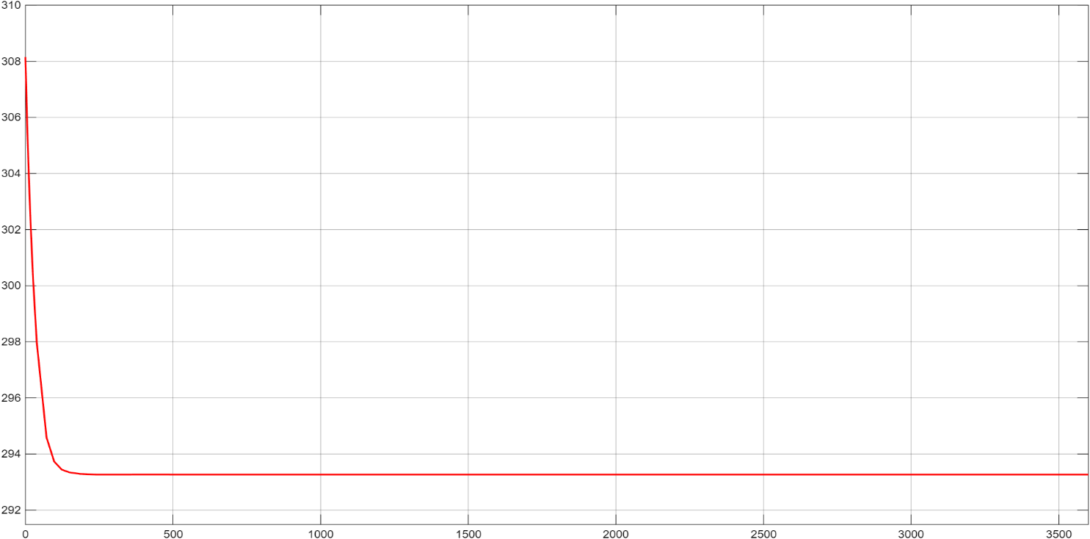  308 → 293.27 K | Layer = 3 mm  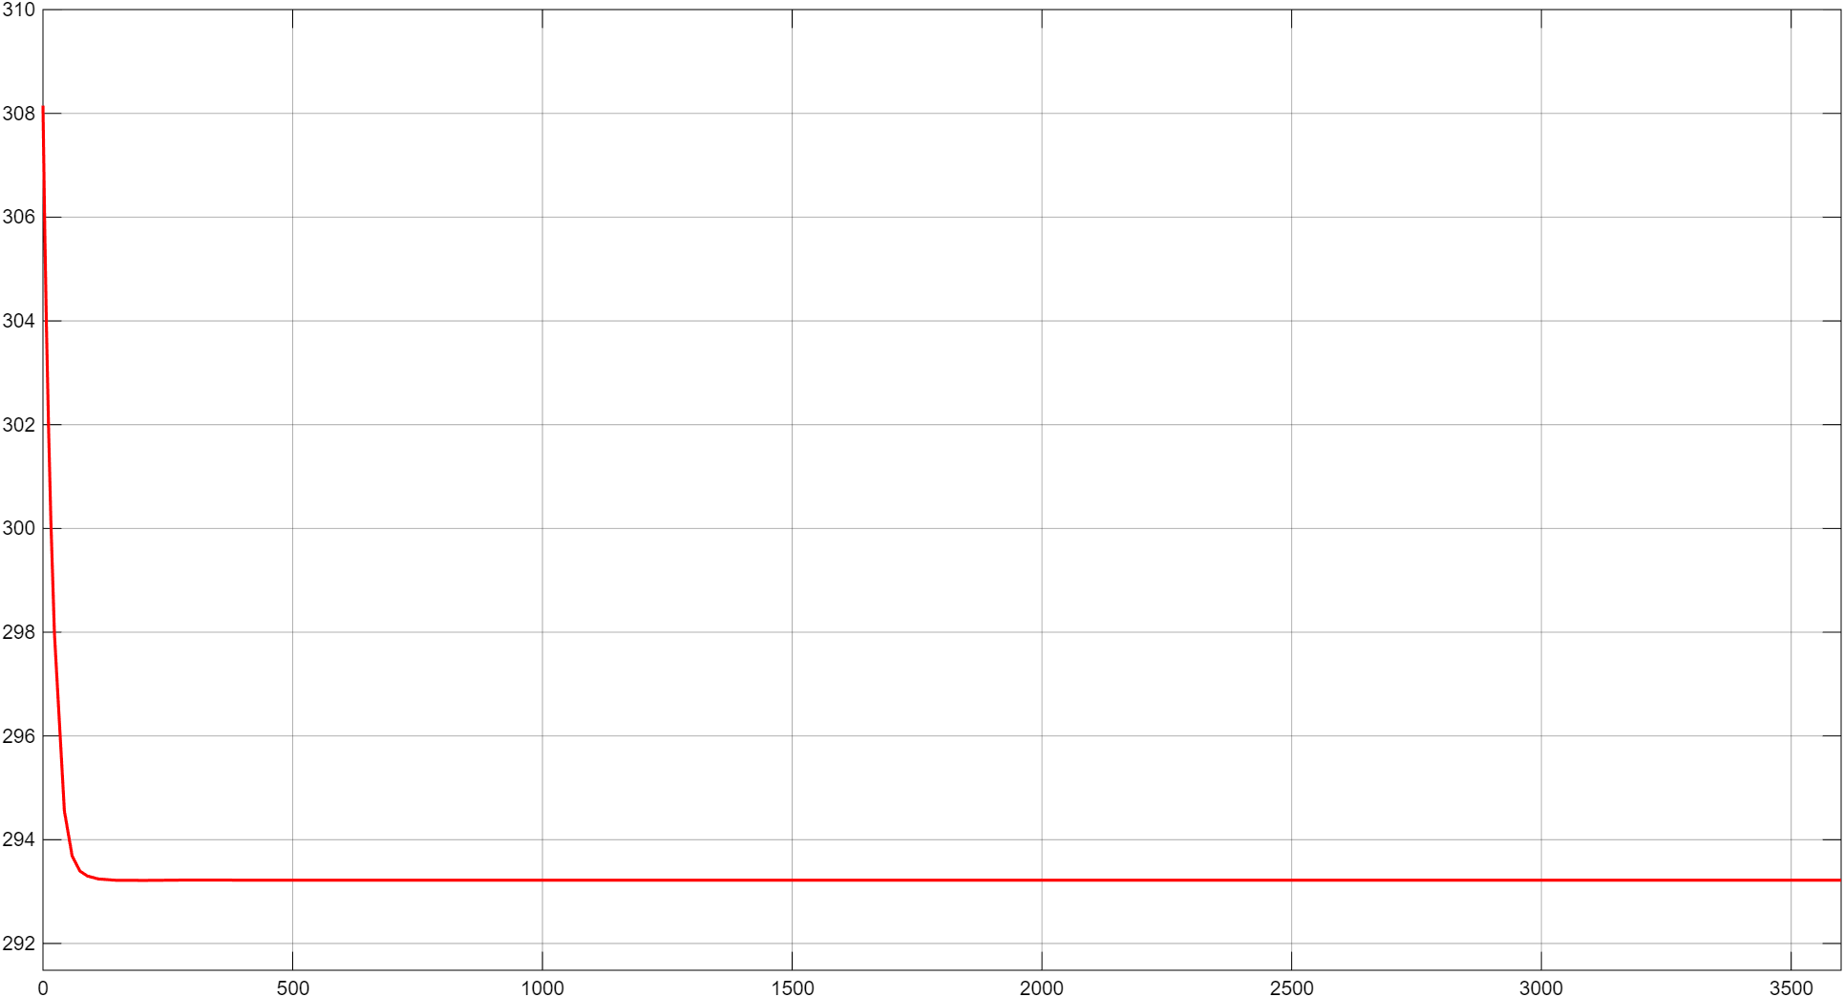  308 → 293.22 K

Takeaway Temperature drops fast and settles close to the cold plate temperature. A thinner conductive layer gives a quicker initial drop because its thermal resistance is lower.
Part I conclusion
 | Convective (direct to ambient) | Conductive (cold plate)
Final battery temperature | 315 – 320 K | ≈ 293 K
Speed of response | Slow, gradual rise | Rapid drop, then stable
Governing factor | Convective coefficient h | Thermal resistance of layer

- Cold-plate conduction stabilises the battery faster and at a lower temperature than direct convection under the same heat load.

PART II
R-1234yf Vapour-Compression Cycle in Simulink

Aim Build a closed-loop refrigeration model (evaporator, compressor, condenser) and verify it on a pressure–enthalpy (P–H) diagram.
Simulink model of the cycle
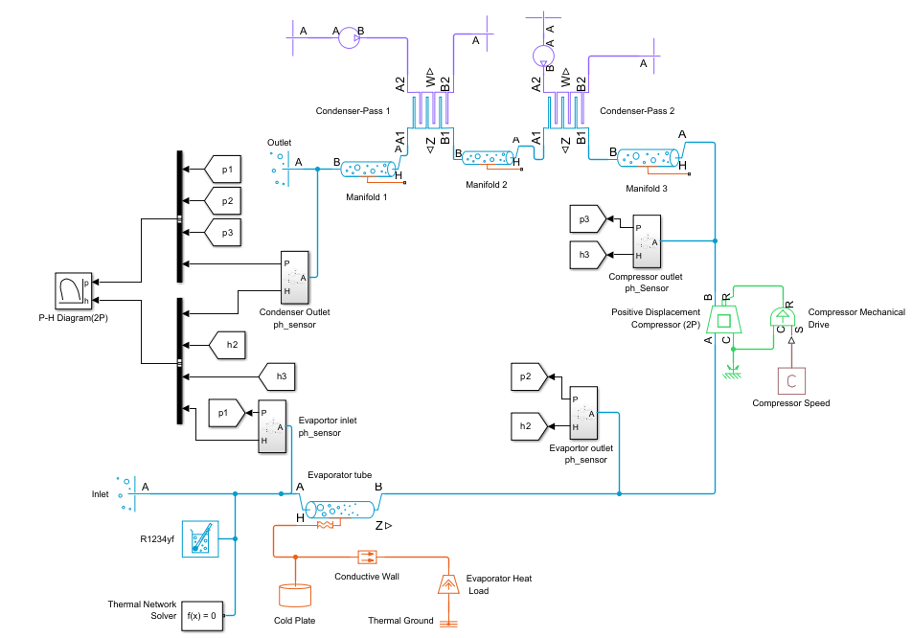
Closed refrigerant loop with p–h sensors feeding the P–H diagram block
Main components
Component | Role in the cycle
Evaporator tube | Low-pressure refrigerant absorbs heat and changes phase
Heat load + cold plate | Applies the heat load to the evaporator by conduction
Positive displacement compressor | Raises refrigerant pressure and enthalpy using mechanical work
Compressor drive & speed input | Supplies controlled mechanical power; speed can be varied
Condenser pass 1 & 2 + manifolds | Reject heat from high-pressure refrigerant in stages
R-1234yf property block | Gives realistic phase change and P–H behaviour
p–h sensors + P–H generator | Read state points and plot the cycle for validation
Thermal solver / ground | Keeps the energy balance stable and convergent

Result: P–H diagram of R-1234yf
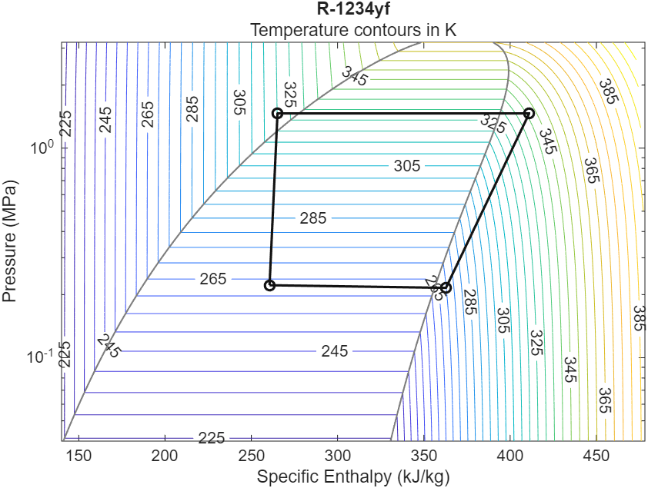
Simulated cycle plotted on the R-1234yf pressure–enthalpy chart
Process | What the diagram shows
Evaporation | Moves right to higher enthalpy: heat absorbed from the load
Compression | Pressure and enthalpy rise sharply: work added by the compressor
Condensation | Enthalpy falls at nearly constant pressure: heat rejected
Pressure drop | Flow restrictions cause throttling between condenser and evaporator

Key observations
- The loop shows all four processes and stays stable without diverging.
- Refrigerant leaves the evaporator superheated, so all the heat is absorbed.
- No expansion valve is modelled; pressure drops in the manifolds and pipes act as throttling.

Conclusion The results match refrigeration theory, and the modular model can be extended later, for example with an expansion valve control.
Link to my project: the scroll compressor
In this cycle the compressor is the positive displacement component. My project designs that component as a scroll compressor, with a fixed and an orbiting scroll. Together they cover the full chain from battery heat to refrigerant compression.
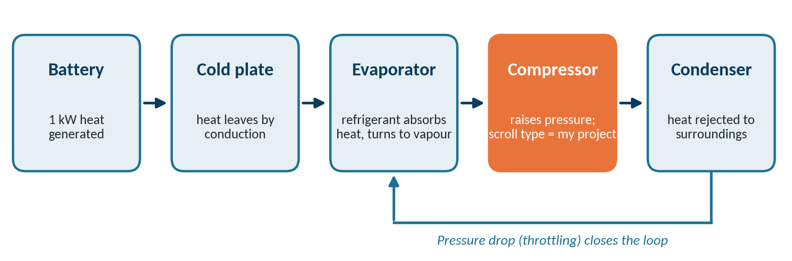
Where my scroll compressor sits in an EV battery cooling loop

