AI-VISION BASED GUIDED PICK AND PLACE DUAL ARM MANIPULATOR
Report submitted to the SASTRA Deemed to be University as the requirement for the course
MCT300 / MEC300 MINI PROJECT
Submitted by
Perugu Venkata Aditya - 127161035
B.Tech. Mechanical Engineering (Digital Manufacturing)
May 2026
SCHOOL OF MECHANICAL ENGINEERING
SASTRA DEEMED TO BE UNIVERSITY
THANJAVUR, TAMIL NADU, INDIA - 613 401
SCHOOL OF MECHANICAL ENGINEERING
THANJAVUR - 613 401
Bonafide Certificate
This is to certify that the report titled “AI-Vision Based Guided Pick and Place Dual Arm Manipulator” submitted as a requirement for the course MCT300/MEC300 Mini-project for the B.Tech. Mechanical Engineering (Digital Manufacturing) programme, is a bonafide record of the work done by
Perugu Venkata Aditya (Reg No: 127161035)
during the academic year 2025-26, in the School of Mechanical Engineering, under my supervision.
Signature of Project Supervisor : ______________________
Dr. Badri Narayanan R
Sr. Asst. Professor, School of Mechanical Engineering
Date : 24-04-2026
Mini-project Viva-voce held on : 07-05-2026
Examiner 1 Examiner 2
SCHOOL OF MECHANICAL ENGINEERING
THANJAVUR - 613 401
Declaration
I declare that the report titled “AI-Vision Based Guided Pick and Place Dual Arm Manipulator” submitted by me is an original work done by me under the guidance of Dr. Badri Narayanan R, Sr. Asst. Professor, School of Mechanical Engineering, SASTRA Deemed to be University, during the even semester of the academic year 2025-26.
Wherever I have used material from other sources, I have given due credit and cited it in the text of the report. This report has not formed the basis for the award of any degree, diploma, associateship, fellowship or similar title to any candidate of any University.
Signature of the candidate : ______________________
Perugu Venkata Aditya (Reg No: 127161035)
Date : 24-04-2026
Acknowledgements
I extend my heartfelt gratitude to Dr. Badri Narayanan R, my project guide, for his continuous support, valuable guidance and encouragement throughout this project.
My sincere thanks to our Honourable Vice Chancellor, Dr. S. Vaidhyasubramaniam, and our respected Dean-SOME, Dr. Pugazhenthi S, for their encouragement and support in carrying out this work. I also acknowledge Dr. Hari Krishnan R, Mr. Kishore and Mr. Karunakaran for their guidance, and the TIC staff for their assistance and cooperation. Finally, I thank the institution for providing the facilities and resources needed to complete this work successfully.
Abstract
Autonomous operation is an important aspect of modern robotic systems, improving efficiency, consistency and adaptability in changing environments. This work develops a vision-guided dual-arm manipulator by integrating artificial intelligence, physical-AI concepts and perception-based decision making. A YOLOv8 object detector, trained entirely on synthetic data generated in NVIDIA Isaac Sim, identifies and classifies cubes and cylinders of four colours. Depth information from a simulated RGB-D camera is fused with each detection to recover the object’s 3D position, which is then transformed from the camera frame to the robot base frame using the ROS 2 TF framework. Inverse kinematics solved in MATLAB converts the target position into joint angles, and the dual-arm robot performs the pick-and-place operation in simulation. The trained model reaches an mAP@0.5 of about 0.99, and the complete perception-to-action pipeline is demonstrated in NVIDIA Isaac Sim. The approach is suited to automated sorting and material-handling tasks in structured industrial environments.

Specific Contribution
- Worked on the dual-arm robot in NVIDIA Isaac Sim using ROS 2 for object handling and motion control.
- Implemented MATLAB-based inverse-kinematics calculations to determine joint angles for the motion.

Specific Learning
- NVIDIA Isaac Sim, ROS 2 (Action Graph, TF), YOLOv8 object detection, and inverse kinematics in MATLAB.

Technical Limitations and Ethical Challenges Faced
- ROS 2 Action Graph issues caused mismatched paths and inaccurate object positioning.
- MATLAB joint-angle errors reduced coordination and precision in dual-arm manipulation.
Table of Contents

List of Figures
No. | Title
4.1 | System architecture: perception-to-action pipeline
6.1 | Creation of the simulation environment in Isaac Sim
6.2 | 2D label data in YOLO format
6.3 | RGB image from the simulated camera
6.4 | Object detection output
6.5 | ROS 2 Publish Transform Tree (TF) node
6.6 | Inverse kinematics in MATLAB
6.7 | Picking of object
6.8 | Holding of object
6.9 | Placing of object
6.10 | ROS 2 Action Graph
6.11 | YOLOv8 F1-Confidence curve
6.12 | YOLOv8 Recall-Confidence curve
6.13 | Per-class mAP@0.5 of YOLOv8n
6.14 | YOLOv8n Precision-Recall curve
6.15 | YOLOv8n F1-Confidence curve

List of Tables
No. | Title
1 | Comparison between YOLOv8 and YOLOv8n
2 | Literature survey summary and research gaps
3 | Tools and technologies used
4 | Challenges faced and solutions adopted

CHAPTER 1: INTRODUCTION

1.1 Background
A dual-arm robotic manipulator consists of two coordinated robotic arms mounted on a common base. It is designed for tasks that need precision, coordination and adaptability. Unlike single-arm systems, a dual-arm manipulator can imitate human-like operations such as holding an object with one arm while working on it with the other, which makes it well suited to assembly, sorting and automated material handling.
When artificial intelligence is added, such a system can detect objects and take decisions in real time through computer vision. This matches the aims of Industry 4.0 – smart connectivity and intelligent, flexible automation – and makes dual-arm robots important in next-generation manufacturing.

1.2 Motivation: Why Vision-Guided Robots
Most industrial robots follow fixed programs and pre-defined paths. They work well in a controlled setting but fail when object positions or lighting change. Perception is the link between the physical environment and robot action. In this project a camera captures the workspace, an AI model identifies and locates the objects, and the robot then decides how to act on that visual information.

1.3 Advantages of a Dual-Arm Manipulator
- Coordinated operation: both arms can act at the same time (e.g. hold and manipulate), which reduces sequential steps and task time.
- Better precision and stability: one arm stabilises the object while the other works on it, reducing slipping and misalignment.
- Complex task handling: assembly, alignment and re-orientation that a single arm cannot do easily.
- Higher productivity: parallel execution increases throughput.
- Flexibility: adapts to different tasks and objects without major hardware changes.
- Safer human–robot interaction: can take over dangerous or repetitive work, with force limiting and collision avoidance.

1.4 Vision-Based Object Detection Using YOLO
YOLO (You Only Look Once) treats object detection as a single regression problem. The whole image is processed in one forward pass, which gives real-time speed. It was selected because of four properties:
- Real-time detection: single-pass processing gives the fast response needed for continuous robotic operation.
- Accurate localisation: produces bounding boxes and class labels from which object position is derived.
- Robustness: reliable under changes of lighting, orientation and background.
- Easy integration: works smoothly with ROS-based frameworks and supports real-time data streaming.

1.5 Comparison Between YOLOv8 and YOLOv8n
YOLOv8 was chosen as the main model and compared with its lightweight nano variant, YOLOv8n, to judge accuracy against speed and resource use (Table 1).
Table 1: Comparison between YOLOv8 and YOLOv8n
S.No | Parameter | YOLOv8 | YOLOv8n (Nano)
1 | Model size | Larger, more layers and parameters | Very lightweight and compact
2 | Accuracy | High, due to deeper feature extraction | Slightly lower, acceptable for basic tasks
3 | Inference speed | Moderate, slower due to complexity | Very fast, suited to real time
4 | Computation | High GPU and memory demand | Runs on low-end hardware
5 | Deployment | Powerful systems, cloud / edge GPUs | Embedded and real-time edge devices
6 | Feature extraction | Strong, good for complex scenes | Limited
7 | Latency | Higher | Very low
8 | Best use case | Accuracy-critical inspection | Robotics, mobile and fast-response systems

CHAPTER 2: LITERATURE SURVEY
Nine representative works on vision-based grasping and dual-arm manipulation were reviewed. Each addresses part of the problem, but none combines AI detection, depth-based 3D localisation, frame transformation and dual-arm control in one pipeline. Table 2 summarises what each work did and the gap that this project fills.
Table 2: Literature survey summary and research gaps
S.No | Work (Author, year) | What they did | Research gap / how this project differs
1 | Multi-task CNN for grasping (Zhang et al., 2019) | Classification and grasp detection together in stacked scenes | No full dual-arm execution; this project links detection with dual-arm control
2 | YOLO (Redmon et al., 2016) | Real-time detection as one regression pass | No depth or manipulation; this project adds RGB-D 3D localisation and pick-and-place
3 | Pick-and-place planning for dual-arm (Harada et al., 2012) | Synchronised, collision-aware dual-arm trajectories | No AI perception; this project adds YOLO + depth
4 | Visual imitation learning for grasp points (Zhang et al., 2024) | Learned grasp points from human demonstrations | Needs demonstrations; this project uses direct detection + coordinate transformation
5 | Hand–eye coordination (Levine et al., 2018) | End-to-end grasping learned from large-scale robot data | Needs huge real-world data; this project uses simulation + IK
6 | 6D pose estimation (Le et al., 2021) | Deep learning with 3D vision for pose | Pose only, no robot control; this project completes the loop
7 | Deep RL grasping (Chen et al., 2023) | Grasp policy learned by interaction | High compute and training time; this project uses a practical fixed pipeline
8 | Dual-arm push and grasp (Wang & Kasaei, 2025) | Push + grasp synergy in clutter | Complex learning; this project targets structured pick-and-place
9 | LFD for dual-arm robots (Cui et al., 2024) | Learning tasks from human demonstration | Depends on demo quality; this project is autonomous
Research gap: an integrated, simulation-based framework that connects YOLO detection, depth sensing, TF coordinate transformation and inverse kinematics to a dual-arm robot is still needed. This project provides it using YOLOv8, ROS 2, Isaac Sim and MATLAB.

CHAPTER 3: PROBLEM STATEMENT AND OBJECTIVES

3.1 Problem Statement
- Industrial robots mostly run fixed programs and fail when object positions or lighting change.
- Conventional vision struggles to detect and classify objects in complex real scenes.
- Vision sensing and motion control are rarely integrated, especially for dual-arm robots where coordination is critical.
- Building and testing a physical system is costly and risky, so the task should first be designed and verified in a virtual environment.

3.2 General Objective
To design and implement an integrated robotic system that detects objects, estimates their 3D position and performs motion towards them using inverse kinematics inside a simulated environment.

3.3 Specific Objectives
- Visual perception: real-time detection of cubes and cylinders using YOLOv8, with bounding boxes, class labels and confidence scores.
- Depth sensing: integrate RGB-D data through ROS 2 to estimate object distance.
- 3D localisation: convert 2D pixel coordinates into 3D coordinates using camera intrinsic parameters.
- Coordinate mapping: transform coordinates between frames using the ROS 2 Humble TF library and connect perception and control by publisher–subscriber communication.
- Motion generation: send joint commands through ROS 2 control interfaces and validate the response in Isaac Sim.
- Motion computation and evaluation: compute joint configurations by inverse kinematics in MATLAB and analyse accuracy, synchronisation and integration limits.

CHAPTER 4: SYSTEM OVERVIEW AND TOOLS

4.1 System Architecture
The system is a perception-to-action pipeline of eight stages (Figure 4.1). The first four stages give the robot the ability to see and recognise; stages five and six convert what it sees into a position the robot can use; stages seven and eight compute and execute the motion.
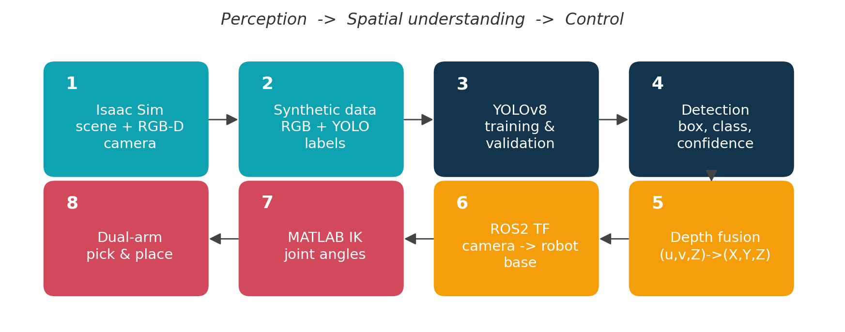
Figure 4.1: System architecture: perception-to-action pipeline

4.2 Tools and Technologies
Table 3: Tools and technologies used
Tool | Role in the project
NVIDIA Isaac Sim | Physics-based simulation of the workspace, dual-arm robot and RGB-D camera; automatic generation of synthetic images and labels
YOLOv8 / YOLOv8n | Object detection and classification of 8 classes (cube and cylinder in red, green, white, black)
ROS 2 Humble | Communication between simulation, perception and control (publisher–subscriber topics)
ROS 2 Action Graph | Node graph inside Isaac Sim that streams RGB and depth, publishes the TF tree and sends joint commands
ROS 2 TF | Maintains frame relationships (camera to robot base) with rotation and translation
MATLAB Robotics Toolbox | Inverse kinematics solver that returns joint angles for a target position

CHAPTER 5: METHODOLOGY – STEP-BY-STEP PROCEDURE
The work was carried out as eight sequential steps. The output of each step is the input of the next.

Step 1: Synthetic Data Generation
Virtual scenes are created in NVIDIA Isaac Sim. Objects are placed with varying position, orientation and lighting. RGB images, depth maps and 2D bounding-box annotations are generated automatically, which avoids manual data collection and gives a large, diverse dataset.

Step 2: Dataset Preparation
Annotations are converted to YOLO format (class id and normalised box coordinates). Images and labels are organised into training and validation sets, and label accuracy, class ids and box alignment are verified.

Step 3: Training the YOLO Model
YOLOv8 is trained on the prepared dataset for several epochs. Hyper-parameters such as learning rate and batch size are tuned, and the best weights (best.pt) are saved for deployment.

Step 4: Testing and Validation
The model is evaluated on the validation set with precision, recall and F1-score. Predicted boxes are inspected visually to confirm correct detection before integration.

Step 5: Adding 3D Information (Depth Fusion)
The centre pixel of each bounding box is combined with the depth value at that pixel to compute real-world X, Y, Z coordinates in the camera frame.

Step 6: Coordinate Transformation (Camera to Robot Base)
The camera-frame coordinates are transformed into the robot base frame using rotation and translation (ROS 2 TF), so that the position is meaningful to the robot.

Step 7: Grasp Planning and Inverse Kinematics
A grasp point is chosen from the object position and shape. Inverse kinematics in MATLAB then converts this target position into the joint angles of the arm.

Step 8: Motion Planning and Execution (Pick-and-Place)
Trajectories from the start pose to the object and then to the target location are executed. The gripper closes, lifts, transports and releases the object, with both arms coordinated.

CHAPTER 6: IMPLEMENTATION, RESULTS AND DISCUSSION
This chapter follows the same eight steps and shows the result obtained at each one.

6.1 Step 1 and 2: Environment and Synthetic Data
A virtual workspace was built in NVIDIA Isaac Sim with the dual-arm manipulator, a table, and cubes and cylinders in four colours. Lighting, camera placement and object layout were varied to resemble real scenes. RGB images and YOLO-format labels were then generated automatically.
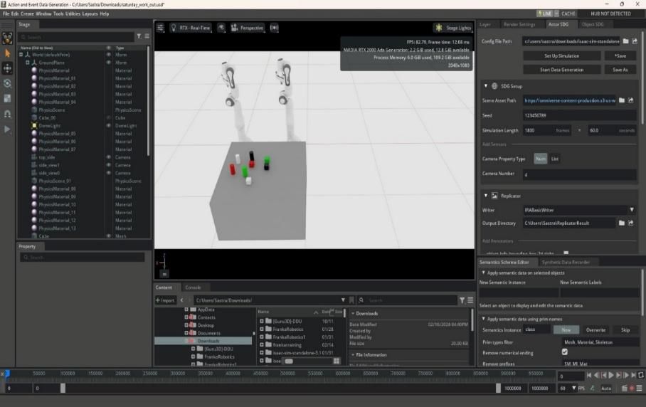
Figure 6.1: Creation of the simulation environment in Isaac Sim
Each label file has one line per object with five numbers: class_id, x_center, y_center, width and height. The four box values are normalised between 0 and 1 by the image width and height, which makes the labels independent of image resolution.
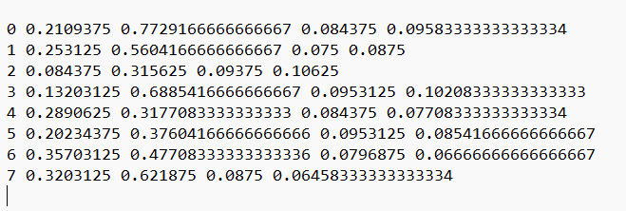
Figure 6.2: 2D label data in YOLO format
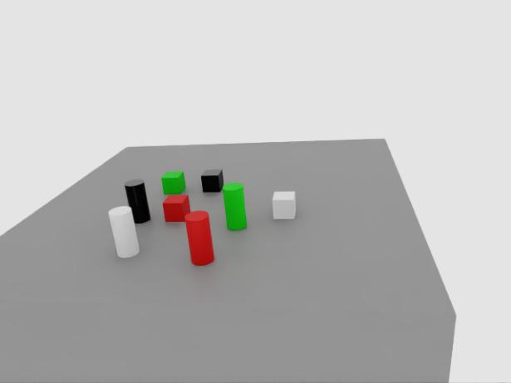
Figure 6.3: RGB image captured by the simulated camera

6.2 Step 3 and 4: Training, Testing and Object Detection
The trained model was run on live camera frames from Isaac Sim. It detected all objects and returned a bounding box, a class label and a confidence score for each. Confidence values of about 0.98 to 0.99 were observed for the detected cubes and cylinders (Figure 6.4). Early training with a small dataset gave poor accuracy, which improved after the number of training images was increased.
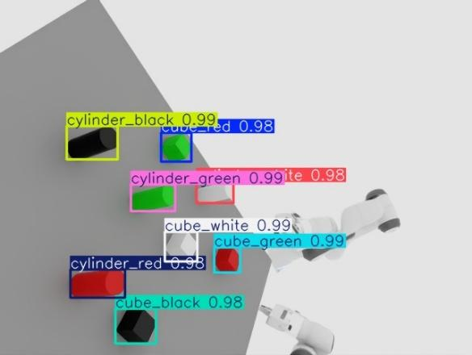
Figure 6.4: Object detection output with class labels and confidence scores

6.3 Step 5: Depth Fusion – 2D to 3D
The detected pixel (u, v) and the depth Z at that pixel are converted to camera-frame coordinates with the pinhole camera model:
X = (u − cₓ) × Z / fₓ Y = (v − cᵧ) × Z / fᵧ
Here (cₓ, cᵧ) is the principal point and (fₓ, fᵧ) are the focal lengths in pixels. For a detected object at pixel (148, 247) with Z = 1.159 m and f = 600 px, this gives X ≈ −0.178 m and Y ≈ −0.141 m. The result is the 3D position of the object relative to the camera.

6.4 Step 6: Coordinate Transformation (Camera to Robot Frame)
The 3D position is expressed in the camera frame, but the robot needs it in its own base frame. The ROS 2 Publish Transform Tree node in the Action Graph publishes the frames and their rotation and translation, so positions can be converted accurately. Early results showed wrong coordinates because of improper frame alignment; correcting the frame configuration in TF fixed this.
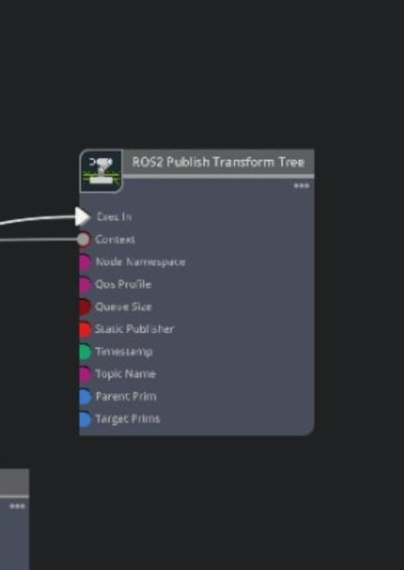
Figure 6.5: ROS 2 Publish Transform Tree (TF) node

6.5 Step 7: Inverse Kinematics Using MATLAB
The transformed (X, Y, Z) target is passed to a MATLAB inverse-kinematics solver (Robotics Toolbox). It returns the joint angles at which the end-effector reaches the target, and also reports the position error. MoveIt and other IK solvers were tried first but did not work reliably in this set-up, so MATLAB was adopted.
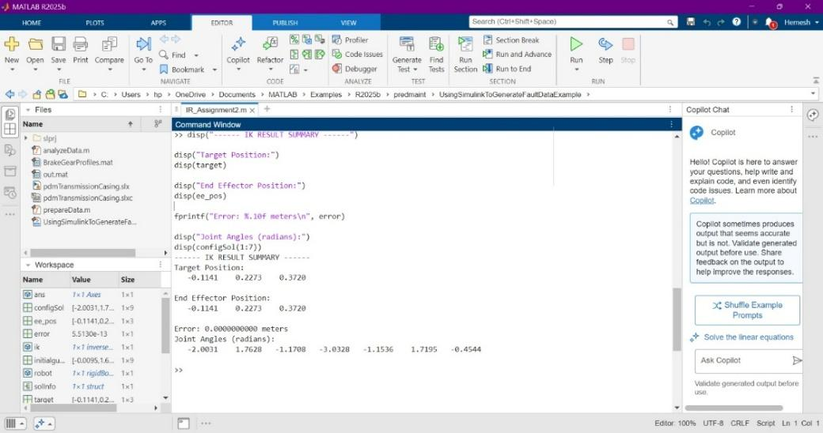
Figure 6.6: Inverse kinematics solution in MATLAB (joint angles and end-effector error)

6.6 Step 8: Pick-and-Place Operation
Using the computed joint angles, the manipulator moves towards the detected object, closes the gripper for a stable grasp, lifts the object, transports it and places it at the target location. This demonstrates the complete integration of perception, planning and control.
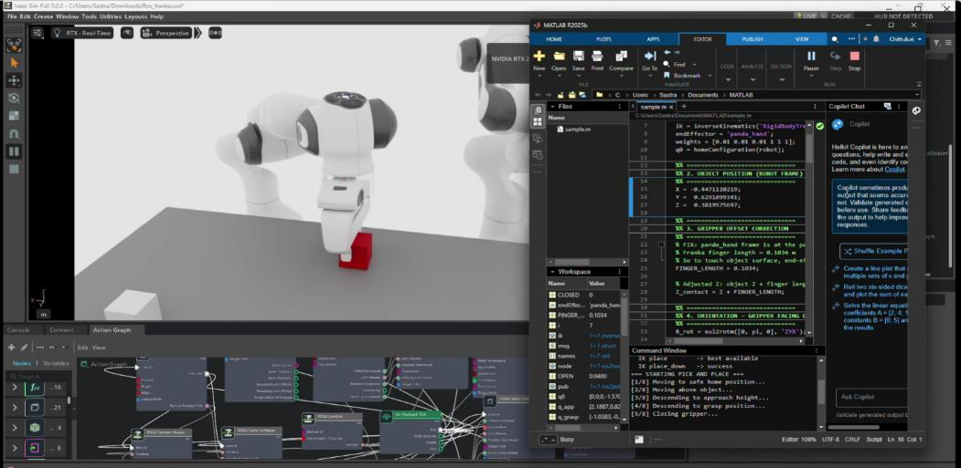
Figure 6.7: Picking of object
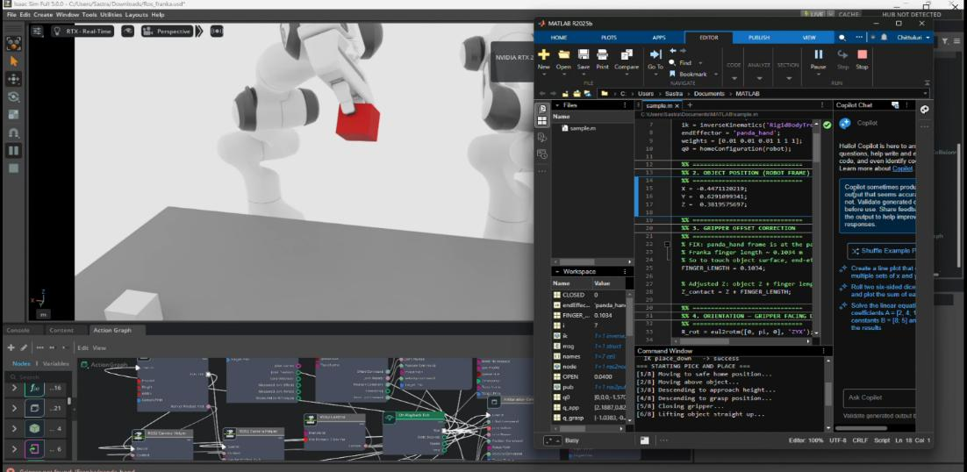
Figure 6.8: Holding of object
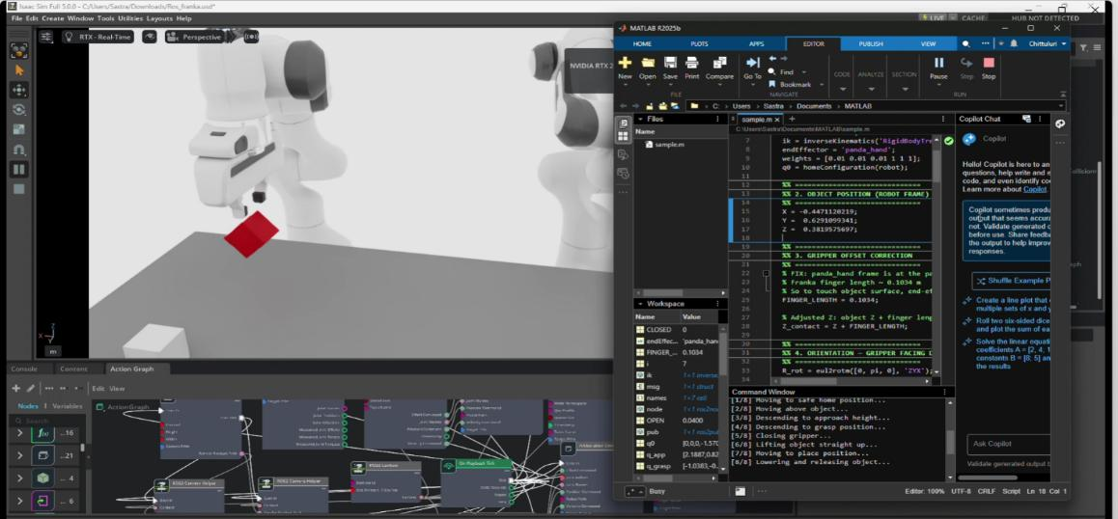
Figure 6.9: Placing of object

6.7 ROS 2 Action Graph
The Action Graph connects all nodes in Isaac Sim. Camera and depth nodes stream RGB and depth data continuously; the TF node publishes frame transforms; and control nodes send joint commands to both arms. Depth was first attempted with the built-in Replicator script, which gave repeated syntax errors, so the Action Graph was adopted for stable data acquisition.
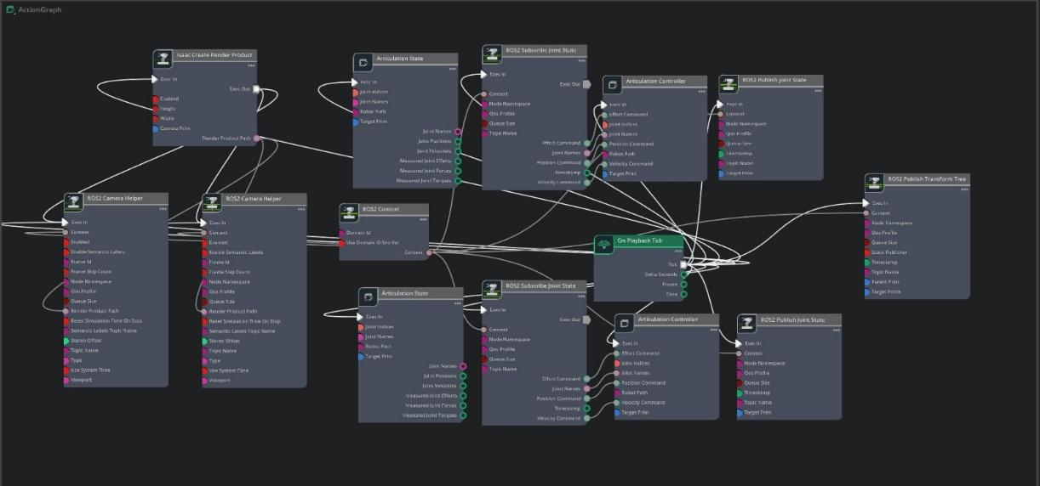
Figure 6.10: ROS 2 Action Graph used for data streaming, transformation and joint control

6.8 Model Performance Evaluation
The detector was evaluated with precision, recall and F1-score. Precision is the fraction of detections that are correct; recall is the fraction of real objects that are found; and F1 is their harmonic mean, giving a balanced measure. The most informative curves are shown below.

(a) YOLOv8
The F1 and recall curves stay at 1.0 over most of the confidence range and fall only near the highest confidence thresholds, which means that almost every object is found and correctly labelled for any practical threshold.
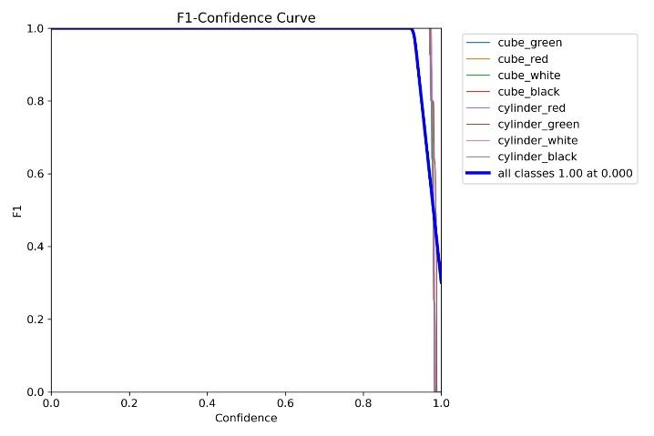
Figure 6.11: YOLOv8 F1–Confidence curve
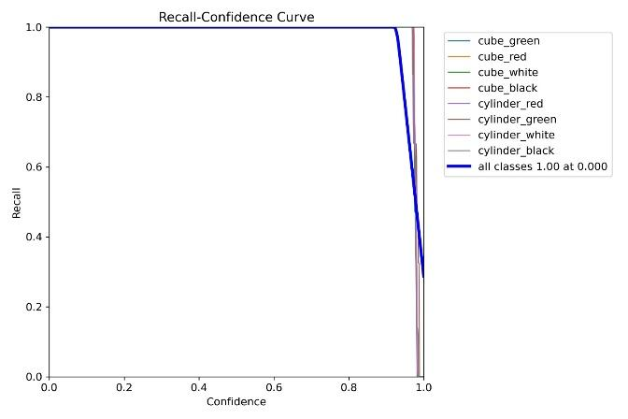
Figure 6.12: YOLOv8 Recall–Confidence curve

(b) YOLOv8n
YOLOv8n reached an overall mAP@0.5 of 0.990. Per-class values lie between 0.987 and 0.991, so no class is weak. The Precision–Recall curve stays close to the top-right corner, and the F1 curve peaks at about 1.0 near a confidence of 0.9.
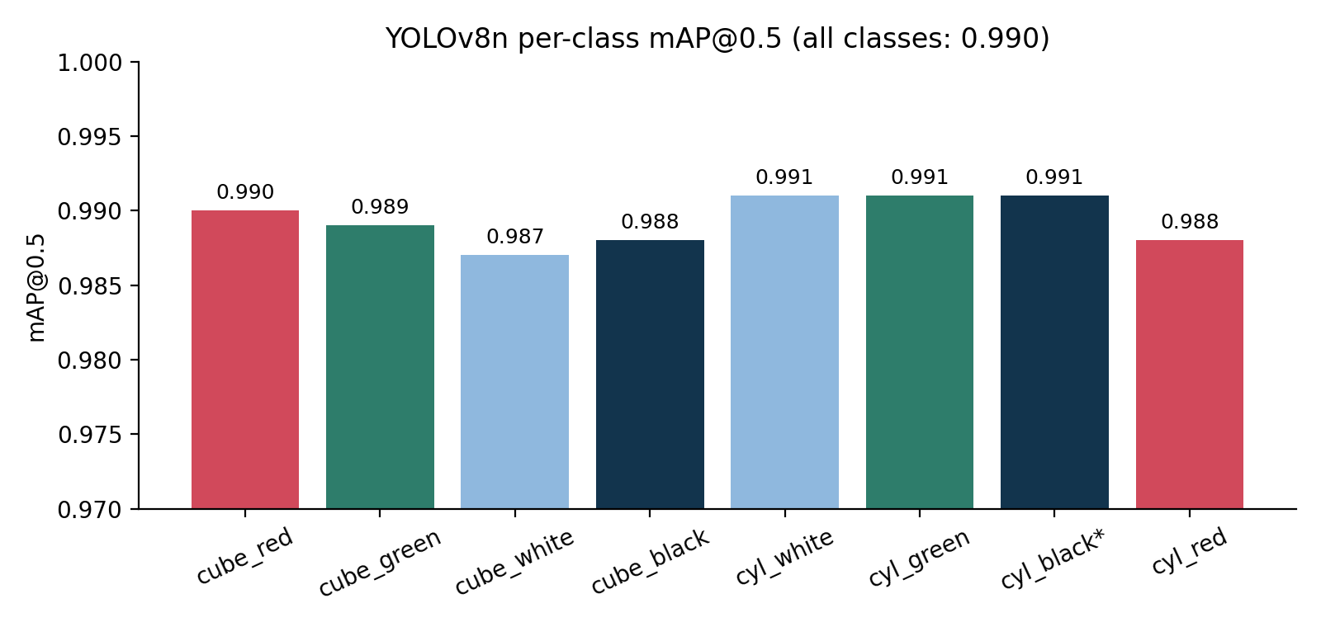
Figure 6.13: Per-class mAP@0.5 of YOLOv8n
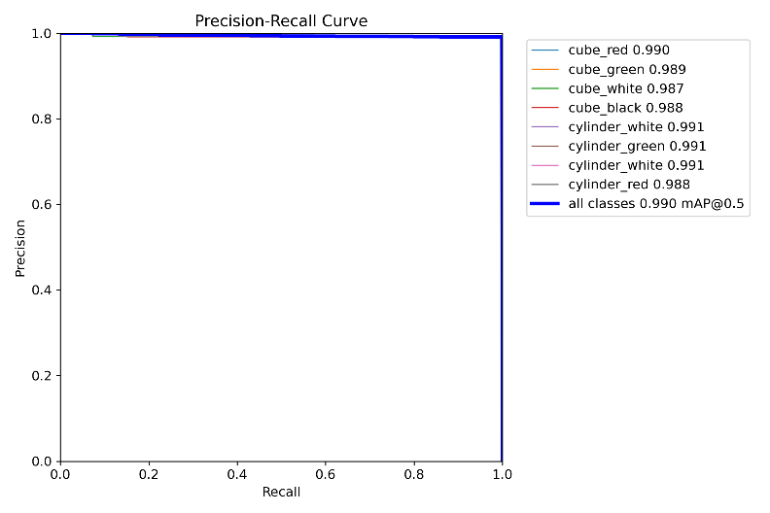
Figure 6.14: YOLOv8n Precision–Recall curve
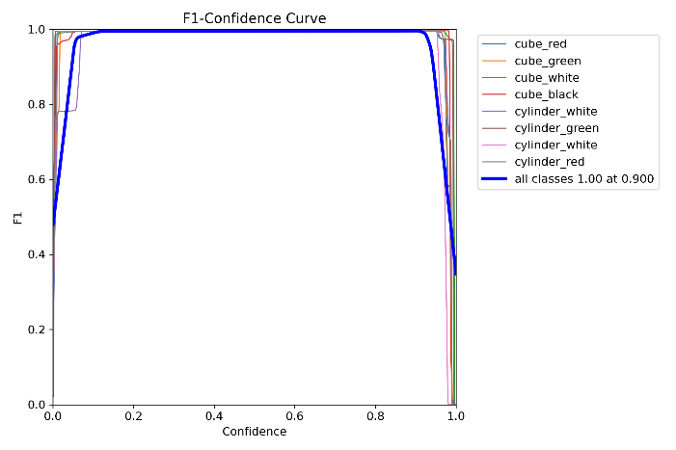
Figure 6.15: YOLOv8n F1–Confidence curve

6.9 Interpretation
- YOLOv8 detects objects reliably in the simulation, with confidence of about 0.98 to 0.99.
- Fusing depth with the 2D detection gives true 3D position, which a 2D detection alone cannot provide.
- TF transformation maps positions correctly into the robot workspace, and shows that frame alignment is essential to link perception with action.
- MATLAB inverse kinematics converts task-space targets into joint-space commands, completing a perception-to-action framework.
- Note: the near-perfect scores are for a clean synthetic dataset. Real-world performance will be lower because of sensor noise, reflections and clutter (the simulation-to-reality gap), so real testing is future work.

6.10 Challenges Faced and Solutions
Table 4: Challenges faced and solutions adopted
Challenge | Cause | Solution
Poor detection accuracy | Small initial training dataset | Increased the number of synthetic training images
Depth script errors | Syntax issues in the built-in Replicator script | Used ROS 2 Action Graph for depth and RGB streaming
Wrong object coordinates | Improper frame alignment in the transformation | Configured the coordinate frames correctly using ROS 2 TF
IK failure with MoveIt and other solvers | Solvers did not work reliably in this set-up | Computed joint angles with MATLAB Robotics Toolbox
Mismatched paths and inaccurate positioning | Action Graph configuration issues | Debugged node connections and re-checked paths
Reduced dual-arm coordination | Errors in MATLAB joint angles | Re-solved IK and verified end-effector error

CHAPTER 7: MY CONTRIBUTION AND LEARNING

7.1 Contribution
- Worked on the dual-arm robot in NVIDIA Isaac Sim using ROS 2 for object handling and motion control.
- Implemented MATLAB-based calculations to determine the joint angles for the robot motion.
- Worked on the ROS 2 Action Graph connections for data streaming and joint commands.

7.2 Learning
- Simulation of robots and sensors in NVIDIA Isaac Sim.
- ROS 2 communication, Action Graph and TF coordinate frames.
- Converting task-space positions into joint angles by inverse kinematics.

7.3 Technical Limitations and Ethical Considerations
- Action Graph path mismatches caused inaccurate object positioning.
- MATLAB joint-angle errors reduced coordination and precision in dual-arm manipulation.
- All results are from simulation; safety, force limits and collision checks must be validated before any deployment near humans.

CHAPTER 8: CONCLUSION AND FUTURE SCOPE

8.1 Conclusion
An autonomous dual-arm robotic system integrating AI-based object detection, depth estimation and robotic manipulation was developed and demonstrated in NVIDIA Isaac Sim. YOLOv8 gave accurate real-time detection (mAP@0.5 of about 0.99), depth fusion converted 2D detections into 3D positions, ROS 2 TF mapped them into the robot frame, and MATLAB inverse kinematics produced the joint angles for the pick-and-place operation.
The ROS 2-based architecture is modular and scalable, and the simulation environment provides a safe, low-cost platform to test behaviour before real deployment. The dual-arm configuration improves stability and precision through coordinated action.

8.2 Future Scope
- Deploy and test on a physical dual-arm robot with a real RGB-D camera, and measure the simulation-to-reality gap.
- Add collision-aware motion planning and real-time synchronisation of both arms.
- Automate the MATLAB IK step inside ROS 2 for fully closed-loop operation.
- Extend to cluttered scenes, more object classes and 6D pose estimation.

REFERENCES
- Chen, Y. L., Cai, Y. R., & Cheng, M. Y. (2023). Vision-based robotic object grasping—a deep reinforcement learning approach. Machines, 11(2), 275.
- Cui, Z., Kou, L., Chen, Z., Bao, P., Qian, D., Xie, L., & Tang, Y. (2024). Research on LFD system of humanoid dual-arm robot. Symmetry, 16(4), 396.
- Harada, K., Foissotte, T., Tsuji, T., Nagata, K., Yamanobe, N., Nakamura, A., & Kawai, Y. (2012). Pick and place planning for dual-arm manipulators. IEEE ICRA, 2281–2286.
- Le, T. T., Le, T. S., Chen, Y. R., Vidal, J., & Lin, C. Y. (2021). 6D pose estimation with combined deep learning and 3D vision techniques for a fast and accurate object grasping. Robotics and Autonomous Systems, 141, 103775.
- Levine, S., Pastor, P., Krizhevsky, A., Ibarz, J., & Quillen, D. (2018). Learning hand-eye coordination for robotic grasping with deep learning and large-scale data collection. The International Journal of Robotics Research, 37(4-5), 421–436.
- Redmon, J., Divvala, S., Girshick, R., & Farhadi, A. (2016). You only look once: Unified, real-time object detection. IEEE CVPR, 779–788.
- Wang, Y., & Kasaei, H. (2025). Learning dual-arm push and grasp synergy in dense clutter. IEEE Robotics and Automation Letters.
- Zhang, H., Lan, X., Bai, S., Wan, L., Yang, C., & Zheng, N. (2019). A multi-task convolutional neural network for autonomous robotic grasping in object stacking scenes. IEEE/RSJ IROS, 6435–6442.
- Zhang, S., Li, S., Li, Y., Li, X., & Wang, Z. (2024). A visual imitation learning algorithm for the selection of robots’ grasping points. Robotics and Autonomous Systems, 172, 104600.

